Web Development Using PHP

**O7 Solution IT Company**

**A summer training report**

Submitted in partial fulfillment of the requirements for the award of a degree of

**Diploma Engineering**

**(Computer Science and Engineering)**

**Submitted to**

**LOVELY PROFESSIONAL UNIVERSITY**

**PHAGWARA, PUNJAB**



**From 03/06/24 to 20/06/24**

**SUBMITTED BY**

**Name of student: Harsika Kumari Submitted to:**

**Registration Number: 12205096 Janki Singh**

**Signature of the student:**

# Table of content

| **S.No** | **Title** | **Page** |
| --- | --- | --- |
| 1 | Declaration by Student | 3 |
| 2 | Training Certification from the organization | 4 |
| 3 | Acknowledgment | 5 |
| 4 | Introduction To Company | 6 |
| 5 | Chapter 1- Introduction of Project | 7 |
| 6 | Chapter 2- Hardware and Software Requirements | 15 |
| 7 | Chapter 3 - Feasibility Study | 16 |
| 8 | Chapter 4 - System Analysis | 17 |
| 6 | Chapter 5 - Technology Used | 19 |
| 7 | Chapter 6 - Software Process Model | 29 |
| 8 | Chapter 7 - Design | 33 |
| 9 | Chapter 8 - DFD: Data Flow Diagram | 35 |
| 10 | Chapter 9 - SnapShot | 38 |
| 11 | Chapter 10 - Testing | 41 |
| 12 | Chapter 11 - Implementation | 46 |
| 13 | Chapter 12 - Maintenance | 47 |
| 14 | Chapter 13 - Conclusion | 48 |

# 

# 

# CERTIFICATE

I hereby certify that the work which is being presented in the industrial summer training entitled “BodyC” in partial fulfilment of the requirement for the award of degree of and submitted in Department of Mechanical Engineering, Lovely Professional University, Punjab is an authentic record of my own work carried out during period of summer training under the supervision of Industry supervisor name, Designation, Department of “Name of Department” “Company name”,

The matter presented in this summer training has not been submitted by me anywhere for the award of any other degree or to any other Institute.

**Date: 20/07/24 Harsika kumari**

This is to certify that the above statement made by the candidate is correct to best of my knowledge

**Date: 20/06/24 Janki Singh**

**Industry Supervisor**

# ACKNOWLEDGEMENT

I have accumulated a large number of debts in preparing this project. While a brief acknowledgement here in no way writes them off, it is a small courtesy whose sentiments are sincere. I would like to extend my sincere thanks to all the people who helped me in different ways with the development of this project report. Without their continuous support and guidance, the completion of my project would have been impossible.

I extend my gratitude to “Satnam Singh”, Head of the Department, “Diploma”, for his continuous support and encouragement throughout the degree. I also wish to express my most sincere thanks to my supervisor “-- for her invaluable guidance, advice, support, and encouragement. I will carry out her guidance throughout my life.

I shall be falling behind in my duties if I do not place on record my sincere thanks to all those writers and authors from whose writings I have benefited.

I would like to express my special gratitude and thanks **O7 Services** Staff for giving me such attention and time.

In the end, I would also like to mention that this project would not have been possible but for the continuous support and guidance of my parents who gave me the strength and will to succeed. My thanks and appreciation also go to my friends in developing the project and the people who have willingly helped me out with their abilities.

Harsika Kumari

# 

# O7 Services is ISO 9001:2015 Certified company founded in 2015. They specialise in a variety of services including Web Development, Mobile Application Development, Custom Software Development, UI/UX Designing, Hosting services, Digital Marketing, Registration of Domain Names with various extensions, AMC & MMC Services, Bulk SMS and voice calls. O7 Services offers advanced IT solutions supporting the entire business cycle - from consulting to system development, deployment, quality assurance, and 24x7 support. With over 9 years of experience, the company aims to form long-lasting strategic partnerships with clients, offering affordable prices, timely delivery, and measurable business results. Their headquarter is located in Jalandhar with a branch office in Hoshiarpur. Some of the products developed by O7 Services include Vehicle Tracking System, Invoice Software, School Management System, Hospital Management System, Parents - Teacher Communication App, Fee Management system, Task Management System, Online Food Ordering App, Security App, Admission system, Inventory Software, and Car Servicing App. Additionally, O7 Services provides training programs including 6 Weeks/6 Months Industrial Training, Project-Based Training, Corporate Training, and Job-Oriented Courses Training, covering major IT trends such as Full Stack Development (MEAN/MERN), Flutter, Kotlin Android, Swift UI (iOS), Firebase, Python, Angular, React Js, Vue Js, Node Js, ASP.NET, .NET Core, PHP, Laravel, CodeIgniter, Software Testing, Cloud Computing, Blockchain, DevOps, Data Science, Artificial Intelligence, Machine Learning, UI/UX Designing, Digital Marketing, WordPress, Linux, CCNP, CCNA Security, Network Security, Cyber Security, MCSE, MCITP, Java, Spring, Hibernate, C/C++, Photoshop, Adobe Illustrator, Figma, CorelDraw and many more.

# CHAPTER 1 INTRODUCTION

## 1.1. INTRODUCTION:

In the contemporary world of online fashion retail, BodyChic emerges as a beacon of style and accessibility. This project is dedicated to transforming the fashion retail experience by harnessing cutting-edge technology to streamline operations and elevate customer satisfaction.

With a commitment to optimizing inventory management and enhancing user interaction, our project aims to establish a sophisticated online platform. This platform will not only facilitate seamless browsing and purchase of fashion products but also integrate robust functionalities for order management and customer engagement.

By leveraging advanced e-commerce solutions, BodyChic seeks to set new standards in the digital fashion industry. This initiative aims to enhance customer experience through intuitive navigation, personalized recommendations, and efficient logistics management. Through these innovations, BodyChic aims to redefine online fashion retailing, ensuring a dynamic and engaging shopping experience while meeting the evolving demands of fashion-conscious consumers worldwide.

## 1.2. PROJECT DESCRIPTION:

### Modules of Project

The BodyChic project consists of the following modules, each serving specific functions to ensure the smooth operation of the platform:

1. Admin
2. Customer

### Admin module of BodyChic:

The admin module provides functionalities for administrators to manage various aspects of the BodyChic platform.

* **Admin Login:** Secure login for administrators to access administrative functions.
* **Category Management:** Enables administrators to manage product categories by adding and updating category details.

### Customer modules of BodyChic:

The project provides many facilities to the students.

* **Register**
* **Login**
* **View books**
* **ViewProfile**
* **View issued book**
* **View return book**
* **Logout**

## 1.3. PROBLEM DEFINITION:

Despite their significant presence in the fashion industry, many online fashion platforms face challenges in effectively managing their product offerings and meeting the diverse needs of customers in a competitive digital market. Traditional e-commerce systems often lack the flexibility and efficiency required to keep pace with evolving trends and customer expectations:

* **Inefficient Product Management:** Manual updating and tracking of product listings can lead to inefficiencies in inventory management, hindering the ability to respond promptly to customer demands and preferences.
* **Limited User Experience:** Outdated systems may lack user-friendly interfaces and robust search functionalities, making it difficult for customers to navigate and explore products effectively.

### Administrative Overhead: Manual administrative tasks such as order processing, customer management, and inventory control can consume significant time and resources, diverting attention from core business activities.

### Data Security Concerns: With the increasing digitization of customer information and online transactions, there is a growing need to ensure the security and integrity of sensitive customer data against potential cyber threats and breaches.

## 1.4. EXISTING SYSTEM:

The current state of BodyChic's online fashion platform involves a combination of traditional e-commerce practices and basic web functionalities. While these systems have supported BodyChic's operations, they face several challenges in adapting to the evolving needs of digital consumers and technological advancements:

* **Limited Product Management:** The current system relies on manual updates and management of product listings. This manual approach can lead to inefficiencies in updating inventory, product descriptions, and pricing, which may hinder the ability to promptly respond to market trends and customer preferences.
* **Basic User Experience:** The existing website design lacks advanced user interface (UI) features and robust search functionalities. This limitation makes it challenging for customers to easily navigate through product categories, explore new arrivals, and find specific items of interest efficiently.
* **Administrative Overhead:** Administrative tasks such as order processing, customer management, and inventory tracking are primarily handled manually. This manual handling can consume significant time and resources, diverting focus from strategic business activities and customer service improvements.
* **Security and Compliance Concerns:** With the increasing digitization of customer data and online transactions, there's a heightened risk of data breaches and unauthorized access. The current system may lack robust security measures to safeguard sensitive customer information, potentially exposing BodyChic to cybersecurity threats and privacy violations.

### Limited Scalability: The existing platform may face challenges in scaling operations to accommodate growth in customer traffic, product offerings, and technological integrations. This limitation could restrict BodyChic's ability to expand its market reach, integrate new features, and adapt to dynamic market demands effectively.

## 1.5. PROPOSED SYSTEM:

The proposed enhancements to BodyChic's online fashion platform aim to modernize and optimize operations through innovative technology solutions, thereby enhancing customer experience and operational efficiency:

* **Integrated E-commerce Platform:** The system will introduce a robust e-commerce platform accessible to both customers and administrators. This platform will serve as a centralized hub for all online retail activities, including product browsing, selection, and purchase, as well as order management and customer service interactions.
* **Enhanced User Interface and Experience:** Advanced UI/UX design principles will be implemented to improve navigation, product discovery, and overall user engagement. This includes intuitive search functionalities, personalized recommendations, and seamless checkout processes to enhance the shopping experience and increase conversion rates.
* **Automated Product Management:** Cutting-edge algorithms will automate product cataloguing and inventory management processes. This automation will streamline the addition of new products, update product information dynamically, and ensure accurate stock management. Integration of AI-driven analytics may optimize inventory levels and predict customer demand trends.

### Secure Payment Gateway Integration: Robust payment gateway solutions will be integrated to ensure secure and seamless transactions. This includes support for various payment methods and compliance with industry-standard security protocols to protect customer financial data.

### Scalability and Flexibility: The proposed platform will be designed with scalability in mind, allowing for future expansion in product offerings, customer base, and technological integrations. Cloud-based infrastructure and modular architecture will facilitate agility in adapting to market changes and implementing new features.

### Data Analytics and Reporting: Implementation of advanced analytics tools will provide insights into customer behaviour, sales trends, and operational performance. Customizable reporting functionalities will empower administrators to make data-driven decisions and optimize business strategies effectively.

## 1.6. Future Scope:

In the future, I plan to integrate the OpenAI API into my project to significantly enhance its capabilities. By leveraging advanced AI technologies, BodyChic will be able to offer more sophisticated and accurate clothing recommendations, considering not just body sizing and skin tone but also individual preferences, current fashion trends, and seasonal styles.

Moreover, we will expand our services to include personalized jewelry recommendations. By analyzing the user's skin tone, clothing design, and even the occasion, BodyChic will suggest jewelry pieces that perfectly complement their overall look. This will transform BodyChic from a clothing recommendation website into a comprehensive personal styling platform.

Further enhancements will include user feedback integration, allowing the platform to learn and adapt to each user’s unique style over time. We also aim to incorporate augmented reality (AR) features, enabling users to virtually try on clothes and jewelry before making a purchase. This immersive experience will bridge the gap between online and in-store shopping, providing users with confidence in their choices.

By continually evolving and incorporating cutting-edge technologies, BodyChic aims to become the go-to destination for personalized fashion and styling advice, catering to the diverse needs of our users and setting new standards in the fashion tech industry.

### 

### 

# CHAPTER 2 HARDWARE & SOFTWARE REQUIREMENTS

For this project minimum hardware and software requirements are listed below:

## 2.1. Hardware Requirements:

**Processor** : Intel X86

**RAM** : 512MB/8 GB

**Hard Disk** : 50 GB

## 2.2. Software Requirements:

**Front End Tool** : HTML, CSS, JAVASCRIPT, BOOTSTRAP

**Web Server** : PHP Server 8.0.0 (or Above).

**Back End Tool**  : MYSQL

**Browser**  : IE 7.0/Mozilla Firefox 6.0/Cross

**Operating System** : Windows Operating System/Linux

# 

# CHAPTER 3: FEASIBILITY STUDY

The educational guide project aims to enhance student services by providing comprehensive information about timetables, fee structures, and academic resources to support both home and classroom learning.

## 3.1. Economic Feasibility:

The project is economically feasible as it is free to use for students. The operational costs are minimal as users enter data through a user-friendly interface. Data can be displayed in HTML tabular form, ensuring accessibility and ease of use.

## 3.2. Technical Feasibility:

Technically, the project is feasible with its use of modern web technologies such as HTML, CSS3, JavaScript, jQuery, Ajax, and JSON. These technologies ensure robust web-based functionality and enhance user interaction and data management capabilities.

## 3.3. Behavioural Feasibility:

The project is behaviourally feasible due to its intuitive user interface that enhances user experience. Operators and end-users find it easy to navigate and operate the system. The system responds quickly to user inputs, facilitating efficient data management and access.

## 3.4. Methodology / Planning of Work:

The project's objectives are:

1. **Enhanced User Experience:** Prioritizing intuitive interface designs, comprehensive product information, and seamless checkout processes to enhance user satisfaction and loyalty.
2. **Optimized Inventory Management:** Implementing advanced inventory control systems and predictive analytics to streamline stock replenishment, reduce overheads, and improve product availability.
3. **Scalable Business Operations:** Leveraging cloud-based technologies and scalable infrastructure to support rapid growth, expand market reach, and capitalize on emerging market opportunities.
4. **Continuous Improvement:** Embracing agile development methodologies and user feedback loops to iterate on features, enhance platform performance, and meet evolving customer expectations.

## 3.5. Use Case Diagrams:

Use case diagrams are essential during the analysis phase to depict system functionality and interactions between users (actors) and the system itself. Here are some key use cases identified for the educational guide project:

# 

# CHAPTER 4 SYSTEM ANALYSIS

## 4.1. DATA ANALYSIS

Before developing this project, we first analyze the existing system of study. In the existing system, all greetings are given manually. As we know, nowadays computers are used in every field. We can remove the manual work by using an automatic system. We see first that if it is feasible or not whether technically, economically, or operationally. We test whether it properly works or not. Its technical requirements are feasible or not. We analysed the system properly and then started designing it. After Designing, we implement this project to see whether this project works properly or not. After implementing the project, we check whether there is any problem for the user while using this project. Prior to stating whether the system we have to develop is feasible or not we believe that we should emphasize what is implied by the word “Analysis”. Analysis is the measure of how beneficial or practical the Development of the system will be to the organisation. It is a preliminary survey for the system's investigation. It aims to provide information to facilitate a later in-depth investigation.

## 4.2. Types

There are various measures of analysis that help to decide whether a particular project is feasible or not.

These measures include –

1. Operational Analysis
2. Technical Analysis
3. Economical Analysis

Each of these types will be explained in detail throughout the project report

## 4.3. Operational analysis

A proposed system is beneficial only if it can be turned into an information system that will meet the operational requirements of an organisation. A system often fails if it does not fit within existing operations and if users resist the change.

Important issues a systems developer must look into are: Will the new system be used if implemented in an organisation?

Are there any major barriers to implementation or is the proposed system accepted without destructive resistance?

The whole purpose of computerising is to handle the work much more accurately and efficiently with less time consumption. There will be additional work to be completed because now the website will have to maintain a database of both their admins as well as their Customers. Compared to the semi-computerized system the chances of avoiding errors in a computerised system are much higher because the user need not stress himself unnecessarily resulting in recklessness. Unlike the semi-computerized system, there would be backup data for all the information concerning the daily transactions. Another important fact to be regarded is the security control, which is handled by the system. Since data regarding each Customer is confidential, security is a key issue. Information falling into the wrong hands could jeopardise the entire website organisation. Unlike semi-computerized systems, the proposed system offers adequate control to protect against fraud and embezzlement and guarantees the accuracy and Security of data and information. This is handled by the system providing individuals with separate login names and passwords. The new system is user-friendlier, which enables the end-user to complete his/her work efficiently and accurately with interest. After taking the above facts into consideration we can state the operation of the proposed system is feasible.

## 4.4. Economical Analysis

In making recommendations a study of the economics of the proposed system should be made. Even though finding out the costs of the proposed project is difficult we assume and estimate the costs and benefits as follows. According to the computerised system we propose, the costs can be broken down into two categories:

1. Costs associated with the development of the system.
2. Costs associated with operating the system.

# 

# Chapter 5 Technology Used

## 5.1. HTML

HTML Stands for HyperText Markup Language, where

* HyperText stands for Link between web pages.
* Markup Language means Text between tags that define the structure.

HTML is a markup language that is used to create web pages. It defines how the web page looks and how to display content with the help of elements. It forms or defines the structure of our Web Page, thus it forms or defines the structure of our Web Page. We must remember to save your file with the .html extension.

## 5.2. CSS

Cascading Style Sheets, fondly referred to as CSS, is a simply designed language intended to simplify the process of making web pages presentable. CSS allows you to apply styles to web pages. More importantly, CSS enables you to do this independently of the HTML that makes up each web page.

CSS is easy to learn and understand, but it provides powerful control over the presentation of an HTML document.

### WHY CSS?

* **CSS saves time:** You can write CSS once and reuse the same sheet in multiple HTML pages.
* **Easy Maintenance:** To make a global change simply change the style, and all elements in all the webpages will be updated automatically.
* **Search Engines:** CSS is considered a clean coding technique, which means search engines won’t have to struggle to “read” its content.
* **Superior styles to HTML:** CSS has a much wider array of attributes than HTML, so you can give a far better look to your HTML page in comparison to HTML attributes.
* **Offline Browsing:** CSS can store web applications locally with the help of an offline cache. Using this we can view offline websites.

## 5.3. Javascript

JavaScript is a lightweight, cross-platform, and interpreted scripting language. It is well-known for the development of web pages, and many non-browser environments also use it. JavaScript can be used for Client-side developments as well as Server-side developments. JavaScript contains a standard library of objects, like Array, Date, and Maths, and a core set of language elements like operators, control structures, and statements.

### Client-side: It supplies objects to control a browser and its Document Object Model (DOM). Like if client-side extensions allow an application to place elements on an HTML form and respond to user events such as mouse clicks, form input, and page navigation. Useful libraries for the client side are AngularJS, ReactJS, VueJS and so many others.

### Server-side: It supplies objects relevant to running JavaScript on a server. Like if the server-side extensions allow an application to communicate with a database, and provide continuity of information from one invocation to another of the application, or perform file manipulations on a server. The useful framework which is the most famous these days is node.js.

JavaScript can be added to your HTML file in two ways:

* **Internal JS:** We can add JavaScript directly to our HTML file by writing the code inside the <script> tag. The <script> tag can either be placed inside the <head> or the <body> tag according to the requirement.
* **External JS:** We can write JavaScript code in another file having an extension .js and then link this file inside the <head> tag of the HTML file in which we want to add this code.

## 5.4. Introduction to PHP

**PHP** is a general-purpose server-side scripting language originally designed for Web development to produce dynamic Web pages. It is one of the first developed server-side scripting languages to be embedded into an HTML source document rather than calling an external file to process data. The code is interpreted by a Web server with a PHP processor module which generates the resulting Web page. It also has evolved to include a command-line interface capability and can be used in standalone graphical applications.



### Advantages of PHP

* PHP is accessible
* It's available for free
* It's available with documentation in many languages
* There are many support groups, forums, and teams supporting PHP
* There is a wealth of online information regarding PHP
* It's quick to develop in PHP
* PHP is loosely typed, which makes basic scripts much faster to develop with less attention to design
* PHP is flexible. Use OOP or not. Use naming convention(s) or not
* It runs on many different operating systems
* It can be optimised, even "compiled" for performance closer to that of more established compiled languages.

### What is the scope of PHP?

* PHP is basically a scripting language used for web development. The websites created by PHP are dynamic and attractive
* Scope in PHP is really high as PHP is a language known in the world of technology for many years. So it has gained the maximum popularity in this era.

## 5.5. Bootstrap

Bootstrap is a free and open-source tool collection for creating responsive websites and web applications. It is the most popular HTML, CSS, and JavaScript framework for developing responsive, mobile-first websites. It solves many problems which we had once, one of which is the cross-browser compatibility issue. Nowadays, the websites are perfect for all browsers (IE, Firefox, and Chrome) and for all sizes of screens (Desktop, Tablets, Phablets, and Phones). All thanks to Bootstrap developers -Mark Otto and Jacob Thornton of Twitter, though it was later declared to be an open-source project.



### Why Bootstrap?

* Faster and Easier Web Development.
* It creates Platform-independent web pages.
* It creates Responsive web pages.
* It is designed to be responsive to mobile devices too.
* It is Free! Available on [www.getbootstrap.com](http://www.getbootstrap.com)
* How to use Bootstrap 4 on a webpage: There are two ways to include Bootstrap on the website.
* Include Bootstrap from the CDN link.
* Download Bootstrap from getbootstrap.com and use it.

## 

## 5.6. Xampp server

XAMPP is one of the widely used cross-platform web servers, which helps developers create and test their programs on a local webserver. It was developed by Apache friends, and its native source code can be revised or modified by the audience. It consists of an Apache HTTP server, Maria DB, and interpreters for different programming languages like PHP and Perl. It is available in 11 languages and supported by different platforms such as the IA-32 package of Windows and the x64 package of macOS and Linux.

### What is XAMPP?

XAMPP is an abbreviation where X stands for Cross-Platform, A stands for Apache, M stands for MySQL and Ps stands for PHP and Perl. It is an open-source package of web solutions that includes Apache distribution of many servers and common-line executables along with modules such as Apache server, MariaDB, PHP, and Perl.

XAMPP helps a local host or server to test its website and clients via computer and laptop before releasing it to the main server. It is a platform that furnishes a suitable environment to test and verify the working of projects based on Apache, Perl, MySQL database, and PHP through the system of the host itself. Among these technologies, Perl is a programming language used for web development, PHP is a backend scripting language, and MariaDB Is the most vividly used database developed by MySQL.

## 5.7. MYSQL

A database is a separate application that stores a collection of data. Each database has one or more distinct APIs for creating, accessing, managing, searching and replicating the data it holds.

Other kinds of data stores can also be used, such as files on the file system or large hash tables in memory but data fetching and writing would not be so fast and easy with those types of systems.

Nowadays, we use relational database management systems (RDBMS) to store and manage huge volumes of data. This is called a relational database because all the data is stored in different tables and relations are established using primary keys or other keys known as Foreign Keys.

A Relational DataBase Management System (RDBMS) is a software that −

* Enables you to implement a database with tables, columns and indexes.
* Guarantees the Referential Integrity between rows of various tables.
* Updates the indexes automatically.
* Interprets an SQL query and combines information from various tables.

### RDBMS Terminology

Before we proceed to explain the MySQL database system, let us revise a few definitions related to the database.

* Database − A database is a collection of tables, with related data.
* Table − A table is a matrix with data. A table in a database looks like a simple spreadsheet.
* Column − One column (data element) contains data of one and the same kind, for example, the column postcode.
* Row − A row (= tuple, entry or record) is a group of related data, for example, the data of one subscription.
* Redundancy − Storing data twice, redundantly to make the system faster.
* Primary Key − A primary key is unique. A key value cannot occur twice in one table. With a key, you can only find one row.
* Foreign Key − A foreign key is the linking pin between two tables.
* Compound Key − A compound key (composite key) is a key that consists of multiple columns because one column is not sufficiently unique.
* Index − An index in a database resembles an index at the back of a book.
* Referential Integrity − Referential Integrity makes sure that a foreign key value always points to an existing row.

### MySQL Database

MySQL is a fast, easy-to-use RDBMS being used for many small and big businesses. MySQL is developed, marketed and supported by MySQL AB, which is a Swedish company.

### 

### MySQL is becoming so popular because of many good reasons −

* MySQL is released under an open-source license. So you have nothing to pay to use it.
* MySQL is a very powerful program in its own right. It handles a large subset of the functionality of the most expensive and powerful database packages.
* MySQL uses a standard form of the well-known SQL data language.
* MySQL works on many operating systems and with many languages including PHP, PERL, C, C++, JAVA, etc.
* MySQL works very quickly and works well even with large data sets.
* MySQL is very friendly to PHP, the most appreciated language for web development.
* MySQL supports large databases, up to 50 million rows or more in a table. The default file size limit for a table is 4GB, but you can increase this (if your operating system can handle it) to a theoretical limit of 8 million terabytes (TB).
* MySQL is customizable. The open-source GPL license allows programmers to modify the MySQL software to fit their own specific environments.

# 

# CHAPTER 6 SOFTWARE PROCESS MODEL

## Waterfall Model

The waterfall model is a sequential design process, often used in software development processes, in which progress is seen as flowing steadily downwards (like a waterfall) through the phases of Conception, Requirement Analysis, Design, Coding, Testing, Deployment, and Maintenance.

Following is a diagrammatic representation of different phases of the waterfall model.

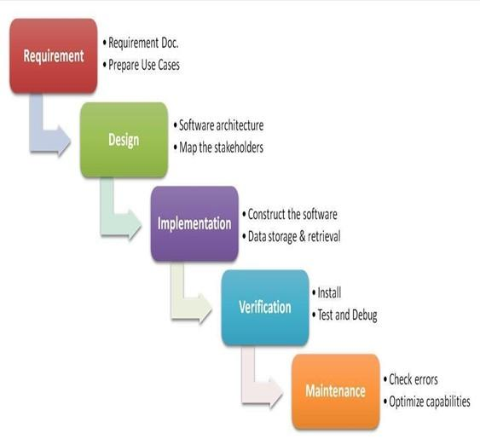

## The sequential phases in the Waterfall model:

### Requirement Gathering and analysis

All possible requirements of the system to be developed are captured in this phase. Requirements are a set of functionalities and constraints that the end-user (who will be using the system) expects from the system. The requirements are gathered from the end-user by consultation, these requirements are analyzed for their validity and the possibility of incorporating the requirements in the system to be developed is also studied. Finally, all requirements are documented in a requirement specification doc.

### System Design

Before starting for actual coding, it is highly important to understand what we are going to create and what it should look like. The requirement specifications from the first phase are studied in this phase and system design is prepared. System Design helps in specifying hardware and system requirements and also helps in defining overall system architecture. The system design specifications serve as input for the next phase of the model.

### Implementation

With inputs from system design, the work is divided into modules/units and actual coding is started. The system is first developed in small programs called units, which are integrated in the next phase. Each unit is developed and tested for its functionality which is referred to as Unit Testing. Unit testing mainly verifies if the modules/units meet their specifications.

* **Integration and Testing**

All the units developed in the implementation phase are integrated into a system after testing of each unit. These units are integrated into a complete system during the Integration phase and tested to check if all modules/units coordinate with each other and if the system as a whole behaves as per the specifications. Post integration the entire system is tested for any faults and failures.

### Maintenance

This phase of "The Waterfall Model" is virtually never-ending. There are some issues which come up in the client environment. Not all problems come into the picture directly but they arise from time to time and need to be solved. To fix those issues patches are released. Also to enhance the product some better versions are released. Maintenance is done to deliver these changes in the customer environment.

All these phases are cascaded to each other in which progress is seen as flowing steadily downwards (like a waterfall) through the phases. The next phase is started only after the defined set of goals are achieved for the previous phase and it is signed off, so the name "Waterfall Model". In this model, phases do not overlap. The Waterfall model is the earliest SDLC approach that was used for software development.

## Waterfall Model Application

Every software developed is different and requires a suitable SDLC approach to be followed based on internal and external factors. Some situations where the use of the Waterfall model is most appropriate are:

* Requirements are very well documented, clear and fixed.
* Product definition is stable.
* Technology is understood and is not dynamic.
* There are no ambiguous requirements.
* Ample resources with the required expertise are available to support the product.

## Waterfall Model Pros & Cons:

### Advantage

The advantage of waterfall development is that it allows for departmentalization and control. A schedule can be set with deadlines for each stage of development and a product can proceed through the development process model phases one by one.

Development moves from concept, through design, implementation, testing, installation, and troubleshooting, and ends up with operation and maintenance. Each phase of development proceeds in strict order.

### Disadvantage

The disadvantage of waterfall development is that it does not allow for much reflection or revision. Once an application is in the testing stage, it is very difficult to go back and change something that was not well-documented or thought upon in the concept stage. Not suitable for the projects where requirements are at a moderate to high risk of changing. So risk and uncertainty are high with this process model.

## Why do we use the waterfall model?

As it is a major project and being a beginner, we already have the requirements for our ongoing project. The waterfall model is considered to be a downward approach and we don’t have to look up to the previous level that frequently, it’s beneficial for our project to be completed in a timely manner. Thus if we want to modify anything within our project after deployment, we can start from the initial phase. Thus it does not freeze the possibility for any kind of change.

# 

# CHAPTER 7 DESIGN

## 7.1. SYSTEM DESIGN

The most creative and challenging phase of SDLC is system design. The term design describes a final system and the process by which it is developed. It includes the construction of programs and program testing.

The purpose of the design phase is to plan a solution to the problem specified by the requirements document. This phase is the first step in moving from the problem domain to the solution domain. Starting with what is needed; design takes us towards how to satisfy the needs. The design of the system is perhaps the most critical factor affecting the quality of the software. It has a major impact on the later phase, particularly testing and maintenance. The output of this phase is the design document. This document is similar to the blueprint or plan for the solution and is used later during implementation, testing and maintenance.

A systematic method has to achieve the beneficial result at the end. It includes starting with an average idea and developing it into a series of steps. The series of steps for successful system development are given below:

* Study the problem completely because first of all, we should know the goal, which he has to achieve.
* We should see what kind of output we require and what kind of input we give so we can get the desired output from the system. It is a very challenging step of system development.
* According to the output requirement of the system, the strength of various databases should be designed.
* Next, we should know what kind of program we should develop, which will lead us to reach our final goal.
* Then we write this individual program, which later on joining will solve the problem.
* Then we test these programs and make necessary corrections in them to achieve the target of the program.
* At last, combining all these problems in the form of a bar in the menu of windows will complete the software package for general insurance.

The three main objectives which the designer has to bear in mind are:-

* How fast the design will be does the user work given particular hardware resources?
* The extent to which the design is secure against human errors and machine malfunctions.
* The ease with which the design allows the system to be changed.

To meet these objectives analysts and programmers use a top-down and bottom-up design.

### TOP-DOWN DESIGN

It is also known as system design, and aims to identify the modules that should be in a system. It starts with a large picture and moves to the details. The analyst and team members look at major functions that the system must provide and break these down into smaller and smaller activities.

### BOTTOM-UP APPROACH

It is also known as detailed design. It starts with details and then moves to the big picture. This approach is appropriate when users have specific requirements for output.

# 

# CHAPTER 8 DFD: Data Flow Diagram

Data Flow Diagrams were first developed by Larry Constantine as a way of expressing system requirements in a graphical form. DFD is also known as bubble chart and has the purpose of clarifying system requirements and identifying major transformations and will become the program in the system design.

Data Flow Diagramming is a means of representing a system at any level of detail with a graphic network of symbols showing data flows, data stores, data processes, and data sources/destinations.

## Purpose:

The purpose of data flow diagrams is to provide a semantic bridge between users and systems developers.

The diagrams are:

* Graphical, eliminating thousands of words.
* Logical representations, modelling WHAT a system does, rather than physical models showing HOW it does it.
* Hierarchical, showing systems at any level of detail
* Allowing users to understand and review.

## DFD Symbols are as follows:

* The External Entity symbol represents sources of data to the system or destinations of data from the system.
* The Data Flow symbol represents the movement of data.



* The Data Store symbol represents data that is not moving (delayed data at rest).



* The Process symbol represents an activity that transforms or manipulates the data.

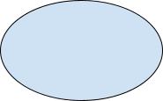

## DFD Level 0:

### Context Level Diagram

Here User and Admin interact with the system for different purposes. The database contains all the information which users need.

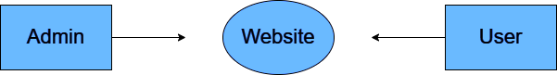

## 

## Level 1 DFD:

### For Admin:

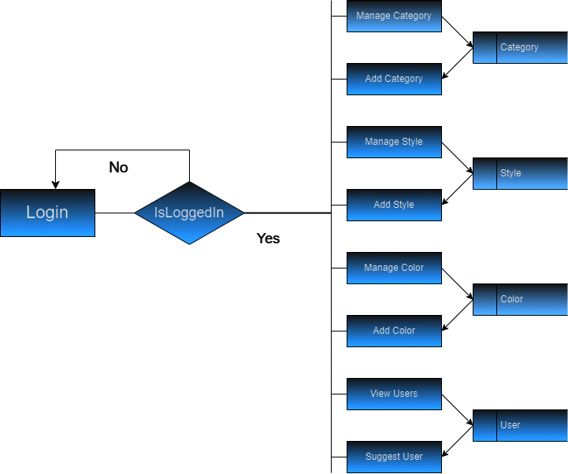

### 

### For User:

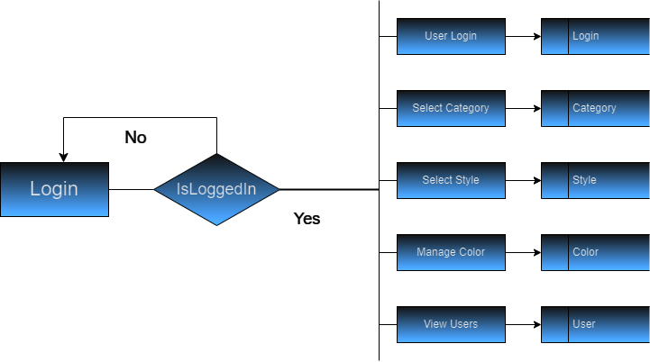

# 

# CHAPTER 9

# SNAPSHOTS

# **9.1 Database:**

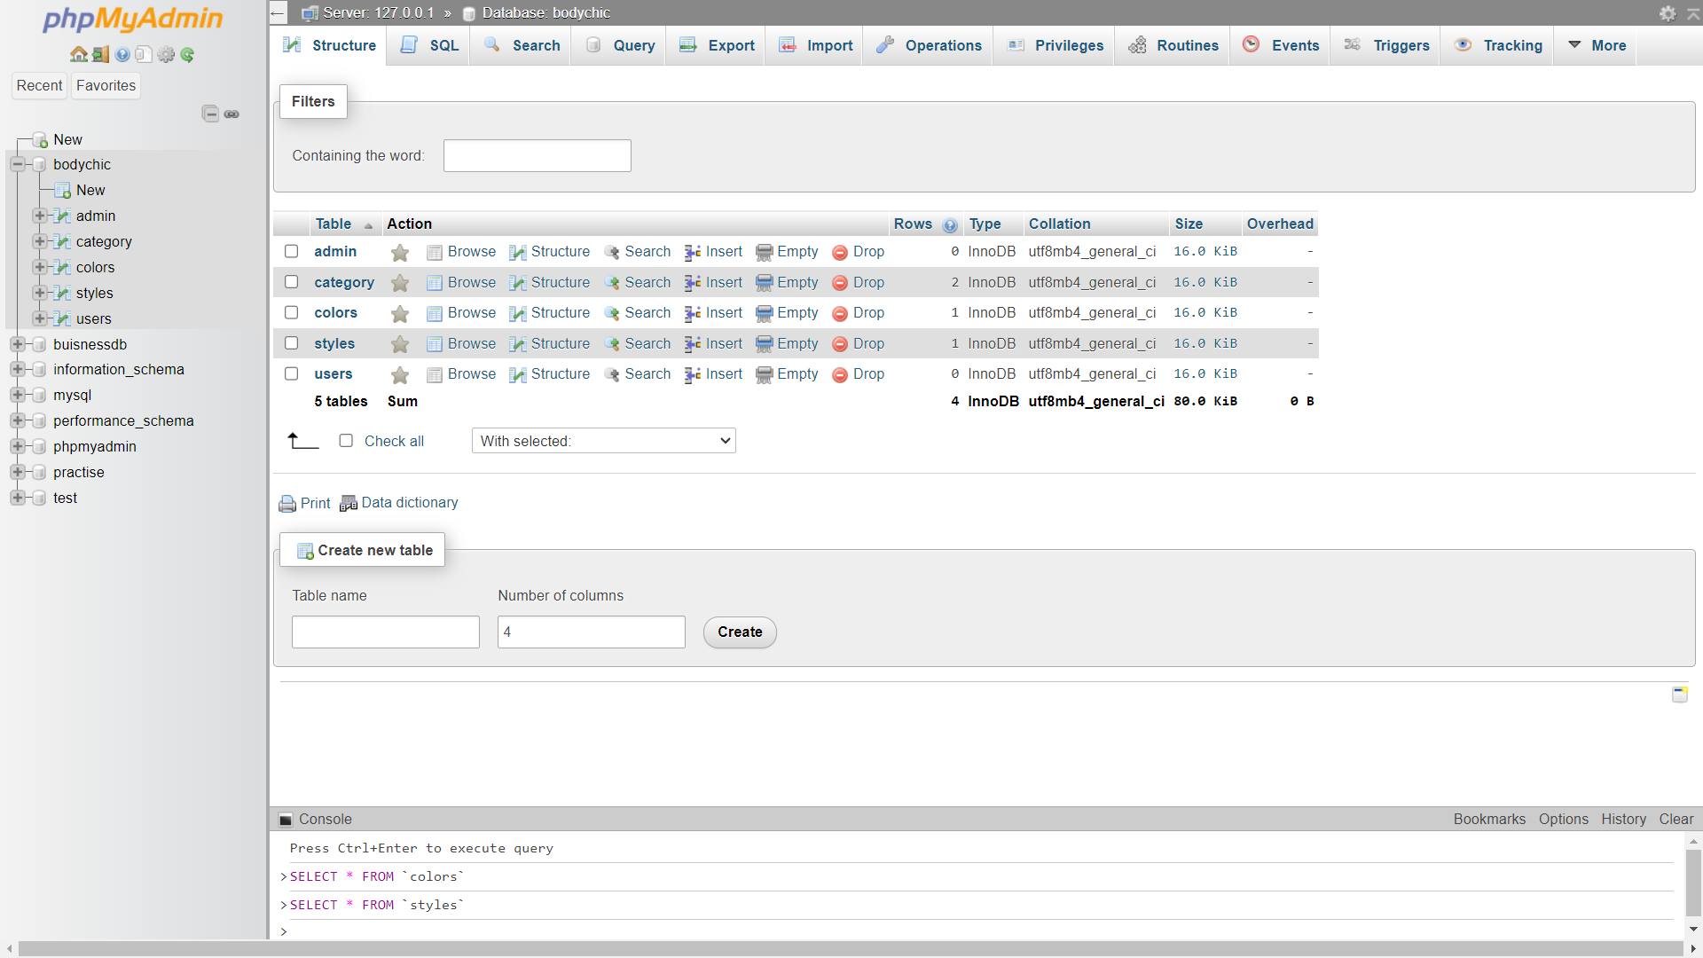

# 

**9.2 Admin table:**

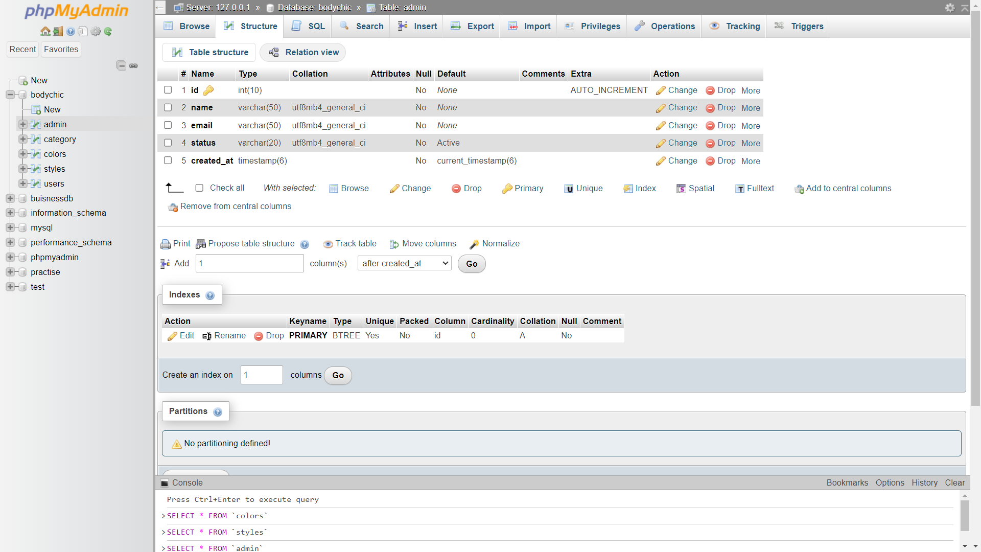

**9.3 Category Table:**

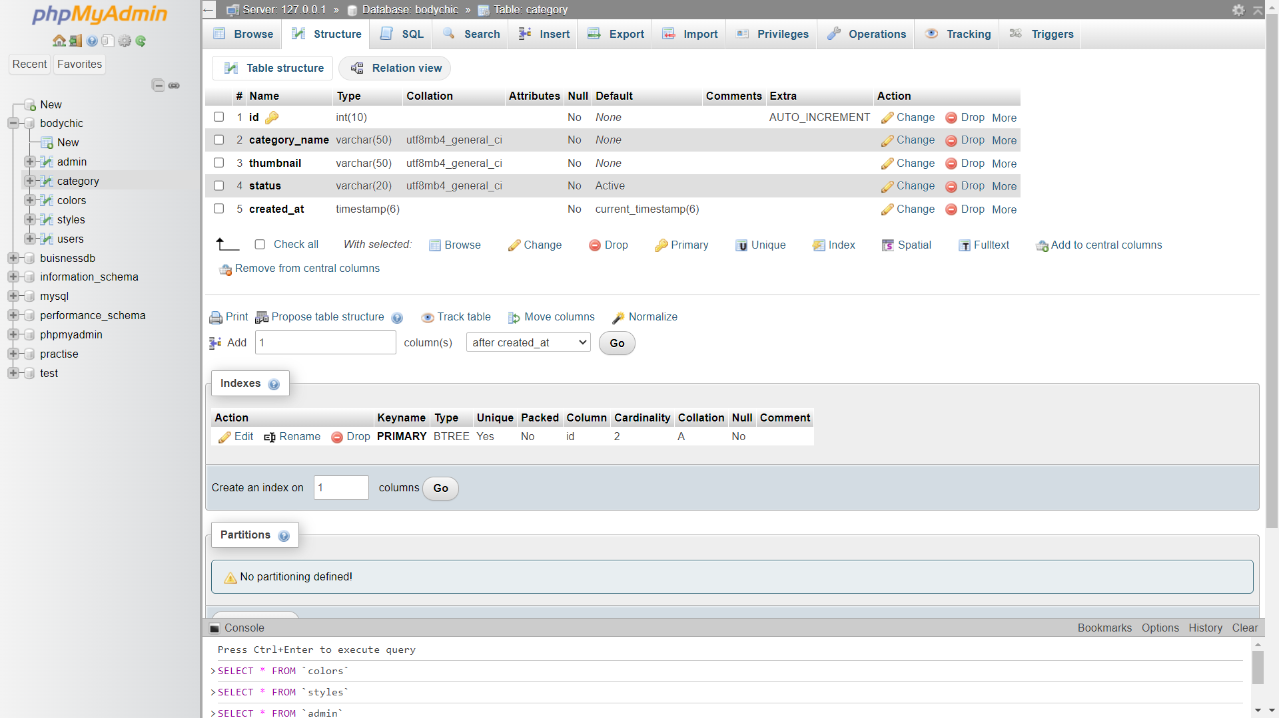

**9.4 Colors Table:**

**9.5 Styles Table:**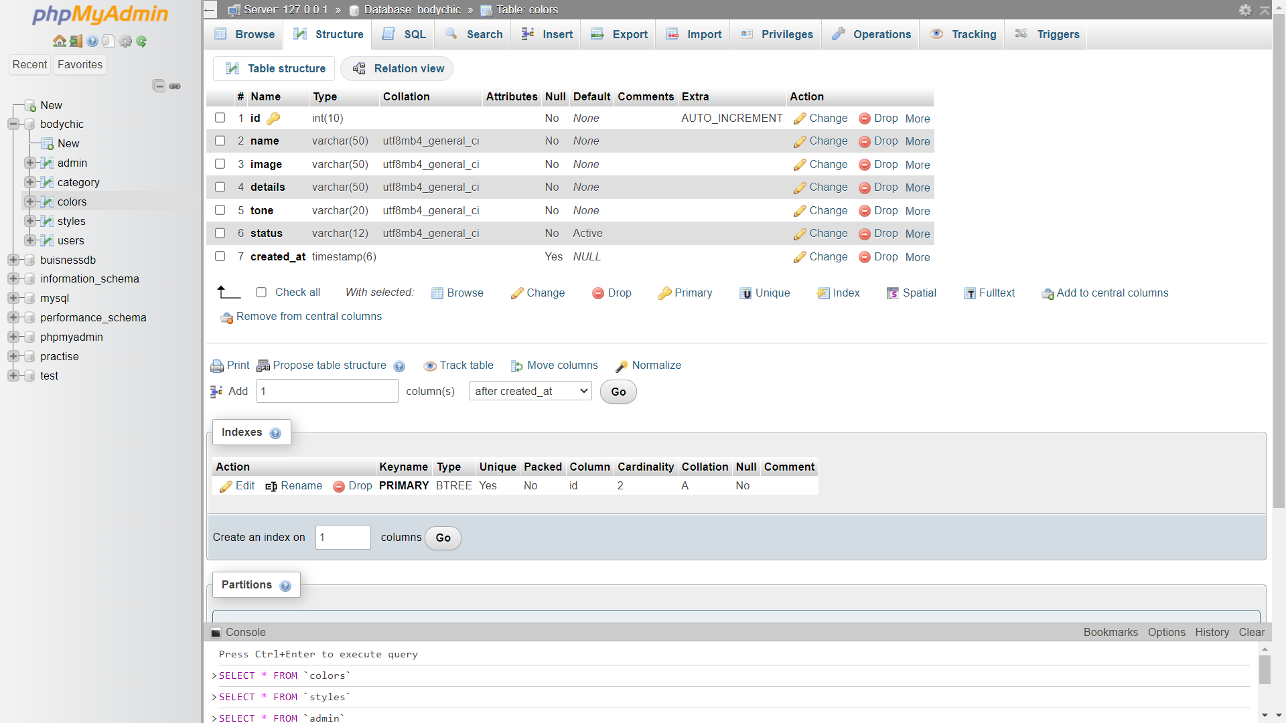

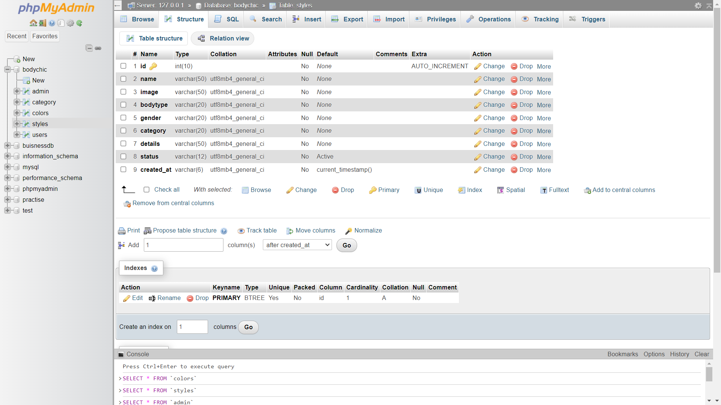

**9.6 Users Table:**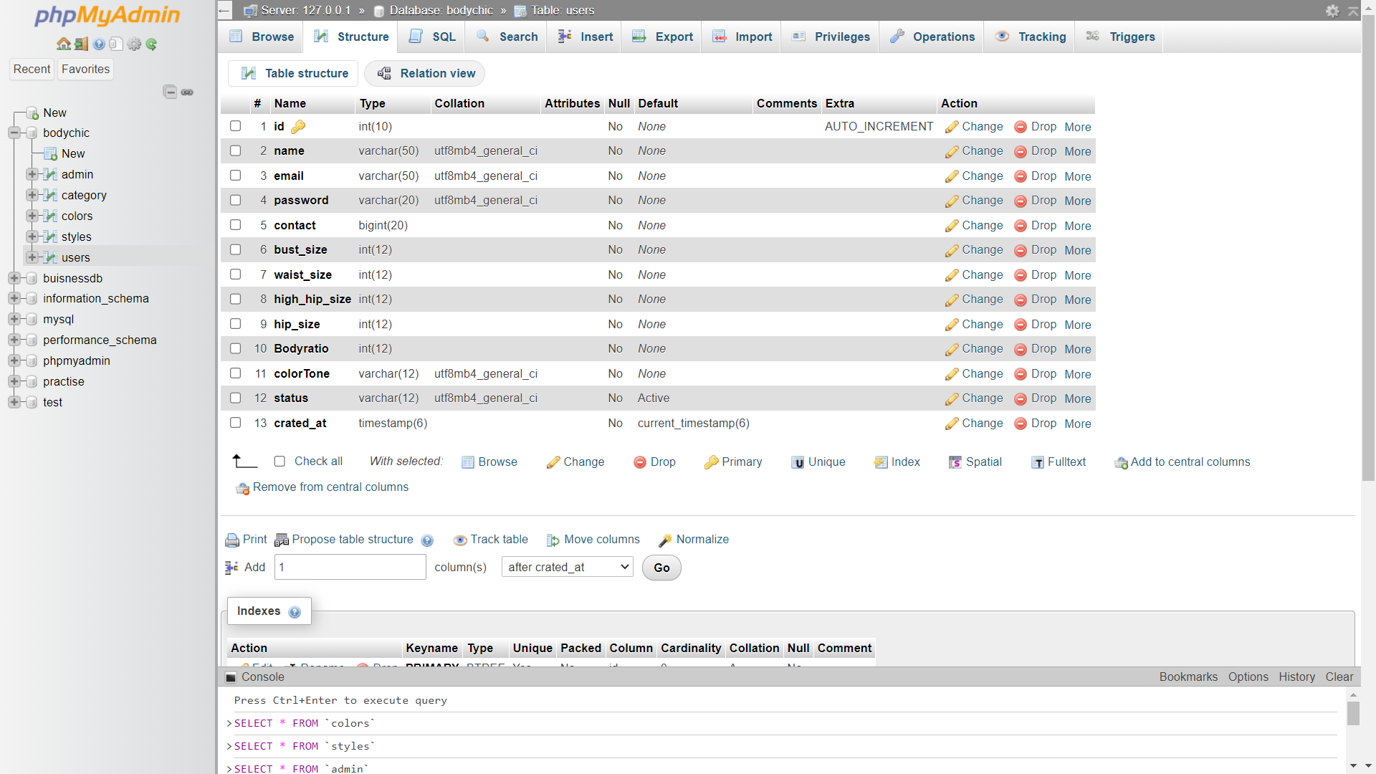

# **CHAPTER 10 TESTING**

## 10.1. Introduction to Testing:

Testing is the major quality control measure employed during software development. Testing is the process of executing a program with the intent of finding an error. No piece of code is completely ready unless it has been fully tested. This stage is very important as at this stage it is verified whether the code developed meets the requirement specifications or not. Moreover, all validations are also checked in the testing stage.

Testing is the process of executing a program with the intent of finding an error. A good test case is one that has a probability of finding an as-yet-undiscovered error. If testing is conducted successfully (according to the objective stated) it will uncover errors in the software. As a secondary benefit, testing demonstrates that the software function appears to be working according to the specification and that performance requirements appear to have been met.

Testing is the set of activities that can be planned in advance and conducted systematically. It is an integral part of program development. It is in this stage, that we check that the program that has been coded. Performs according to the requirements. The purpose of doing the test is not to demonstrate that there are no errors in the program but to detect any bugs that may still exist.

In the testing stage, the main aim is to look for errors that unknowingly have occurred. It is a common misconception that the purpose of testing is to prove that a program is working correctly. This is a dangerous myth because it can lead to insufficient testing, and programs with hidden faults. Because the actual result and expected result may differ in the field of reality and it can be hazardous for a program.

The importance of software testing and its implications with respect to software quality cannot be overemphasized. Software testing is a crucial element of software quality and represents the ultimate review of specification design and coding.

The increasing visibility of motivating forces for well-planned thorough testing. It is not unusual for software development organizations to expend 40% of total project effort on testing.

## 10.2. Test Strategy

Implemented System is tested using Basic levels of Testing that are:

1. UNIT TESTING.
2. INTEGRATION TESTING.
3. SYSTEM TESTING.
4. ACCEPTANCE TESTING.

These different levels of testing attempt to detect different types of faults. The relation of the faults introduced in different phases and the different levels of testing are shown:

### UNIT TESTING

The first level of testing is unit testing. In this different modules are tested against the specifications produced during the design for the modules. Unit testing is essential for verification of the code produced during the coding phase and hence the goal is to test the internal logic of the modules

### INTEGRATION TESTING

The next level of testing is often called integration testing. In this many tested modules are combined into sub-systems, which are then tested the goal here is to see if the modules can be integrated properly, the emphasis being on testing interfaces between modules. This activity can be considered as testing the design, and hence the emphasis on testing module interactions.

### SYSTEM TESTING

The next level of testing is system testing. Here the entire software system is tested. The reference document for this process is a requirement document, and the goal is to see if the software meets its requirements. This is essentially a validation exercise. And it was found that they all are working well to meet the Owners requirements.

### ACCEPTANCE TESTING

The last level of testing is acceptance testing. Acceptance testing is performed with realistic data from the client to demonstrate that the software is working satisfactorily. Testing here focuses on the external behaviour of the system; the internal logic of the program is not emphasized.

## 10.3. Test Cases

For testing to be successful, proper selection of test cases is essential. There are two different approaches to selecting cases - functional testing and structural testing.

* Non-functional testing of the software or the module to be tested is treated as a black box, and the test cases are decided based on the specifications of the system or the module. For this reason, this type of testing is also called "black box testing". The focus here is on testing the external behaviour of the system.
* In structural testing, the test cases are decided based on the logic of the module to be tested. A common approach here is to achieve some type of coverage of the statements in the code. One common coverage criterion is statement coverage, which requires that test cases be selected so that together they execute each statement exactly once.

### Test Case 1

| Test Case Identification | Login Screen |
| --- | --- |
| Expected Results | It should display the message invalid login parameters. |
| Actual Results | It should display the error invalid login parameters |
| Remarks | Pass |

When the User accidentally enters a wrong username and password combination, then error message will display an invalid username or password.

### Test Case 2

| Test Case Identification | New Account Screen |
| --- | --- |
| Expected Results | It should display the message for the fields which is required to be filled. |
| Actual Results | It displays the error message Please enter your name, Please enter your Phone Number etc. |
| Remarks | Pass |

When any user accidentally submits the data without filling in full details, then an error message will display.

### Test Case 3

| Test Case Identification | New Account Screen |
| --- | --- |
| Expected Results | It should display the message Please enter the correct email. |
| Actual Results | It displays the error message Please enter the correct email. |
| Remarks | Pass |

When a user enters the wrong email address on creating a new account page, then the error message will display “Please enter the correct email”.

# CHAPTER 11 IMPLEMENTATION

System implementation generally benefits from high levels of user involvement and management support. User participation in the design and operation of information systems has several positive results. First, if users are heavily involved in systems design, they move opportunities to mould the system according to their priorities and business requirements, and more opportunities to control the outcome. Second, they are more likely to react positively to the change process. Incorporating user knowledge and expertise leads to better solutions. The relationship between users and information systems specialists has traditionally been a problem area for information systems implementation efforts. This is referred to as the user-designer communications gap. These differences lead to divergent organizational loyalties, approaches to problem-solving, and vocabularies. Examples of these differences or concerns are below:

## User Concerns

* Will the system deliver the information I need for my work?
* How quickly can I access the data?
* How easily can I retrieve the data?
* How much clerical support will I need to enter data into the system?
* How will the operation of the system fit into my daily business schedule?

## Designer Concerns

* How much disk storage space will the master file consume?
* How many lines of program code will it take to perform this function?
* How can we cut down on CPU time when we run the system?
* What are the most efficient ways of storing this data?
* What database management system should we use?

# CHAPTER 12 MAINTENANCE

## Introduction to Software Maintenance

Software maintenance denotes any changes made to a software product after it has been delivered to the customer. Maintenance is inevitable for almost any kind of product. It is practically impossible to make the software completely error-free because the input domain of most software products is very large and it is not practical to test the software exhaustively with respect to each value that the input data may assume. Maintenance is also needed to enhance the features of the software to add more functionality to it and to port to new platforms etc.

## Types of Software Maintenance

Maintenance is fixing or enhancing a system. Many different types of maintenance must be performed on the system to ensure it continues to operate as expected. These include:

* Adaptive maintenance - making changes to increase system functionality to meet new requirements.
* Corrective maintenance - making changes to repair system defects and bugs observed while the system is in use.
* Perfective maintenance - making changes to enhance the system and improve such things as processing performance and usability.
* Preventive maintenance - making changes to reduce the chance of future system failures.

# 

# CHAPTER 13 Conclusion

In conclusion, the development of a dynamic library management system represents a significant step forward in modernising library services and adapting to the demands of the digital age. Through the implementation of advanced technologies and innovative solutions, this project aims to address key challenges faced by libraries in efficiently managing resources, enhancing user experience, and ensuring data security.

By providing a user-friendly interface, streamlined administrative processes, and robust security measures, the proposed system not only improves operational efficiency but also fosters a culture of lifelong learning and community engagement. The transition from traditional, manual-based systems to a modernised, digital platform enables libraries to better meet the needs and expectations of patrons while remaining relevant in an ever-evolving technological landscape

# 

# 

# BIBLIOGRAPHY

Websites:

<https://www.google.com>

<https://www.stackoverflow.com>