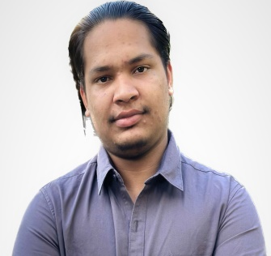 M

* Diploma in **Computer Programming** - Seneca College, Toronto (Expected Year of Completion: [2025])
* **Blockchain Certificate** – [Udemy], [2023]

Description: Complete course including learning solidity, JavaScript and other useful tools for development of dapps

* Senior Secondary Education –[Swami sant dass public school], [2022]

**Major**: Mathematics and Computer Science

**Education**

* Served as a **Computer Instructor** at Guru Nanak Internet Cafe, providing instruction on Microsoft services and teaching students fundamental programming concepts.

**Experience**

* **Student Management System**(Python), Blockchain based **lottery system** , Blockchain based **To-do list** website**, Crowd funding** website and , many more
* **Social Media API** using FastAPI, incorporating authentication, CRUD operations, and validation. Built a robust backend system where users can securely log in, create posts, and interact with other users' posts through likes and comments.
* Blockchain-powered **Chat application** using React, Solidity, and IPFS for secure and censorship-resistant messaging
* **Decentralized Autonomous Organization** (DAO) application using React and Solidity, facilitating transparent and decentralized decision-making processes.
* Blockchain-based **Energy trading** application using React, Solidity, and FastAPI, enabling users to trade renewable energy resources in a secure and transparent manner.

**Projects**

* As a fresher in the field of blockchain development, I am highly motivated to contribute to innovative projects, gain practical experience, and continuously expand my knowledge. So I am seeking for a job where I can apply my knowledge
* I am deeply fascinated by the potential of blockchain technology to reshape industries, enhance transparency, and create new opportunities for collaboration and decentralization.

**Summary**

* **English**

**Language**

**Experience**

* **Computer Instructor**

**(2022-2023)**

React

Python

Java

Javascript

Solidity

**Skills**

**Contact Details**

+91 81468-22429

hsdosanjh1234@gmail.com

**BlockChain Web Developer**

**Harsimranjit Singh**