Airflow configuration
In windows,
I tried installing apache using 2 methods
- Using python env
- Using docker (was heavy in ram usage)
But once installing couldnt run using airflow standalone (got few package issues)
STEP 1: Enable WSL2 on your Windows system

IN windows, powershell with admin access
- Installed wsl and created a new unix user and password
amha, NeoFragon@20010929

> wsl --install

>sudo apt update && sudo apt install -y python3 python3-venv python3-pip

sudo apt update → refreshes package lists
apt install → installs Python and related tools:
- python3 → main Python interpreter
- python3-venv → allows creating virtual environments
- python3-pip → Python package manager

So i installed wsl ( accessing windows workspace as ubuntu -> need to look further into this concept)

- Next to re-login, we need
> wsl -d ubuntu (next time when we open)

- Once logged in
I created a new directory named airflow_project
mkdir airflow_project
cd airflow_project

- Created python env and activate it
> python3 -m venv airflow_venv
> source airflow_venv/bin/activate

If you see (airflow_venv) user@machine:~/airflow_project$

Then activated.
- Install apache airflow
> pip install apache-airflow

- To run airflow scheduler, executer and worker
>airflow standalone

By default, uses
Executer - LocalExecuter(parallel threads)
DB (to store the metadata) - Use sqlite
Creates a default SQLite database for metadata.
Creates a default admin user (auto-generated).
Starts:
- Airflow webserver (UI)
- Airflow scheduler
Prints the login credentials and web URL

standalone | Starting Airflow Standalone
Simple auth manager | Password for user 'admin': KYkkHHDgQxaUwv7Q

- Try to initialize the db
> airflow db init

Based on the above direct installation, pip directly installed latest version for all the dependent libraries for apache airflow that was causing an issue due to various version mismatch.
So follow the next tab for the correct installation
Or follow
https://chatgpt.com/c/69062566-1b20-8323-a496-9a6431f21733

Correct airflow installations
- Install apache-airflow based on the python version that we have previously installed in out system
>python3 -m venv airflow_venv
>source airflow_venv/bin/activate

>AIRFLOW_VERSION=3.1.1
>PYTHON_VERSION=3.12
>pip install "apache-airflow==${AIRFLOW_VERSION}" --constraint "https://raw.githubusercontent.com/apache/airflow/constraints-${AIRFLOW_VERSION}/constraints-${PYTHON_VERSION}.txt"

Note:
Do not manually install structlog — always use the Airflow constraints.
Airflow 3.x → structlog ≥ 25.4.0
Airflow 2.7.x → structlog 22.1.0
Your errors come from mixing Airflow 3.x packages with Airflow 2.x logging code.

- Once after the successful installation of apache-airflow without version mismatch, we can initialize the db
>airflow db migrate

Instead of db init

- Start the servers(scheduler, executer and worker)
> airflow standalone ( I guess at this step below password got autogenerated)

Admin user created:
Username: admin
Password: Xyz123

To cross-check
>airflow users list

- Visit http://localhost:8080 and log in with your admin credentials.
Simple auth manager | Password for user 'admin': KYkkHHDgQxaUwv7Q

Steps to change Executer

Check AIRFLOW_HOME
Airflow stores its configuration in $AIRFLOW_HOME by default. Run:
echo $AIRFLOW_HOME

- This will print the directory where airflow.cfg is located.
- Default is usually:
~/airflow

or in your user home:
/home/<username>/airflow

Then, the config file path is:
$AIRFLOW_HOME/airflow.cfg

2️⃣ Use the Airflow CLI to show config
Airflow has a built-in command to show configuration locations:
airflow info

Look for the lines:
airflow home: /path/to/airflow_home
config file: /path/to/airflow.cfg

- The config file line gives the full path to airflow.cfg.
- airflow home is the directory containing it (usually $AIRFLOW_HOME).

How to check if an env var is overriding
Run in your shell:
echo “$AIRFLOW__CORE__EXECUTOR”

- If it prints LocalExecutor, that’s why airflow info still shows LocalExecutor.
- You can temporarily override it for your shell session:
export AIRFLOW__CORE__EXECUTOR=SequentialExecutor

Then run:
airflow info | grep executor

It should now show SequentialExecutor.(But it didn’t work)
We can check executor at that time using 2 ways.
- From /home/amha/airflow/airflow.cfg file
>executer = SequentialExecuter
- > airflow config get-value core executor

Postgres Installation using docker
https://chatgpt.com/c/69064190-0dcc-8324-aa00-b8b018cd7556 (Chatgpt ref for full context)

Note: Have docker desktop installed in windows and see if it is running daemon process

- Run below commands to get the image of postgres version 15 and to create a user with password, db
# Pull the latest Postgres image
>docker pull postgres:15

# Run Postgres container
>docker run --name local-postgres \
-e POSTGRES_USER=airflow_user \
-e POSTGRES_PASSWORD=airflow_pass \
-e POSTGRES_DB=airflow_db \
-p 5432:5432 \
-d postgres:15
Explanation of environment variables:
- POSTGRES_USER → username (here: airflow_user)
- POSTGRES_PASSWORD → password (here: airflow_pass)
- POSTGRES_DB → database name (here: airflow_db)
- -p 5432:5432 → map local port 5432 to container
- To check if the image is running or not ( in windows powershell)
> docker ps
- OPTION - 1(local install required in windows)
Now the postgres is available, we need to install postgres client to access the postgress server in port 5432. For that needed to install postgres ( I think this could have been done from docker as well -> docker exec and required sql commands)
> choco install postgresql
>psql -h localhost -p 5432 -U admin -d airflow_db
Will ask for password - admin
Once installing,

Add PostgreSQL bin to PATH
- Press Win + S, search Environment Variables, click Edit the system environment variables.
- In System Properties → Advanced → Environment Variables…
- Under System variables, find Path → click Edit…
- Click New → paste your PostgreSQL bin folder path (e.g., C:\Program Files\PostgreSQL\16\bin)
- Click OK to close all dialogs.
- Important: Open a new terminal after this (old terminals won’t pick up updated PATH).

Option 2: Use pgAdmin (no local install required)
Since installing psql can be extra work on Windows, you can just use pgAdmin in Docker, which acts as a GUI client.
docker run --name local-pgadmin \
-e PGADMIN_DEFAULT_EMAIL=admin@admin.com \
-e PGADMIN_DEFAULT_PASSWORD=admin \
-p 8080:80 \
-d dpage/pgadmin4

- Go to http://localhost:8080 → login with admin@admin.com / admin.
- Add a new server:
  - Host: host.docker.internal
  - Port: 5432
  - Username: admin
  - Password: admin
  - Database: airflow_db
- Then you can browse tables and run queries.
I used,
> winpty docker exec -it local-postgres psql -U admin -d airflow_db
winpty docker exec -it local-postgres psql -U admin -d airflow_db
psql (15.14 (Debian 15.14-1.pgdg13+1))
Type "help" for help.

airflow_db=# \du
List of roles
Role name | Attributes | Member
of
-----------+------------------------------------------------------------+-------
----
admin | Superuser, Create role, Create DB, Replication, Bypass RLS | {}
:
psql (15.14 (Debian 15.14-1.pgdg13+1))
Type "help" for help.

airflow_db=# \du
airflow_db=#
airflow_db=# \c airflow_db
You are now connected to database "airflow_db" as user "admin".
airflow_db=# create table employees (
airflow_db(# id serial primary key,
airflow_db(# name varchar(50),
airflow_db(# dept varchar(10));
CREATE TABLE
airflow_db=# insert into employees (name, dept) values ("Alice', "Eng");
airflow_db"# select * from table;
airflow_db"# select * from employees;
airflow_db"# ^C
airflow_db=# insert into employees (name, dept) values ('alice', 'eng');
INSERT 0 1
airflow_db=# select * from employees;
id | name | dept
----+-------+------
1 | alice | eng
(1 row)

airflow_db=# ^C

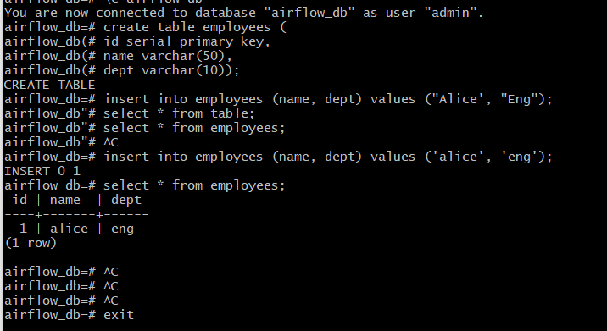

Apache airflow Postgres configurations
STEPS FOR ENABLING CONFIGURATION TO CONNECT POSTGRES TABLES RUNNING IN DOCKER FROM APACHE AIRFLOW
>pip install "apache-airflow-providers-postgres>=5.6.0,<6.0.0"
(make sure this is compatible with the airflow version)

>source ~/airflow_env/bin/activate

# Windows (PowerShell)
.\airflow_env\Scripts\activate
2️⃣ Install the Postgres provider
Inside the same environment where Airflow is installed, run:

bash
Copy code
pip install "apache-airflow-providers-postgres>=5.6.0,<6.0.0"
This adds Postgres hooks and connection type to your Airflow installation.

No need to reinstall Airflow itself.

3️⃣ Restart Airflow Standalone
Since you are using airflow standalone:

bash
Copy code
# Stop your current instance (Ctrl+C in terminal)
airflow standalone
Then start it again:

bash
Copy code
airflow standalone
Now when you go to Admin → Connections → +, you will see Postgres as a connection type.
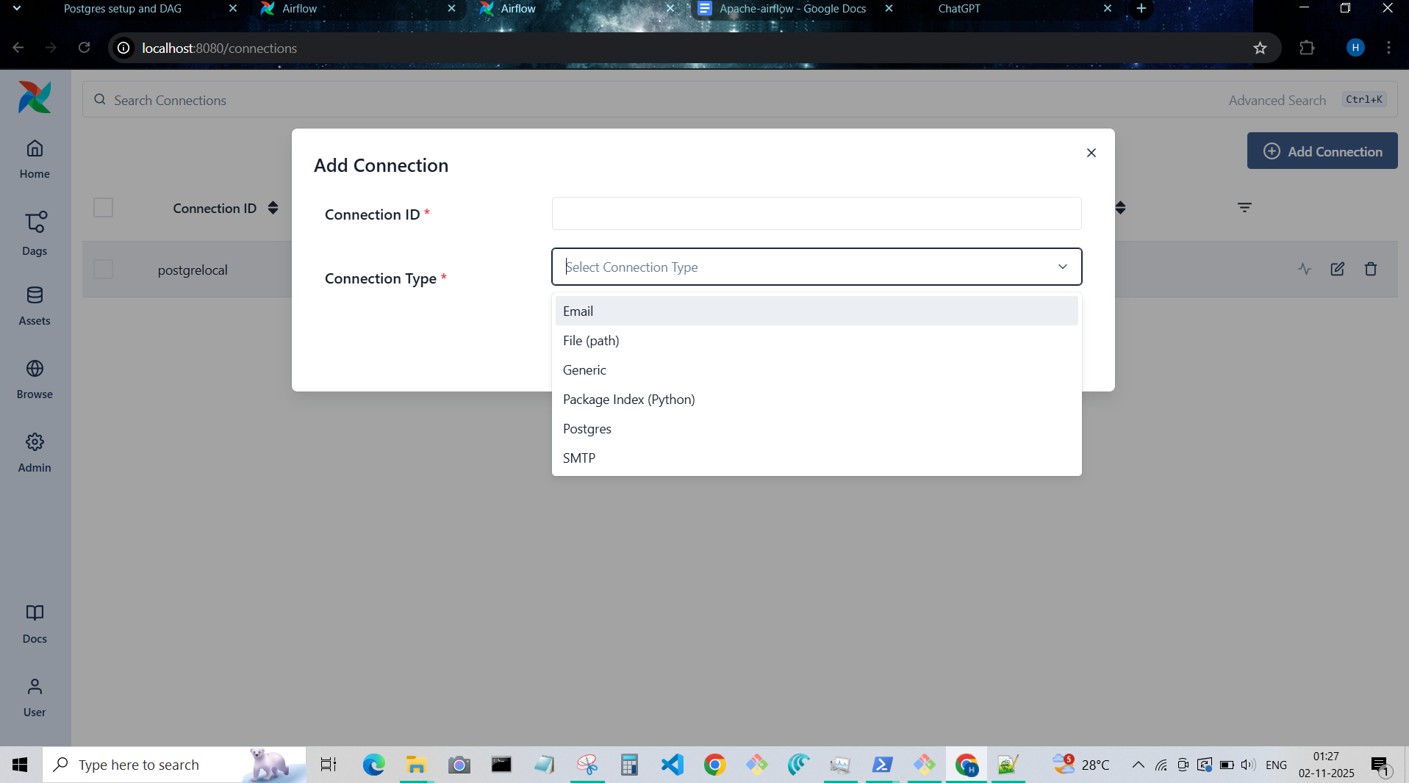
My configurations:

Add your Postgres connection
- Conn Id: postgrelocal
- Conn Type: Postgres
- Host: localhost
- Schema: airflow_db
- Login: admin
- Password: admin
- Port: 5432
Once giving it save it
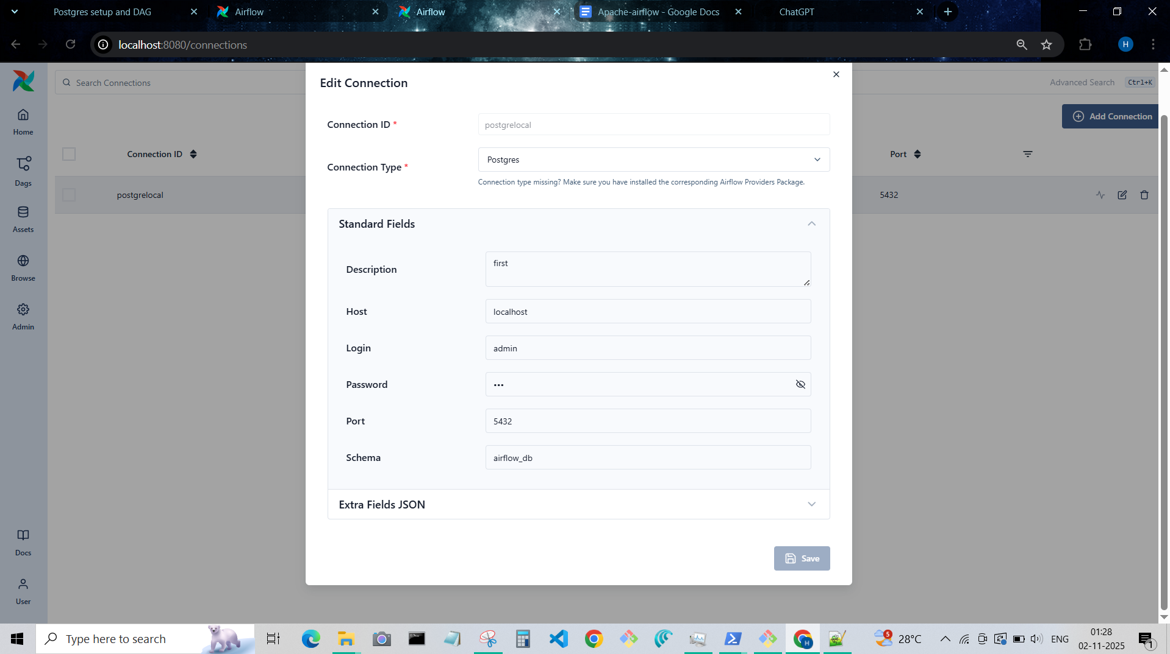

Python DAG file
Python1.py file (DAG script TO connect airflow to the postgress and display the data from table employees which is created in previous table in airflow logs under this DAG)
from airflow import DAG
from airflow.providers.postgres.hooks.postgres import PostgresHook
from airflow.providers.standard.operators.python import PythonOperator
from datetime import datetime

def fetch_employees():
hook = PostgresHook(postgres_conn_id="postgrelocal")
records = hook.get_records("SELECT * FROM employees;")
for row in records:
print(f"Employee Record: {row}")

with DAG(
dag_id="fetch_postgres_data",
start_date=datetime(2025, 11, 1),
schedule=None, # manual trigger
catchup=False,
tags=["example"],
) as dag:

task_fetch = PythonOperator(
task_id="fetch_employees_task",
python_callable=fetch_employees
)

- Steps to move the above file to wsl -d ubuntu
# In WSL terminal
>cp /mnt/c/Users/Harsini/Documents/python1.py ~/airflow/dags/
Or
> cp /mnt/c/users/Harsini/Documents/python1.py /home/amha/airflow/dags

- After placing the file in ~/airflow/dags, if you couldn’t see the DAG listed using DAG_ID in script, check with below command if there are any syntax issue
>python /home/amha/airflow_project/dags/python1.py

- You will see the list of files scanned by the scheduler in the logs

dag-processor | 2025-11-01T18:51:29.932904Z [info ]
dag-processor | ================================================================================
dag-processor | DAG File Processing Stats
dag-processor | Bundle File Path PID Current Duration # DAGs # Errors Last Duration Last Run At
dag-processor | ------------ ---------------------------------------------------------- ----- ------------------ -------- ---------- --------------- -------------------
dag-processor | example_dags tutorial_taskflow_api_virtualenv.py 1 0 1.68s 2025-11-01T18:51:05
dag-processor | example_dags standard/example_hitl_operator.py 1 0 0.59s 2025-11-01T18:51:23
dag-processor | example_dags standard/example_external_task_parent_deferrable.py 1 0 0.27s 2025-11-01T18:51:21
dag-processor | example_dags standard/example_bash_operator.py 1 0 0.26s 2025-11-01T18:51:23
dag-processor | example_dags standard/example_branch_operator_decorator.py 1 0 0.23s 2025-11-01T18:51:21
dag-processor | example_dags standard/example_short_circuit_operator.py 1 0 0.21s 2025-11-01T18:51:27
dag-processor | example_dags tutorial_dag.py 1 0 0.20s 2025-11-01T18:51:23
dag-processor | example_dags example_display_name.py 1 0 0.20s 2025-11-01T18:51:11
dag-processor | example_dags example_workday_timetable.py 1 0 0.18s 2025-11-01T18:51:23
dag-processor | example_dags example_time_delta_sensor_async.py 1 0 0.17s 2025-11-01T18:51:23
dag-processor | example_dags tutorial_taskflow_templates.py 1 0 0.17s 2025-11-01T18:51:19
dag-processor | example_dags standard/example_short_circuit_decorator.py 1 0 0.16s 2025-11-01T18:51:28
dag-processor | example_dags standard/example_external_task_marker_dag.py 2 0 0.15s 2025-11-01T18:51:19
dag-processor | example_dags example_setup_teardown_taskflow.py 1 0 0.15s 2025-11-01T18:51:11
dag-processor | example_dags standard/example_branch_day_of_week_operator.py 1 0 0.15s 2025-11-01T18:51:28
dag-processor | example_dags example_params_ui_tutorial.py 1 0 0.14s 2025-11-01T18:51:11
dag-processor | example_dags example_params_trigger_ui.py 1 0 0.14s 2025-11-01T18:51:10
dag-processor | example_dags example_assets.py 10 0 0.13s 2025-11-01T18:51:08
dag-processor | example_dags example_kubernetes_executor.py 0 0 0.12s 2025-11-01T18:51:11
dag-processor | example_dags example_asset_alias_with_no_taskflow.py 4 0 0.12s 2025-11-01T18:51:11
dag-processor | example_dags example_setup_teardown.py 1 0 0.12s 2025-11-01T18:51:09
dag-processor | example_dags example_local_kubernetes_executor.py 0 0 0.12s 2025-11-01T18:51:11
dag-processor | example_dags standard/example_python_decorator.py 1 0 0.11s 2025-11-01T18:51:22
dag-processor | example_dags example_nested_branch_dag.py 1 0 0.11s 2025-11-01T18:51:05
dag-processor | example_dags example_skip_dag.py 1 0 0.11s 2025-11-01T18:51:11
dag-processor | example_dags standard/example_bash_decorator.py 1 0 0.11s 2025-11-01T18:51:22
dag-processor | example_dags plugins/listener_plugin.py 0 0 0.11s 2025-11-01T18:51:22
dag-processor | example_dags standard/example_branch_datetime_operator.py 3 0 0.10s 2025-11-01T18:51:21
dag-processor | example_dags standard/example_sensor_decorator.py 1 0 0.10s 2025-11-01T18:51:28
dag-processor | example_dags example_custom_weight.py 1 0 0.10s 2025-11-01T18:51:11
dag-processor | example_dags example_task_group.py 1 0 0.09s 2025-11-01T18:51:23
dag-processor | example_dags example_branch_labels.py 1 0 0.09s 2025-11-01T18:51:12
dag-processor | example_dags example_dynamic_task_mapping.py 2 0 0.09s 2025-11-01T18:51:11
dag-processor | example_dags example_simplest_dag.py 1 0 0.09s 2025-11-01T18:51:08
dag-processor | example_dags plugins/decreasing_priority_weight_strategy.py 0 0 0.09s 2025-11-01T18:51:23
dag-processor | example_dags example_task_group_decorator.py 1 0 0.09s 2025-11-01T18:50:59
dag-processor | example_dags example_asset_alias.py 4 0 0.08s 2025-11-01T18:51:12
dag-processor | example_dags tutorial_objectstorage.py 1 0 0.08s 2025-11-01T18:51:23
dag-processor | example_dags tutorial.py 1 0 0.08s 2025-11-01T18:51:19
dag-processor | example_dags standard/example_trigger_controller_dag.py 1 0 0.08s 2025-11-01T18:50:59
dag-processor | example_dags example_xcom.py 1 0 0.08s 2025-11-01T18:51:19
dag-processor | example_dags example_branch_python_dop_operator_3.py 1 0 0.08s 2025-11-01T18:51:11
dag-processor | example_dags standard/example_external_task_child_deferrable.py 1 0 0.08s 2025-11-01T18:51:19
dag-processor | example_dags example_passing_params_via_test_command.py 1 0 0.08s 2025-11-01T18:51:05
dag-processor | example_dags tutorial_taskflow_api.py 1 0 0.07s 2025-11-01T18:51:25
dag-processor | example_dags example_latest_only_with_trigger.py 1 0 0.07s 2025-11-01T18:51:11
dag-processor | example_dags standard/example_sensors.py 1 0 0.07s 2025-11-01T18:51:22
dag-processor | example_dags standard/example_branch_operator.py 1 0 0.07s 2025-11-01T18:51:28
dag-processor | example_dags example_complex.py 1 0 0.07s 2025-11-01T18:51:08
dag-processor | example_dags example_xcomargs.py 2 0 0.07s 2025-11-01T18:51:05
dag-processor | example_dags example_asset_decorator.py 3 0 0.06s 2025-11-01T18:51:07
dag-processor | example_dags example_asset_with_watchers.py 1 0 0.06s 2025-11-01T18:51:10
dag-processor | example_dags example_inlet_event_extra.py 2 0 0.06s 2025-11-01T18:51:09
dag-processor | example_dags example_trigger_target_dag.py 1 0 0.06s 2025-11-01T18:51:28
dag-processor | example_dags example_outlet_event_extra.py 3 0 0.06s 2025-11-01T18:51:08
dag-processor | example_dags example_dag_decorator.py 1 0 0.05s 2025-11-01T18:51:07
dag-processor | example_dags standard/example_python_operator.py 1 0 0.05s 2025-11-01T18:51:22
dag-processor | dags-folder python1.py 0 1 0.05s 2025-11-01T18:51:19
dag-processor | example_dags plugins/event_listener.py 0 0 0.04s 2025-11-01T18:51:25
dag-processor | example_dags plugins/workday.py 0 0 0.03s 2025-11-01T18:50:59
dag-processor | example_dags example_dynamic_task_mapping_with_no_taskflow_operators.py 1 0 0.03s 2025-11-01T18:51:08
dag-processor | example_dags standard/example_latest_only.py 1 0 0.03s 2025-11-01T18:51:27

dag-processor | dags-folder python1.py 0 1 0.05s 2025-11-01T18:51:19 —-> my file, there was some syntax issue so, DAG count was 0

- Once rectifying the issue, I saw the dag_id in the UI(webser of airflow)
And I ran the task, It was success
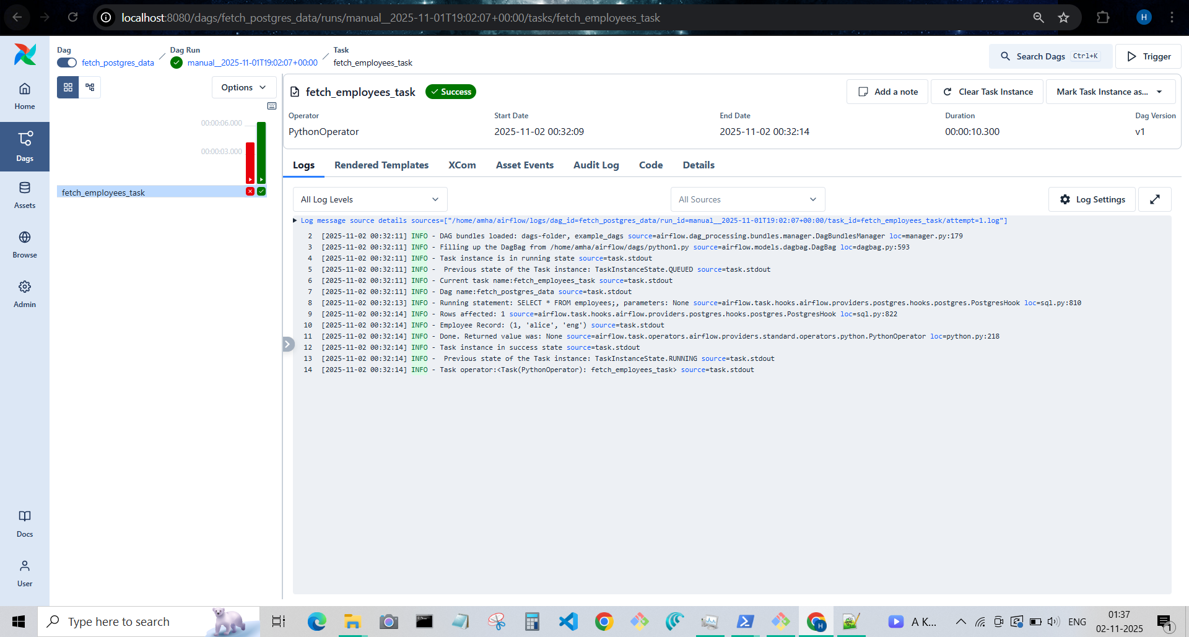
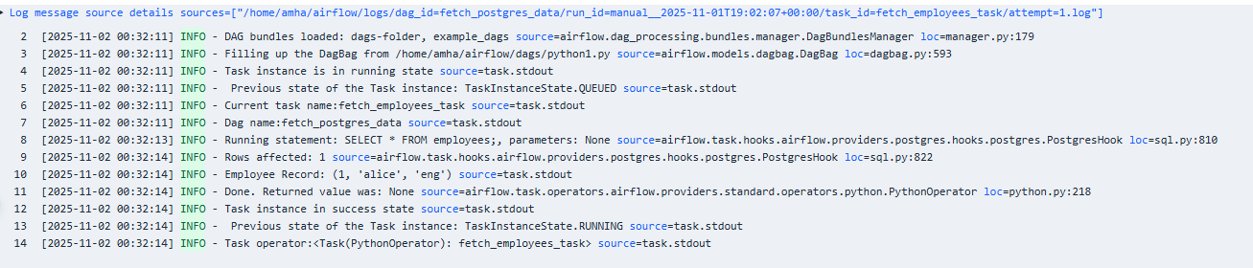
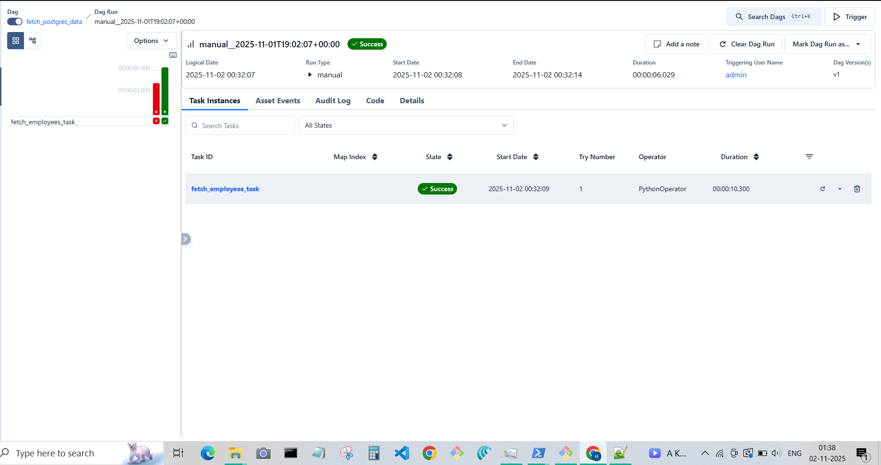
Testing:
Insured one more row into db

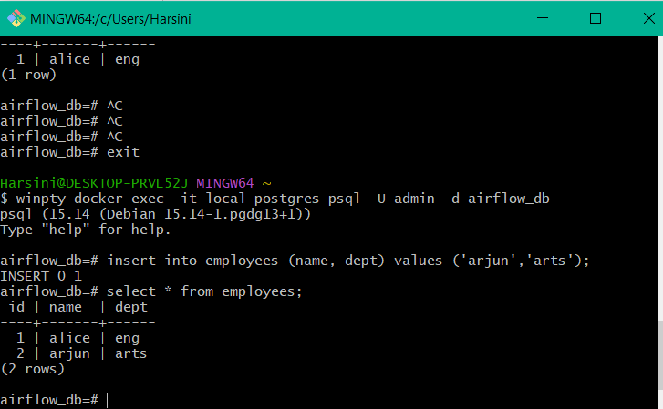

Running the DAG instance:
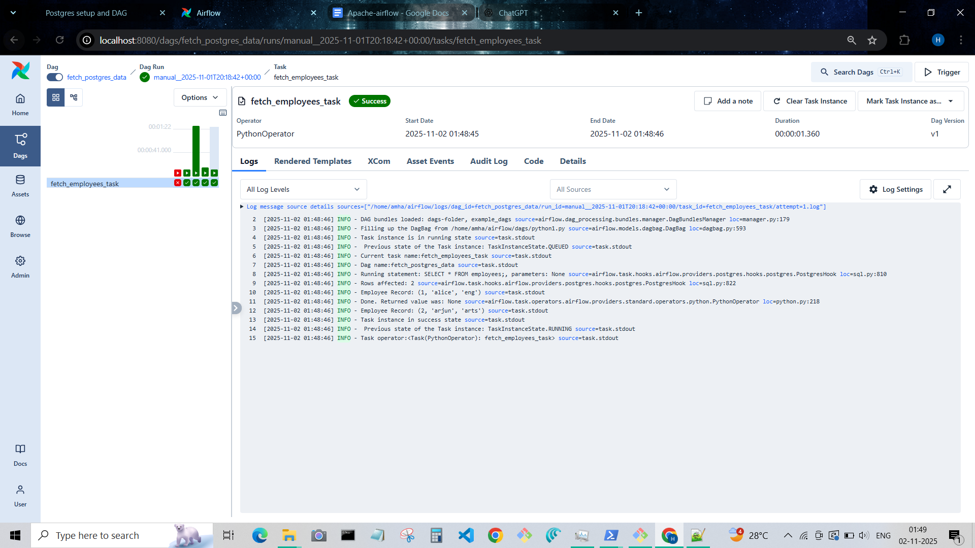
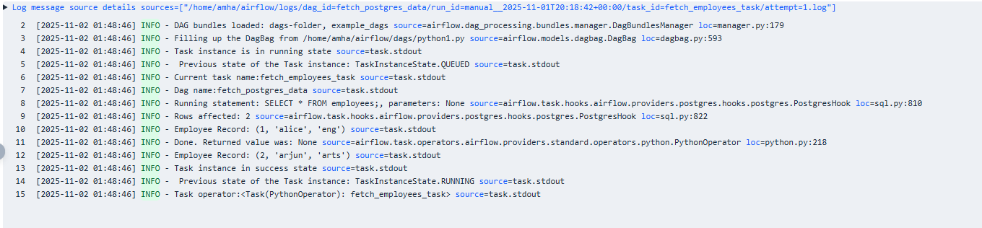

To close docker postgres
$ docker ps
CONTAINER ID IMAGE COMMAND CREATED STATUS PORTS NAMES
02fd60e66aea postgres:15 "docker-entrypoint.s…" 3 hours ago Up 3 hours 0.0.0.0:5432->5432/tcp, [::]:5432->5432/tcp local-postgres

Harsini@DESKTOP-PRVL52J MINGW64 ~
$ ^C

Harsini@DESKTOP-PRVL52J MINGW64 ~
$ docker start local-postgres
local-postgres

Harsini@DESKTOP-PRVL52J MINGW64 ~
$ docker ps
CONTAINER ID IMAGE COMMAND CREATED STATUS PORTS NAMES
02fd60e66aea postgres:15 "docker-entrypoint.s…" 3 hours ago Up 3 hours 0.0.0.0:5432->5432/tcp, [::]:5432->5432/tcp local-postgres

Harsini@DESKTOP-PRVL52J MINGW64 ~
$ docker stop local-postgres
echo $?

130

Harsini@DESKTOP-PRVL52J MINGW64 ~
$ echo $?
0

Harsini@DESKTOP-PRVL52J MINGW64 ~
$ docker stop local-postgres
local-postgres

Harsini@DESKTOP-PRVL52J MINGW64 ~
$ echo $?
0

Harsini@DESKTOP-PRVL52J MINGW64 ~
$ docker ps
CONTAINER ID IMAGE COMMAND CREATED STATUS PORTS NAMES

Harsini@DESKTOP-PRVL52J MINGW64 ~
$ docker ps -a
CONTAINER ID IMAGE COMMAND CREATED STATUS PORTS NAMES
02fd60e66aea postgres:15 "docker-entrypoint.s…" 3 hours ago Exited (137) 41 seconds ago local-postgres
0ba3f2e2aab4 docker/welcome-to-docker:latest "/docker-entrypoint.…" 10 days ago Exited (255) 10 days ago 0.0.0.0:8088->80/tcp welcome-to-docker

To restart,
docker start local-postgres

DAG connection after stopping postgres container
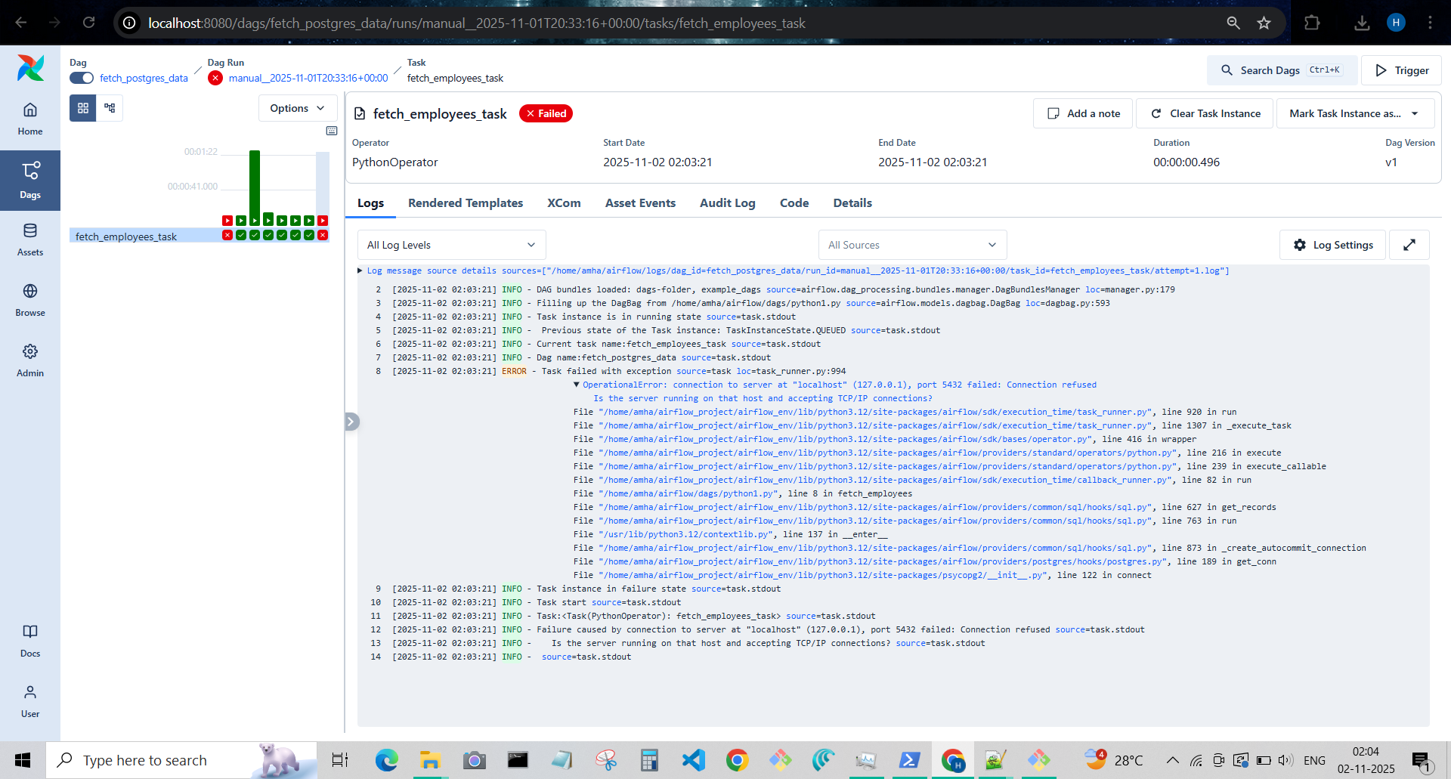

Reconnect once again
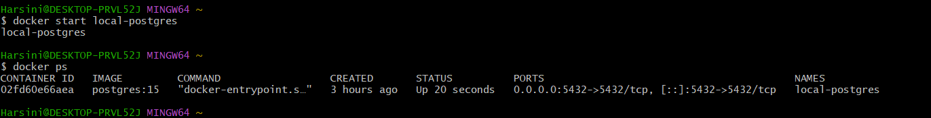

Success in DAG
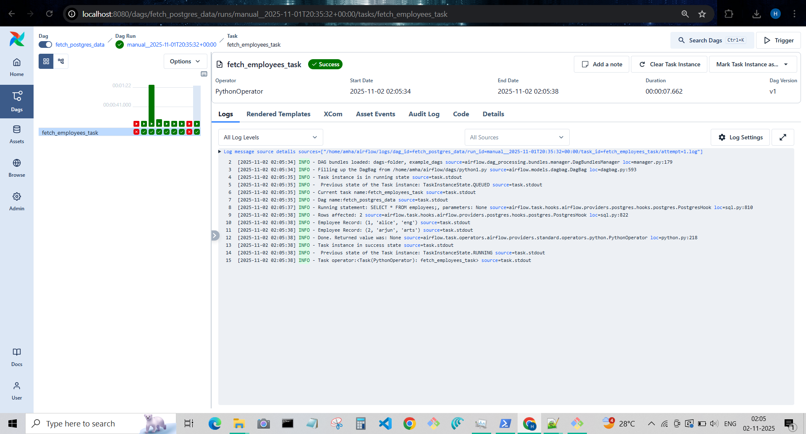
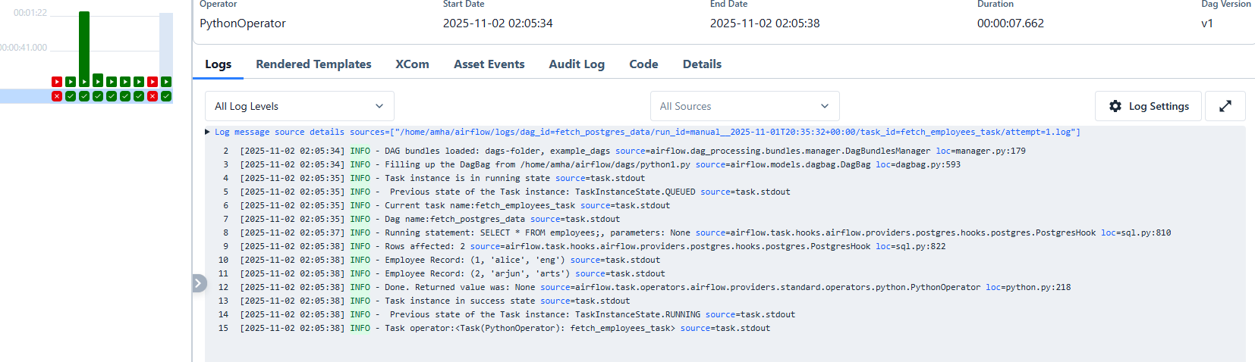

Airflow queued issue solution
Chats - https://chatgpt.com/c/69074a16-3998-8321-9d56-3fb3bf929c5f
When I tried restarting my apache-airflow using the below commands
- First login to wsl
> wsl -d ubuntu
> cd /home/amha/airflow_project
- Activate the env where apache-arflow is installed
> source airflow_env/bin/activate
- Start apache airflow
> airflow standalone
Faced an issue, where I tried starting the task, but it was always queued.

So I followed below steps and task is success.

# 1️⃣ Kill any old/stuck Airflow processes
pkill -f airflow

# 2️⃣ Remove any stale PID or SQLite locks
rm -f ~/airflow/airflow-scheduler.pid

# 3️⃣ Restart cleanly
airflow standalone

In non-prod server, how to check why the airflow server is running continuously
# See if Airflow webserver process is running
ps aux | grep airflow | grep webserver

# See if it's managed by systemd
sudo systemctl list-units | grep airflow

# See if it's running inside Docker
docker ps | grep airflow

We’ll verify which setup you have and fix it accordingly.

🧩 STEP 1 – Check Scheduler Process

Step 1 — Check for running processes (manual/standalone)
ps aux | grep airflow | grep scheduler

- If you see a process like airflow scheduler running directly in the host OS → manual/standalone mode.
- If no process appears → go to next step.

🧭 Step 2 — Check if systemd is managing it
sudo systemctl list-units | grep airflow

- Look for services like airflow-scheduler.service or airflow-webserver.service.
- If you see Active: active (running) → systemd-managed.
- If not → go to next step.

🧭 Step 3 — Check if scheduler is running inside Docker
docker ps | grep airflow

- Look for containers like airflow-scheduler or airflow-webserver.
- If found → Docker-managed scheduler.
Bonus: If it’s deployed via docker-compose, you can also check:
docker compose ps

✅ Summary Table
Check | Command | Outcome
Manual / Standalone | `ps aux | grep airflow
Systemd | `sudo systemctl list-units | grep airflow`
Docker | `docker ps | grep airflow`

🧩 STEP 2 – Start the Scheduler

🟢 If it’s a manual setup (no systemd, no Docker):
Run:
airflow scheduler -D

(-D runs it as a daemon/background process.)
Check again:
ps aux | grep airflow | grep scheduler

Then trigger your DAG again — it should move from “queued” → “running”.

🔵 If Airflow runs under systemd (as a service):
Check:
sudo systemctl status airflow-scheduler

If it’s inactive or failed, start it:
sudo systemctl start airflow-scheduler
sudo systemctl enable airflow-scheduler

Verify:
sudo systemctl status airflow-scheduler

Once it’s running, trigger the DAG again.

🟠 If Airflow runs inside Docker:
List containers:
docker ps | grep airflow

If you only see airflow-webserver but not airflow-scheduler,
start the scheduler container:
docker start airflow-scheduler

Or if it’s a docker-compose deployment:
docker compose up -d scheduler

Then your queued tasks will run.

🧩 STEP 3 – Verify Executor Type
Run:
grep executor ~/airflow/airflow.cfg

Expected for SQLite:
executor = SequentialExecutor

If it says LocalExecutor or CeleryExecutor but you’re using SQLite, that’s invalid —
SQLite doesn’t support parallel tasks.
Fix it:
airflow config set core.executor SequentialExecutor
airflow db upgrade

Then restart scheduler.

🧩 STEP 4 – Watch Scheduler Logs
Tail the scheduler log:
tail -f ~/airflow/logs/scheduler/latest/*.log

You should see messages like:
INFO - Queuing task: <dag_id>.task_id
INFO - Executing <dag_id>.task_id

If you see nothing, scheduler isn’t processing DAGs → re-check Steps 1-3.

✅ QUICK SUMMARY
Root Cause | Fix
Scheduler not running | Start it (airflow scheduler -D or systemctl/docker equivalent)
Wrong executor (SQLite + LocalExecutor) | Set to SequentialExecutor
Scheduler crashed / stale PID | Kill old process & restart
Logs silent / stuck | Tail scheduler log to verify activity

Terdata installation to connect with DAG

Configure Airflow Connection for Teradata
You’ll now link Airflow to this database.

(a) Install Teradata Python library
Inside your Airflow environment (venv or Docker):
pip install teradatasql

(b) Create Airflow Connection
You can do this either:

Option 1: via Airflow UI
- Go to Admin → Connections
- Click + (Add a new connection)
- Fill:
Field | Value
Conn Id | teradata_conn
Conn Type | Teradata (or Generic if not listed)
Host | localhost
Port | 1025
Schema | mydb
Login | dbc
Password | dbc

Option 2: via CLI
airflow connections add 'teradata_conn' \
--conn-type 'teradata' \
--conn-host 'localhost' \
--conn-login 'dbc' \
--conn-password 'dbc' \
--conn-port '1025' \
--conn-schema 'mydb'

5️⃣ Create Airflow DAG to Query Teradata
Now the fun part — your custom DAG.
Below is a working example DAG that:
- Connects to Teradata
- Executes a SELECT query
- Prints the results to the log

🧩 File: dags/teradata_dag.py
from datetime import datetime
from airflow import DAG
from airflow.operators.python import PythonOperator
import teradatasql

def query_teradata():
# Connect using the connection string
con = teradatasql.connect(host='localhost', user='dbc', password='dbc', database='mydb')
cursor = con.cursor()

cursor.execute("SELECT * FROM employee;")
rows = cursor.fetchall()

print("=== Employee Table Data ===")
for row in rows:
print(row)

cursor.close()
con.close()

with DAG(
dag_id='teradata_example_dag',
start_date=datetime(2024, 1, 1),
schedule_interval=None,
catchup=False,
tags=['teradata', 'example']
) as dag:

query_task = PythonOperator(
task_id='query_teradata_task',
python_callable=query_teradata
)

query_task

(b) Deploy the DAG
Place it inside your Airflow DAGs folder, e.g.:
/home/amha/airflow/dags/teradata_dag.py

(c) Run the DAG
In Airflow UI:
- Go to DAGs
- Turn it ON
- Click Run
Then check Logs → you should see your table data printed.

