============================================================
CUSTOMER SEGMENTATION - MARKETING INTELLIGENCE
============================================================

Dataset: 200 customers, 5 features
CustomerID Genre Age Annual Income (k$) Spending Score (1-100)
0 1 Male 19 15 39
1 2 Male 21 15 81
2 3 Female 20 16 6
3 4 Female 23 16 77
4 5 Female 31 17 40

Optimal K = 5 (Silhouette: 0.5547)
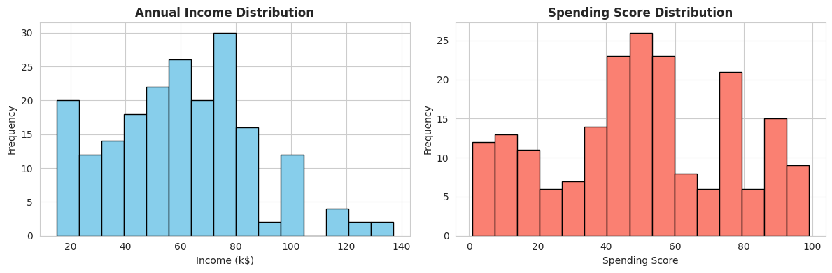
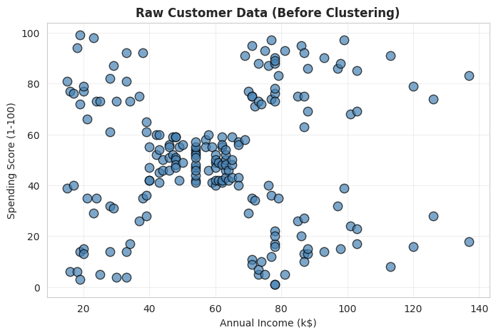
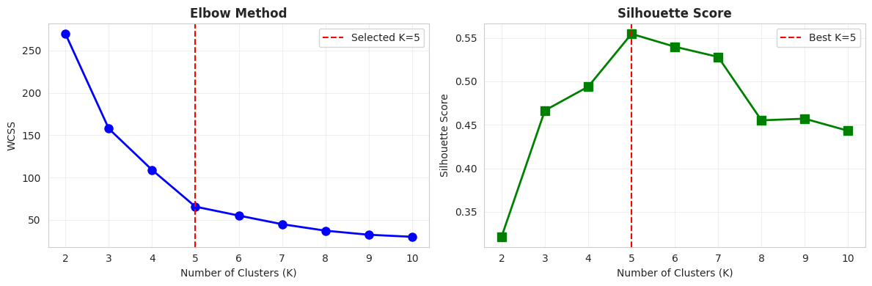
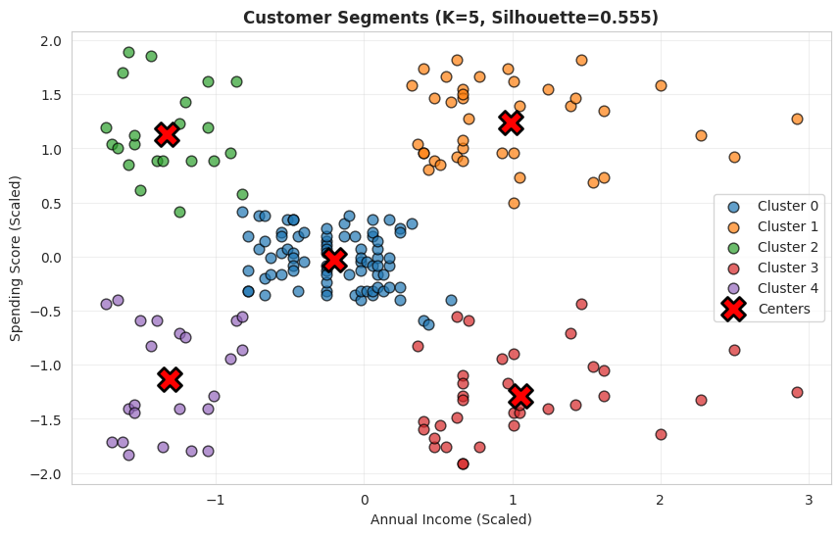
============================================================
RESULTS SUMMARY
============================================================
--- CLUSTER CENTERS ---
Income (k$) Spending Score
0 55.296296 49.518519
1 86.538462 82.128205
2 25.727273 79.363636
3 88.200000 17.114286
4 26.304348 20.913043
--- CLUSTER SIZES ---
Cluster 0: 81 customers (40.5%)
Cluster 1: 39 customers (19.5%)
Cluster 2: 22 customers (11.0%)
Cluster 3: 35 customers (17.5%)
Cluster 4: 23 customers (11.5%)
--- PERFORMANCE METRICS ---
Number of Clusters: 5
Silhouette Score: 0.5547
Inertia (WCSS): 65.57

✅ Saved: Segmented_Customers.csv

============================================================
PROJECT COMPLETE
============================================================

