You are required to build a website to manage the documents. You are given a database script, your responsibility is only to complete the web application. Please note that there are some functions listed in Table 1 that are required to comply.

|  |  |  |
| --- | --- | --- |
| **URL** | **Function Name** | **Description** |
| /login | Login Page | The login page to authenticate with the system |
| /list | List Article | The page that display the list of articles |
| /insert | Create new Article | The page that allows user to create a new article. |

To access any function, the user will only use the URL defined in Table 1. Below is a detailed description for each function:

* When user access the Login Page (see figure 1), the system allows user to authenticate by username and password that defined in [Account] Table.

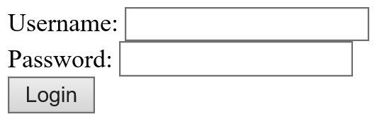

Figure 1: Login page

* If user enters correct username and password that defined in [Account] Table, system displays “Login successful!”
* Otherwise system displays “username or password is invalid!”

Student gains **2 points** if both of the requirements are satisfied, otherwise gains nothing.

* User can access the List page, (**2 points** will be given to this part only if the student can complete the first part)
  + If user has not been authenticated, system displays “Access denied!”
  + Otherwise system displays the list of articles (the real page should display as Figure 2)

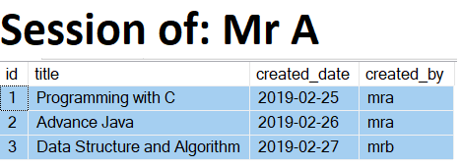

Figure 2: List articles page

* User can access the Create New page, (**2 points** will be given to this part only if the student can complete the first part)
  + If user has not been authenticated, system displays “Access denied!”
  + Otherwise system allows user to create new article

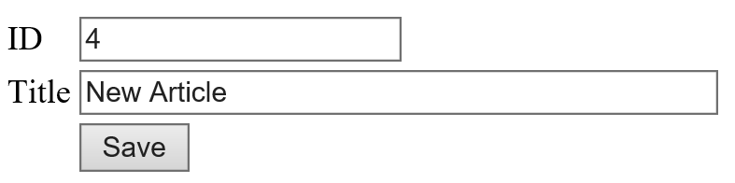

When the user clicks [Save] button, the new article corresponding to entered ID, Title, current Date time and logged user, is added to [Article] table.