**1: Which platforms and post types generate the highest engagement or views?**

select Platform,post_type,sum(engagement) as Total_Engagements, sum(Views)as total_views

from social

group by Platform,post_type

order by Total_Engagements desc, total_views desc

limit 5;

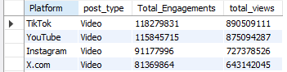

**2: -- What content categories (e.g., product promotion, educational) drive the best performance across different regions?**

select Content_Category, region,Platform, sum(views) as Total_views,sum(Comments)as Total_comments,sum(Likes)as Total_likes,sum(engagement) as Total_Engagements

FROM social

group by Content_Category,Region,Platform

order by Total_views desc,Total_comments desc,Total_likes desc,Total_Engagements desc

limit 5;

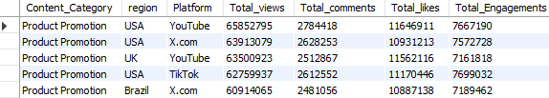

-- Content_Category VS region Vs Total_Engagements

select Content_Category, region, sum(engagement) as Total_Engagements

FROM social

group by Content_Category,Region

order by Total_Engagements desc

limit 5;

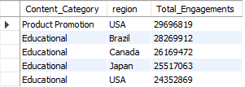

-- Content_Category VS region Vs Total_views

select Content_Category,Platform, region, sum(views) as Total_views

FROM social

group by Content_Category, Platform,Region

order by Total_views desc

limit 5;

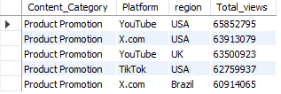

-- Content_Category VS region Vs Total_likes

select Content_Category,Platform, region, sum(likes) as Total_likes

FROM social

group by Content_Category, Platform,Region

order by Total_likes desc

limit 5;

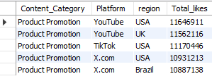

- 3: **How do performance metrics vary by platform, post format, or hashtag usage?**

-- performance vs platform

select platform,sum(engagement) as Total_Engagement

from social

group by Platform,engagement

order by Total_Engagement desc

limit 5;

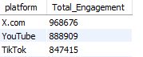

-- performance vs postformant

select Post_Type, sum(engagement) as Total_Engagement

from social

group by Post_Type,engagement

order by Total_Engagement desc

limit 5;



-- performance vs hastag

-- performance vs postformant

select Main_Hashtag, sum(engagement) as Total_Engagement

from social

group by Main_Hashtag,engagement

order by Total_Engagement desc

limit 5;



-- Combining Platform, Post Format & Hashtags

select platform, post_type,Main_Hashtag, sum(engagement) as Total_Engagement

from social

group by platform, post_type,Main_Hashtag

order by Total_Engagement desc

limit 5 ;



**4: What are the ideal days and hours to publish content for maximum engagement?**

select Post_Date ,Post_Published_AMPM,Post_Hour,sum(engagement) as Total_Engagement,Engagement_Level

from social

group by Post_Hour,Post_Date,Post_Published_AMPM,Engagement_Level

order by Total_Engagement desc

limit 5;

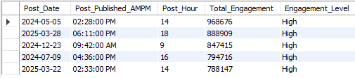

**5: -- Are there regional differences in engagement and click-through performance**

select region, Click_Through_Rate, Engagement_Rate

from social

group by Region,Click_Through_Rate, Engagement_Rate

order by Click_Through_Rate desc, Engagement_Rate desc

limit 5;

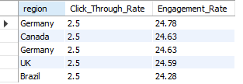

-- regions by highest Engagement_Rate

select region, Engagement_Rate

from social

group by Region, Engagement_Rate

order by Engagement_Rate

limit 5;

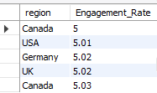

-- regions by highest click-through rate

select region, Click_Through_Rate

from social

group by Region,Click_Through_Rate

order by Click_Through_Rate

limit 5;

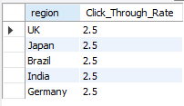

**6: -- What hashtags are most effective in increasing impressions or clicks**

-- hastags with highest impression

select Main_Hashtag, sum(impressions) as Total_impression

from social

group by Main_Hashtag

order by Total_impression desc

limit 5;

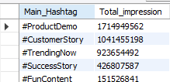

-- hastags with highest clicks

select Main_Hashtag, sum(clicks) as Total_clicks

from social

group by Main_Hashtag

order by Total_clicks desc

limit 5;

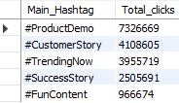

**7: -- Which countries or regions consistently show high video view counts or live stream interest?**

-- region with highest video view

select region, sum(Video_Views) as Total_video_views

from social

group by region

order by Total_video_views desc

limit 5;

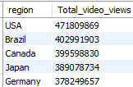

-- region with highest live stream

select region, sum(Live_Stream_Views) as Total_live_stream

from social

group by region

order by Total_live_stream desc

limit 5;

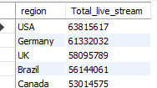

**8: - Are there correlations between engagement levels and content categories or publishing time?**

select Content_Category,Post_Published_AMPM,sum(Engagement)as Total_Engagement,Engagement_Level

from social

group by Content_Category,Engagement_Level,Post_Published_AMPM

order by Total_Engagement desc

limit 5 ;

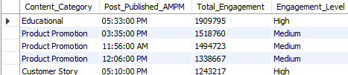

-- Are there correlations between engagement levels and content categories

select Content_Category,sum(Engagement)as Total_Engagement,Engagement_Level

from social

group by Content_Category,Engagement_Level

order by Total_Engagement desc

limit 5 ;

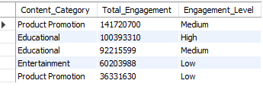

select Content_Category,sum(Engagement)as Total_Engagement,Post_Published_AMPM

from social

group by Content_Category,Post_Published_AMPM

order by Total_Engagement desc

limit 5 ;

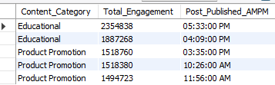

**10: -- How do organic vs. promoted content types compare in terms of reach and performance?**

select Content_Type,sum(Engagement)as Total_Engagement

from social

group by Content_Type

order by Total_Engagement desc

limit 5;

