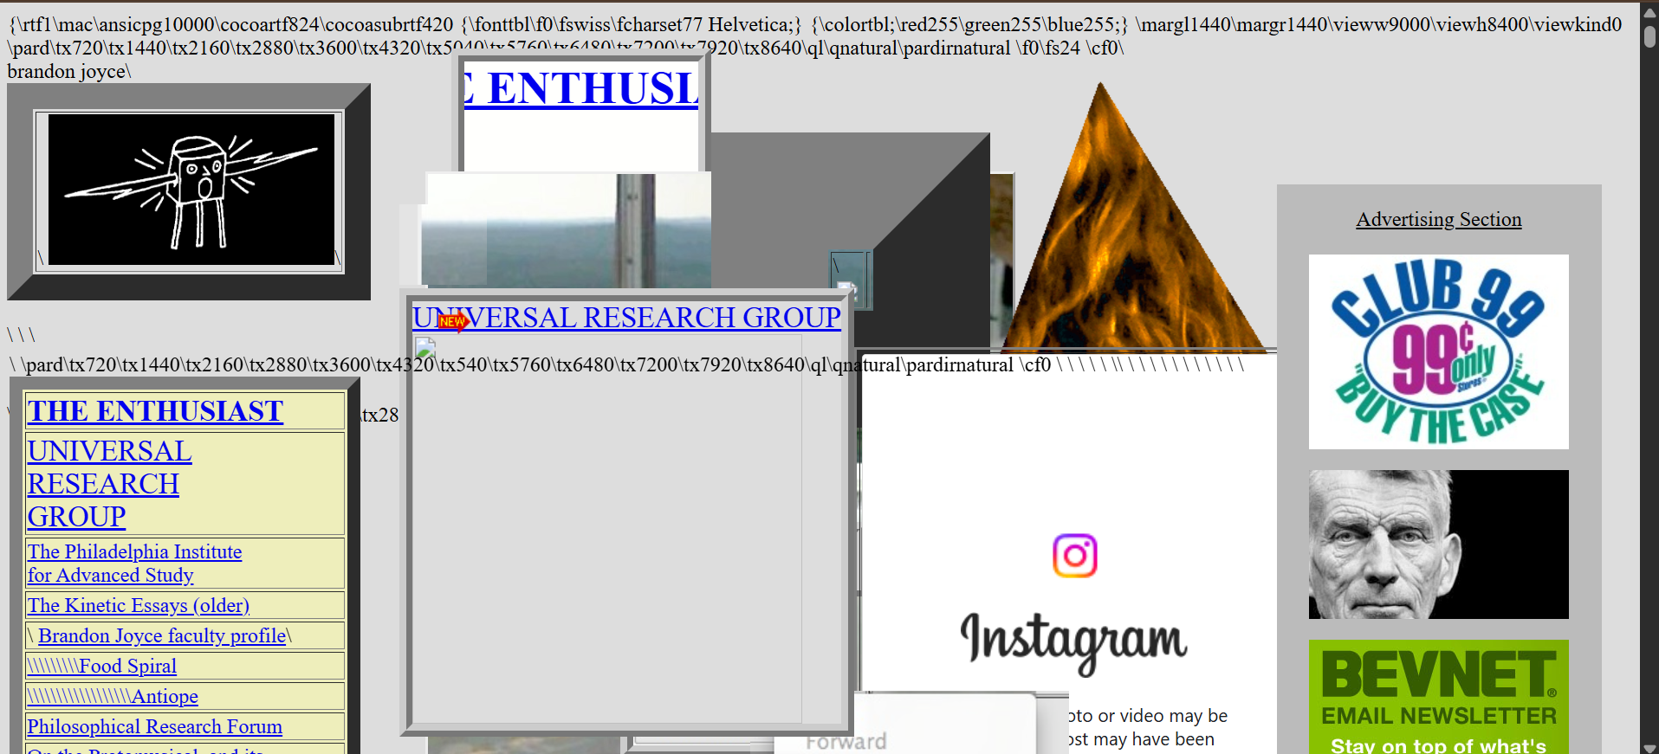

1. <https://lifeactionrevival.org/>
2. Target audience: Movie enthusiasts and anyone looking for entertainment.
3. What I like;

* Has hyperlinks
* Has a scroll button so the user doesn’t have to scroll using the mouse-scroll.

1. What I don’t like;

* Crowded with pictures
* Absence of navigation bar
* Unnecessary space as you keep scrolling down.
* Overlapping pictures and links
* Poor coloring
* Irrelevant pictures
* Some links don’t work
* It appears as though the source code was entangled with the website.
* The hyperlinks are ugly
* No background

Improvements.

* Crowded with pictures………….. limit the number of pictures.
* Absence of navigation bar……..create a navigation bar
* Unnecessary space as you keep scrolling down…………keep the page short, straight to the point and concise as possible.
* Overlapping pictures and links…………. arrange pictures in a uniform and pleasant grid format.
* Poor coloring……………use eye-catching and relaxing colors like teal, green, aqua etc.
* Irrelevant pictures…………..use pictures that hold a message
* Some links don’t work……………make them work.
* It appears as though the source code was entangled with the website………manage source code professionally.
* The hyperlinks are ugly……………….edit them to look like colorful and animated.
* No background……………..create an eye-catching background. Either with gradients or a picture.