**Query 1 output:**

**Users with most number of followers**

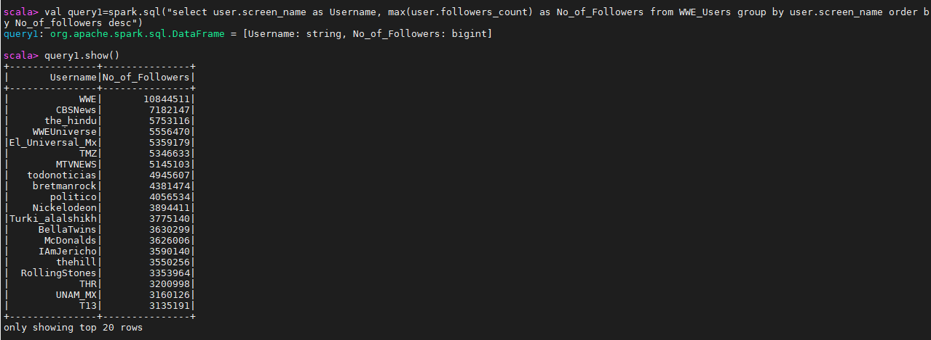

**Query2 output:**

**Number of Tweets based on a day**

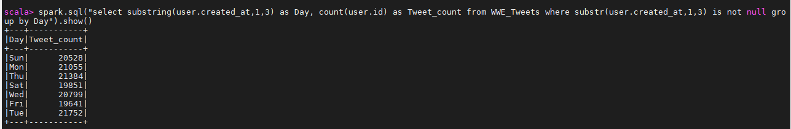

**Query3 output :**

**Users with most number of Tweets**

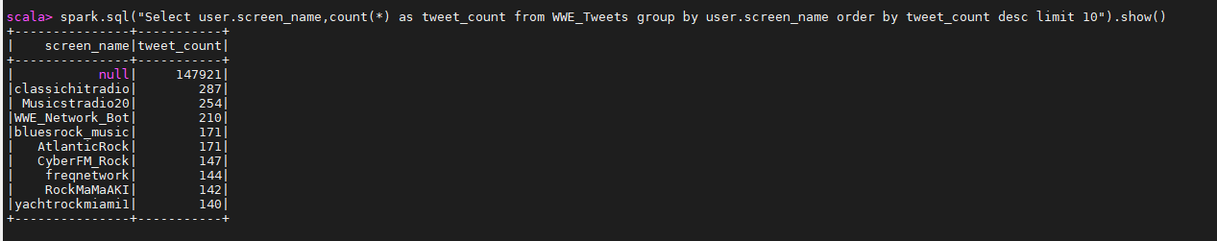

**Query4 output :**

**Users with more number of retweets for his tweet:**

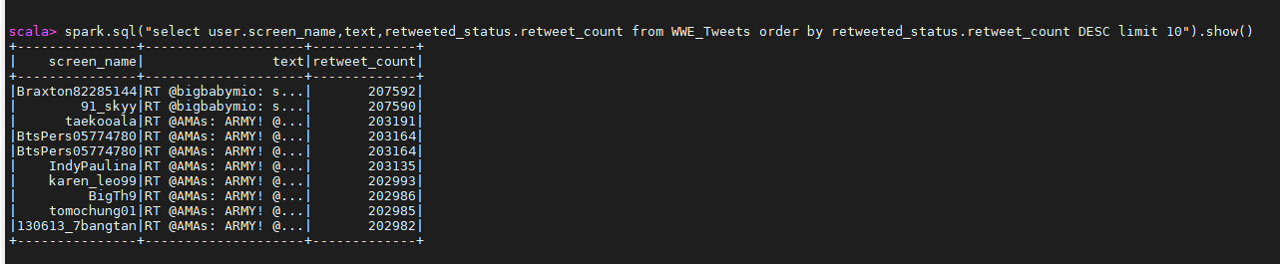

**Query5 output:**

**Number of Tweets for a particular player :**

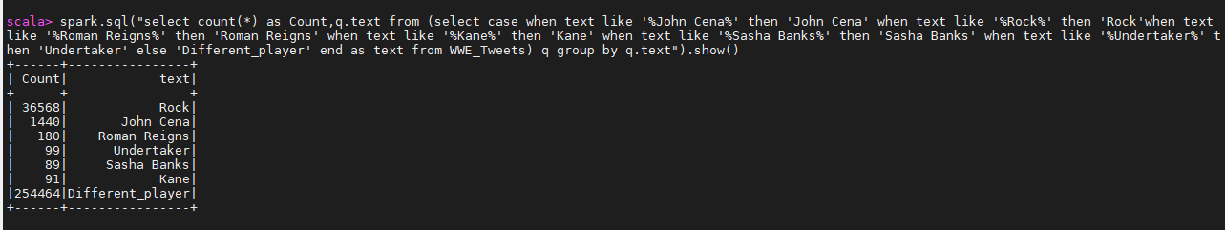

**Query 6 output :**

**Number of Tweets created by users per year:**

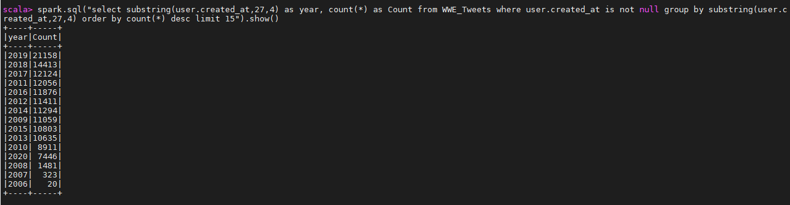

**Query 7 output :**

**Top countries where Tweets came from:**

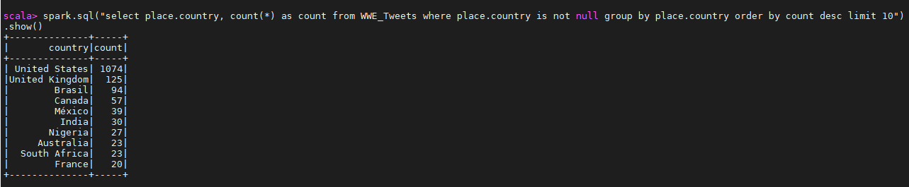

**Query 8 output :**

**Tweets posted on weekend and weekday**

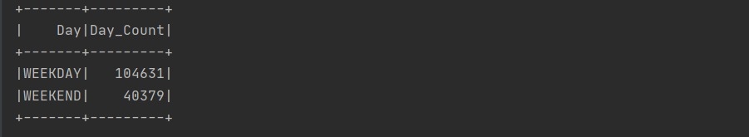

**Query 9 output :**

**Tweet count based on language:**

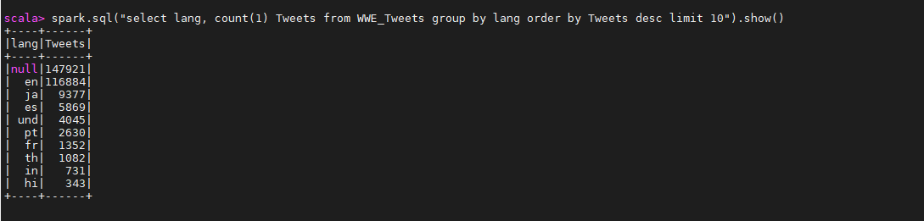

**Query 10 output :**

**Number of Tweets by users based on month:**

