Labeling Tool

This tool is designed for video image per pixel class labeling. It provides pixel level, super pixel level and polygon mode labeling.

**Tool Configuration**

In the folder, you will find an xml file named ‘processSetting.xml’. This file specifies the configuration of the label classes and their respective color. It also specifies the input video file path and the output directory for labeled images and their label images. Each setting is defined in its own xml tag.

<InputFilePath>: specify the input file path.

<OutputDir>: specify the output directory.

<Labeling_Frame_Interval>: specify the interval for labeling frames.

<LabelList>: specify the class name and its color.

Please keep ‘processSetting.xml’ file in the same directory as the exe file.

**Tool Usage**

**Video viewing**

1. Set your ‘processSetting.xml’ file.
2. Open the ‘LabelerSoftWare.exe’ file.
3. Play your video.

Now, you can play the video by click ‘play’ button, pause with ‘pause’ button and stop with ‘stop’ button.

You can also get to any position of the video by dragging progress bar or setting index accurately in the line edit widget and clicking ‘Commit Settings’ button.

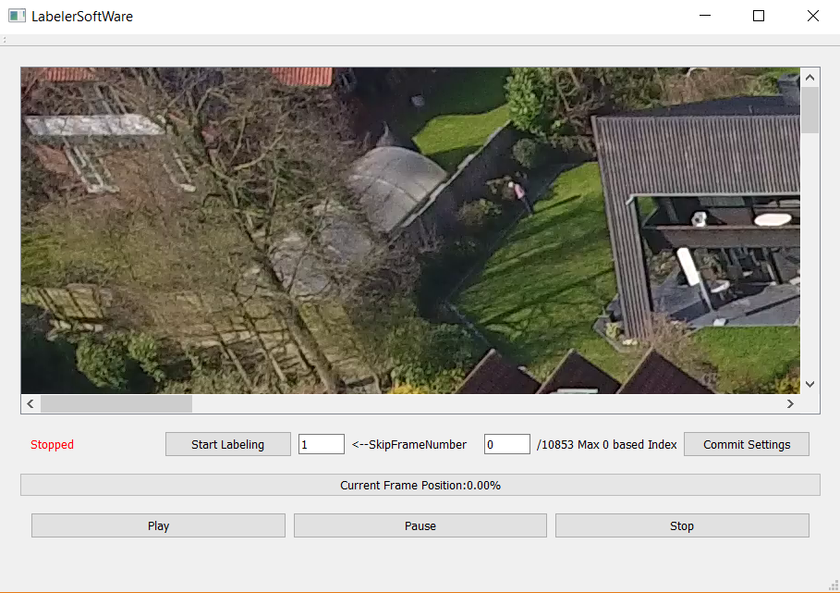

As the image is shown with qt label, and frame grabbed with opencv library, it is not highly optimized for video viewing. So changing skip frame number or image size is a bad idea for this tool. Besides, this tool is aimed for labeling task.

**Video labeling**

1. Click start labeling to enter labeling mode. You will see the main panel in the top middle of your screen. And two small windows for labeling task.

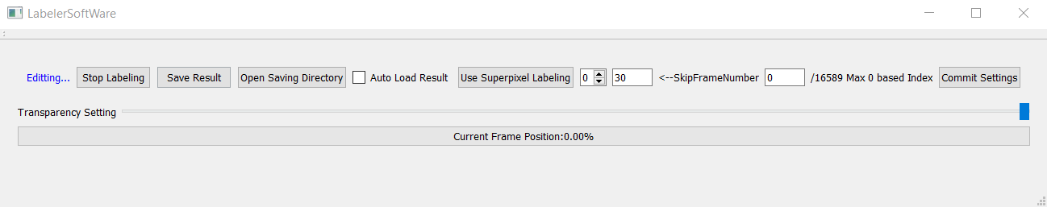

The following shows what the buttons are used for.

1. ‘Stop Labeling’ button: exit labeling process without saving and return to video viewing.
2. ‘Save Result’ button: save current editing frame and current label image together.
3. ‘Open Saving Directory’ button: open file explorer and navigate to the saving directory.
4. ‘Auto Load Result’ checkbox: if ticked, and if saving directory has the corresponding label image for current frame, the label image will be loaded.
5. ‘Use Superpixel Labeling’ button: if you want to use super pixel labeling mode, click this button to run SLIC segmentation with multiple scales. It takes a few seconds to run the algorithm depending on your computation power. Then, a new window will be opened for super pixel mode labeling.
6. Spin Box next to ‘Use Superpixel Labeling’ button: apply different scale of the super pixel.
7. ‘SkipFrameNumber’ edit line: set the interval for getting the next or the previous frame for labeling. Apply this setting by clicking ‘Commit Settings’ button.
8. ‘index’ edit line: set the index for the labeling frame. Apply this setting by clicking ‘Commit Settings’ button.
9. ‘Commit Setting’ button: apply the settings for skip frame number and current index.
10. ‘Transparency Setting’ bar: change the blend ratio between original image and label image.

**Labeling windows**

In total, there are three windows for labeling, they are listed below. Each window references to another image, which is used for blending purpose to see the label quality. All three windows can be used to label, and they are synchronized. Just select a class and then label it.

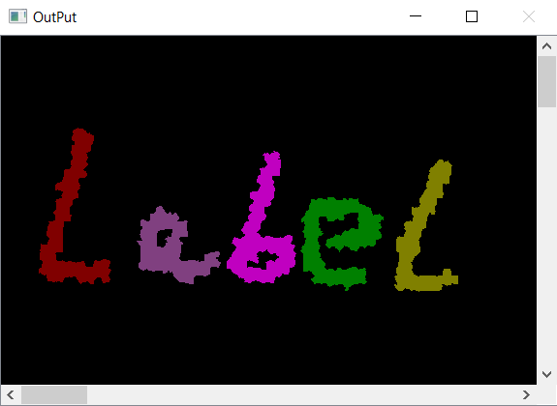 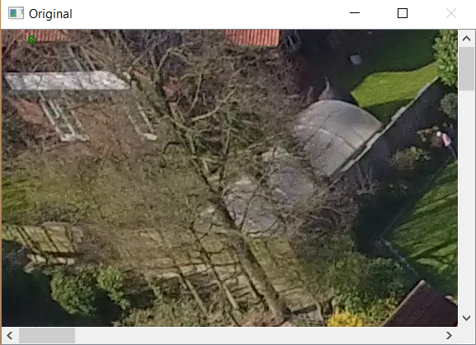 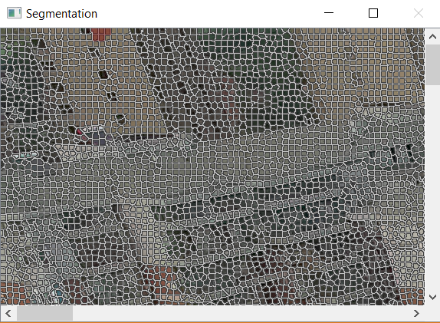

OutPut window Original window Segmentation window

Three labeling mode (the following shows example with blending on. (Shot key: tab)):

1. Pixel level: in output window and original window, you can draw label directly.

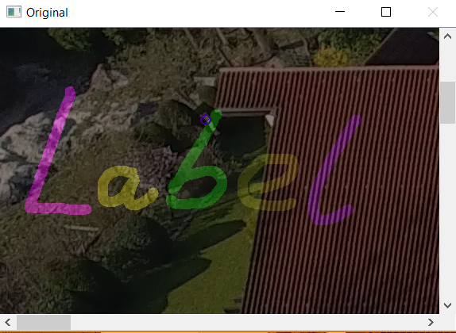

1. Super pixel level: in segmentation window, you can draw label with super pixels.

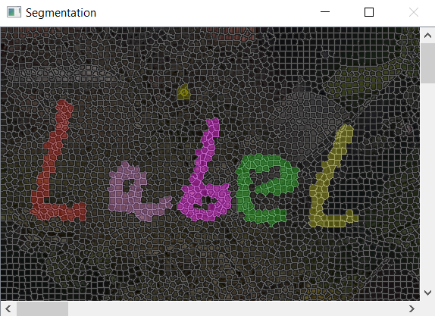

1. Polygon model: in original window, you can draw polygons, right mouse click to enter polygon mode, left mouse double click to draw polygon.

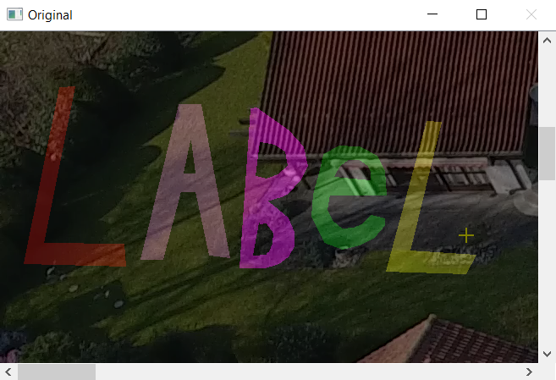

To erase part of the label. Just select void class and draw above the unwanted part.

**Shot Key Table**

(Holding means press continuously)

|  |  |
| --- | --- |
| Shot Key | Function |
| Tab | Blending the image with the reference image |
| Shift(Holding) | Hovering mouse on opened panel to select class |
| r | Clear all the labeled pixels |
| Ctrl + mouse wheel | Change pen size |
| Alt + mouse wheel | Zoom the image |
| v | Zoom to original scale |
| X + mouse wheel  (segmentation window) | Change super pixel scale |
| w | Move scroll bar up |
| s | Move scroll bar down |
| a | Move scroll bar left |
| d | Move scroll bar right |
| Left mouse click | If not in polygon mode: Draw labels  If in polygon mode: Add a polygon vertex |
| Right mouse click  (original window) | Switch between polygon editing mode and pixel level labeling mode |
| Ctrl + Z  (original window, polygon mode) | Undo adding a vertex from current polygon |
| Left mouse double click  (original window, polygon mode) | Finish drawing current polygon |
| 🡪 | Skip to next frame for labeling |
| 🡨 | Skip to previous frame for labeling |

**Saving name rules**

When saving the label, both original image and label image will be saved.

Output label file name is:’ <index>.bmp’, and the corresponding original image file name is ‘<index>_ori.bmp’.

**Good practice for labeling**

1. Label objects in the back first, then label objects in the front.
2. Class order of labeling: building -> road -> moving cars -> static cars -> vegetation -> tree. You can also do it in your own preference anyway.
3. Save result constantly in case you lost the label by accident.
4. If you have already labeled some parts and saved in the output directory, you can always load it by tick ‘Auto Load Result’ checkbox.
5. Remember to save result before you exit or switch frame.
6. Mode selection: For regular objects, use polygon mode. For round corners use pixel mode. For objects with saw tooth boundaries, use super pixel mode.

**Question**

If you have any question, you are welcome to contact me.

Email: y.lyu@utwente.nl