第二讲：输出文本与绘图
- 显示器为多个程序共享，只能在窗口的客户区内输出。
- 客户区是窗口中可以由程序任意书写和传递视觉信息的部分，通常显示了用户的某种交互需求
- 窗口大小不固定，窗口之间的覆盖，要求开发者更新对应的客户区
- 处理客户区的绘制，一般在WM_PAINT消息的处理过程中完成

- GDI: Graphics Device Interface
- WM_PAINT消息
  - 在WinMain()中的UpdateWindow()函数直接给窗口过程发送第一个WM_PAINT消息。
  - 当窗口客户区域的一部分或全部变成“无效”，以致必须刷新时，系统将产生这个消息：
- 当窗口被最初创建时，整个客户区域都是无效的，第一个WM_PAINT消息通常是在WinMain()中调用UpdateWindow产生的；
- 当窗口的大小发生变化时，整个客户区域都变得无效；
- 当窗口区域的一部分不再被其他窗口遮盖之后，先前被遮盖的客户区域将变得无效；
- 设备描述表(DC：Device Context):是GDI内部保存的数据结构，指物理输出设备,与特定显示设备相关，其属性定义了被输出文本的颜色、文本的背景色、字体等。
- 设备描述表句柄是GDI函数的窗口“通行证”，有了这种设备内容句柄，程序员就能自如地在显示区域上绘图。Windows提供了几个GDI函数，用于将字符串输出到窗口的显示区域内

- 绘制的一般过程

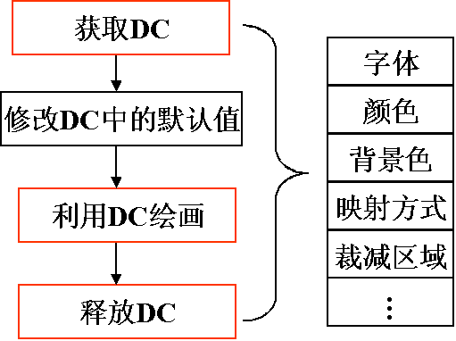

- 获取设备描述表句柄方法一：
处理WM_PAINT消息,必须使用BeginPaint()和EndPaint()，BeginPaint()和EndPaint()必须成对出现。
在BeginPaint()调用中，它使用注册窗口类的WNDCLASS结构的hbrBackGround域中指定的刷子来删除无效区域背景，BeginPaint()调用使整个客户区域有效。
如果窗口过程不处理WM_PAINT消息，则必须把它传给DefWindowProc()来处理，DefWindowProc()函数依次调用BeginPaint()和EndPaint()以使整个客户区域有效。
绘图信息结构PAINSTRUCT: 在程序调用BeginPaint()时，WINDOWS填充该结构的各个字段，若fErase为0，则意味着在调用BeginPaint()时，BeginPaint()已经用刷子删除无效区域背景；RECT rcPaint字段定义了包围无效区域的最小矩形，GDI输出函数只能在这个矩形内输出。
typedef struct tagPAINTSTRUCT
{
HDC hdc ;
BOOL fErase ;
RECT rcPaint ;
BOOL fRestore ;
BOOL fIncUpdate ;
BYTE rgbReserved[32] ;
} PAINTSTRUCT ;
- 获取设备描述表句柄方法二：
在处理非WM_PAINT消息时，在客户区上做图获取设备描述表句柄的方法是GetDC()和ReleaseDC()，用GetDC()获取的设备描述表句柄，可在整个客户区上做图。
- 程序必须在处理单个消息期间，获取和释放设备描述表句柄。
- 系统字体：设备描述表的默认字体是系统字体，系统字体是Windows用来在标题条、菜单和对话框中显示文本串的字体。
- 字体大小：系统用结构TEXTMETRIC来描述字体的各个参数，用函数GetTextMetrics (hdc, &tm) 来取得当前字体的尺寸。结构TEXTMETRIC的定义如下：

typedef struct tagTEXTMETRIC
{
LONG tmHeight ;
LONG tmAscent ;
LONG tmDescent ;
LONG tmInternalLeading ;
LONG tmExternalLeading ;
LONG tmAveCharWidth ;
LONG tmMaxCharWidth ;
[other structure fields]
} TEXTMETRIC, * PTEXTMETRIC ;
tmAveCharWidth field is a weighted average of lowercase characters.
tmMaxCharWidth is the width of the widest character in the font.
The low bit of the tmPitchAndFamily field in the TEXTMETRIC structure is 1 for a variable-width font and 0 for a fixed-pitch font.

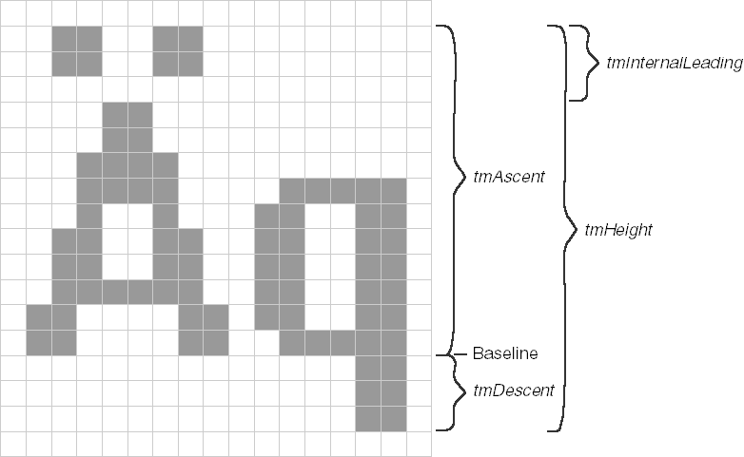
- 文本输出函数TextOut(hdc, x, y, psText, iLength):
TextOut writes a character string to the client area of the window. The psText argument is a pointer to the character string, and iLength is the length of the string in characters. The x and y arguments define the starting position of the character string in the client area. (More details soon on how these work.) The hdc argument is a "handle to a device context".
- 映射方式（Mapping Mode）:
映射方式定义了如何把逻辑坐标转换成物理坐标,系统默认的映射方式是WM_TEXT，在WM_TEXT映射方式下，逻辑单位和物理单位相同，以像素为单位。

- 输出文本程序例
/*-----------------------------------------------
SYSMETS.H -- System metrics display structure
-----------------------------------------------*/

#define NUMLINES ((int) (sizeof sysmetrics / sizeof sysmetrics [0]))

struct
{
int iIndex ;
TCHAR * szLabel ;
TCHAR * szDesc ;
}
sysmetrics [] =
{
SM_CXSCREEN, TEXT ("SM_CXSCREEN"),
TEXT ("Screen width in pixels"),
SM_CYSCREEN, TEXT ("SM_CYSCREEN"),
TEXT ("Screen height in pixels"),
SM_CXVSCROLL, TEXT ("SM_CXVSCROLL"),
TEXT ("Vertical scroll width"),
SM_CYHSCROLL, TEXT ("SM_CYHSCROLL"),
TEXT ("Horizontal scroll height"),
SM_CYCAPTION, TEXT ("SM_CYCAPTION"),
TEXT ("Caption bar height"),
SM_CXBORDER, TEXT ("SM_CXBORDER"),
TEXT ("Window border width"),
SM_CYBORDER, TEXT ("SM_CYBORDER"),
TEXT ("Window border height"),
SM_CXFIXEDFRAME, TEXT ("SM_CXFIXEDFRAME"),
TEXT ("Dialog window frame width"),
SM_CYFIXEDFRAME, TEXT ("SM_CYFIXEDFRAME"),
TEXT ("Dialog window frame height"),
SM_CYVTHUMB, TEXT ("SM_CYVTHUMB"),
TEXT ("Vertical scroll thumb height"),
SM_CXHTHUMB, TEXT ("SM_CXHTHUMB"),
TEXT ("Horizontal scroll thumb width"),
SM_CXICON, TEXT ("SM_CXICON"),
TEXT ("Icon width"),
SM_CYICON, TEXT ("SM_CYICON"),
TEXT ("Icon height"),
SM_CXCURSOR, TEXT ("SM_CXCURSOR"),
TEXT ("Cursor width"),
SM_CYCURSOR, TEXT ("SM_CYCURSOR"),
TEXT ("Cursor height"),
SM_CYMENU, TEXT ("SM_CYMENU"),
TEXT ("Menu bar height"),
SM_CXFULLSCREEN, TEXT ("SM_CXFULLSCREEN"),
TEXT ("Full screen client area width"),
SM_CYFULLSCREEN, TEXT ("SM_CYFULLSCREEN"),
TEXT ("Full screen client area height"),
SM_CYKANJIWINDOW, TEXT ("SM_CYKANJIWINDOW"),
TEXT ("Kanji window height"),
SM_MOUSEPRESENT, TEXT ("SM_MOUSEPRESENT"),
TEXT ("Mouse present flag"),
SM_CYVSCROLL, TEXT ("SM_CYVSCROLL"),
TEXT ("Vertical scroll arrow height"),
SM_CXHSCROLL, TEXT ("SM_CXHSCROLL"),
TEXT ("Horizontal scroll arrow width"),
SM_DEBUG, TEXT ("SM_DEBUG"),
TEXT ("Debug version flag"),
SM_SWAPBUTTON, TEXT ("SM_SWAPBUTTON"),
TEXT ("Mouse buttons swapped flag"),
SM_CXMIN, TEXT ("SM_CXMIN"),
TEXT ("Minimum window width"),
SM_CYMIN, TEXT ("SM_CYMIN"),
TEXT ("Minimum window height"),
SM_CXSIZE, TEXT ("SM_CXSIZE"),
TEXT ("Min/Max/Close button width"),
SM_CYSIZE, TEXT ("SM_CYSIZE"),
TEXT ("Min/Max/Close button height"),
SM_CXSIZEFRAME, TEXT ("SM_CXSIZEFRAME"),
TEXT ("Window sizing frame width"),
SM_CYSIZEFRAME, TEXT ("SM_CYSIZEFRAME"),
TEXT ("Window sizing frame height"),
SM_CXMINTRACK, TEXT ("SM_CXMINTRACK"),
TEXT ("Minimum window tracking width"),
SM_CYMINTRACK, TEXT ("SM_CYMINTRACK"),
TEXT ("Minimum window tracking height"),
SM_CXDOUBLECLK, TEXT ("SM_CXDOUBLECLK"),
TEXT ("Double click x tolerance"),
SM_CYDOUBLECLK, TEXT ("SM_CYDOUBLECLK"),
TEXT ("Double click y tolerance"),
SM_CXICONSPACING, TEXT ("SM_CXICONSPACING"),
TEXT ("Horizontal icon spacing"),
SM_CYICONSPACING, TEXT ("SM_CYICONSPACING"),
TEXT ("Vertical icon spacing"),
SM_MENUDROPALIGNMENT, TEXT ("SM_MENUDROPALIGNMENT"),
TEXT ("Left or right menu drop"),
SM_PENWINDOWS, TEXT ("SM_PENWINDOWS"),
TEXT ("Pen extensions installed"),
SM_DBCSENABLED, TEXT ("SM_DBCSENABLED"),
TEXT ("Double-Byte Char Set enabled"),
SM_CMOUSEBUTTONS, TEXT ("SM_CMOUSEBUTTONS"),
TEXT ("Number of mouse buttons"),
SM_SECURE, TEXT ("SM_SECURE"),
TEXT ("Security present flag"),
SM_CXEDGE, TEXT ("SM_CXEDGE"),
TEXT ("3-D border width"),
SM_CYEDGE, TEXT ("SM_CYEDGE"),
TEXT ("3-D border height"),
SM_CXMINSPACING, TEXT ("SM_CXMINSPACING"),
TEXT ("Minimized window spacing width"),
SM_CYMINSPACING, TEXT ("SM_CYMINSPACING"),
TEXT ("Minimized window spacing height"),
SM_CXSMICON, TEXT ("SM_CXSMICON"),
TEXT ("Small icon width"),
SM_CYSMICON, TEXT ("SM_CYSMICON"),
TEXT ("Small icon height"),
SM_CYSMCAPTION, TEXT ("SM_CYSMCAPTION"),
TEXT ("Small caption height"),
SM_CXSMSIZE, TEXT ("SM_CXSMSIZE"),
TEXT ("Small caption button width"),
SM_CYSMSIZE, TEXT ("SM_CYSMSIZE"),
TEXT ("Small caption button height"),
SM_CXMENUSIZE, TEXT ("SM_CXMENUSIZE"),
TEXT ("Menu bar button width"),
SM_CYMENUSIZE, TEXT ("SM_CYMENUSIZE"),
TEXT ("Menu bar button height"),
SM_ARRANGE, TEXT ("SM_ARRANGE"),
TEXT ("How minimized windows arranged"),
SM_CXMINIMIZED, TEXT ("SM_CXMINIMIZED"),
TEXT ("Minimized window width"),
SM_CYMINIMIZED, TEXT ("SM_CYMINIMIZED"),
TEXT ("Minimized window height"),
SM_CXMAXTRACK, TEXT ("SM_CXMAXTRACK"),
TEXT ("Maximum draggable width"),
SM_CYMAXTRACK, TEXT ("SM_CYMAXTRACK"),
TEXT ("Maximum draggable height"),
SM_CXMAXIMIZED, TEXT ("SM_CXMAXIMIZED"),
TEXT ("Width of maximized window"),
SM_CYMAXIMIZED, TEXT ("SM_CYMAXIMIZED"),
TEXT ("Height of maximized window"),
SM_NETWORK, TEXT ("SM_NETWORK"),
TEXT ("Network present flag"),
SM_CLEANBOOT, TEXT ("SM_CLEANBOOT"),
TEXT ("How system was booted"),
SM_CXDRAG, TEXT ("SM_CXDRAG"),
TEXT ("Avoid drag x tolerance"),
SM_CYDRAG, TEXT ("SM_CYDRAG"),
TEXT ("Avoid drag y tolerance"),
SM_SHOWSOUNDS, TEXT ("SM_SHOWSOUNDS"),
TEXT ("Present sounds visually"),
SM_CXMENUCHECK, TEXT ("SM_CXMENUCHECK"),
TEXT ("Menu check-mark width"),
SM_CYMENUCHECK, TEXT ("SM_CYMENUCHECK"),
TEXT ("Menu check-mark height"),
SM_SLOWMACHINE, TEXT ("SM_SLOWMACHINE"),
TEXT ("Slow processor flag"),
SM_MIDEASTENABLED, TEXT ("SM_MIDEASTENABLED"),
TEXT ("Hebrew and Arabic enabled flag"),
SM_MOUSEWHEELPRESENT, TEXT ("SM_MOUSEWHEELPRESENT"),
TEXT ("Mouse wheel present flag"),
SM_XVIRTUALSCREEN, TEXT ("SM_XVIRTUALSCREEN"),
TEXT ("Virtual screen x origin"),
SM_YVIRTUALSCREEN, TEXT ("SM_YVIRTUALSCREEN"),
TEXT ("Virtual screen y origin"),
SM_CXVIRTUALSCREEN, TEXT ("SM_CXVIRTUALSCREEN"),
TEXT ("Virtual screen width"),
SM_CYVIRTUALSCREEN, TEXT ("SM_CYVIRTUALSCREEN"),
TEXT ("Virtual screen height"),
SM_CMONITORS, TEXT ("SM_CMONITORS"),
TEXT ("Number of monitors"),
SM_SAMEDISPLAYFORMAT, TEXT ("SM_SAMEDISPLAYFORMAT"),
TEXT ("Same color format flag")
} ;

/*----------------------------------------------------
SYSMETS1.C -- System Metrics Display Program No. 1
(c) Charles Petzold, 1998
----------------------------------------------------*/

#define WINVER 0x0500
#include <windows.h>
#include "sysmets.h"

LRESULT CALLBACK WndProc (HWND, UINT, WPARAM, LPARAM) ;

int WINAPI WinMain (HINSTANCE hInstance, HINSTANCE hPrevInstance,
PSTR szCmdLine, int iCmdShow)
{
static TCHAR szAppName[] = TEXT ("SysMets1") ;
HWND hwnd ;
MSG msg ;
WNDCLASS wndclass ;

wndclass.style = CS_HREDRAW | CS_VREDRAW ;
wndclass.lpfnWndProc = WndProc ;
wndclass.cbClsExtra = 0 ;
wndclass.cbWndExtra = 0 ;
wndclass.hInstance = hInstance ;
wndclass.hIcon = LoadIcon (NULL, IDI_APPLICATION) ;
wndclass.hCursor = LoadCursor (NULL, IDC_ARROW) ;
wndclass.hbrBackground = (HBRUSH) GetStockObject (WHITE_BRUSH) ;
wndclass.lpszMenuName = NULL ;
wndclass.lpszClassName = szAppName ;

if (!RegisterClass (&wndclass))
{
MessageBox (NULL, TEXT ("This program requires Windows NT!"),
szAppName, MB_ICONERROR) ;
return 0 ;
}

hwnd = CreateWindow (szAppName, TEXT ("Get System Metrics No. 1"),
WS_OVERLAPPEDWINDOW,
CW_USEDEFAULT, CW_USEDEFAULT,
CW_USEDEFAULT, CW_USEDEFAULT,
NULL, NULL, hInstance, NULL) ;

ShowWindow (hwnd, iCmdShow) ;
UpdateWindow (hwnd) ;

while (GetMessage (&msg, NULL, 0, 0))
{
TranslateMessage (&msg) ;
DispatchMessage (&msg) ;
}
return msg.wParam ;
}

LRESULT CALLBACK WndProc (HWND hwnd, UINT message, WPARAM wParam, LPARAM lParam)
{
static int cxChar, cxCaps, cyChar ;
HDC hdc ;
int i ;
PAINTSTRUCT ps ;
TCHAR szBuffer [10] ;
TEXTMETRIC tm ;

switch (message)
{
case WM_CREATE:
hdc = GetDC (hwnd) ;

GetTextMetrics (hdc, &tm) ;
cxChar = tm.tmAveCharWidth ;
cxCaps = (tm.tmPitchAndFamily & 1 ? 3 : 2) * cxChar / 2 ;
cyChar = tm.tmHeight + tm.tmExternalLeading ;

ReleaseDC (hwnd, hdc) ;
return 0 ;

case WM_PAINT :
hdc = BeginPaint (hwnd, &ps) ;

for (i = 0 ; i < NUMLINES ; i++)
{
TextOut (hdc, 0, cyChar * i,
sysmetrics[i].szLabel,
lstrlen (sysmetrics[i].szLabel)) ;

TextOut (hdc, 22 * cxCaps, cyChar * i,
sysmetrics[i].szDesc,
lstrlen (sysmetrics[i].szDesc)) ;

SetTextAlign (hdc, TA_RIGHT | TA_TOP) ;

TextOut (hdc, 22 * cxCaps + 40 * cxChar, cyChar * i, szBuffer,
wsprintf (szBuffer, TEXT ("%5d"),
GetSystemMetrics (sysmetrics[i].iIndex))) ;

SetTextAlign (hdc, TA_LEFT | TA_TOP) ;
}
EndPaint (hwnd, &ps) ;
return 0 ;

case WM_DESTROY :
PostQuitMessage (0) ;
return 0 ;
}
return DefWindowProc (hwnd, message, wParam, lParam) ;
}
- 客户区的大小
当窗口大小改变时，WINDOWS给窗口过程发送WM_SIZE消息，LOWWORD(lParam)为窗口客户区的水平宽度，LOWWORD(lParam)为窗口客户区的垂直宽度，
ShowWindow()→WM_SIZE。
- SCROLLBAR(滚动条)
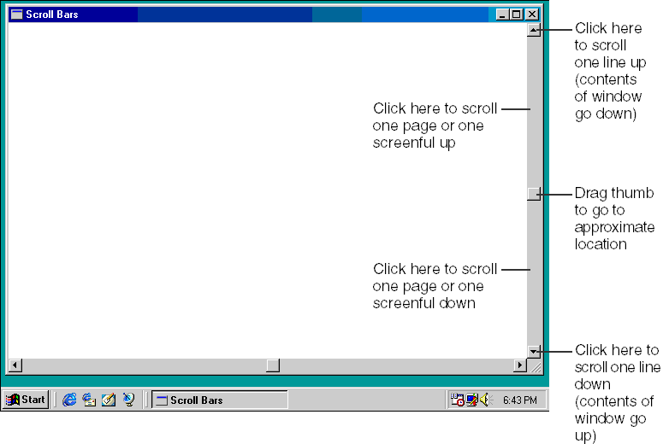
- 在CreateWindow()函数中的第三个参数中包含WS_VSCROLL(水平滚动条)和WS_HSCROLL(垂直滚动条)。
- 滚动条的范围和滚动框的位置
SetScrollRange(hwnd,iBar,iMin,iMax,bRedraw);
SetScrollPos(hwnd,iBar,iPos,bRedraw);
IBar:SB_VERT,SB_HORZ
BRedraw:FALSE(不重画滚动条),TRUE(重画滚动条)
- 滚动条消息WM_VSCROLL和WM_HSCROLL
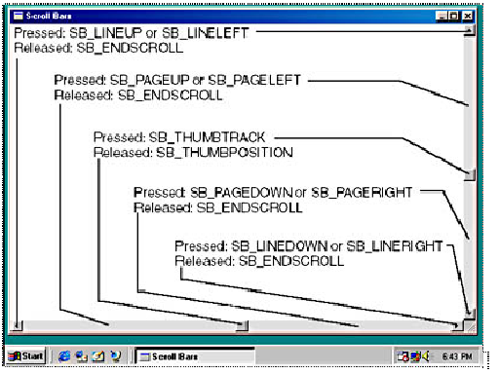

- 程序Sysmets2的要点：Each position of the scroll bar corresponds to a line of text displayed at the top of the client area.

Windows 98 and Windows 2000: WINVER=0x0500

滚动条的编程方法

初始化滚动条的范围和滚动框的位置：

处理窗口过程的滚动条消息：

更新滚动框的位置

更改客户区的内容以响应对滚动框的位置修改

InvalidateRect()
The InvalidateRect function adds a rectangle to the specified window's update region. The update region represents the portion of the window's client area that must be redrawn.
BOOL InvalidateRect(
HWND hWnd, // handle to window
CONST RECT *lpRect, // rectangle coordinates
BOOL bErase // erase state
);
Parameters
hWnd
[in] Handle to the window whose update region has changed. If this parameter is NULL, the system invalidates and redraws all windows, and sends the WM_ERASEBKGND and WM_NCPAINT messages to the window procedure before the function returns.
lpRect
[in] Pointer to a RECT structure that contains the client coordinates of the rectangle to be added to the update region. If this parameter is NULL, the entire client area is added to the update region.
bErase
[in] Specifies whether the background within the update region is to be erased when the update region is processed. If this parameter is TRUE, the background is erased when the BeginPaint function is called. If this parameter is FALSE, the background remains unchanged.
Return Values
If the function succeeds, the return value is nonzero.
If the function fails, the return value is zero.
calls InvalidateRect to invalidate the client area. This causes Windows to place a WM_PAINT message in the message queue.

SYSMETS2的缺点：若显示行数小于客户区行数，SCROLLBAR总是显示；滚动框大小没有与显示行数成比例关系。

SYSMETS3：
typedef struct tagSCROLLINFO {
UINT cbSize;
UINT fMask;
int nMin;
int nMax;
UINT nPage;
int nPos;
int nTrackPos;
} SCROLLINFO, *LPSCROLLINFO;
typedef SCROLLINFO CONST *LPCSCROLLINFO;
SIF_ALL= SIF_PAGE|SIF_POS| SIF_RANGE|SIF_TRACKPOS；

- BOOL ScrollWindow(
HWND hWnd, // handle to window
int XAmount, // horizontal scrolling
int YAmount, // vertical scrolling
CONST RECT *lpRect, // client area
CONST RECT *lpClipRect // clipping rectangle
);

int XAmount：X方向滚动的数量，正值向右，负值向左；

int YAmount：Y方向滚动的数量，正值向下，负值向上；
CONST RECT *lpRect： Pointer to the RECT structure specifying the portion of the client area to be scrolled. If this parameter is NULL, the entire client area is scrolled.
Windows自动把客户区中未被滚动操作覆盖的矩形设为无效区域。

图形及曲线绘制
- 曲线绘制函数
To draw a straight line, you must call two functions. The first function specifies the point at which the line begins, and the second function specifies the end point of the line. In the default device context, the current position is initially set to the point (0, 0).
MoveToEx (hdc, xBeg, yBeg, NULL) ;
LineTo (hdc, xEnd, yEnd) ;
When you have an array of points that you want connected with lines, you can draw the lines more easily using the Polyline function.
POINT apt[5] ={ 100, 100, 200, 100, 200, 200, 100, 200, 100, 100} ;

Polyline (hdc, apt, 5) ;
The last argument is the number of points.
- 颜色：是由红、绿、兰三种颜色组成，用一个无符号32位整数来表示，用一个宏代换RGB(r,g,b)来表示，r,g,b分别表示红色、绿色、兰色，取值范围是0-255。如RGB(0,0,0)表示黑色，RGB(255,255,255)表示白色。
- 画笔：当调用画线函数时，Windows使用设备描述表中当前选中的“画笔”来画线，设备描述表中默认画笔是BLACK_PEN, 画笔决定线的颜色、宽度、和线型。
（1）Windows系统提供三种现成画笔BLACK_PEN、WHITE_PEN、 NULL_PEN。
HPEN hPen=GetStockObject (WHITE_PEN) ;
SelectObject (hdc, hPen) ;
（2）创建自己的画笔：
HPEN hPen= CreatePen (iPenStyle, iWidth, crColor) ;
hPen2 = CreatePen (PS_SOLID, 3, RGB (255, 0, 0)) ;
SelectObject (hdc, hPen2) ;
DeleteObject (hPen2) ;

  - 绘图方式：被画线的颜色由画笔的颜色和目标位置处原来像素的颜色做某种按位布尔运算。
SetROP2 (hdc, iDrawMode) ;
设备描述表中默认设置是R2_COPYPEN，把画笔的颜色拷贝到目标位置处。
SetROP2 (hdc, R2_NOT) ; R2_NOT把目标位置处的颜色“按位取反”。

- 区域填充函数
draws a rectangle:
Rectangle (hdc, xLeft, yTop, xRight, yBottom) ;
draw an ellipse，
Ellipse (hdc, xLeft, yTop, xRight, yBottom) ;
GDI also fills the enclosed area. by default the area is filled with white.

  - 画刷：当调用区域填充函数时，Windows使用设备描述表中当前选中的“画刷”来填充区域，设备描述表中默认画刷是WHITE_BRUSH, Windows系统提供6种现成画刷，WHITE_BRUSH, LTGRAY_BRUSH, GRAY_BRUSH, DKGRAY_BRUSH, BLACK_BRUSH, and NULL_BRUSH
HBRUSH hBrush ;
hBrush = GetStockObject (GRAY_BRUSH) ;
SelectObject (hdc, hBrush) ;
;
示例程序
HBRUSH hBrush ;
HPEN hPen;

hBrush = (HBRUSH)GetStockObject (GRAY_BRUSH) ;
SelectObject (hdc, hBrush) ;
Rectangle (hdc, 100, 100, 400, 400) ;

hPen=(HPEN)GetStockObject (WHITE_PEN) ;
SelectObject (hdc, hPen) ;

hBrush = (HBRUSH)GetStockObject (LTGRAY_BRUSH) ;
SelectObject (hdc, hBrush) ;
Rectangle (hdc, 200, 200, 300, 300) ;

hPen=(HPEN)GetStockObject (BLACK_PEN) ;
SelectObject (hdc, hPen) ;

MoveToEx (hdc,199, 299, NULL) ;
LineTo (hdc, 299, 299);

MoveToEx (hdc,299, 299, NULL) ;
LineTo (hdc, 299, 199);

