SALES CUSTOMER
RETENTION ANALYSIS
Excel • Power Query • Power Pivot • DAX • PivotCharts
Portfolio Project Documentation
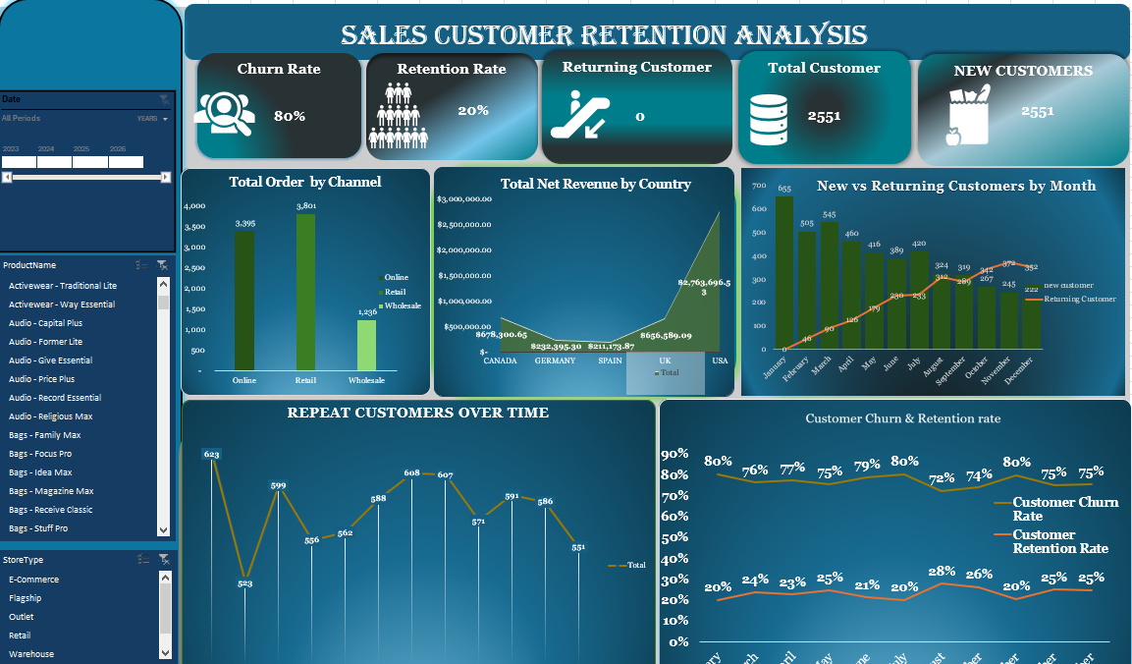
Final interactive customer-retention dashboard.
Prepared as a professional end-to-end analytics case study

1. Executive Summary
This project analyses sales and customer behaviour to understand how effectively the business acquires customers, generates repeat purchasing, retains customers from one month to the next, and converts sales activity into revenue and profit. The workflow was completed in Excel using Power Query for data preparation, the Excel Data Model/Power Pivot for relational modelling and DAX measures, and PivotTables/PivotCharts for interactive analysis.
The cleaned fact table contains 8,432 sales-line records, representing 2,834 unique orders and 2,551 unique customers. Net revenue is approximately $4.54 million. Based on the available TotalCost field, the data produces about $2.76 million in gross profit-equivalent contribution and an overall margin of about 60.8% (Net Revenue less Total Cost, divided by Net Revenue).
Portfolio KPI | Result | Interpretation
Clean sales rows | 8,432 | Transaction-line records used for analysis
Unique orders | 2,834 | Distinct OrderID values
Unique customers | 2,551 | Distinct CustomerID values
Net revenue | $4.54M | Revenue after discount in the cleaned fact table
Repeat customers | 2,178 (85.4%) | Customers purchasing in at least two distinct months
Weighted month-to-month retention | ~8.4% | Across valid consecutive months through 2025
Weighted month-to-month churn | ~91.6% | Customers from the prior month not returning in the immediately following month
The strongest behavioural finding is the contrast between long-term repeat purchasing and immediate monthly retention: 85.4% of customers appear in at least two distinct purchase months, yet only about 8.4% of prior-month customers return in the immediately following month when measured on true year-month periods. This suggests that many customers return, but not necessarily in the next calendar month. The business should therefore analyse repurchase intervals rather than interpreting monthly churn as permanent customer loss.

2. Introduction
Customer retention is a core indicator of commercial health because acquiring customers without generating repeat behaviour can create unstable revenue and higher acquisition pressure. This project combines transaction, customer, product, store, employee and date data into a structured analytical model to answer both sales-performance and customer-loyalty questions.

3. Business Problem
The business needs a clear view of who is buying, who is returning, how quickly customers come back, where revenue is generated, and whether customer loyalty is improving. Raw operational data alone does not answer these questions reliably because it contains inconsistent values, duplicate-like customer records, mixed regional labels, missing descriptive fields and transaction-level granularity that must be transformed into business measures.
- How many unique customers and orders does the business serve?
- How many customers are new, returning, repeat and retained?
- What proportion of previous-month customers return in the next month?
- Which countries, regions and sales channels generate the most revenue?
- Is the business becoming more dependent on existing customers over time?
- Which customer-retention metrics should management monitor without misinterpreting normal repurchase cycles?

4. Data Overview and Model Structure
The workbook is organised around a sales fact table and supporting dimensions. This is appropriate for analytical reporting because descriptive attributes are separated from transaction events, reducing duplication and enabling consistent filtering across PivotTables and measures.
Table | Role | Key analytical fields
Fact_Sales / cleaned fact | Fact | OrderID, CustomerID, ProductID, StoreID, EmployeeID, Date, Channel, Quantity, UnitPrice, DiscountPct, GrossRevenue, TotalCost, NetRevenue, PaymentMethod, OrderStatus
Dim_Customer | Dimension | CustomerID, CustomerName, Segment, Region, SignupDate, LoyaltyTier
Dim_Product | Dimension | ProductID, ProductName, Category, SubCategory, UnitCost, UnitPrice, Supplier
Dim_Store | Dimension | StoreID, Region, Country, StoreType, StoreName
Dim_Employee | Dimension | EmployeeID, EmployeeName, Role, Region, HireDate, Manager
Dim_Date | Dimension | Date, Day, Month, MonthName, Quarter, Year, FiscalPeriod, Weekday, IsWeekend
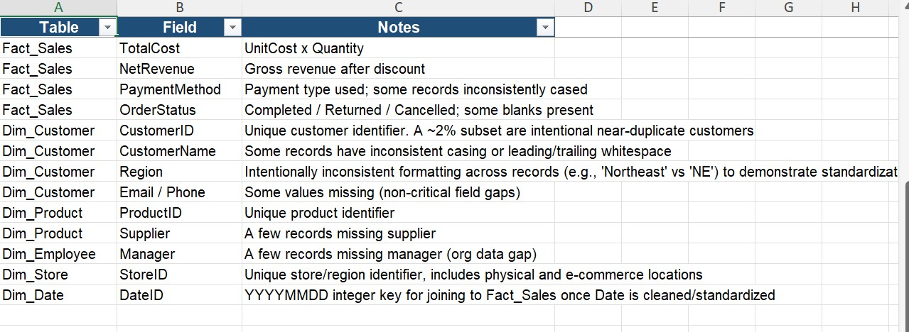
Figure 1. Data dictionary used to document fields and known data-quality issues.
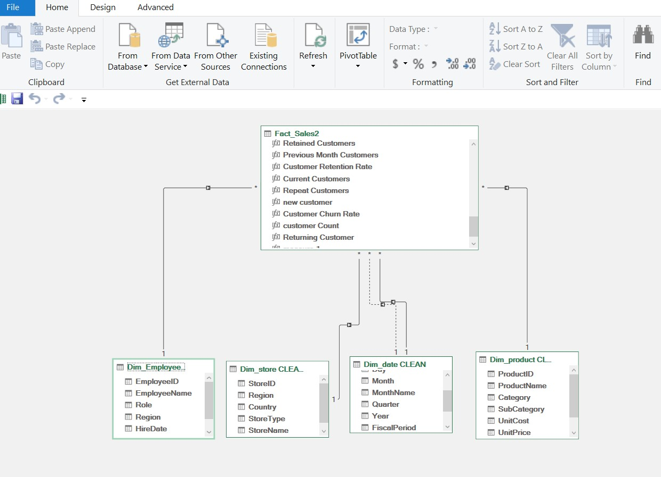
Figure 2. Excel Data Model showing the fact table linked to date, store, product and employee dimensions.
The model follows a star-schema pattern: the fact table sits on the many side of relationships, while dimensions sit on the one side. The date dimension is especially important because retention measures require a continuous calendar and consistent time filtering.

5. Data Cleaning and Transformation
Power Query was used to make the dataset analysis-ready before loading it into the Data Model. Cleaning is essential because inconsistent identifiers, text values, dates or numeric types can break relationships, distort aggregations and produce misleading retention calculations.
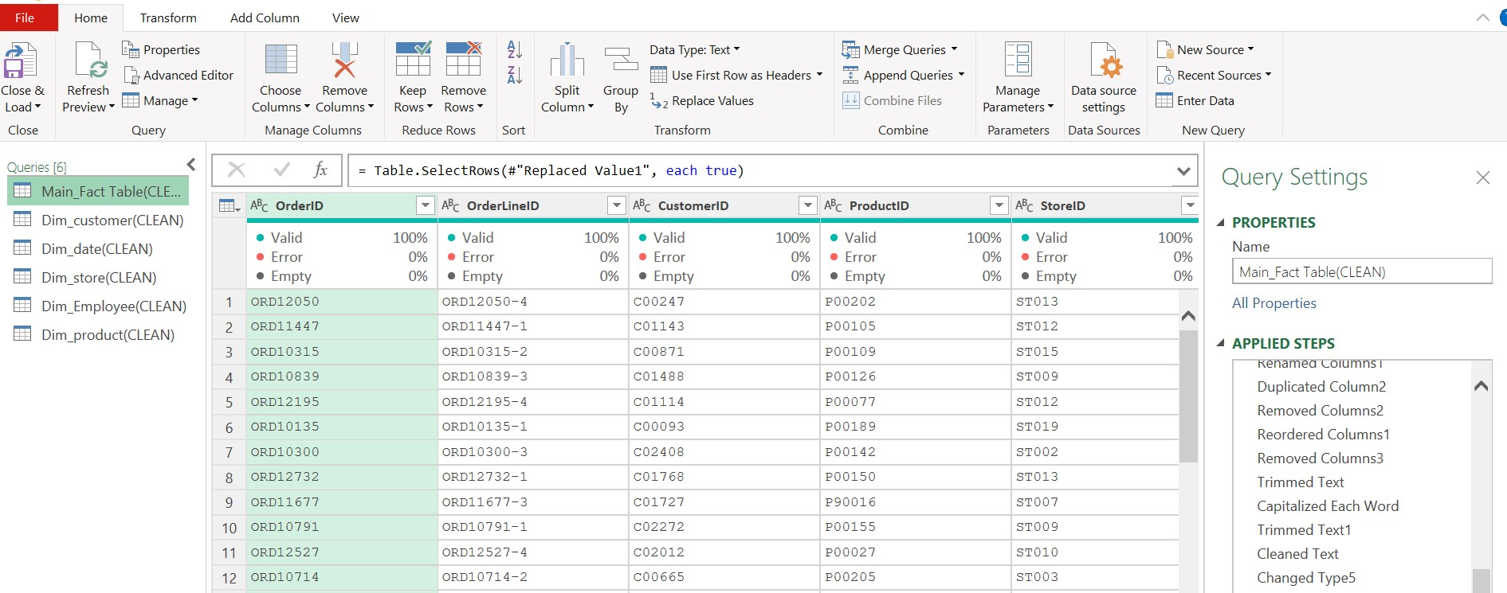
Figure 3. Power Query cleaning workflow for the main fact table.
Cleaning action / function | Why it was used | Analytical risk prevented
Trim / Clean text | Removes leading/trailing spaces and non-printing characters from keys and categories | Prevents visually identical values from being treated as separate categories
Standardise case / Replace Values | Normalises inconsistent region, status and payment labels | Avoids fragmented totals such as Northeast vs NE
Change Type | Ensures Date, Quantity, UnitPrice and Discount fields have correct data types | Prevents text-based sorting, broken calculations and invalid time intelligence
Remove/inspect duplicates | Checks repeated keys and duplicate-like customer records | Reduces double counting and relationship problems
Handle missing values | Replaces or flags non-critical blanks such as contact fields while preserving valid transactions | Prevents unnecessary row loss while keeping quality issues visible
Create Purchase Month | Normalises transactions to month-level periods for retention/repeat analysis | Supports consistent month-to-month comparison
Clean numeric fields | Creates reliable quantity, unit-price and discount fields | Protects revenue/cost calculations from invalid text or inconsistent values
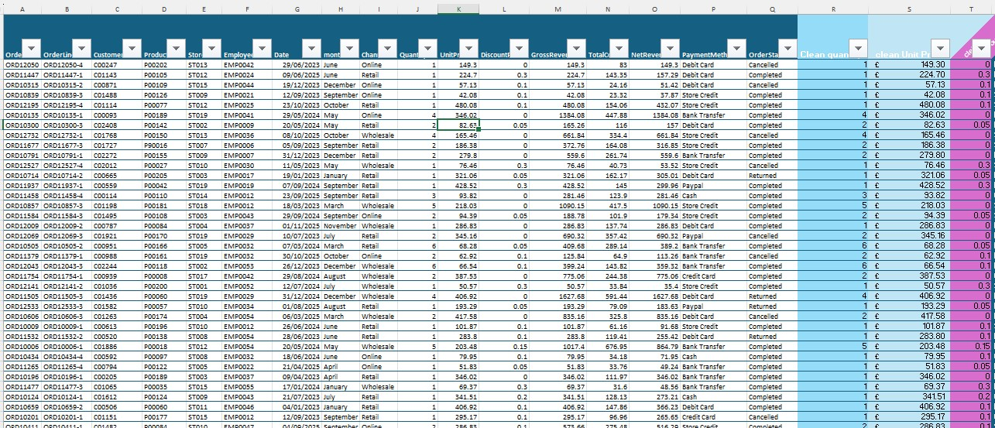
Figure 4. Cleaned fact table with transaction fields and cleaned numeric/status fields.
A key quality-control principle in this project is to preserve valid transaction rows while correcting fields needed for joins and measures. Descriptive blanks such as email or manager are not automatically reasons to remove a sale; by contrast, invalid transaction keys, dates or numeric values require direct correction or exclusion because they affect analytical totals.

6. Data Analysis: KPI Definitions and Findings
The Data Model measures convert transaction rows into business KPIs. Each KPI answers a different question, so the definitions must remain distinct.
KPI | Definition | Business meaning
Total Customers | DISTINCTCOUNT(CustomerID) | Unique customers active in the selected filter context
New Customers | Customers whose first observed purchase falls inside the selected period | Customer acquisition
Returning Customers | Customers active in the selected period whose first purchase occurred earlier | Existing-customer activity
Repeat Customers | Customers with purchases in at least two distinct purchase months | Longer-term repeat behaviour
Previous Month Customers | Unique customers active in the immediately previous month | Retention denominator
Retained Customers | Intersection of current-month and previous-month customer sets | Customers who stayed active month-to-month
Retention Rate | Retained Customers / Previous Month Customers | Immediate monthly continuity
Churn Rate | 1 - Retention Rate | Share of prior-month customers not seen in the next month
Net Revenue | SUM(NetRevenue) | Revenue after discount
Profit Margin | (Net Revenue - Total Cost) / Net Revenue | Profitability using the workbook cost definition

6.1 Sales Performance
Finding | Evidence | Interpretation
Revenue concentration by country | USA: ~$2.76M of $4.54M net revenue | The USA is the dominant market and carries concentration risk/opportunity
Next-largest country markets | Canada: ~$678K; UK: ~$657K | Canada and the UK form a meaningful second tier
Channel order volume | Retail: 2,336 orders; Online: 2,204; Wholesale: 1,056 | Retail leads order count, with Online close behind
Channel net revenue | Retail: ~$2.02M; Online: ~$1.78M; Wholesale: ~$734K | Retail is the largest revenue channel; Wholesale is materially smaller
Order status mix | 5,567 completed; 1,419 returned; 1,361 cancelled; 85 pending sales lines | Returns and cancellations deserve operational investigation

6.2 Customer Behaviour
Year | Active customers | First-time customers | Returning customers
2023 | 1,723 | 1,723 | 0
2024 | 1,689 | 599 | 1,090
2025 | 1,723 | 229 | 1,494
2026* | 26 | 0 | 26
*2026 is only a small partial period in the uploaded sales data and should not be compared directly with complete years.
The customer mix changes substantially from acquisition-led in 2023 to returning-customer-led by 2025. First-time customers fall from 1,723 in 2023 to 599 in 2024 and 229 in 2025, while returning customers rise to 1,494 in 2025. This is positive evidence of an established customer base, but the sharp fall in first-time acquisition should be monitored so future growth does not become overly dependent on existing customers.
Across the full dataset, 2,178 of 2,551 customers (about 85.4%) purchased in at least two distinct months. This is a strong repeat-purchase signal. However, true consecutive-month retention through 2025 is much lower, about 8.4% on a weighted basis, with individual month rates roughly 5.3% to 11.5%. The combination indicates delayed repeat purchasing rather than frequent next-month purchasing.

7. Deeper General Insights
- Customer loyalty is stronger over a longer horizon than a one-month horizon. A customer who skips one or more months can still be a repeat buyer, so monthly churn should not be labelled permanent loss.
- The acquisition mix is weakening: first-time customer counts decline materially after 2023. Retention can support revenue, but sustained growth also needs a healthy flow of new customers.
- Revenue is geographically concentrated. The USA contributes roughly 61% of net revenue, so growth initiatives can either deepen this strong market or deliberately diversify into Canada, the UK, Germany and Spain.
- Retail and Online are the two core commercial channels. Their combined revenue is roughly $3.81M, making channel-specific retention and repeat-purchase analysis particularly valuable.
- The partial 2026 period should be clearly labelled in all year-level visuals to prevent false year-over-year conclusions.

8. Visual and Dashboard Interpretation
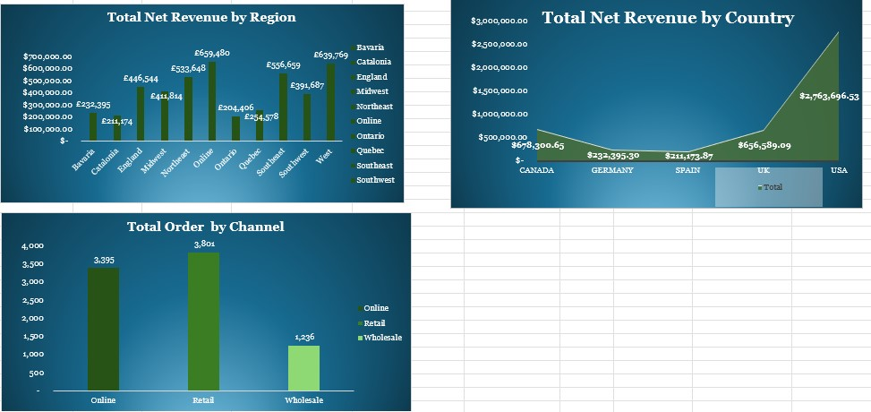
Figure 5. Supporting sales charts: net revenue by region/country and orders by channel.
The regional and country charts show where commercial value is concentrated. Online is the highest individual region-like category in the current store mapping at about $659K, while West and Southeast are the strongest named US regions. At country level, the USA dominates with about $2.76M, followed by Canada and the UK.
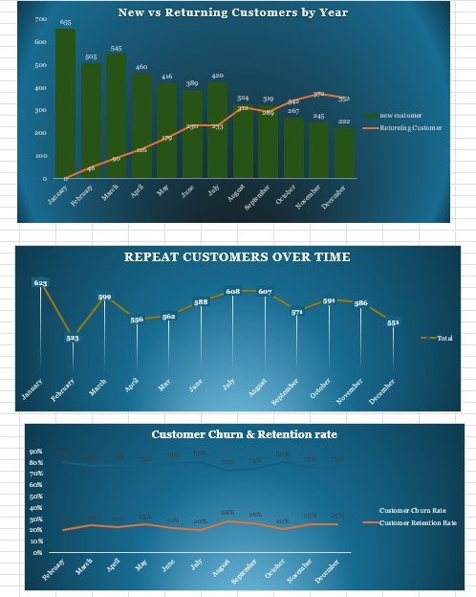
Figure 6. Customer behaviour charts used in the retention analysis.
The New vs Returning chart shows the customer base shifting toward returning customers as the dataset matures. The Repeat Customers chart indicates substantial repeat activity across months. The Retention vs Churn chart is useful conceptually, but it should be plotted using a true Year-Month axis or a Year slicer. Aggregating January across multiple years, February across multiple years, and so on can change the filter context and produce rates that do not represent consecutive calendar-month retention.
Figure 7. Final interactive Sales Customer Retention Analysis dashboard.
The dashboard combines KPI cards, revenue/channel charts, customer acquisition/returning trends, repeat customers, retention/churn, and slicers. This gives decision-makers a single view of commercial performance and customer behaviour. The slicers allow the same measures to be explored by date, product and store type.

8.1 Important Dashboard Validation Note
The current dashboard screenshot displays New Customers = 2,551 and Returning Customer = 0 at the all-period total. This is a filter-context effect, not a meaningful lifetime customer split: when the selected period is the entire dataset, every customer’s first purchase falls inside that period, so all customers can be classified as “new” relative to the full-range context. For portfolio presentation, show New vs Returning by Year/Month or apply a specific Year slicer rather than using those two measures as unfiltered lifetime KPI cards.
Similarly, the displayed 80% churn / 20% retention KPI in the screenshot reflects the current dashboard context and should not be described as the overall consecutive-month retention rate unless the date filter is explicitly defined. The year-month calculation from the underlying transactions produces materially lower immediate retention. This distinction should be stated in the portfolio to demonstrate strong analytical judgement.

9. Recommendations
Priority | Recommendation | Why it matters
1 | Replace all-period New/Returning KPI cards with period-specific cards or a Year/Month selection | Prevents filter-context misinterpretation and makes acquisition/returning metrics decision-ready
2 | Use a Year-Month key on the retention/churn trend and retain a Year slicer | Ensures every point represents a true consecutive calendar month
3 | Add Average Months Between Purchases / repurchase interval bands | Explains why repeat purchasing is high while immediate monthly retention is low
4 | Investigate the decline in first-time customers after 2023 | A mature returning base is valuable, but weak acquisition can constrain future growth
5 | Segment retention by product category, channel, country and loyalty tier | Identifies where retention programmes will have the greatest commercial impact
6 | Analyse returned and cancelled orders by product/store/channel | High return/cancellation activity can damage satisfaction and repeat behaviour
7 | Create cohort retention analysis | Tracks customers from their acquisition month and compares retention on a like-for-like basis
8 | Label 2026 as partial data | Avoids misleading comparisons against full-year 2023-2025 results

10. Conclusion
This project demonstrates an end-to-end Excel analytics workflow: understanding data quality, cleaning and standardising data in Power Query, building a star-schema Data Model, creating DAX customer measures, validating time-based calculations, and communicating findings through an interactive dashboard. The analysis shows a business with a large repeat-customer base and strong returning-customer presence by 2025, but with low immediate month-to-month continuity and declining first-time acquisition. The next analytical step is to measure the normal repurchase interval and cohort retention so that customer loyalty is evaluated over the time horizon that matches actual buying behaviour.

Appendix: Portfolio Talking Points
- Problem: understand customer acquisition, repeat behaviour, retention/churn and sales performance from multi-table transactional data.
- Tools: Excel, Power Query, Power Pivot/Data Model, DAX, PivotTables, PivotCharts and slicers.
- Data modelling: fact table connected to dimensions for date, store, product, employee and customer analysis.
- Quality control: standardised text, corrected data types, cleaned numeric fields, handled blanks and validated relationships.
- Analytical judgement: distinguished repeat customers from retained customers and identified filter-context risks in all-period retention KPIs.
- Business value: translated raw transactions into actionable customer, channel, geography and revenue insights.

