HM REVENUE & CUSTOMS

Spending Analysis — June 2026
Excel • Power Query • Power Pivot • DAX • PivotTables • Dashboard
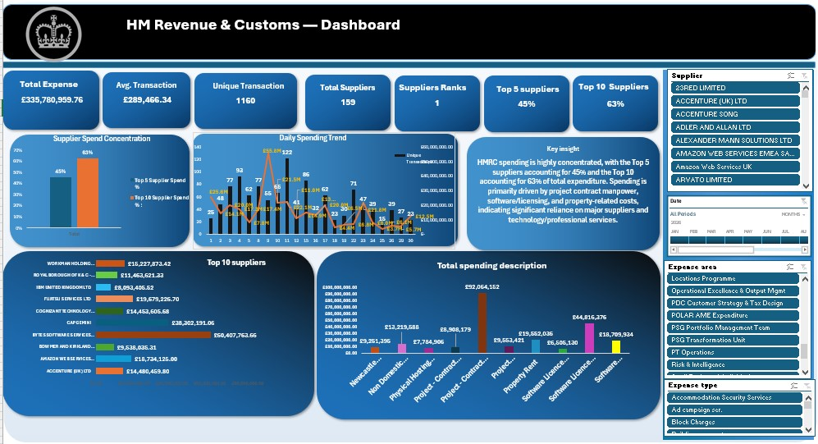
Final interactive HMRC spending dashboard.
PORTFOLIO PROJECT DOCUMENTATION
Purpose: transform transaction-level public spending data into a structured analytical model and decision-focused dashboard.

1. Executive Summary
This project analyses HM Revenue & Customs (HMRC) spending transactions for June 2026 using Excel, Power Query, Power Pivot and DAX. The objective was to transform transaction-level expenditure data into a reliable analytical model, identify the main drivers of spending, assess supplier concentration, examine transaction behaviour over the month, and present the findings through an interactive dashboard.
The analysed data contains 1,397 transaction rows, £335.78 million in total expenditure, 1,160 unique transaction numbers and 159 suppliers. Average expenditure per unique transaction was approximately £289.47K. Supplier spending is concentrated: the top five suppliers account for 45.4% of total expenditure and the top ten account for 62.7%. BYTES Software Services Ltd was the largest supplier at £60.41M, while supplier-controlled project contract mandays were the largest spending description at £92.06M.
The analysis also found that only 56 unique transactions in the £1M+ band generated approximately £174.18M—more than half of total net expenditure—showing that a relatively small number of high-value transactions materially shape the monthly spending profile. Daily expenditure peaked on 9 June at approximately £55.76M.

2. Introduction
Public-sector spending data can contain hundreds of individual payments across suppliers, expense types and organisational areas. A raw transaction table is useful for record keeping, but it does not immediately answer management questions such as who receives the most expenditure, what activities drive cost, whether spending is concentrated among a small group of suppliers, or which dates contain unusual spending spikes.
This project demonstrates an end-to-end Excel analytics workflow: data preparation in Power Query, dimensional modelling in Power Pivot, DAX measures for business metrics, PivotTable analysis, and dashboard visualisation.

3. Business Problem
The central problem was to convert detailed HMRC spending records into a concise view that supports expenditure monitoring and supplier analysis. The analysis was designed to answer the following questions:
- How much was spent during the period, and how many unique transactions and suppliers were involved?
- Which suppliers received the highest total expenditure, and how concentrated is supplier spending?
- Which spending descriptions and expense areas are the largest cost drivers?
- Are total costs driven by many routine transactions or a small number of very high-value payments?
- On which dates did expenditure spike, and how did transaction volume compare with spend?
- Which areas should be investigated further for procurement concentration, high-value payments or unusual credits?

4. Data Overview
Field | Role in analysis
Department family / Entity | Organisational context
Date | Daily trend and time filtering
Expense type | Classification of expenditure
Expense area | Business-area analysis
Supplier | Supplier concentration and ranking
Transaction number | Unique transaction counting
Amount | Core financial measure
Description | Detailed spending-purpose analysis
Supplier Postcode | Supplier reference/location attribute
After preparation, the fact dataset used for analysis contained 1,397 rows with no missing values across the ten analysed fields. The period represented is June 2026.
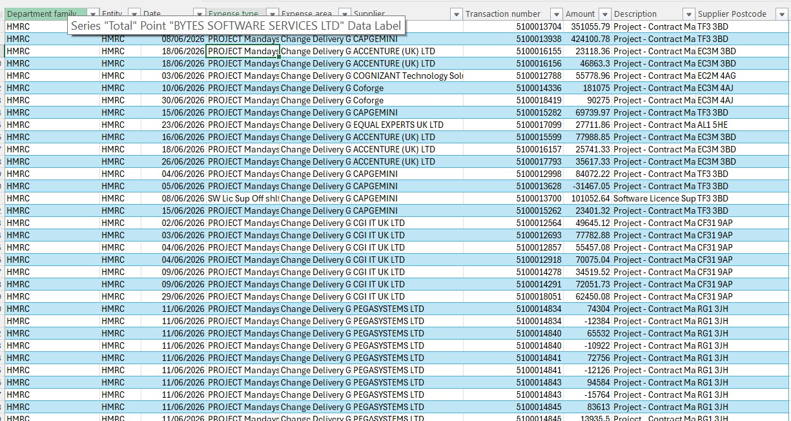
Transaction-level fact table used as the analytical base.

5. Data Cleaning and Transformation
The data was prepared in Power Query before analysis. Cleaning was necessary to ensure that text categories matched consistently, relationship keys were reliable, and calculations were based on correctly typed fields.
Step / function | What was done | Why it mattered
Promote Headers | Used the first row as column headers. | Creates meaningful field names for analysis.
Changed Type | Date was set as Date, Amount as numeric, and categorical fields as Text. | Prevents incorrect aggregation and enables date intelligence.
Trim | Removed leading and trailing spaces from text fields. | Avoids visually identical categories being treated as different values.
Clean | Removed non-printing characters. | Improves matching and category consistency.
Filter blanks/nulls | Excluded invalid blank dimension keys where applicable. | Prevents unusable members in relationships and slicers.
Remove Duplicates — dimensions | Kept one unique key per dimension. | Required for the one-side of one-to-many relationships.
UPPERCASE — Expense Type | Standardised case before deduplication. | Resolved case variants that Power Pivot treated as duplicate relationship keys.
Reference queries | Created Supplier, Expense Type, Expense Area and Date dimensions from the prepared data. | Supports a reusable star-schema model without altering the fact transactions.
Duplicates were not removed column-by-column from the fact table because repeated suppliers, dates and expense types are expected in transactional data. Removing them would incorrectly delete legitimate spending records. Duplicate removal was instead applied to dimension keys so that each lookup value appeared once.

Data model
A star schema was created with the spending table at the centre and four lookup dimensions. Each dimension is on the “1” side and the fact table is on the “many” side. This design allows slicers from the dimensions to filter financial measures consistently.
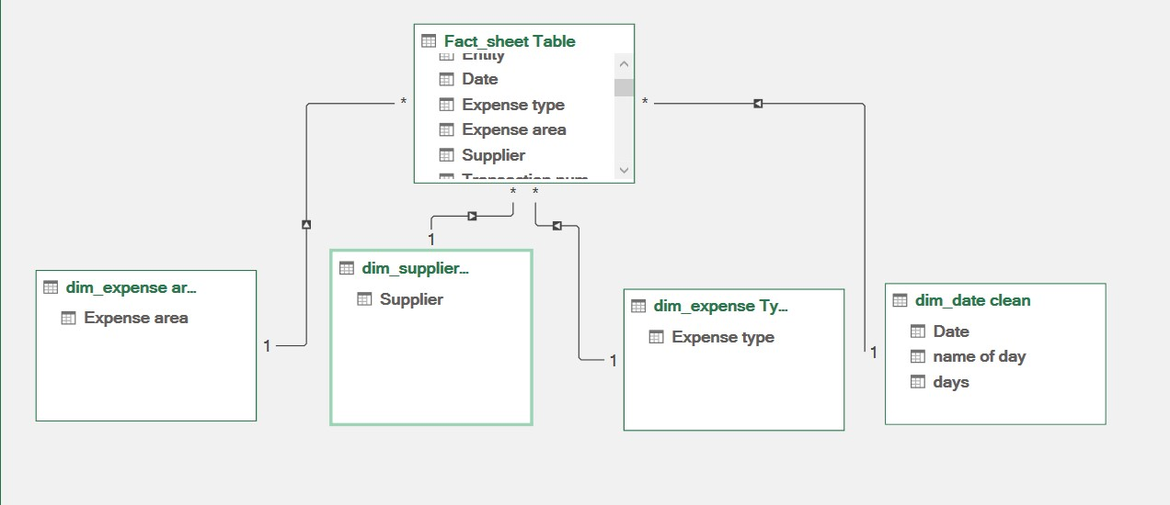
Power Pivot star schema: Date, Supplier, Expense Type and Expense Area dimensions connected to the fact table.

6. Data Analysis and KPI Framework
DAX measures were created in Power Pivot so that KPIs respond dynamically to filters and slicers. The core measures and their interpretation are shown below.
KPI | Result | Meaning
Total Expense | £335,780,959.76 | Net expenditure represented by the dataset.
Average Transaction | £289,466.34 | Total spend divided by 1,160 unique transaction numbers.
Unique Transactions | 1,160 | Distinct transaction numbers in the period.
Total Suppliers | 159 | Distinct suppliers represented in the fact data.
Top 5 Supplier Share | 45.4% | Share of total expenditure accounted for by the five largest suppliers.
Top 10 Supplier Share | 62.7% | Share accounted for by the ten largest suppliers.
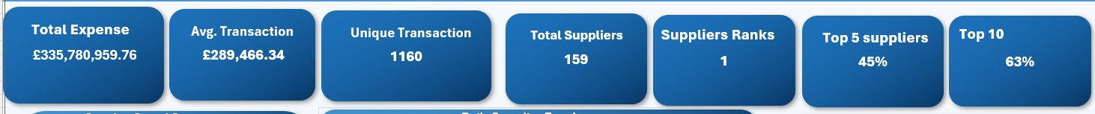
Executive KPI cards used on the dashboard.

Core DAX logic
- Total Expense := SUM(Fact_Spending[Amount])
- Unique Transactions := DISTINCTCOUNT(Fact_Spending[Transaction number])
- Total Suppliers := DISTINCTCOUNT(Fact_Spending[Supplier])
- Average Transaction Value := DIVIDE([Total Expense], [Unique Transactions], 0)
- Supplier Rank := RANKX(ALL(Dim_Supplier[Supplier]), [Total Expense], , DESC, DENSE)
Note: the displayed “Suppliers Ranks = 1” KPI is best interpreted only when a supplier is selected. For an executive overview, replacing this card with Largest Transaction (£39.04M) or Median Transaction (£63.88K) would communicate more information at a glance.

7. Analysis and Findings

7.1 Supplier concentration
BYTES Software Services Ltd was the largest supplier at £60.41M, followed by Capgemini at £38.30M and Fujitsu Services Ltd at £19.68M. The top five suppliers collectively represented 45.4% of total expenditure, while the top ten represented 62.7%. This indicates that expenditure is materially concentrated among a relatively small group of suppliers.
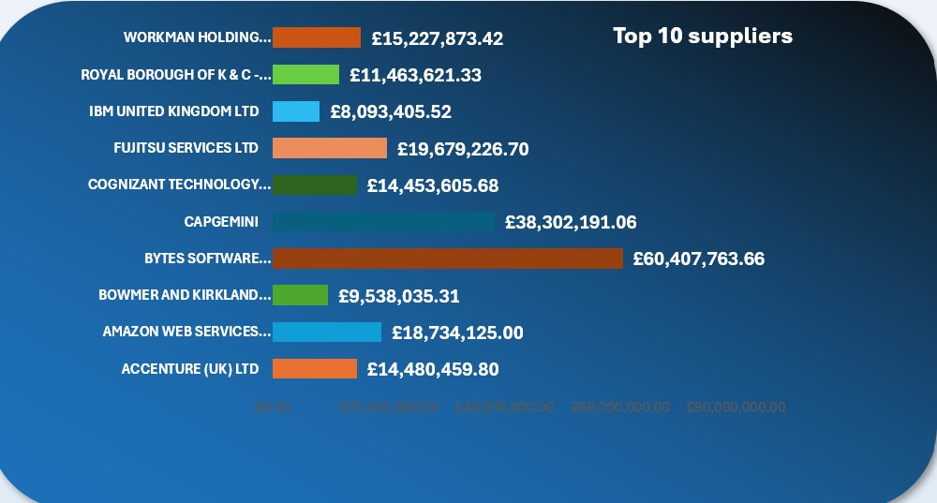
Top 10 suppliers by total expenditure.

7.2 Spending purpose
The largest spending description was Project – Contract Mandays (supplier controlled) at £92.06M, equivalent to about 27.4% of total expenditure. Software Licence Support – off the shelf contributed £44.82M, Property Rent £19.55M, and off-the-shelf software licences £18.71M. Together, the pattern shows that contracted project resources, technology/software and property-related costs are major expenditure drivers.
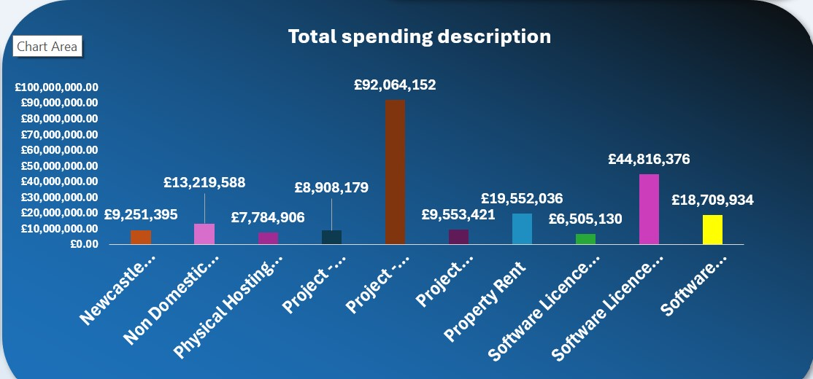
Leading spending descriptions and their total expenditure.

7.3 Expense-area concentration
CDIO – Core was the dominant expense area at approximately £161.50M, representing about 48.1% of total net expenditure. Estates followed at £33.17M and Change Delivery Group at £23.06M. The scale of CDIO – Core suggests that digital/technology-related expenditure deserves particular attention in any deeper cost-driver or supplier-dependency review.

7.4 Transaction-value bands
Transaction band | Unique transactions | Net spend
Credit / Zero | 22 | -£1.04M
£0–£50K | 468 | £14.42M
£50K–£100K | 304 | £22.02M
£100K–£500K | 370 | £79.64M
£500K–£1M | 63 | £46.57M
£1M+ | 56 | £174.18M
The strongest distribution finding is the £1M+ band: only 56 unique transactions generated approximately £174.18M, or about 51.9% of total net expenditure. In contrast, the 468 unique transactions below £50K contributed only about £14.42M. This shows that monthly expenditure is driven disproportionately by a small number of very high-value transactions.

7.5 Daily spending behaviour
Daily expenditure was volatile. The highest-spending date was 9 June, at approximately £55.76M from 55 unique transactions. By contrast, 11 June recorded the highest transaction count among the displayed dates—122 unique transactions—but approximately £22.10M in spend. This difference shows that transaction volume and expenditure value do not move together: a day with fewer transactions can have much higher spending because of large individual payments.
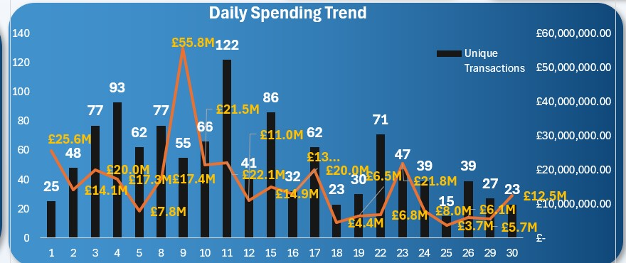
Daily spending trend with unique transaction volume.

7.6 Credits and negative transactions
The dataset contains 23 rows with zero-or-negative amounts, representing 22 unique transaction numbers and approximately -£1.04M net value. These records should not automatically be classified as errors; they may represent credits, reversals or adjustments. They should be reviewed using transaction descriptions and source documentation before drawing a conclusion.

8. Dashboard Interpretation
The final dashboard combines executive KPIs with supplier concentration, daily spending, top suppliers, spending descriptions and interactive slicers. It is designed so that a user can begin with the overall financial position and then narrow the analysis by supplier, date, expense area and expense type.
Final dashboard combining KPIs, supplier concentration, trend analysis, ranked suppliers and spending descriptions.
The dashboard tells a coherent story: total expenditure is £335.78M; supplier concentration is significant; BYTES and other technology suppliers occupy prominent positions among the largest suppliers; supplier-controlled project mandays are the largest spending purpose; and daily spending contains clear spikes. The slicers allow these findings to be tested within specific expense areas, suppliers and expenditure types rather than viewed only at the aggregate level.
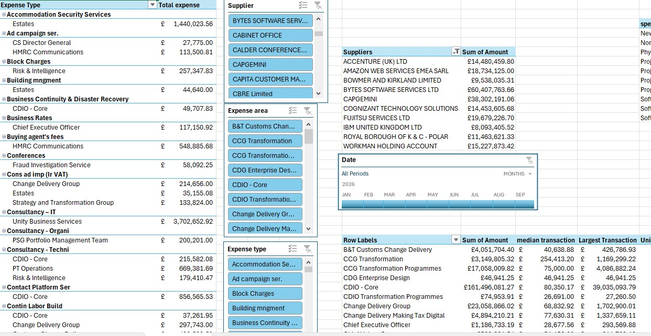
PivotTable analysis and slicers used to explore expense type, supplier and expense-area detail.

9. Deeper General Insights
- High-value concentration is more pronounced at transaction level than transaction counts alone suggest: 56 £1M+ transactions account for more than half of net spend.
- Supplier concentration is substantial: 159 suppliers are represented, yet the top ten receive almost two-thirds of total expenditure.
- Technology and project-delivery costs are central to the spending profile, reflected in leading suppliers, descriptions and the dominance of CDIO – Core.
- Transaction volume is not a reliable proxy for expenditure value. The 9 June spending spike occurred with fewer unique transactions than 11 June, demonstrating the importance of analysing both count and value.
- Negative transactions reduce net expenditure by roughly £1.04M and warrant separate validation rather than automatic deletion.

10. Recommendations
- Review high-value transactions (£1M+) separately. Because they account for more than half of net spend, management review of these transactions will provide greater analytical value than focusing only on transaction volume.
- Monitor supplier concentration. Track Top 5 and Top 10 supplier shares over time and investigate whether high concentration reflects strategic contracts, unavoidable specialisation or opportunities for supplier diversification.
- Prioritise CDIO – Core and technology-related expenditure for deeper cost-driver analysis, including supplier, expense type and contract-purpose drill-downs.
- Investigate major daily spikes by tracing the largest dates back to suppliers, descriptions and transaction numbers; this can distinguish scheduled contractual payments from exceptional events.
- Validate credits and reversals. Maintain negative transactions in the analytical record but reconcile them to supporting descriptions/source records before classifying them.
- Extend the dataset across multiple months. A 12–24 month history would support month-on-month and year-on-year comparisons, rolling averages, seasonality analysis and a more defensible spending forecast.
- Improve the executive KPI row by replacing the standalone Supplier Rank card with Median Transaction or Largest Transaction unless the dashboard is filtered to a specific supplier.

11. Conclusion
This project demonstrates how Excel can be used as a complete analytical environment rather than only a spreadsheet. Power Query established data quality, Power Pivot provided a structured star-schema model, DAX created reusable business measures, and PivotTables and charts converted those measures into decision-focused insights. The main analytical conclusion is that June 2026 HMRC spending is highly concentrated both among major suppliers and among a relatively small number of high-value transactions, with technology, contracted project resources and property-related expenditure forming major cost drivers.

