PUBLIC HEALTH ANALYTICS

Mortality in England: Data Analysis & Insights
MySQL • Data Cleaning • Star Schema • Public Health Trend Analysis

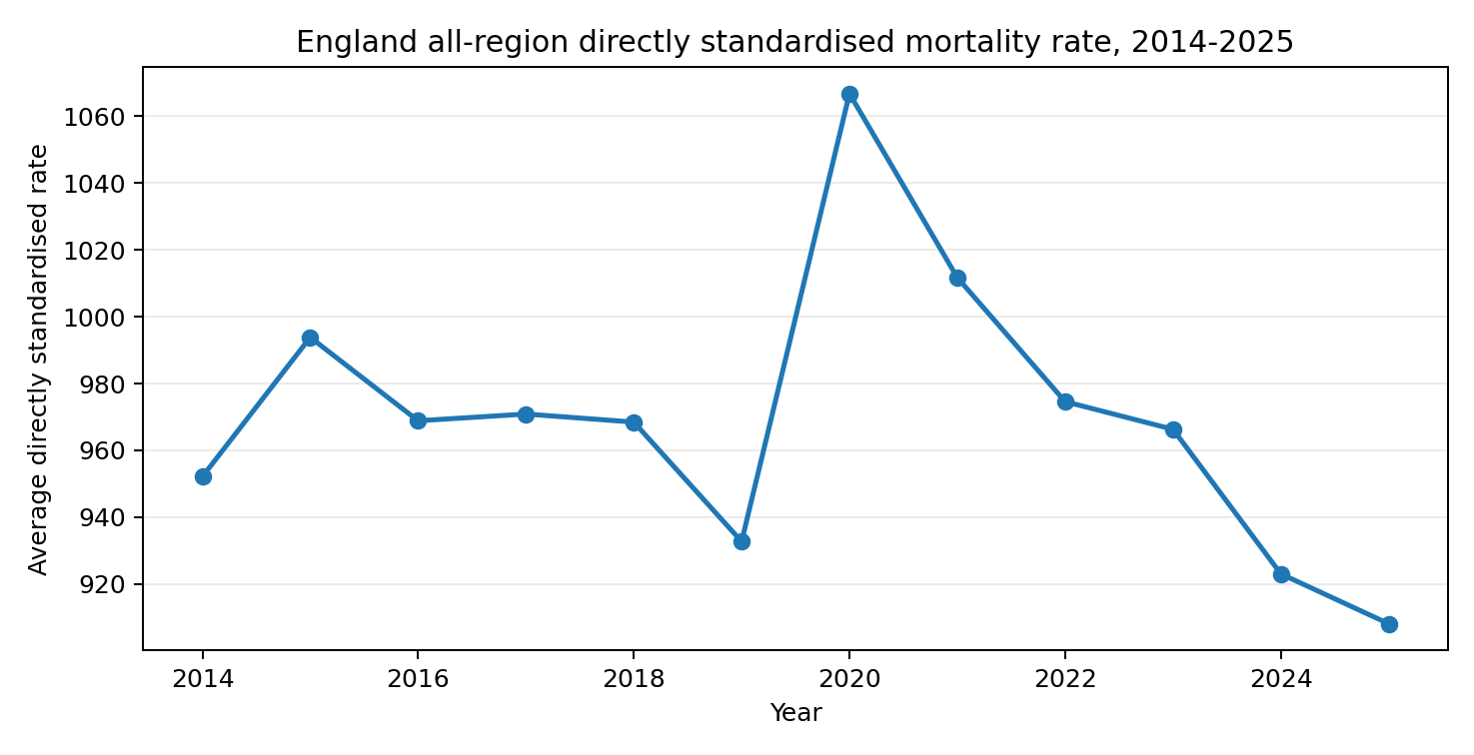
Portfolio project overview: directly standardised mortality-rate trend for England, 2014-2025.
Professional Portfolio Project Documentation

1. Executive Summary
This project analyses mortality patterns in England using monthly public-health records covering January 2014 to April 2026. The analytical model contains 31,080 fact rows and separates time, geography, sex and age group into dimensions. MySQL was used to clean, validate, model and query the data, with a strong focus on registered deaths, directly standardised mortality rates and 95% confidence intervals.
Headline finding | Result | Interpretation
2019 all-region mortality rate | 932.73 | Pre-2020 baseline for Persons, All ages
2020 all-region mortality rate | 1,066.78 | 14.4% higher than 2019
2020 registered deaths | 569,700 | 14.8% higher than 2019
Highest long-run regional rate | North East: 1,100.01 | Highest average among English regions
Largest 2019→2020 regional increase | London: +22.7% | Largest relative regional increase
April 2020 mortality rate | 1,975.3 | About 102% above April 2019
The clearest structural finding is the exceptional rise in mortality during 2020, particularly in April. Mortality then declined from the 2020 peak; by 2025 the all-region rate was about 14.9% below 2020 and 2.6% below 2019, although registered deaths remained above the 2019 total.

2. Introduction
Mortality analysis helps public-health teams identify changes in population health, differences between regions and demographic groups, and periods of abnormal mortality. This project transforms a detailed mortality dataset into a structured analytical database so that trends can be investigated consistently across time, geography, sex and age groups.

3. Problem Being Solved
The project was designed to answer questions such as:
- How has mortality changed over time in England?
- Which regions have persistently higher or lower mortality rates?
- How large was the mortality increase from 2019 to 2020?
- Which demographic age groups experience the highest mortality rates?
- Are there meaningful differences between males and females?
- Which months tend to show higher mortality?
- Did mortality return toward pre-2020 levels after the 2020 spike?

4. Data Overview
The cleaned fact dataset contains 31,080 monthly records. It includes 148 distinct month keys, 10 geographic areas (nine English regions plus All regions), three sex categories and seven age-group categories. The primary measures are Registered Deaths, Directly Standardised Rate, Lower 95% Confidence Interval and Upper 95% Confidence Interval.
Data component | Fields / examples | Purpose
Fact table | registered_deaths, directly_standardised_rate, lower_95_ci, upper_95_ci | Stores measurable mortality outcomes
Date dimension | date_key, date, year, month_number, month_name | Time trend and period comparison
Area dimension | area_key, area_code, area_name | Regional comparison
Sex dimension | sex_key, sex | Male, female and persons analysis
Age-group dimension | age_group_key, age_group | 0-24 through 85+ and All ages

Data model
The database follows a star-schema design: Fact_Mortality sits at the centre and joins to Dim_Date, Dim_Area, Dim_Sex and Dim_Age_Group through surrogate keys. This design reduces repetition and makes analytical queries easier to maintain.
Dim_Date → Fact_Mortality ← Dim_Area
↑
Dim_Sex / Dim_Age_Group

5. Data Cleaning & Preparation
Data cleaning was necessary because mortality-rate values are not always available when registered deaths are below the statistical disclosure threshold. In the source data, these suppressed or non-calculable rates were represented by a note such as “Rate not calculated due to count <10”; in the SQL-ready sentinel version, -999 was used as a temporary marker. These values must not be treated as real mortality rates in averages or trend analysis.
Data types: Converted monthly date fields to a consistent date/date-key format; ensured death counts were numeric integers and mortality-rate/confidence-interval fields were numeric decimals.
Missing/suppressed rates: Converted non-calculable rate values to NULL (or excluded sentinel -999 values) so AVG() would not distort results.
Duplicate and integrity checks: Checked primary identifiers and dimension uniqueness and tested for orphan foreign keys after loading the star schema.
Text standardisation: Standardised region, sex and age-group labels so joins and GROUP BY operations produce one consistent category.
Validation: Tested the complete star-schema join and reviewed distinct values and date coverage before running analytical queries.

SQL functions and techniques used
SQL function / technique | Example use | Why it was used
SUM() | SUM(f.registered_deaths) | Calculates total registered deaths for a period or group.
AVG() | AVG(f.directly_standardised_rate) | Measures the average mortality rate across months or categories.
ROUND() | ROUND(AVG(...), 2) | Produces presentation-ready rates and percentages.
COUNT() / DISTINCT | COUNT(DISTINCT d.year) | Validates row coverage and counts unique periods/categories.
INNER JOIN | Fact table joined to date, area, sex and age dimensions | Combines measures with descriptive categories.
LEFT JOIN | Current-year vs previous-year comparison | Keeps the current period while matching prior-period values.
GROUP BY | GROUP BY year / area_name / age_group | Aggregates mortality metrics at the required analytical grain.
ORDER BY | ORDER BY avg_mortality_rate DESC | Ranks high/low mortality areas and trends.
NULLIF() | Protects percentage calculations from zero denominators | Prevents divide-by-zero errors.
CTE / derived tables | Year-on-year and 2019-vs-2020 comparisons | Makes multi-stage analytical logic easier to read and audit.

6. Data Analysis & Findings

6.1 Overall mortality trend
Figure 1. Annual average directly standardised mortality rate for Persons, All ages, All regions.
The all-region mortality rate fell from 993.84 in 2015 to 932.73 in 2019, before increasing sharply to 1,066.78 in 2020. This was a 14.4% rise in the average directly standardised rate. Registered deaths increased from 496,370 in 2019 to 569,700 in 2020, a 14.8% increase.

6.2 Regional inequality
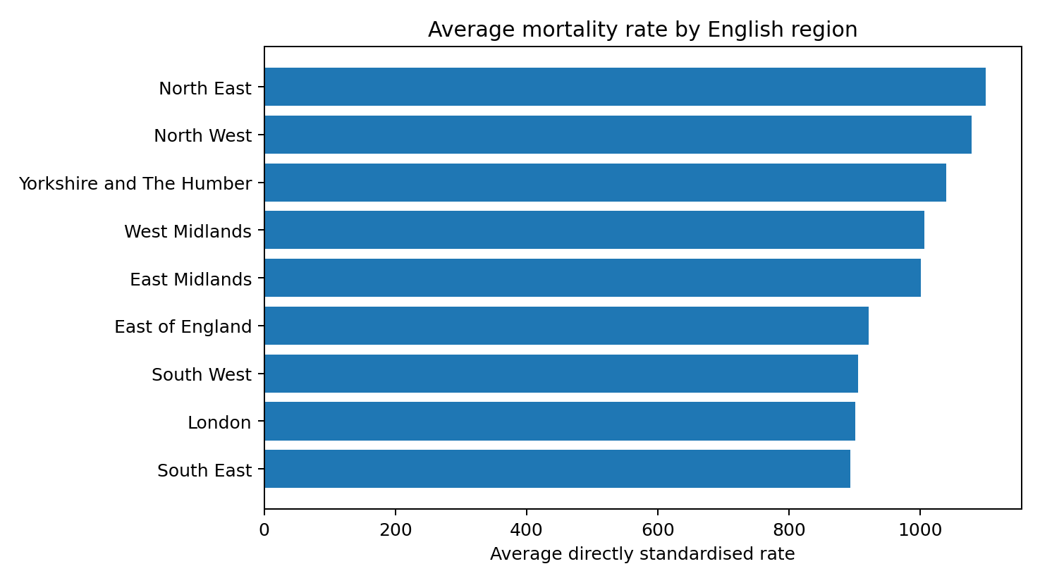
Figure 2. Long-run average directly standardised mortality rate by region.
Region | Average mortality rate
North East | 1,100.01
North West | 1,078.72
Yorkshire and The Humber | 1,040.41
West Midlands | 1,006.11
East Midlands | 1,001.55
East of England | 921.30
South West | 905.44
London | 900.74
South East | 893.39
North East has the highest long-run average mortality rate (1,100.01), followed by North West (1,078.72) and Yorkshire and The Humber (1,040.41). South East has the lowest average (893.39). This reveals a persistent geographic mortality gradient across England.

6.3 2019 to 2020 regional change
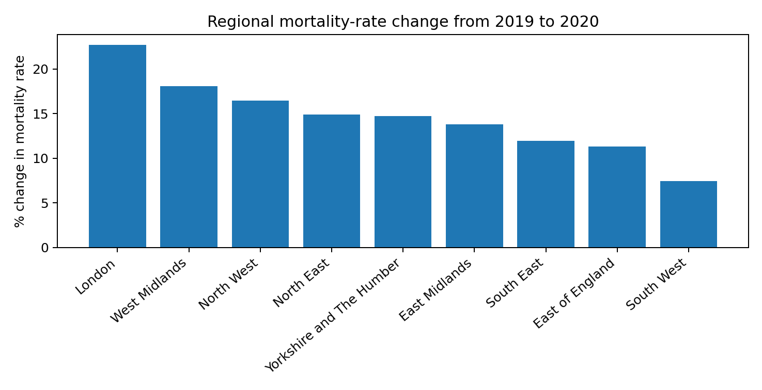
Figure 3. Percentage change in regional mortality rate from 2019 to 2020.
Every English region recorded a higher average mortality rate in 2020 than in 2019. London experienced the largest relative increase at 22.7%, followed by West Midlands at 18.1% and North West at 16.5%. South West recorded the smallest increase at 7.4%.

6.4 Age and sex differences
Age group | Average rate | Registered deaths
85+ | 15,428.28 | 2,549,920
75-84 | 4,264.20 | 1,851,004
65-74 | 1,532.22 | 1,026,511
50-64 | 511.23 | 669,680
25-49 | 112.25 | 251,787
0-24 | 31.33 | 65,477
Mortality risk rises steeply with age. The 85+ group has by far the highest average rate (15,428.28), followed by ages 75-84 (4,264.20). The age gradient is therefore one of the strongest patterns in the data.
Sex | Average rate | Registered deaths
Males | 1,137.57 | 3,210,389
Persons | 969.67 | 6,414,379
Females | 834.49 | 3,203,990
For all ages and all regions, males have a higher average mortality rate (1,137.57) than females (834.49). This indicates a substantial sex difference in mortality risk over the study period.

7. Deeper General Insights

April 2020 was an exceptional mortality shock
April 2019 recorded 41,167 deaths with a directly standardised rate of 979.4. April 2020 recorded 83,494 deaths and a rate of 1,975.3. That represents approximately a 102.8% increase in deaths and a 101.7% increase in the mortality rate compared with the same month one year earlier.

Mortality declined after 2020
By 2025, the all-region mortality rate had fallen to 908.13, approximately 14.9% below 2020 and 2.6% below 2019. However, 2025 registered deaths (534,007) were still about 7.6% above 2019, showing why both counts and standardised rates should be analysed together rather than relying on one measure.

Seasonality is visible
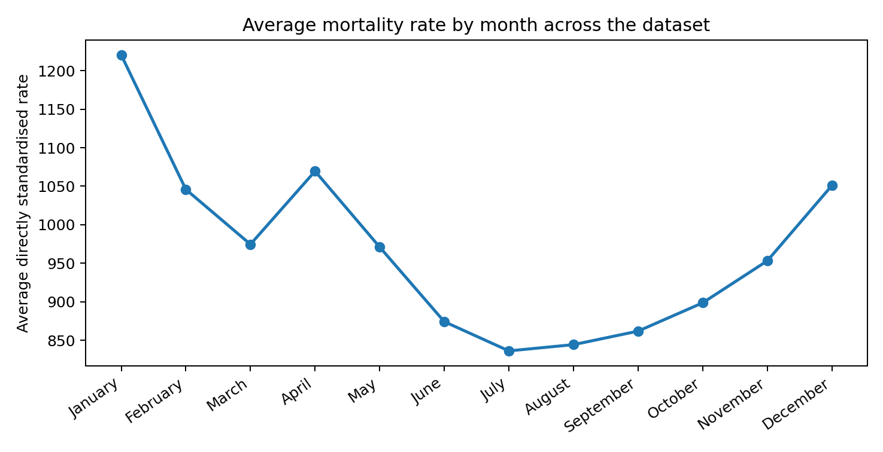
Figure 4. Average monthly mortality rate across the full dataset.
January has the highest average mortality rate across the full period (1,220.44), while July and August are among the lowest. The general winter-high / summer-low pattern suggests clear seasonality in mortality, with April also elevated because of the exceptional 2020 spike.

Confidence intervals matter
The lower and upper 95% confidence intervals provide an indication of statistical uncertainty around each directly standardised rate. Wider intervals are especially important when counts are low. A professional interpretation should therefore avoid treating small differences between rates as meaningful without considering the confidence intervals.

8. Dashboard / Visual Story
For a Power BI or Excel dashboard, the analysis should be presented as a decision-oriented story rather than a collection of charts. A strong layout would contain KPI cards for Total Registered Deaths, Average Mortality Rate, 2020 vs 2019 Change, Highest-Rate Region and Male/Female Rate Gap; a yearly line chart; a regional bar chart; an age-group bar chart; a sex comparison; a monthly seasonality chart; and slicers for Year, Region, Sex and Age Group.
Recommended visual | Question answered
Yearly mortality-rate line chart | How has mortality changed over time?
Regional horizontal bar chart | Which regions have the highest and lowest rates?
Age-group bar chart | Which age groups face the greatest mortality burden?
Male vs Female comparison | How does mortality differ by sex?
Monthly line/column chart | Is there a seasonal pattern?
2019 vs 2020 change chart | Where was the 2020 increase largest?
When your final healthcare dashboard screenshots are available, they can be inserted into this section with figure-by-figure commentary in exactly the same style as the HMRC and restaurant portfolio reports.

9. Recommendations
Prioritise high-mortality regions: Use regional rate comparisons to identify areas such as North East and North West that may require deeper investigation into demographic, socioeconomic and health-service factors.
Monitor older age groups: Because mortality rates rise sharply in ages 75-84 and 85+, age-specific monitoring should remain central to public-health planning.
Investigate sex differences: The higher male mortality rate warrants deeper analysis by age group, region and time period to identify where the gap is largest.
Use standardised rates with counts: Registered deaths show burden, while directly standardised rates improve comparability. Both should be displayed together.
Flag suppressed rates correctly: Never average sentinel -999 values or interpret low-count suppressed rates as zeros. Maintain NULL handling and explanatory notes.
Build confidence-interval visuals: Where possible, add error bars or confidence-band context so users can judge uncertainty in mortality-rate comparisons.
Separate partial-year data: 2026 currently covers only January-April, so it should not be compared directly with complete prior years without a year-to-date comparison.
Extend analysis: Add deprivation, cause-of-death, population denominators or local-authority detail if available to explain the drivers behind regional mortality inequalities.

10. Conclusion
This project demonstrates a complete SQL-based public-health analytics workflow: raw mortality data was cleaned, transformed into a star schema, validated for integrity and queried using aggregation, joins, year-on-year comparisons and demographic segmentation. The analysis identifies a major mortality shock in 2020, persistent regional inequalities, a strong age gradient, higher male mortality rates and clear seasonal patterns. These findings show how structured data analysis can turn public-health records into evidence that supports monitoring, prioritisation and further investigation.

Appendix: Portfolio Talking Points
Tools and techniques: MySQL • SQL data cleaning • star schema • fact/dimension modelling • SUM • AVG • ROUND • COUNT • DISTINCT • INNER JOIN • LEFT JOIN • GROUP BY • ORDER BY • NULL handling • derived tables/CTEs • year-on-year analysis • confidence intervals • public-health dashboard design.
Portfolio summary: Built a mortality analytics database for England from 31,080 monthly records, modelled the data using a star schema, cleaned suppressed rate values, and used SQL to analyse long-term trends, regional inequalities, age/sex differences, seasonality and the 2020 mortality shock. Translated the results into dashboard-ready insights and public-health recommendations.

