Video Compression – HW3 (05/18/2021)

Instructions – Follow these carefully:

1. Please upload your work to Moodle. In the zip file, it must have the source code and a PDF report where you explain and display the outputs for each problem.
2. You can use either C, Python, or Matlab to do the homework work.
3. Please feel free to read related materials available in the official Matlab/Python documentation.
4. It is due by 6/1, 11:59pm.

In this assignment, we will use the block-based encoding approach, where the size of a block is 8x8. Only the Luma component is considered for the following questions.

1. (50%) Fourier Transform

Please apply Fourier Transform to the luma component of “foreman_qcif_0_rgb.bmp” and demonstrate its magnitudes in a 2-D image as the example below. Note that you need to shift the origin to the center of the image for the magnitude plot.

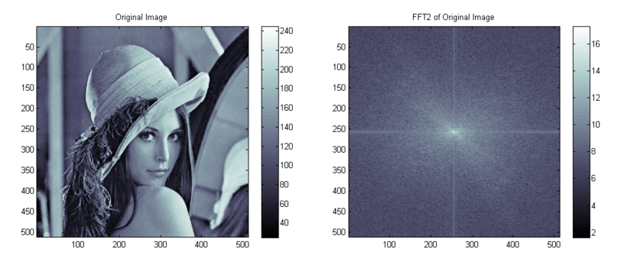

1. (50%) DCT

Please apply DCT to all the 8x8 luma blocks of “foreman_qcif_0_rgb.bmp” and print the DCT coefficients out in each 8x8 block in the Zig-Zag scanning order as below. So, you will be showing an 8x8 block in a 1-D form.

You can also check the reference here:

<https://users.cs.cf.ac.uk/Dave.Marshall/Multimedia/node238.html>

|  |  |  |  |  |  |  |  |
| --- | --- | --- | --- | --- | --- | --- | --- |
| 0 | 1 | 5 | 6 | 14 | 15 | 27 | 28 |
| 2 | 4 | 7 | 13 | 16 | 26 | 29 | 42 |
| 3 | 8 | 12 | 17 | 25 | 30 | 41 | 43 |
| 9 | 11 | 18 | 24 | 31 | 40 | 44 | 53 |
| 10 | 19 | 23 | 32 | 39 | 45 | 52 | 54 |
| 20 | 22 | 33 | 38 | 46 | 51 | 55 | 60 |
| 21 | 34 | 37 | 47 | 50 | 56 | 59 | 61 |
| 35 | 36 | 48 | 49 | 57 | 58 | 62 | 63 |