CSE 676 assignment1 question 4:

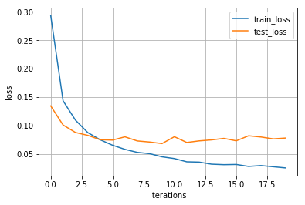

Figure 1: Train loss and test loss vs iteration

How to run the code?

1. Use jupyter notebook, environment need ***tensorflow, matplotlib***
2. Press the menu ***cell/run all***
3. If there is no MNIST data, the code will download MNIST dataset by Internet