1

(1). Prove: P(A,B|K) = P(A|B,K)P(B|K).

RHS = P(A,B,K) / P(B,K) * P(B|K)

= P(A,B,K) / [ P(B|K)*P(K) ] * P(B|K)

= P(A,B,K)/P(K)

= P(A,B|K)

= LHS

(2). Prove: P(A|B,K) = P(B|A,K)*P(A|K)/P(B|K)

LHS = P(A,B,K) / P(B,K)

= P(A,B,K) / [ P(B|K)*P(K) ]

= P(A,B|K) / P(B|K)

= P(B,A|K) / P(B|K)

= P(B|A,K)*P(A|K) / P(B|K) (based on the conslusion from (1) )

= RHS

2.

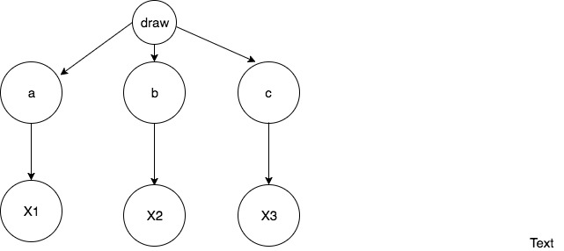

There are two CPT tables:

|  |  |
| --- | --- |
| Coin | Pr(Coin) |
| a | 1/3 |
| b | 1/3 |
| c | 1/3 |

|  |  |  |
| --- | --- | --- |
| Coin | Outcome Xi | Pr(Xi|coin) |
| a | X1(heads) | 0.2 |
| b | X2(heads) | 0.6 |
| c | X3(heads) | 0.8 |

3.

|  |  |  |  |  |
| --- | --- | --- | --- | --- |
| W | Black | Square | One | P |
| 1 | T | T | T | 2/13 |
| 2 | T | T | F | 4/13 |
| 3 | T | F | T | 1/13 |
| 4 | T | F | F | 2/13 |
| 5 | F | T | T | 1/13 |
| 6 | F | T | F | 1/13 |
| 7 | F | F | T | 1/13 |
| 8 | F | F | F | 1/13 |

P(α1) = 2/13 + 4/13 + 1/13 + 2/13 = 9/13 (worlds 1, 2, 3 ,4)

P(α2) = 2/13 + 4/13 + 1/13+ 1/13 = 8/13 (worlds 1,2,5,6)

P(α3) = (2/13 + 4/13 + 1/13) / (1-1/13-1/13) = 7/11 (worlds 1,2,5)

Set1:

α: One

β: Square

γ: Black

Set2:

α: One

β: Square

γ: Not black

4(a). The assumptions are listed below:

I (A, NULL, BE)

I (B, NULL, AC)

I (C, A, BDE)

I (D, AB, CE)

I (E, B, ACDFG)

I (F, CD, ABE)

I (G, F, ABCDEH)

I (H, FE, ABCDG)

(b).

d_separated (A, BH, E):

False, in the path ACFHE, FHE is a converged value but H⊆BH, this path is not blocked.

d_seperated (G, D, E):

False, the path GFHE is not blocked.

d_seperated (AB, F, GH)

False, the path ADBEH is not blocked.

(c).

P (a, b, c, d, e, f, g, h) = P(a|b,c,d,e,f,g,h)*P(b|c,d,e,f,g,h)*P(c|d,e,f,g,h)*P(d|e,f,g,h)*P(e|f,g,h)*

P(f|g,h)*P(g|h)*P(h)

(d).

A and B are independent, so

P (A=0, B=0) = P(A=0) * P(B=0)

= 0.8*0.3

= 0.24

Since A and E are independent,

P(E=1 | A=1) = P(E=1)

= P(E=1, B =1) + P(E=1, B=0)

= P(E=1| B=1) * P(B=1) + P(E=1| B=0) * P(B=0)

= 0.1*0.7 + 0.9*0.3

= 0.34