September 19-29, 2025, SUSTech, Shenzhen, China
Biomedical Engineering Laboratory I (Fall 2025)

Lab 1 introduction to microscopy

姚子墨  12312221 | Author Name  Affiliation  City, State, Country

Author Name  Affiliation  City, State, Country | Author Name  Affiliation  City, State, Country | Author name  Affiliation  City, State, Country

Abstract
INTRODUCTION
MATERIALS AND METHODS

Results
For the procedure 4, the flow velocities of microbeads at three distinct positions (P1, P2, P3) within the microfluidic network were successfully quantified. The raw tracking data revealed a clear trend of decreasing velocity from position P1 to P3. We obtained the speed of each bean by performing linear fitting on the measured X values.

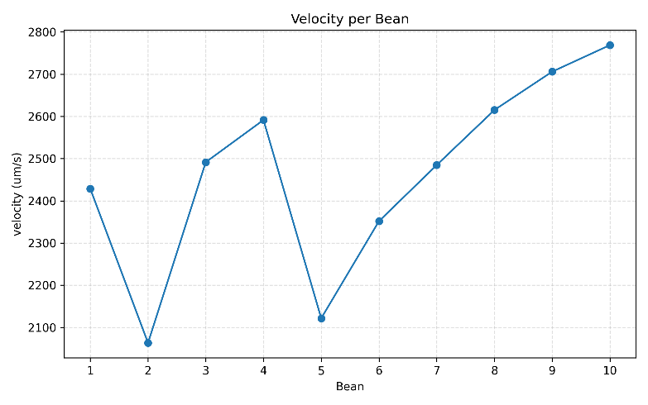
Position P1 exhibited the highest mean velocity (2462.22 ± 231.65 µm/s), followed by P2 (1952.31 ± 210.53 µm/s), and finally P3 with the lowest mean velocity (1488.73 ± 145.35 µm/s). The distribution of individual bead velocities at each position is visually represented in Figure 1 (Plot of bead velocities at positions P1, P2 and P3), which illustrates the systematic downward shift in the data distributions. (Only P1 is presented here. The rest is in appendix)
Figure 1.1. Plot of Bead Velocities in Position P1
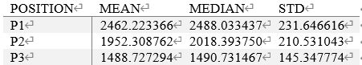
The mean, median, and standard deviation for each of the 3 sets of measurements is shown in Table 1.
Table 1. Mean, Median, and Standard Deviation of Velocities
The cumulative probability distributions of bead velocities, plotted in Figure 2 (Cumulative probability distributions of bead velocities), show the distinct separation and rightward shift of the curves from P3 to P1, indicating a progressive increase in velocity. (Only P1 is presented here. The rest is in appendix)
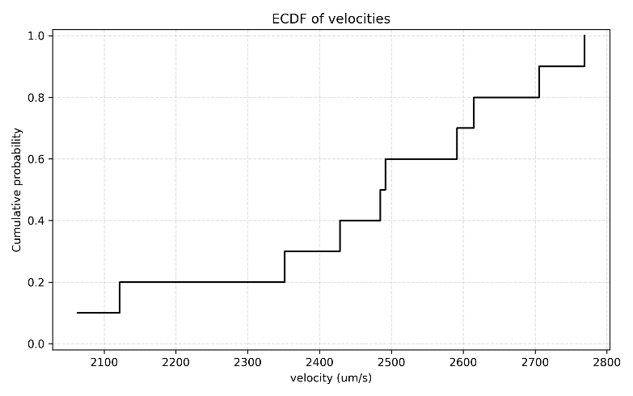
Figure 2.1. Cumulative Probability Distributions of Bean Velocity in Position P1

A one-way analysis of variance (ANOVA) was conducted to determine if the observed differences in mean velocity across the three positions were statistically significant. The results indicated a highly significant effect of channel position on bead velocity, F = 85.23, *p* < .001. This confirms that the differences in flow velocity between the positions are far greater than that would be expected by random chance alone. (Relevant Coding shown in Appendix)

To show the specific differences between each pair of positions, a Tukey HSD post-hoc test was performed. The post-hoc analysis revealed that all pairwise comparisons were statistically significant (all *p* < 0.001), with a mean difference of -509.91 µm/s between P1 and P2, -973.50 µm/s between P1 and P3, and -463.58 µm/s between P2 and P3. (Relevant Coding shown in Appendix)

discussion
In procedure 4, the main finding is a clear and statistically significant velocity gradient in the microfluidic network: P1 > P2 > P3. This matches the theory of pressure-driven flow. Using the fluid version of Ohm's law, ΔP = Q × R, a constant flow rate (Q) means the pressure drop (ΔP) depends on the channel's flow resistance (R). Resistance for a rectangular channel is R = 12μL/(wh³), so it is very sensitive to channel dimensions. The measured velocity differences strongly suggest that P1, P2, and P3 had different geometries, creating different resistances. Since velocity v = Q/A, a channel with higher resistance will have a slower flow, which is exactly what we observed.
Statistically, the very low p-values (p < 0.001) from ANOVA and Tukey HSD tests give high confidence that these velocity differences are real and not random. The cumulative distribution plots (Figure 2) show that the entire velocity profile shifts between positions, confirming it's a systematic change for all beads, not just in the average value. This is consistent with laminar flow behavior.
In terms of modeling blood vessels, real microvasculature has vessels of different sizes, creating complex flow resistance. Our simple microfluidic network successfully mimics how vessel geometry affects flow speed, proving its usefulness for studying basic hemodynamics.
However, there are limitations. Our model is a simple 2D series network, while real blood vessel networks are complex 3D structures with many parallel connections. Using rigid PDMS channels and water also doesn't fully mimic the properties of real blood or flexible blood cells. Small imperfections in the channels could also affect the flow.
Acknowledgments
I would like to express my sincere gratitude to the members of the research team who contributed to the successful completion of this study. Their dedication, expertise, and commitment were instrumental in the realization of our research objectives. I am thankful for their valuable insights, collaborative spirit, and unwavering support throughout the project.
References
- Weibel D. B., DiLuzo W.R. and Whitesides G.M., Microfabrication meets microbiology, Nat. Rev. Microbiol., 2007, 5(3): 208-218.
- Textbook
Appendix

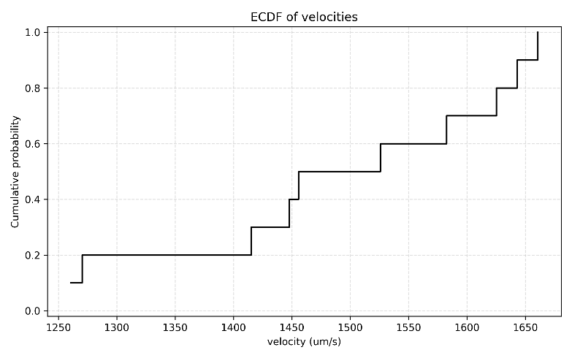
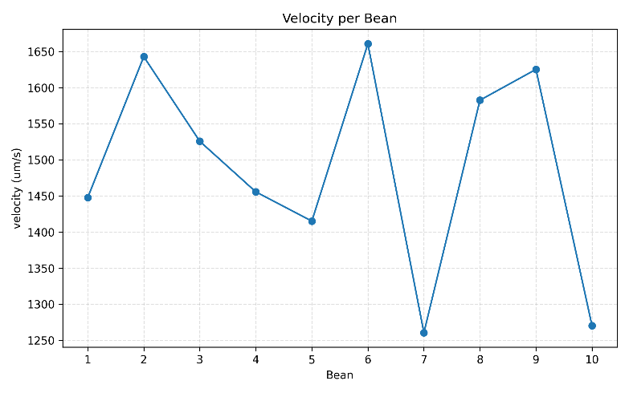
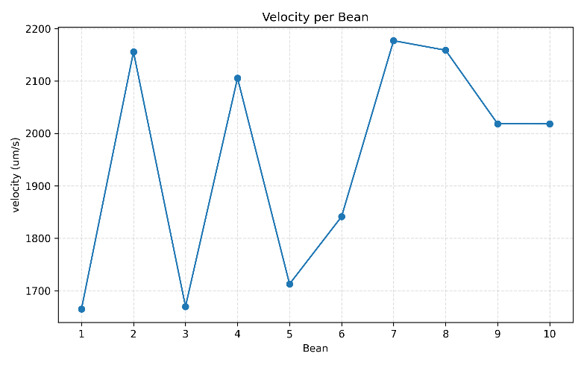
Figure 2.3. Cumulative Probability Distributions of Bean Velocity in Position P3
Figure 1.3. Plot of Bead Velocities in Position P3
Figure 1.2. Plot of Bead Velocities in Position P2
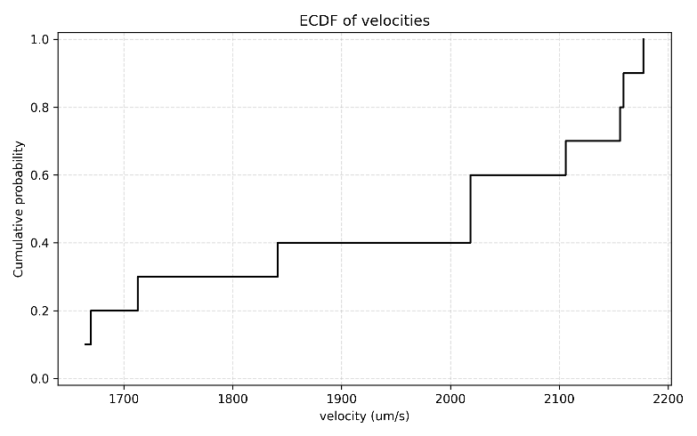
Figure 2.2. Cumulative Probability Distributions of Bean Velocity in Position P2
Coding of Calculus of velocity:
def velocity_fit_through_origin(X: np.ndarray, rows: np.ndarray, dt: float) -> float:
if X.size < 2:
return float("nan")
t = (rows - rows[0]) * float(dt)
X_rel = X - X[0]
denom = np.sum(t * t)
if denom == 0:
return float("nan")
num = np.sum(t * X_rel)
v = num / denom
return float(v)

def compute_per_source_velocities(agg_df: pd.DataFrame, dt: float) -> pd.DataFrame:
sources = sorted(agg_df["source"].unique(), key=lambda s: (re.search(r"(\d+)", s).group(1) if re.search(r"(\d+)", s) else s))
records = []
for s in sources:
sub = agg_df[agg_df["source"] == s].copy()
if sub.empty:
continue
sub = sub.sort_values("row")
X = sub["X"].to_numpy(dtype=float)
rows = sub["row"].to_numpy(dtype=int)
v = velocity_fit_through_origin(X, rows, dt)
records.append({
"source": s,
"n_points": int(len(X)),
"velocity_um_per_s": (np.nan if np.isnan(v) else float(v))
})
return pd.DataFrame.from_records(records, columns=["source", "n_points", "velocity_um_per_s"])

Coding of ANOVA and Tukey HSD:
import pandas as pd
import numpy as np
from scipy import stats
import statsmodels.stats.multicomp as multi
import matplotlib.pyplot as plt
import seaborn as sns

p1_data = [2428.461027, 2063.412462, 2491.481084, 2591.414843, 2121.754856,
2351.665983, 2484.585790, 2615.046765, 2705.758398, 2768.652454]

p2_data = [1665.000417, 2155.767500, 1669.787083, 2105.769643, 1712.777083,
1841.300893, 2177.052500, 2158.845000, 2018.460000, 2018.327500]

p3_data = [1447.764577, 1642.974984, 1525.741463, 1455.721471, 1415.182214,
1660.800027, 1260.562867, 1582.670564, 1625.371094, 1270.483679]

# DataFrame
data = pd.DataFrame({
'velocity': p1_data + p2_data + p3_data,
'position': ['P1']*10 + ['P2']*10 + ['P3']*10
})

print("=== 数据基本统计 ===")
summary = data.groupby('position')['velocity'].agg(['mean', 'median', 'std', 'count'])
print(summary.round(2))

# Anova
f_stat, p_value = stats.f_oneway(p1_data, p2_data, p3_data)

print("\n=== 单因素方差分析 (One-way ANOVA) 结果 ===")
print(f"F统计量: {f_stat:.4f}")
print(f"P值: {p_value:.10f}")

alpha = 0.05
if p_value < alpha:
print(f"结果：在 alpha={alpha} 水平上，不同位置间的平均流速存在显著差异 (p < {alpha})")
else:
print(f"结果：在 alpha={alpha} 水平上，不同位置间的平均流速无显著差异 (p ≥ {alpha})")

levene_stat, levene_p = stats.levene(p1_data, p2_data, p3_data)
print(f"\n方差齐性检验 (Levene's test): p = {levene_p:.4f}")
if levene_p > 0.05:
print("方差齐性假设成立")
else:
print("方差不齐")

# Tukey HSD
tukey_result = multi.pairwise_tukeyhsd(data['velocity'], data['position'], alpha=0.05)

print("\n=== Tukey HSD 事后检验结果 ===")
print(tukey_result)

