Oct 18 to Oct 27, 2025, SUSTech, Shenzhen, China
Biomedical Engineering Laboratory I (Fall 2025)

Lab 3 microfluidics

Group 5
姚子墨  12312221 | 吴赟戎  12313320

姜晨曦  12212109 | 涂昀烨  12313314

Abstract
Microvasculature consists of complex vessel networks with extensive redundant connections, necessary to provide high surface area for tissue perfusion. Modeling the hemodynamic characteristics of these systems to determine their behavior is often difficult. However, the advent of soft lithography has facilitated the creation of microfluidic systems to emulate these flow conditions in vitro. Due to the small dimensions of these channels, flow is typically laminar (Reynolds number <1), allowing for controlled study of fluid dynamics. Here, we formulate a laboratory project to characterize a simple model of the microvascular system using microfluidic chips. We utilize soft lithography techniques to fabricate polydimethylsiloxane (PDMS) channels of various morphologies, first to verify laminar flow regimes. Subsequently, we simulate a microvascular network—modeling anastomoses between arterioles, capillaries, and venules—and characterize its hemodynamics by tracking the velocity of microbeads flowing through varying channel geometries. This study provides a quantitative method to analyze flow data and understand how channel architecture influences fluid resistance in a biologically relevant mode.

INTRODUCTION
The microvasculature, comprising capillaries, arterioles, and venules, plays a critical role in perfusion and exchange processes within tissues, but its complex branching networks pose challenges for hemodynamic modeling. Traditional methods struggle to capture the intricate flow dynamics at microscales, necessitating innovative approaches. Microfluidics has emerged as a powerful tool to emulate microvascular conditions in vitro, enabling precise control over flow parameters and high-throughput assays. This laboratory project leverages soft lithography techniques to fabricate microfluidic chips, focusing on creating channels that mimic microvascular morphologies and characterizing flow behavior using statistical analysis.
Soft lithography, a cost-effective microfabrication method, allows the production of elastomeric molds (e.g., polydimethylsiloxane, PDMS) that can be bonded to substrates to form microchannels. This technique not only facilitates the study of laminar flow—common in microsystems due to low Reynolds numbers (Re)—but also supports applications in diagnostics, such as the development of smartphone-based devices for disease detection.
In this experiment, we conducted a series of procedures to design, produce, and test microfluidic chips. Specifically, we aimed to: (1) master soft lithography by creating PDMS stamps with microchannels of varying geometries; (2) assemble and validate microfluidic devices by bonding PDMS to glass slides; (3) investigate laminar flow properties using fluorescent dyes and microbeads; and (4) quantify flow velocities and statistical distributions to model microvascular networks. Key to this work is the application of fluid dynamics principles, where pressure-driven flow is described by ΔP = Q R, with R representing flow resistance dependent on channel geometry (e.g., for rectangular channels, R = 12 μ L / (w h³), where μ is viscosity, L is length, w is width, and h is height). The Reynolds number, Re = (v l ρ) / μ (where v is velocity, l is characteristic dimension, and ρ is density), is used to predict laminar flow (Re << 1), which is essential for avoiding turbulence in microchannels.
Our approach emphasizes hands-on fabrication and empirical analysis, providing insights into how microfluidic models can approximate hemodynamic conditions. By tracking microbead movements and performing ANOVA on velocity data, we assess the validity of these models for biomedical applications. This work not only enhances understanding of microvascular analogs but also highlights the potential of microfluidics for low-cost diagnostic tools.
MATERIALS AND METHODS
Main materials used in this lab are: Silicon wafers, spinner, knives and scrapers 0.75 mm punch, hot plate (95 °C), UV lamp, film mask, SU-8 2025 photoresist and developer, isopropanol wafer tweezers, PDMS (Dow Corning, Sylgarg 184), plastic cup, electronic balance, glass stirrer, petri dish (10 cm), silicon wafer with PR micro-structure, vacuum desiccator with pump, bake oven (80 °C), plasma cleaner, microscope slide, scotch tape, bake oven or hot plate (125 °C), steel and silicon tubing, 1 mL syringe, needles #6, scissors, inverted microscope, fluorescent dye, deionized water, microbeads suspension (9.0-9.9 μm diameter), beaker and syringe pump.
In this laboratory, we finished a whole procedure from preparation to using, including lithographic fabrication, assembling device, testing laminar flow and modeling a microvascular network. Different materials are used in each part.
In procedure 1, Silicon wafer, spinner, 95°C hot plate, UV lamp, film mask, SU-8 2025 Photoresist, SU-8 Developer, Isopropanol, Wafer Tweezers are used to make a silicon wafer with target features.
We first put the wafer on the spinner and deposit more than 2 ml SU-8 2025 photoresist (PR) onto the center of the wafer. We ran the spinner at 500 rpm for 10 s and then 3000 rpm for 30 s to deposit an even layer of PR ~25 μm thick. The wafer is then baked at 95°C for 7 min.
Next step is to determine the pattern under a UV lamp. A film mask with specific patterns is put on the wafer, which is then exposed under UV lamp for 9s. Being exposed under UV light, PR became crosslinked. The exposed wafer is baked at 95°C for 7 min again.
The baked wafer is transferred into a container of SU-8 developer (in a chemical fume hood since its volatility). We kept gently agitating the container for about 10 minutes and rinsed it with isopropanol. In this step, uncrosslinked PR was washed away while crosslinked PR remained on the wafer.
At last, we dried the silicon wafer with nitrogen and baked it at 95°C for 2 hours. This helped further fix the micro-structure on the surface.

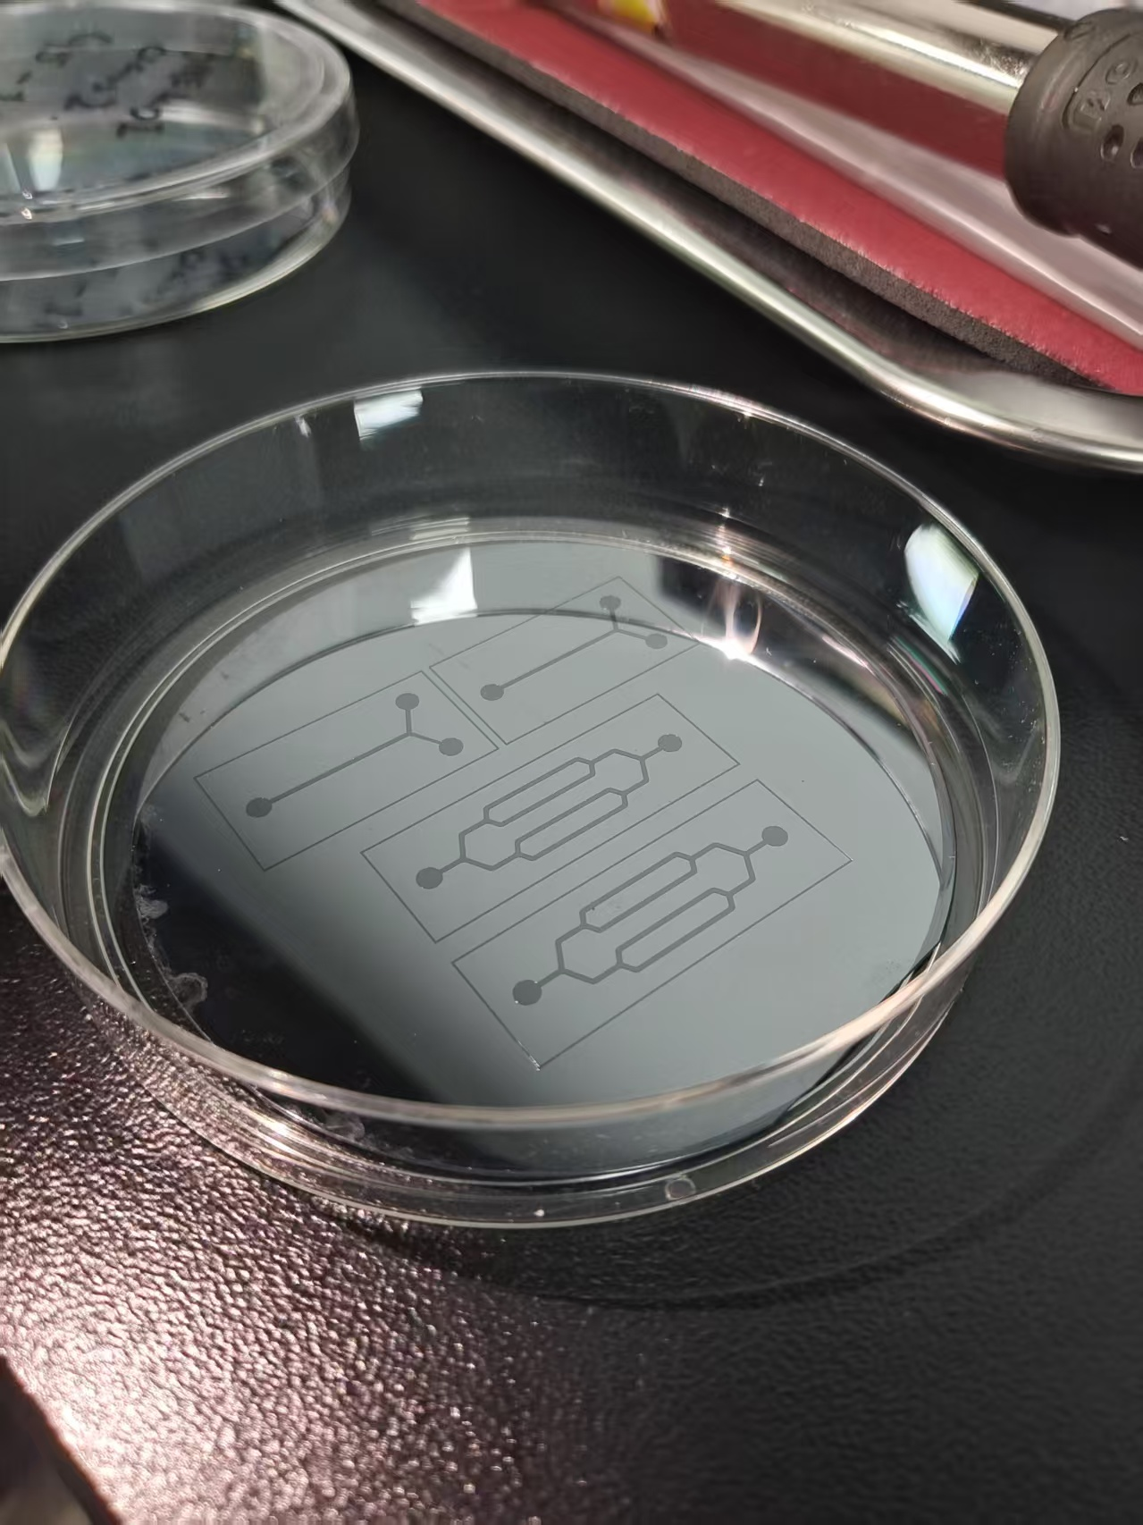
Figure 1: Silicon wafer with target feature

In procedure 2, we used PDMS (Dow Corning, Sylgarg 184), plastic cup, electronic balance, glass stirrer, petri dish (10 cm), silicon wafer with PR micro-structure, vacuum desiccator with pump, bake oven, knives and scrapers, 0.75 mm punch, plasma cleaner, microscope slide and scotch tape to mold a replica and stick it to a slide.
The Microfluidic Device is composed of a glass slide and a solidified PDMS channel. First, we prepared the PDMS. We poured 50 g of PDMS base into a plastic cup, added 5 g of PDMS curing agent to the PDMS base, and vigorously mixed the two components thoroughly (i.e. 10:1 base:curing agent mass ratio). Then we degassed the mixture using a desiccator and vacuumed it. During degassing, we took out the mixture every 2-3 minutes and blew the surface with a rubber bulb to remove the bubbles near the surface. Next, we transferred the mixture into a dish with silicon wafer and removed the bubbles again. The final mixture is then baked at 80°C for 1 hour.
Then we took out the solidified PDMS with a knife and a scraper. Each squared PDMS block has two or three places that need to be punched with a 0.75 mm-diameter punch. We confirmed that the hole was perpendicular to the surface and there were no cracks.
Next, we connect the slide and the PDMS. Remove any dust from the PDMS using scotch tape. Clean the microscope slide with an ethanol wipe. Put the PDMS channel and slide into the plasma cleaner and turn on the cleaner. The clean sides are always facing up and bonded to each other. After bonding the pieces, we tapped the slides gently and baked them at 125°C for 30 min immediately.
In procedure 3, we tested the channel and the laminar flow with steel and silicon tubing, 1 mL syringe, needles #6, scissors inverted microscope fluorescent, dye, and deionized Water.
First, we tested the channel with deionized water. We connected a steel tubing and a silicon tubing then inserted the other end of steel tubing to the channel inlet/outlet. One end of silicon tubing is put into a reservoir of deionized water. We pulled the syringe and made sure the channel was smooth and leakage-free.
Next, we used the “Y” shape channel to test the laminar flow. After removing the bubbles, we put the tubes into the DI water and the dye (Rhodamine) solution. Then we pulled the syringe gentle to mix the two liquids and observed them under a microscope. Reynolds number is used to judge the flow state, which is calculated by the equation:
$$Re=\frac{ρvd}{μ}$$
We assume that the diameter is d and the $μ$, $ρ$ of water and dye are the same. Here v is calculated by dividing the change in volume by the change in time (60 s).
Generally, if the Reynolds number is smaller than 1000 laminar flow occurs, while usually the Reynolds number in microcirculatory flows is smaller than 10. We calculated the number and verified it through the microscope (channels under 4X objective).
In procedure 4, we measured the flowing velocity and modeled a microvascular network with Microbeads Suspension (9.0-9.9 $μ$m diameter), Beaker and Syringe Pump.
This time we use a channel with two holes (an inlet and an outlet).
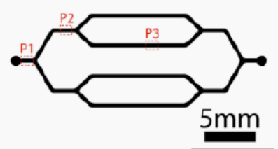
Figure 2: The microfluidic channel.

The basic procedure is the same as what we do in procedure 3, but this time we loaded the syringe with microbeads solution on the syringe pump and set the pump infuse 4 $μ$L/min. Also, during the pump working, we frequently knocked the syringe to avoid the aggregation of microbeads.
Then we observed the microbeads in different channels in the network (P1, P2, P3) and measured the flow velocity through observing the movements of microbeads under 10X objective.
Microscopic videos of the beads moving in channels around 10 s were recorded. In each channel, (P1, P2, P3), 10 microbeads were tracked and had their position sampled every 2 frames, 4-6 sample points, or 6-12 frames in total (Figure 3). A scale bar was applied to convert pixels into actual length travelled, and total frames of each video were acquired, to determine the time interval between frames. Then, each labelled frame for each microbead was given a time-x value coordinate, forming a set of data dots. A linear fit was made with least square for each microbead with reference to the 1st point (done with Python programming), producing the velocity with the slope of the line. The flow velocity was approximately equal to the average velocity of 10 microbeads at the spot.

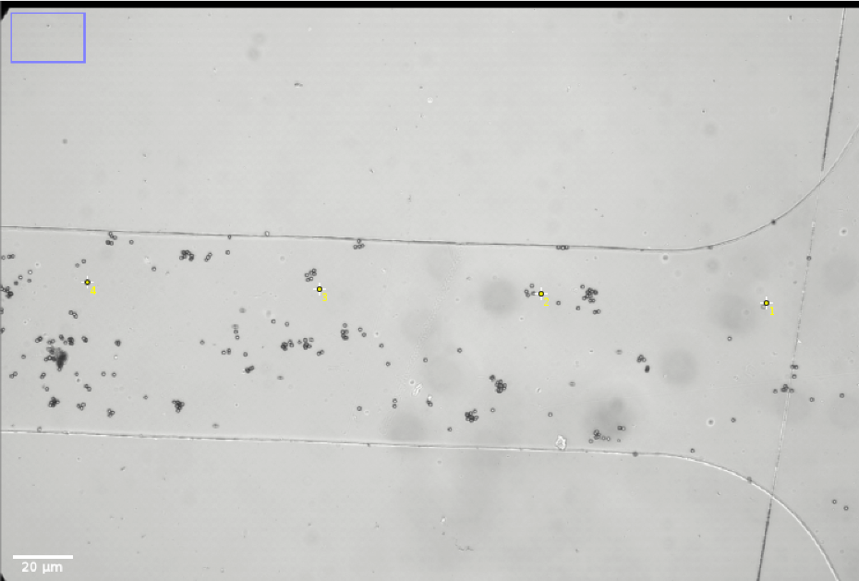
Figure 3: Track of a microbead in position P1, using ImageJ.

Results
After obtaining two silicon masters with lithographic procedures, four PDMS microfluid chips of each channel shape, eight chips in total, were molded, sliced and assembled onto slides. Necessary holes for chip inlets and outlets were punched before bonding.
In procedure 3, a chip with Y-shaped channel is flushed with DI water to remove all air and bubbles. Then, one outlet of the channel branch was connected to Rhodamine dye. DI water and the dye were sucked simultaneously with a syringe on the other end. The converging part of the channel was observed with 4X objective to identify the state of flow.
Fluorescent channel and bright field photos are shown in Fig. 4. In the fluorescent channel, a clear boundary between two fluids can be observed.

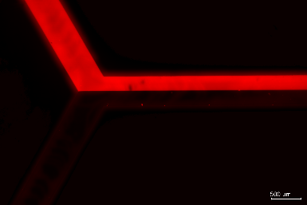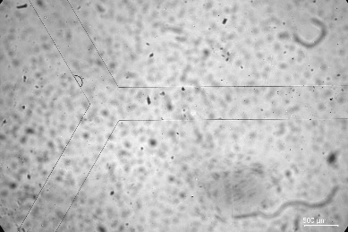
a
b
Figure 4: Converging part of the Y-shaped channel under 4X objective at (a) green excitation fluorescent channel, stained in red, (b) bright field.

The reason behind this phenomenon is that, in microfluidic chips, liquids exhibit laminar flow because the characteristic dimensions of the channels are extremely small—typically in the micrometer range—resulting in a very low Reynolds number (Re ≪ 1). [2]
The Reynolds number represents the ratio of inertial to viscous forces in the fluid. When it is low, viscous forces dominate, and turbulence cannot develop. As a result, the fluid moves in smooth, parallel layers without chaotic mixing. When two different liquids meet inside a microchannel, they flow side by side, forming a stable interface. Mixing between them occurs only through molecular diffusion, which is relatively slow at the microscale. [3] Therefore, instead of blending turbulently as in macroscopic systems, the streams remain distinct and flow in parallel.
To prove this theory, a rough calculation of the Reynold’s number was conducted using the formula $Re=vlρ/μ$, where $ρ=1000 kg/m^{3}$ [4] and $μ = {10}^{-3} kg/m·s$ for water, and l is the hydraulic diameter, in this case defined as $l=4wh/2(w+h)$, equals 47.62 μm with w = 500 μm and h = 25 μm given in the manual.
The remaining unknown in the formula is the fluid velocity v. Since we failed to record the total time of flow in the laminar flow test, an approximate was acquired through pulling the syringe at almost the same rate in the procedure for one minute and recording the fluid volume sucked into the syringe.
As a result, about 0.05 ml of DI water flowed through the system in one minute, which gives a flux of $5×{10}^{-8} m^{3}/min$, or a fluid velocity of $0.0667 m/s$ with a cross-sectional area of $1.25×{10}^{-8} m^{2}$.
Substitute all the figures and we get Re = 3.176. Since fluid in a system with Re < 1000 would behave in laminar flow, the result is generally consistent with our experiment. A laminar flow is expected in this microfluidic system and was clearly observed.
It is obvious that such estimation method for flow velocity is far from precise. In the next procedure a more rational method, using microbeads, to determine linear flow velocity was used, as mentioned in the methods part.
For procedure 4, the flow velocities of microbeads at three distinct positions (P1, P2, P3) within the microfluidic network were successfully quantified.
The framerate implied that the time interval between each sample is about 0.12 s. The raw tracking time- position data was conducted to a linear fit to obtain the velocity. (Table 1) The results revealed a clear trend of decreasing velocity from position P1 to P3.

t(s) |  | 0 | 0.12 | 0.24 | 0.36
x(μm) | P1-1 | 14.796 | 130.718 | 257.077 | 403.949
 | P2-1 | 4.923 | 134.00 | 266.513 | 401.487
 | P3-1 | 60.923 | 143.846 | 231.231 | 320.256

t(s) |  | 0.48 | 0.60 | V(μm/s) | R²
x(μm) | P1-1 | NaN | NaN | 1061.288 | 0.9962
 | P2-1 | 543.436 | NaN | 837.736 | 0.9995
 | P3-1 | 406.410 | 492.154 | 821.805 | 0.9999
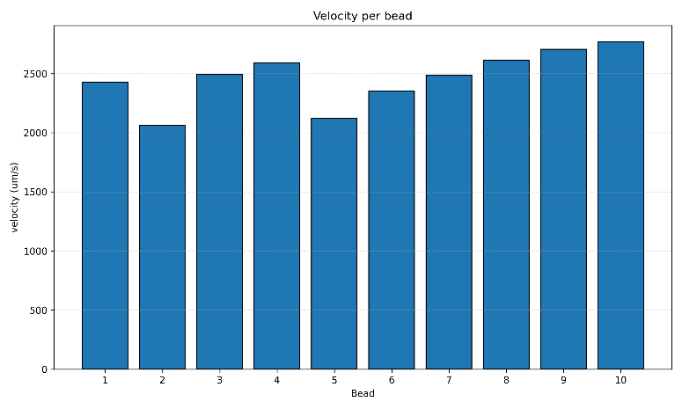
Table 1: Raw track data and linear fit results of one microbead in each position
Figure 5: Histogram of Bead Velocities in Position P1.

Position P1 exhibited the highest mean velocity (1231.59 ± 115.87 µm/s), followed by P2 (982.29 ± 105.93 µm/s), and finally P3 with the lowest mean velocity (744.65 ± 72.70 µm/s). Figure 5 shows the velocity distribution at P1. Analogous histograms for P2 and P3 (Appendix A1–A3) together illustrate a systematic downward shift in the distributions from P1 to P3.
The mean, median, and standard deviation for each of the 3 sets of measurements is shown in Table 2.

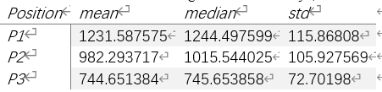
Table 2: Mean, Median, and Standard Deviation of Velocities

The cumulative probability distributions of bead velocities, plotted in Figure 6 (Cumulative probability distributions of bead velocities), show the distinct separation and rightward shift of the curves from P3 to P1, indicating a progressive increase in velocity. (Only P1 is presented here. The rest is provided in Appendix A)
A one-way analysis of variance (ANOVA) was conducted to determine if the observed differences in mean velocity across the three positions were statistically significant. The results indicated a highly significant effect of channel position on bead velocity, F = 85.23, p < .001. This confirms that the differences in flow velocity between the positions are far greater than that would be expected by random chance alone. (Relevant coding shown in Appendix B)
To show the specific differences between each pair of positions, a Tukey HSD post-hoc test was performed. The post-hoc analysis revealed that all pairwise comparisons were statistically significant (all p < 0.001), with a mean difference of -249.29 µm/s between P1 and P2, -486.94 µm/s between P1 and P3, and -237.64 µm/s between P2 and P3. (Relevant coding shown in Appendix B)

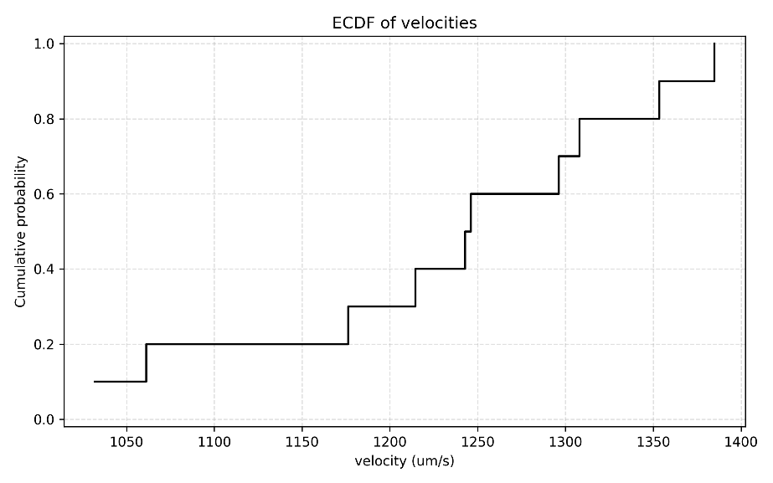
Figure 6: Cumulative Probability Distributions of Bead Velocity in Position P1.
discussion
In procedure 3, laminar flow in microfluidic systems was identified through experiment and calculations for Reynold’s number. Although the estimated Re is slightly above 1, it is still ≪ 10 and far below the laminar–turbulent transition, so the flow remains strictly laminar; the Re < 1 description in the introduction refers to typical orders of magnitude for microvascular flows.
Similarly for microvasculature in real organisms, the flow state of blood can be determined with Reynold’s number.
In microvasculature, the only known terms in the formula are hydraulic diameter l (identical to the inner diameter) and density $ρ$, given that blood has a density almost identical to water. [4] The other factors require complex considerations, therefore a simple model will be used in our case, e.g. ignoring the Fåhraeus–Lindqvist effect for the blood viscosity, which is using same viscosity for blood vessels with different diameters.
After a brief research, the reference value for blood viscosity was decided to be µ = 3.5×10⁻³ Pa/s, [5] and the diameter, data, flow velocity data and the calculated Reynold’s number for three kinds of microvasculature and aorta is provided in Table 3. [6][7][8]
For the aorta, peak velocity in contraction period is used.

 | Arteriole | Capillary | Venule | Aorta
D | ~30 μm | ~7 μm | ~60 μm | ~28 mm
v | ~3 mm/s | ~1 mm/s | ~2 mm/s | ~0.3 m/s
Re | 0.027 | 0.002 | 0.036 | 2.5×10³
Table 3: Figures for three kinds of microvasculature and aorta.

Apparently, a Reynold’s number smaller than 1 is found in three kinds of microvasculature, reflecting a laminar flow of blood. In contrast, for blood vessels with big diameters and high flow velocities like aorta, Re is on the order of 10^3. Under peak systolic conditions it may enter a transitional or mildly turbulent regime, whereas microvessels (Re ≪ 1) remain strictly laminar.
In procedure 4, the main finding is a clear and statistically significant velocity gradient in the microfluidic network: P1 > P2 > P3. This matches the theory of pressure-driven flow. Using the fluid version of Ohm's law, ΔP = Q × R, a constant flow rate (Q) means the pressure drop (ΔP) depends on the channel's flow resistance (R). Resistance for a rectangular channel is R = 12μL/(wh³), so it is very sensitive to channel dimensions. The measured velocity differences strongly suggest that P1, P2, and P3 had different geometries, creating different resistances. Since velocity v = Q/A, a channel with higher resistance will have a slower flow, which is exactly what we observed.
Statistically, the very low p-values (p < 0.001) from ANOVA and Tukey HSD tests give high confidence that these velocity differences are real and not random. The cumulative distribution plots (Figure 6, and Figures A4–A6 in Appendix A) show that the entire velocity profile shifts between positions, confirming it's a systematic change for all beads, not just in the average value. This is consistent with laminar flow behavior.
Regarding the ethics questions, for limitations and assumptions, we modeled blood as a Newtonian liquid and used rigid, near-rectangular PDMS channels under quasi-steady forcing. These assumptions neglect shear-thinning and the Fåhraeus–Lindqvist reduction of apparent viscosity at small diameters, endothelial surface–layer effects, vessel compliance, and pulsatility (Womersley effects). Velocity and shear estimates relied on simple volumetric/marker tracking, so entrance effects, wall roughness, and residual bubbles may bias results. These simplifications improve control and repeatability but limit physiological generalization. [2][9]
For meaning in the microfluidics context, the data support the low-Reynolds-number regime where flow rates and velocity fields are set by channel geometry and hydraulic resistance (Hagen–Poiseuille/Ohmic analogy). This aligns with standard microfluidic practice that exploits predictable, laminar transport for gradient generation, metering, and shear control [10][11].
For implications of a more complex network, adding serial/parallel branches and junctions increases heterogeneity in flow partitioning and residence times and concentrates wall shear at constrictions/expansions; network behavior becomes more sensitive to small geometric variations. Under pulsatile forcing and compliant walls, phase lags and impedance mismatches further alter local shear and flux beyond steady. [9][11]
For “can microfluidics approximate microvascular hemodynamics?”, the answer is yes, but conditionally. If key similarity parameters are matched (e.g. low Re, appropriate Womersley number for the forcing, and relevant transport ratios), microfluidic models can reproduce trends in microvascular flow and mass transport. Without non-Newtonian rheology and wall biology/compliance, however, they should be interpreted as mechanistic surrogates rather than direct physiological replicas. [10][11]
For improving thoughts for the microchip system, we can use shear-thinning blood analogs to mimic hemorheology; program pulsatile pressure/flow to target the desired Womersley regime; refine channel cross-sections and add compliant segments to approximate vessel geometry/mechanics; and validate velocity/shear by micro-PIV. Where feasible, incorporate endothelial coatings to capture near-wall resistance. [2][10]
References
[1] Lab Manual
[2] Whitesides, G. M. (2006). The origins and the future of microfluidics. Nature, 442, 368–373.
[3] Brenner, H., & Stone, H. A. (2002). Design principles for microfluidic devices. Annual Review of Fluid Mechanics, 34, 231-255.
[4] Vitello, D. J., Ripper, R. M., Fettiplace, M. R., Weinberg, G. L., & Vitello, J. M. (2015). Blood Density Is Nearly Equal to Water Density: A Validation Study of the Gravimetric Method of Measuring Intraoperative Blood Loss. Journal of veterinary medicine, 2015, 152730.
[5] Popel, A. S., & Johnson, P. C. (2005). Microcirculation and Hemorheology. Annual review of fluid mechanics, 37, 43–69.
[6] Ebrahimi, S., et al. (2022). A computational study of red blood cell deformability effect on flow in microvessels. Scientific Reports, 12, 4653.
[7] Wang, L., Yuan, J., Jiang, H., Yan, W., Cintrón-Colón, H. R., Perez, V. L., DeBuc, D. C., Feuer, W. J., & Wang, J. (2016). Vessel Sampling and Blood Flow Velocity Distribution With Vessel Diameter for Characterizing the Human Bulbar Conjunctival Microvasculature. Eye & contact lens, 42(2), 135–140.
[8] Garcia, J., van der Palen, R. L. F., Bollache, E., Jarvis, K., Rose, M. J., Barker, A. J., Collins, J. D., Carr, J. C., Robinson, J., Rigsby, C. K., & Markl, M. (2018). Distribution of blood flow velocity in the normal aorta: Effect of age and gender. Journal of magnetic resonance imaging : JMRI, 47(2), 487–498.
[9] Bruus, H. (2008). Theoretical microfluidics. Oxford University Press.
[10] Pries, A. R., Secomb, T. W., & Gaehtgens, P. (2005). Microvascular blood viscosity in vivo and the endothelial surface layer. American Journal of Physiology–Heart and Circulatory Physiology, 289(6), H2657–H2664.
[11] Squires, T. M., & Quake, S. R. (2005). Microfluidics: Fluid physics at the nanoliter scale. Reviews of Modern Physics, 77(3), 977–1026.
[12] Weibel D. B., DiLuzo W.R. and Whitesides G.M., Microfabrication meets microbiology, Nat. Rev. Microbiol., 2007, 5(3): 208-218.

Appendix A

Figure A1. Histogram of Bead Velocities in Position P1.

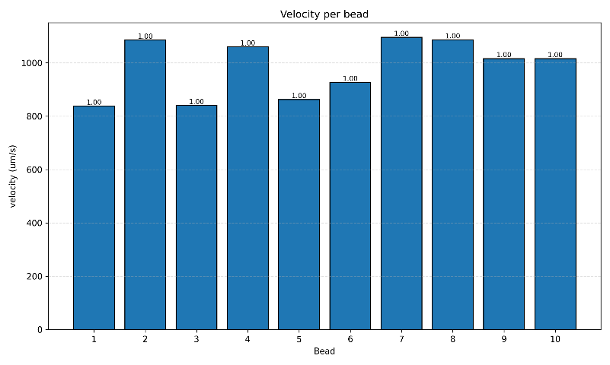
Figure A2. Histogram of Bead Velocities in Position P2.

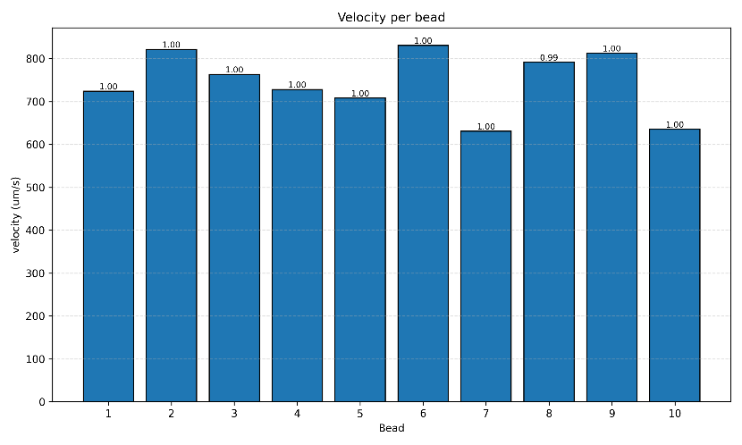
Figure A3. Histogram of Bead Velocities in Position P3.


Figure A4. Cumulative Probability Distributions of Bead Velocity in Position P1.

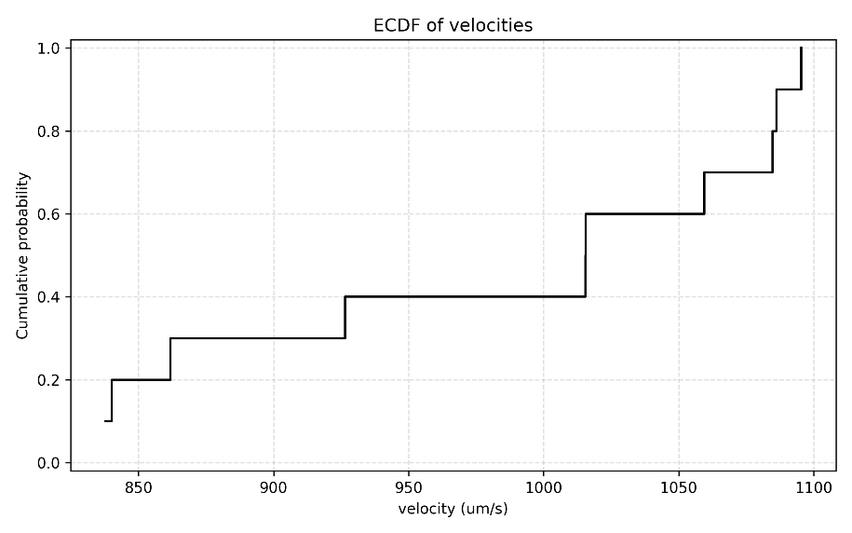
Figure A5. Cumulative Probability Distributions of Bead Velocity in Position P2.

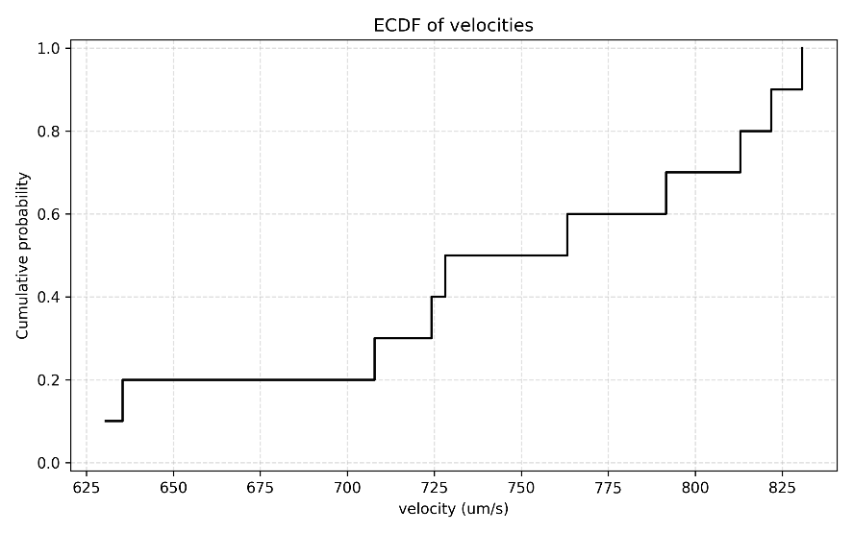
Figure A6. Cumulative Probability Distributions of Bead Velocity in Position P3.

Appendix B

B1: Python program for Velocity Calculations
def velocity_fit_through_origin(X: np.ndarray, rows: np.ndarray, dt: float) -> float:
if X.size < 2:
return float("nan")
t = (rows - rows[0]) * float(dt)
X_rel = X - X[0]
denom = np.sum(t * t)
if denom == 0:
return float("nan")
num = np.sum(t * X_rel)
v = num / denom
return float(v)

def compute_per_source_velocities(agg_df: pd.DataFrame, dt: float) -> pd.DataFrame:
sources = sorted(agg_df["source"].unique(), key=lambda s: (re.search(r"(\d+)", s).group(1) if re.search(r"(\d+)", s) else s))
records = []
for s in sources:
sub = agg_df[agg_df["source"] == s].copy()
if sub.empty:
continue
sub = sub.sort_values("row")
X = sub["X"].to_numpy(dtype=float)
rows = sub["row"].to_numpy(dtype=int)
v = velocity_fit_through_origin(X, rows, dt)
records.append({
"source": s,
"n_points": int(len(X)),
"velocity_um_per_s": (np.nan if np.isnan(v) else float(v))
})
return pd.DataFrame.from_records(records, columns=["source", "n_points", "velocity_um_per_s"])

B2: Python program for ANOVA and Tukey HSD
import pandas as pd
import numpy as np
from scipy import stats
import statsmodels.stats.multicomp as multi
import matplotlib.pyplot as plt
import seaborn as sns

p1_data = [2428.461027, 2063.412462, 2491.481084, 2591.414843, 2121.754856,
2351.665983, 2484.585790, 2615.046765, 2705.758398, 2768.652454]

p2_data = [1665.000417, 2155.767500, 1669.787083, 2105.769643, 1712.777083,
1841.300893, 2177.052500, 2158.845000, 2018.460000, 2018.327500]

p3_data = [1447.764577, 1642.974984, 1525.741463, 1455.721471, 1415.182214,
1660.800027, 1260.562867, 1582.670564, 1625.371094, 1270.483679]

# DataFrame
data = pd.DataFrame({
'velocity': p1_data + p2_data + p3_data,
'position': ['P1']*10 + ['P2']*10 + ['P3']*10
})

print("=== 数据基本统计 ===")
summary = data.groupby('position')['velocity'].agg(['mean', 'median', 'std', 'count'])
print(summary.round(2))

# Anova
f_stat, p_value = stats.f_oneway(p1_data, p2_data, p3_data)

print("\n=== 单因素方差分析 (One-way ANOVA) 结果 ===")
print(f"F统计量: {f_stat:.4f}")
print(f"P值: {p_value:.10f}")

alpha = 0.05
if p_value < alpha:
print(f"结果：在 alpha={alpha} 水平上，不同位置间的平均流速存在显著差异 (p < {alpha})")
else:
print(f"结果：在 alpha={alpha} 水平上，不同位置间的平均流速无显著差异 (p ≥ {alpha})")

levene_stat, levene_p = stats.levene(p1_data, p2_data, p3_data)
print(f"\n方差齐性检验 (Levene's test): p = {levene_p:.4f}")
if levene_p > 0.05:
print("方差齐性假设成立")
else:
print("方差不齐")

# Tukey HSD
tukey_result = multi.pairwise_tukeyhsd(data['velocity'], data['position'], alpha=0.05)

print("\n=== Tukey HSD 事后检验结果 ===")
print(tukey_result)

