- 补充计算Method:
First, group rows by each source and sort by row index. Then for each source, take the first point as reference. Fit a line through the origin using least squares: v = sum(t_i * X_i) / sum(t_i^2). Finally, we get the velocity of a sample.

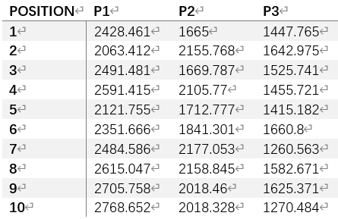
- 补充速度图
Table 2. Calculated Velocity in Three Positions(um/s)
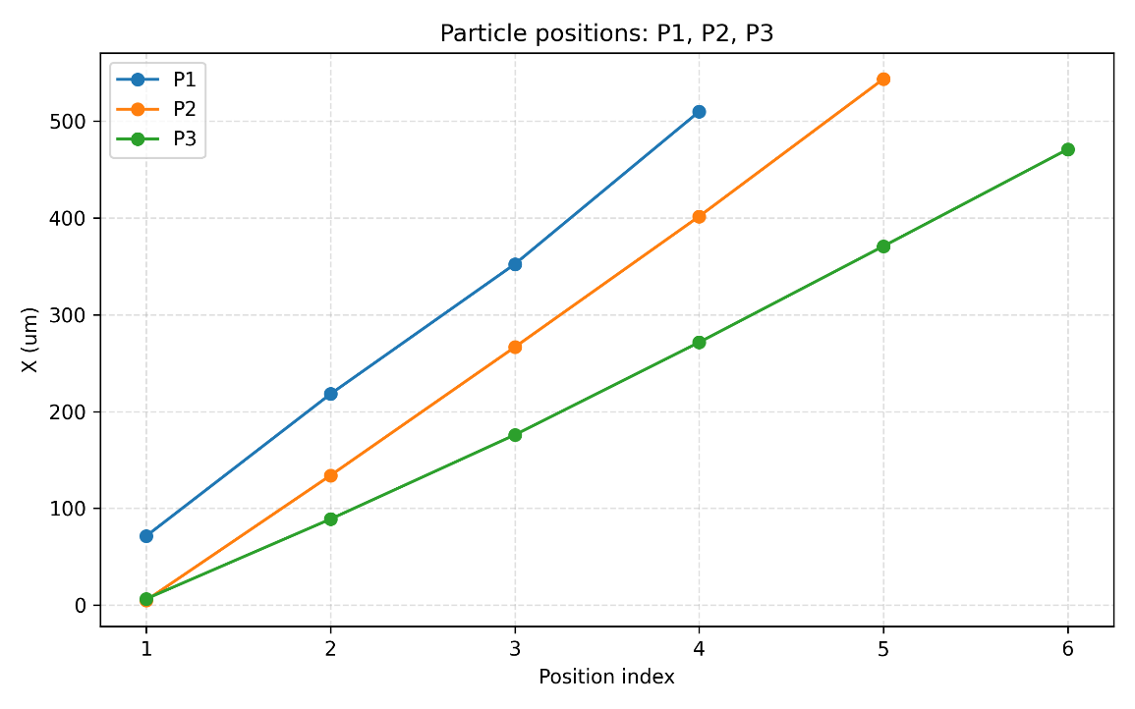
- 速度计算图像
- 新的直方图
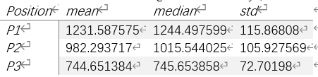
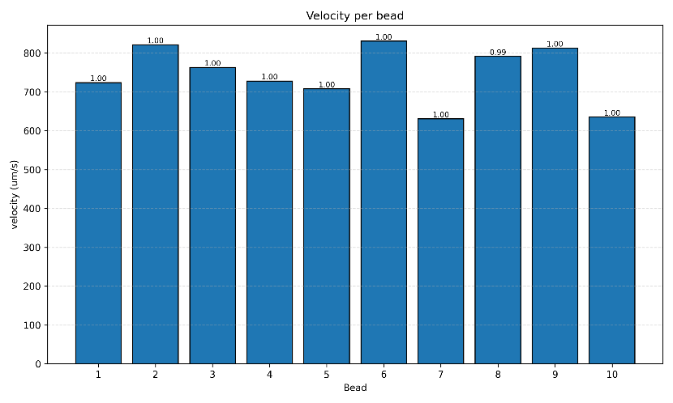
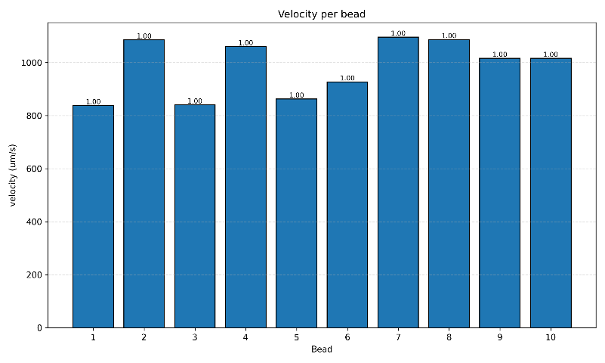
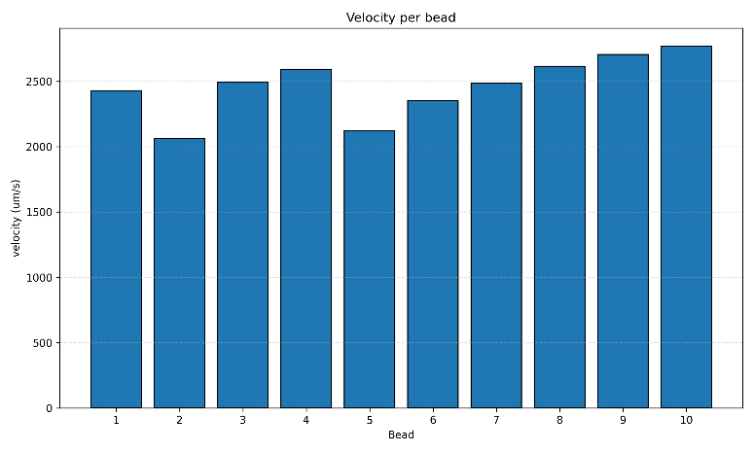
- Table 1
Table 1. Mean, Median, and Standard Deviation of Velocities
Figure 1.3. Plot of Bead Velocities in Position P3
Figure 2.2. Plot of Bead Velocities in Position P2
Figure 3.1. Plot of Bead Velocities in Position P1

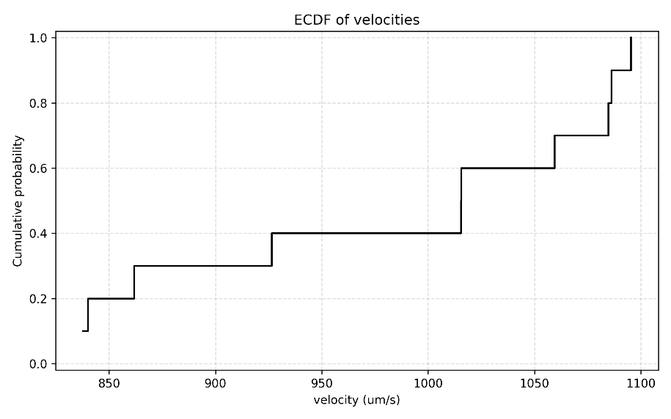
- 概率图
Figure 2.2. Cumulative Probability Distributions of Bean Velocity in Position P2
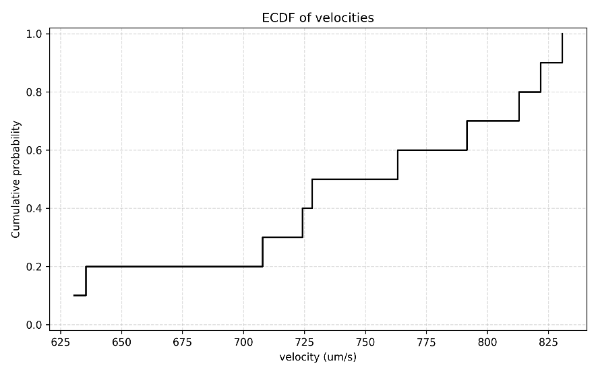
Figure 2.3. Cumulative Probability Distributions of Bean Velocity in Position P3

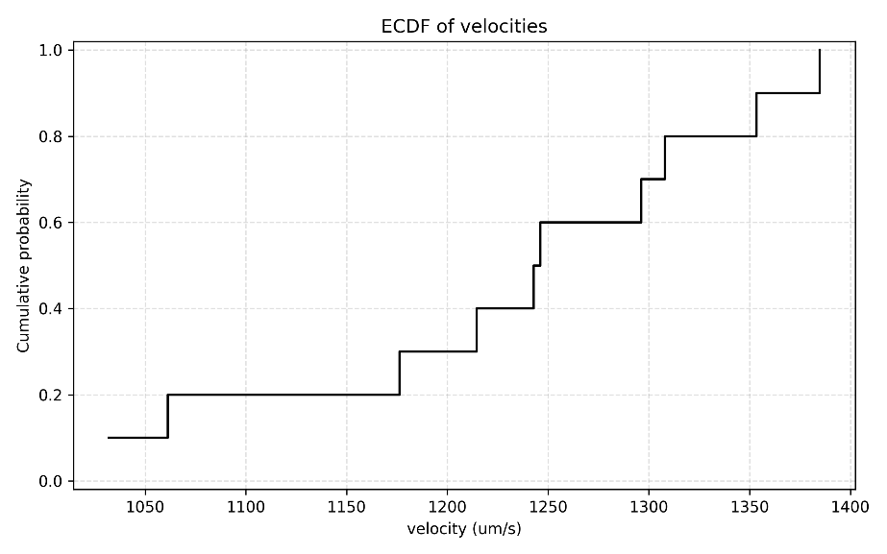
Figure 2.1. Cumulative Probability Distributions of Bean Velocity in Position P1

