September 19-29, 2025, SUSTech, Shenzhen, China
Biomedical Engineering Laboratory I (Fall 2025)

Lab 1 introduction to microscopy

姚子墨  12312221 | Author Name  Affiliation  City, State, Country

Author Name  Affiliation  City, State, Country | Author Name  Affiliation  City, State, Country | Author name  Affiliation  City, State, Country

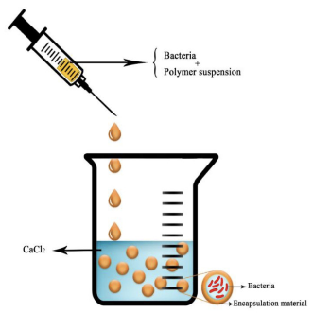
Figure 2. Extrusion Technique

Abstract

INTRODUCTION
Biomaterials are defined as substances engineered to interact with biological systems for medical purposes, such as treating, augmenting, or replacing tissue functions. A key requirement for biomaterial is “Biocompatibility” -- the ability of a biomaterial to perform with an appropriate host response in a specific application, without activating chronic inflammation pathways or an immune response.
Hydrogels, such as alginate, are three-dimensional polymeric networks capable of retaining large amounts of water. They are widely used in drug delivery and tissue engineering due to their tunable physical properties and mild gelation conditions.
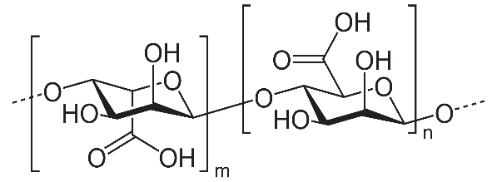
Alginate is a well-established biomaterial, which is synthesized by crosslinking its monomers, D mannuronic acid and L-guluronic acid (Figure 1). Its biocompatibility, low immunogenicity, and ability to encapsulate cells or drugs make it an ideal candidate for controlled release systems.
Figure 1. Structure of Alginate
In this laboratory, we focus on fabricating and characterizing alginate-based delivery systems. To simulate the release kinetics of a therapeutic drug, we employ Trypan Blue as a model compound. Its molecular weight and detectable color provide an excellent analog for studying the diffusion behavior of small-molecule drugs.
The most frequent way to encapsulate active compounds in an alginate bead is by extrusion. The molecule of interest is added in the sodium alginate solution. The beads are obtained by dripping this first solution into a bath of divalent cations in water.
We will fabricate two distinct types of delivery vehicles: alginate beads, formed via external gelation, which are homogeneously cross-linked spheres, and alginate capsules, formed via a modified internal gelation method, which feature a liquid core (containing the model drug) surrounded by an alginate membrane wall. The thickness of this membrane and the size of the beads are critical parameters that can be controlled by varying fabrication conditions, such as needle gauge, dropping height, dropping angle and stirring speed.
Alginate encapsulation is a very efficient, easy to set up, and eco-friendly way to protect substances of interest from environmental conditions until they reach their destination. Due to its outstanding properties such as bio-compatibility, bio-degradation, non-toxicity, and its ability to quickly form a hydrogel when put in the presence of divalent cations, alginate can be used in as many areas such as biology, agriculture, food industry and more.
MATERIALS AND METHODS

Results

discussion

Acknowledgments
I would like to express my sincere gratitude to the members of the research team who contributed to the successful completion of this study. Their dedication, expertise, and commitment were instrumental in the realization of our research objectives. I am thankful for their valuable insights, collaborative spirit, and unwavering support throughout the project.
References
- Wikipedia contributors. (2024, October 21). Alginic acid. In *Wikipedia, The Free Encyclopedia*. Retrieved November 23, 2025, from https://en.wikipedia.org/wiki/Alginic_acidTextbook
- Colin, C., Akpo, E., Perrin, A., Cornu, D., & Cambedouzou, J. (2024). Encapsulation in Alginates Hydrogels and Controlled Release: An Overview. Molecules (Basel, Switzerland), 29(11), 2515. https://doi.org/10.3390/molecules29112515
- Lab manual
Appendix

