Oct 27 to Nov 14, 2025, SUSTech, Shenzhen, China
Biomedical Engineering Laboratory I (Fall 2025)

Lab 4 Biomaterials and Drug Delivery

Group 5
姚子墨  12312221 | 吴赟戎  12313320

姜晨曦  12212109 | 涂昀烨  12313314

Abstract
Alginate hydrogels are widely used as biomaterial carriers for controlled drug delivery. In this laboratory study, we fabricated two types of alginate-based vehicles—homogeneous microbeads produced by external gelation and core–shell capsules produced by a vortex-assisted internal gelation method, and systematically optimized their fabrication parameters. A trypan blue calibration curve at 630 nm (0–5% v/v, $R^{2}=0.995$) was established to convert absorbance into dye concentration. Needle gauge and dripping conditions were tuned to obtain size-consistent beads and capsules, and the appropriate number of carriers per well was determined to yield quantifiable yet unsaturated release signals. Beads prepared with a #4.5 needle (32 beads per well) showed a rapidly decelerating release profile that was well described by a first-order model ($R^{2}≈0.99$), whereas capsules prepared with a #6 needle (6 capsules per well) exhibited a nearly linear, zero-order–like release ($R^{2}≈0.90$) with overall lower concentrations. These results highlight how geometry and shell architecture shift alginate systems from diffusion dominated to membrane controlled kinetics, suggesting beads are more suitable for short-term burst delivery, while capsules are better candidates for sustained release.
INTRODUCTION
Biomaterials are defined as substances engineered to interact with biological systems for medical purposes, such as treating, augmenting, or replacing tissue functions. A key requirement for biomaterial is “Biocompatibility” -- the ability of a biomaterial to perform with an appropriate host response in a specific application, without activating chronic inflammation pathways or an immune response.
Hydrogels, such as alginate, are three-dimensional polymeric networks capable of retaining large amounts of water. They are widely used in drug delivery and tissue engineering due to their tunable physical properties and mild gelation conditions. In particular, alginate-based hydrogels have emerged as versatile carriers in controlled drug delivery, benefiting from their biocompatibility, degradability and facile crosslinking with divalent cations.[5]

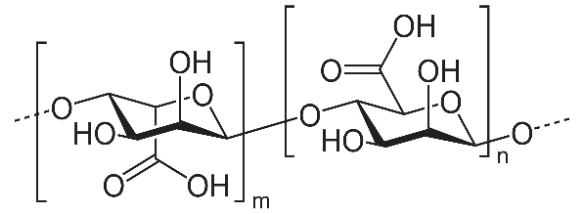
Figure 1: Structure of Alginate Polymer.[2]

Alginate is a well-established biomaterial, which is synthesized by crosslinking its monomers, D mannuronic acid and L-guluronic acid (Figure 1). Its biocompatibility, low immunogenicity, and ability to encapsulate cells or drugs make it an ideal candidate for controlled release systems.
In this laboratory, we focus on fabricating and characterizing alginate-based delivery systems. To simulate the release kinetics of a therapeutic drug, we employ Trypan Blue as a model compound. Trypan blue was used as a visually traceable model solute; however, its charge and potential matrix interactions may differ from neutral small-molecule drugs.
The most frequent way to encapsulate active compounds in an alginate bead is by extrusion. The molecule of interest is added in the sodium alginate solution. The beads are obtained by dripping this first solution into a bath of divalent cations in water.
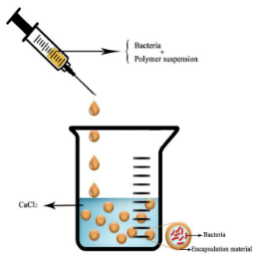
Figure 2: The extrusion Technique.[3]
We will fabricate two distinct types of delivery vehicles: alginate beads, formed via external gelation, which are homogeneously cross-linked spheres, and alginate capsules, formed via a modified internal gelation method, which feature a liquid core (containing the model drug) surrounded by an alginate membrane wall. The thickness of this membrane and the size of the beads are critical parameters that can be controlled by varying fabrication conditions, such as needle gauge, dropping height, dropping angle and stirring speed.
Alginate encapsulation is a very efficient, easy to set up, and eco-friendly way to protect substances of interest from environmental conditions until they reach their destination. Due to its outstanding properties such as bio-compatibility, bio-degradation, non-toxicity, and its ability to quickly form a hydrogel when put in the presence of divalent cations, alginate can be used in as many areas such as biology, agriculture, food industry and more. [3]
MATERIALS AND METHODS
The materials used in this lab include sodium alginate solution (1% and 2%), 4% CaCl2 solution, deionized water, dextran, 1 mL syringes, needles (#12, #6, and #4.5), graduated cylinder, centrifuge tubes (5 mL and 50 mL), Trypan blue, analytical balance, microscope, microplate reader, magnetic stirrer and stir plate, ring stand with clamp, Petri dishes (60 mm/100 mm), 24-well and 96-well plates, pipettes, rulers, and timers.
In procedure 1, to convert the 630 nm absorbance of the solution to the concentration of trypan blue, we aim to plot a standard concentration- A630 curve for calibration.
At least five trypan blue dilutions in deionized water were prepared, spanning 0%–5% (v/v) and a step of 0.5% (11 sample points in total) relative to the trypan blue stock solution. Aliquots (150 µL) of each dilution were transferred into a 96-well plate with deionized water used as the blank, and each concentration was plated in triplicate (n = 3) in separate wells. Absorbance for each well was measured at 630 nm using a microplate reader against the average readings of 3 blank (ddH₂O). The resulting data were used to plot absorbance versus concentration, and a linear regression was applied to generate a calibration curve for converting absorbance values to trypan blue concentrations in subsequent analyses.
In procedures 2, 3 and 4, our main work is to get familiar with the extrusion technique of fabricating microbeads and capsules of alginate hydrogel and carry out pre-experiments to obtain the best parameters for making size-consistent microbeads and capsules, as well as for a stable and assessable releasing process of them.
The solutions are prepared as follows: TA provided us with 1% and 2% Alginate solution, 4% CaCl₂ solution, Trypan blue dye and dextran powder. Dyed solutions, which were used to drip from the syringe, were all in 10% (v/v) Trypan blue, that is, 0.4 ml of Trypan blue and 3.6 ml of 1% alginate solution, 2% alginate solution or 4% CaCl₂ solution in a 5 ml tube, forming a 4 ml dyed solution.
Specifically in dyed CaCl₂, an additional dextran in 5% (w/v, g/ml) was introduced to facilitate the gelation of hydrogel, that is, 0.2 g of dextran was measured with an analytical balance and added into the solution.
For the “baths” solution, 4% CaCl₂ solution was used for microbeads, and alginate solution, whose concentration was adjusted (through mixing 1% solution and ddH₂O to dilute it between 0 and 1%) as a parameter in the pre-experiment, was used for capsules.
To fabricate microbeads, a Petri dish was filled more than halfway with 4% CaCl₂ solution. Trypan blue-dyed alginate solution mixed with trypan blue (1 mL total) was drawn into a 1 mL syringe, and all air bubbles were removed. A #4.5 (26G) needle was attached, the syringe was handheld at a measured height above the CaCl₂ surface, and the alginate was dispensed slowly such that droplets fell into the solution. The procedure was repeated over a fresh CaCl₂ dish using a #12 (18G) needle to generate and measure at least 10 beads. Different settings of alginate concentration, dripping height and drip rate were tested for finding the best parameters for ideal spherical shape and consistent size.
The final settings were fixed at: 2% dyed alginate, 7 cm drip height for #4.5 needle, 5 cm drip height for #12 needle and drip as slow as possible. The beads was blown away from the diving spot to avoid collision of different beads. At least 10 beads were formed (Fig. 3), and full immersion of each bead was ensured. The beads were allowed to remain in the CaCl₂ solution for ~5 min, after which bead diameters were determined from microscope images with scale bars.

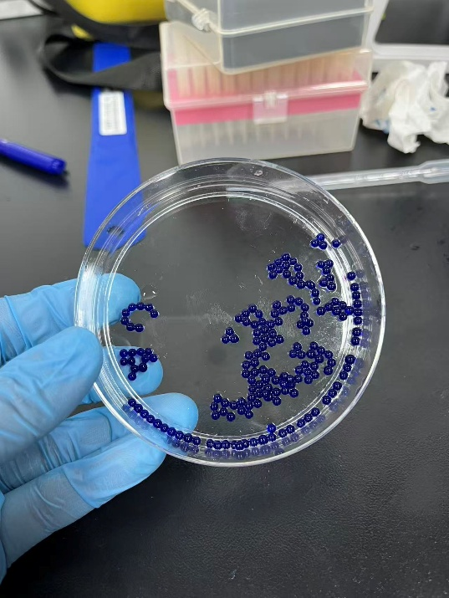
Figure 3: Microbeads, made with final settings and a #4.5 needle.

To fabricate alginate capsules, an alginate solution was placed in a beaker with a small magnetic stir bar, and the solution was stirred at a moderate speed to generate a stable vortex. 1 mL of dyed CaCl₂ (with dextran) was drawn into a 1 mL syringe, and all air was removed. The syringe was attached to the iron stand for more stable drip variables. A #4.5 (26G) needle was attached, the needle tip was cleared of air, and the syringe was positioned above the alginate surface at a measured location relative to the vortex. The dyed CaCl₂ was dispensed very slowly such that droplets fell into the alginate solution, and multiple capsules were generated under the same dropping conditions and allowed to rotate for several minutes (slightly longer than for microbeads). Then the process was repeated using a #6 (23G) needle. Different dripping variables (drop speed, stirring speed, drop height, distance from the vortex, and syringe angle) were systematically tested until spherical capsules were obtained.
The final settings were fixed at: 0.75% alginate, stir speed at 650-750 rpm, 2.5 cm drip height for #4.5 needle, 2 cm drip height for #6 needle, 1.5 cm of drop distance from vortex center, and 15° of syringe angle with respect to the vertical position.(Fig. 4) After capsule formation, stirring was stopped and the capsules were transferred to deionized water and had their structure observed and diameter, wall-thickness measured also with known-scale microscope images.
As is demonstrated, we made two kinds of beads and capsules with different sizes (and wall-thickness) by varying the needle gauge.
Then, pre-experiments of dye releasing were conducted to decide a setting that would produce rational results. Freshly prepared beads (two size groups) or capsules (two wall-thickness groups) were placed into separate wells of a single 24-well plate and fully covered with DI water (1 ml) as the release medium.
For each size/thickness condition, a loading gradient was tested by varying the number of beads/capsules per well as multiples of a baseline amount n (n, 2n, 4n… 10n for beads, n, 2n, 3n… 6n for capsules) across different wells. “n” was determined based on the total volume of each well, where all the beads/capsules should be able to fit in and fully submerged (Table 1).

Type | n
Beads from #4.5 needle | 4
Beads from #12 needle | 3
Capsules from #4.5 needle | 2
Capsules from #6 needle | 2
Table 1: Baseline amount n of each type of bead/capsule.

Every 20 min in a total time of 120 min, 150 µL of solution was withdrawn from each well and transferred to a 96-well plate to measure absorbance at 630 nm against a set of blank; the sampled solution was then returned to the original 24-well plate to maintain constant volume and consistent release conditions. This sampling–measurement cycle was repeated until the endpoint, and the standard curve was used to convert A630 into dye concentration to obtain the time-concentration release plot. At each time point, 6 blank (ddH₂O) readings were acquired, averaged and subtracted from the sample readings to remove background signals. The optimal beads/capsules-per-well and size condition was selected as the loading that produced a robust, non-saturated, and reproducible signal while sensitively capturing the release dynamics.

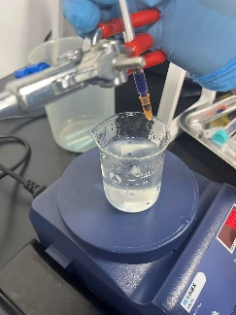
Figure 4: Final configuration of capsule fabrication.

The best configurations for the releasing experiment are: #4.5 needle, 8n, n=4 (32 in total) for beads in each well, and #6 needle, 3n, n=2 (6 in total) for capsules in each well. Detailed plots of pre-experiments are included in RESULTS.
In procedure 5, optimal conditions obtained from the previous procedure were integrated to investigate the release kinetics of the microbeads and capsules. A similar experiment (Fig 5.) was performed, with the time gradient changed into a measurement every 15 min in a total time of 150 min for better resolution of the plot. Beads and capsules were prepared and immersed in 1 ml of ddH₂O in the wells under the conditions mentioned above. with 6 repetitions respectively. At each time point, 6 blank (ddH₂O) readings were acquired, averaged and subtracted from the sample readings to remove background signals.

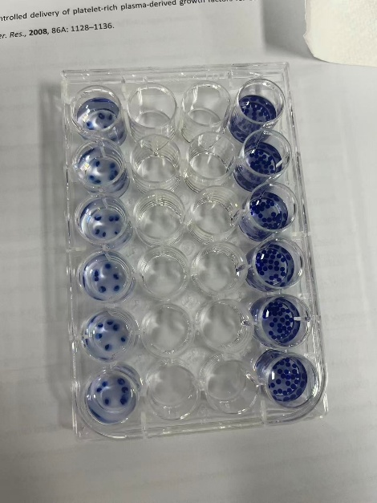
Figure 5: Configuration for the 24-well plate in the final releasing experiment. Well A1-A6 (top) contains 32 beads (from #4.5 needle) each. Well D1-D6 (bottom) contains 6 capsules (from #6 needle) each.

The A630 data at each time point was converted to trypan blue concentration to form a time-concentration release plot. Mathematical fittings were done to the plots to determine the releasing mechanism.
All the quantifying experiments were specified with the underlined settings and parameters, and Table 1, providing sufficient detail for our protocol.
Results
It is necessary for our experiment to establish a calibration by determining the relationship between trypan blue concentration and corresponding absorbance at 630 nm. That is what we did in procedure 1. According to the Beer-Lambert’s law, the absorbance and concentration should be directly proportional [4], so we analyzed the data with MATLAB (Table 2, Fig. 6).

Table 2: Absorbance of trypan blue within a concentration gradient (0%-5%, step = 0.5%).

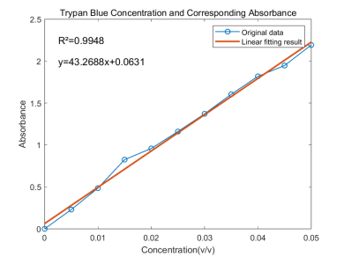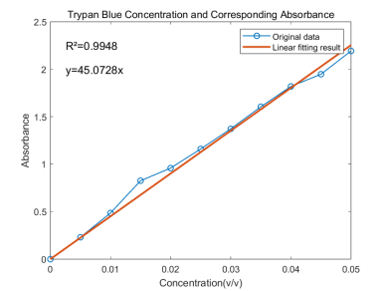
a
b
Figure 6: Concentration-Absorbance standard curve of trypan blue, (a) y intercept = 0.0631, (b) y intercept = 0.

The fitted calibration line should theoretically pass through the origin (Fig. 6), so we have the slope=45.0728, which indicates that concentration=absorbance/45.0728 (e.g. A=0.01, implies that concentration=0.01/45.0728=0.02219%). The R² of the line is 0.9948, that shows our fitting is reliable.
Next, we prepared the solutions as mentioned in METHODS. Before measuring dye release (Procedure 5), some parameters used to produce the beads/capsules are necessary. The key parameters, as determined in the previous procedures (Procedures 3 and 4), include the bead size, the capsule wall thickness, and the quantity of beads/capsules were also mentioned in METHODS.
In procedure 3 and 4, we created beads and capsules under a range of conditions. We considered the needle diameter, needle height, dropping speed, alginate concentration, CaCl₂ concentration and obtained following results regarding their effects on the products:
• Needle Gauge (Diameter): Directly and positively correlated with the final bead and capsule size. However, bigger needle resulted in thinner capsule walls. This is the main method we use to vary the capsule wall thickness.
• Needle Height: Primarily affected the sphericity and shape uniformity of the beads and capsules, too high led to ellipsoid products, while too low would leave the bead/capsule floating on the surface, only partially solidified.
• Alginate Concentration: Higher concentrations led to faster gelation but also increased droplet buoyancy and bath viscosity, at times preventing the droplets from submerging and solidifying as a whole.
• Dextran: During capsules fabrication, dextran plays a significant role. Dextran was included in the CaCl₂ core solution as a viscosity modifier to stabilize droplet formation and help retain the aqueous core during inverse-gelation while the calcium–alginate shell crosslinked. [9]
• Stir speed: Due to the high viscosity of the alginate bath, a decent stir speed is required to form a vortex that helps the droplet to sink, as well as to keep the capsules from sticking together in the beaker. However, too high stir speed would result in stretching the droplet into a tailed shape before it solidifies.
• Distance from the vortex center: Given that the liquid farther from the vortex center would have a higher velocity of flowing, it is not suitable to drop the solution straight into the vortex center. Similar to the stir speed, an ideal distance should be determined.
• Soak duration: Soak duration has barely any effect on microbeads, while it influences the wall thickness of capsules significantly. The walls of the capsules are formed layer by layer as the CaCl₂ solution in the core diffuses out the hydrogel shell and crosslinks as it reaches the alginate bath, showing a multilayer structure. (Fig 7c, d) Therefore, the longer the capsules stayed in the bath, more layers would be created, thickening the capsule wall. However, the speed of thicken would become slower with time, since the solution must diffuse through thicker hydrogel as time goes by. This makes controlling the wall thickness with soak duration hard and complex, hence not adopted in our fabrication protocol.
Our primary method for controlling the product sizes was on the effect of needle diameter. The bigger the diameter, the bigger the beads/capsules. Dimensions of the beads and capsules were measured with microscopic photos with scale bars. (Fig. 7)

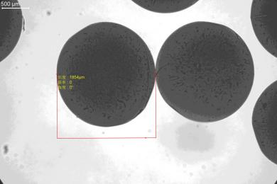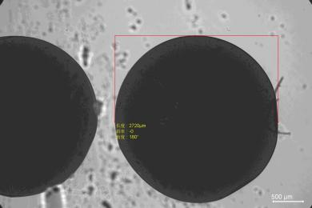
a
b
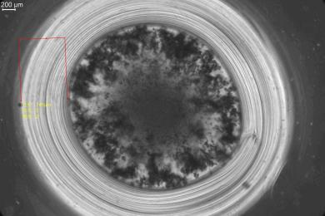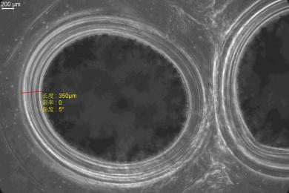
d
c
Figure 7: Beads and capsules under 4X objective from different needles. (a) beads from #4.5 needle, diameter = 1854 μm, (b) beads from #12 needle, diameter = 2720 μm, (c) capsules from #4.5 needle, wall-thickness = 741 μm, diameter = 3689 μm (d) capsules from #6 needle, wall-thickness = 350 μm, diameter = 2290 μm.

Diameters of two kinds of beads were measured, and two independent samples (n=10 each) (Appendix A7) were obtained in total. Datasets were analyzed statistically to observe their distribution, and Welch’s t-test was performed between the datasets of two kinds of beads to find out whether there is a significant difference.

Bead Type | Average (μm) | Std. (μm) | Median (μm)
From #4.5 needle | 1867.3 | 27.7 | 1868.5
From #12 needle | 2641.6 | 173.0 | 2653.0
Table 3: Statistics summary of the datasets of two kinds of beads.

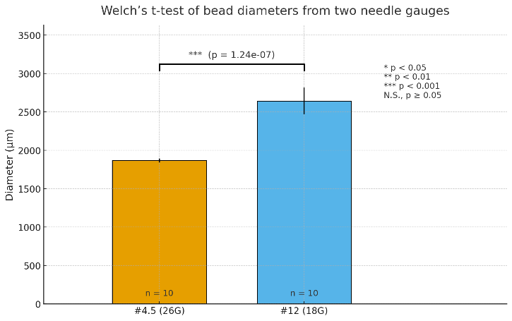
Figure 8: Welch’s t-test results of bead diameters from two needle gauges.

The bead diameters under the two conditions are significantly different (Fig. 8) (Welch’s t-test, p = 1.24 e-07 ≪ 0.05). Diameters of beads from #4.5 needle shows a narrow, approximately unimodal distribution, while diameters of beads from #12 needle exhibits substantially larger variability with a right-tail outlier likely caused by droplet coalescence during gelation. (Table 3)
Figure 9 shows the changes in release concentration of beads over time. In figure, left plot represents for beads made by #4.5 needle and right plot represents for beads made by #6 needle. We found that the #4.5 needle and 32 beads in one well has a best release curve which looks like a first-order curve.
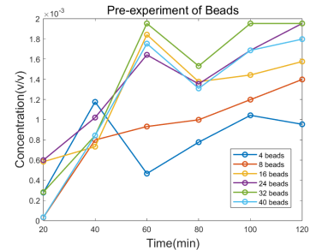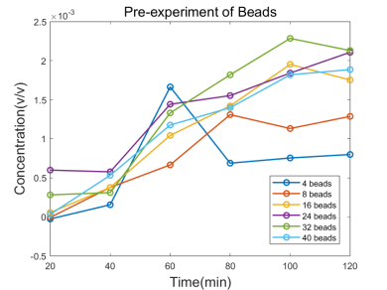
b
a
Figure 9: Release curve of beads in different quantities, (a) beads from #4.5 needle, (b) beads from #12 needle.

Figure 10 shows the changes in release concentration of capsules over time. Smaller capsules are made with #4.5 needle and bigger capsules are made with #6 capsules. The bigger capsules and 6 capsules in one well have enough release concentration and looks like a zero-order curve.

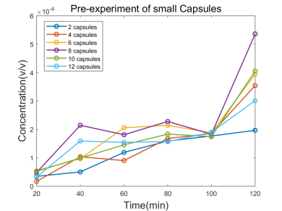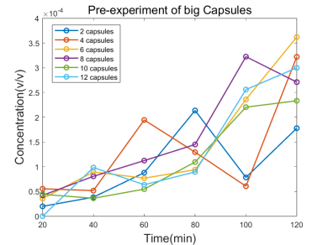
b
a
Figure 10: Release curve of capsules in quantities, (a) capsules from #4.5 needle, (b) capsules from #6 needle.

Complete original absorbance data of two pre-experiments are included in Appendix A1-A4.
In procedure 5, to quantify the kinetics of dye release from alginate beads and capsules, we designed the following experiment.
To understand the diffusion-controlled release mechanism, we evaluated the release curves of the beads and capsules by applying established kinetic models such as zero-order and first-order release.
The parameters of beads we used for procedure 5 is the small-size (from #4.5 (26G) needle and 7cm height) bead and 32 in one well. The parameters of capsules we used for procedure 5 is the middle-size (from #6 (23G) needle and 5cm height) capsule and 6 in one well. Experimental methodology is in part “METHOD”, Absorbance results at each time point were converted to concentration (Table 4), subtracted the average blank reference, and then analyzed and plotted with MATLAB (Fig. 11).

Table 4: Release concentration of trypan blue over time

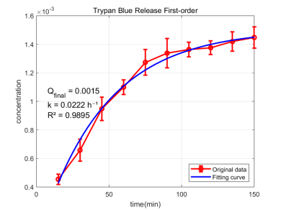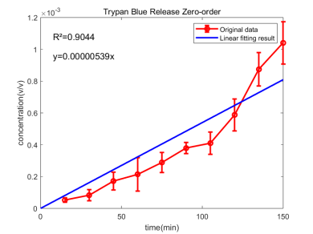
b
a
Figure 11: Release concentration of trypan blue in (a) microbeads, (b) capsules over time, results are presented in mean ± standard deviation of n = 6.

Complete original absorbance data of two pre-experiments are included in Appendix A5-A6.
In Fig.11a, we observed a first-order release, so we fitted a first-order release curve in the form:
$$Q=Q_{final}*(1-e^{-kt})$$
We calculated the coefficient with MATLAB, getting $Q_{final}=0.0015(v/v)$ and $k=0.0222h^{-1}$. An R²value of 0.9895 confirms the success of our fitting procedure and the validity of our fitting model. As a result, the final equation is:
$$Q=0.0015*(1-e^{-0.0222t})$$
The release curve indicates that the release of beads is first fast and then slow, gradually approaching the upper limit of release. After 100min, the concentration of trypan blue remains nearly constant.
In Fig.11b, we observed a zero-order release, in the form:
$$Q=kt+b (b=0)$$
We calculated the coefficient with MATLAB and get $k=5.39×{10}^{-6}$. The R²value of 0.9044 demonstrates a reasonable degree of linearity in our data, supporting the use of a linear model for this analysis.
The release curve suggests that the capsules exhibit zero- order release kinetics, characterized by a relatively constant release rate over time.
Regarding the release kinetics, theoretically, the primary release mechanism of the dye is diffusion, which is driven by the concentration gradient of trypan blue between the solution in the bead/capsule and water. However, the external network structure of the capsule can hinder this diffusion process, becoming a significant factor affecting the dye release.
Within the beads, a homogeneous morphology facilitates effective diffusion. The diffusion rate, governed by the concentration gradient, which follows the Fick’s 1st Law. The gradient slowly weakens as the dye releases, ultimately results in a first-order release profile. However, the release from capsules is dictated by the barrier properties of the shell rather than just concentration. The wall maintains the core concentration at a approximate constant. This leads to a constant gradient and a relatively uniform release speed, which approximates zero-order kinetics. Furthermore, the restrictive function of the capsule wall caused a apparently slower release rate.

Table 5: The sampled absorbance from the wells of beads and capsules at 150 min.

Here the beads and the capsules are in similar size and shape. We measured their absorption at 150 min (Table 5). The capsules indeed have a lower release concentration than beads, implying a slower diffusion rate of capsules compared to beads in similar dimensions.

discussion
In our vortex-assisted capsule fabrication (dispensing CaCl₂ droplets into an alginate bath), we observed a unusual trend that a coarser needle produced thinner capsule walls, which can be explained by the competition between gelation kinetics and hydrodynamic deformation/mass transfer. Larger needles typically generate droplets that are released with a higher instantaneous flow and momentum, causing deeper penetration into the vortex and exposing the nascent gel layer to stronger shear. This enhanced convection can (i) thin or partially strip the forming alginate membrane before it fully strengthens and (ii) disperse Ca²⁺ more rapidly into the bulk solution, shortening the duration of a high interfacial Ca²⁺ concentration needed to continue shell growth. Consequently, the gelation front is arrested earlier and a thinner membrane results, even though the initial droplet size is larger. This interpretation suggests that the apparent “inverse” relationship is process-dependent, and could be mitigated by lowering stir speed, reducing drop height, decreasing ejection rate, and/or dispensing farther from the vortex to reduce shear during the critical early gelation period.
After repeated tests, this study confirmed that: beads fabricated with a #4.5 needle (32 beads/well) showed release profiles closest to first-order kinetics, while capsules made with a #6 needle (6 capsules/well) exhibited sufficient release concentrations and profiles closest to zero-order kinetics. Beads, with larger specific surface areas and shorter diffusion paths, had release more significantly driven by concentration gradients—32 beads/well avoided excessively low concentrations (inadequate for quantification) with fewer beads and abrupt initial rate increases (deviating from first-order model) with more beads. In contrast, large-sized capsules (intact shell, stable barrier regulation) had release dominated by shell resistance; 6 capsules/well balanced release total (ensuring adequate concentration) and rate (maintaining uniformity for zero-order model), while eliminating interference from improper size (e.g., thin, weakly-barriered small capsules) or quantity (e.g., shell compression, release disorder with excessive capsules).
Regarding the releasing kinetical analysis, it can be observed that beads exhibit first-order release, while capsules exhibit zero-order release. And bead release concentrations at all time points were higher than those of capsules. This divergence stemmed from structural differences: beads, with a homogeneous alginate matrix, relied on concentration gradient-driven diffusion, while capsules—stabilized by a dextran-containing shell—were regulated by constant barrier resistance from the shell. These results validated the parameter optimization from procedure 5, clarified the distinct release mechanisms (diffusion-dominated first-order for beads vs. barrier-regulated zero-order for capsules), and provided a quantitative basis for carrier selection, with beads suited for short-term rapid release and capsules for long-term sustained release. As mentioned in RESULTS, diffusion-controlled release from calcium–alginate beads has been widely reported for macromolecules such as dextran, where the release rate decreases over time as the internal concentration gradient decays. [6] Similar zero-order behavior has been described for drug-loaded calcium–alginate gel capsules, where a membrane-controlled mechanism maintains an approximately constant release rate over extended periods. [7]
Despite valuable insights into alginate beads/capsules’ release kinetics and parameter optimization, this study has notable limitations. First, trypan blue (a biologically inert dye) was used as the model agent, failing to reflect actual bioactive substances like growth factors, since replacing it would require addressing key gaps: growth factor bioactivity preservation, simultaneous concentration-bioactivity quantification, carrier compatibility (to avoid binding-induced inactivation), and dose safety control, which were unaccounted for here. Second, in vitro release tests used static deionized water, not simulating in vivo physiological microenvironments (e.g., pH fluctuations, enzymatic degradation), risking discrepancies between in vitro and in vivo behavior. Additionally, critical carrier structures (e.g., capsule shell thickness, alginate crosslinking degree) lacked precise quantitative characterization, with release-structure relationships inferred indirectly, weakening result reproducibility.
The microbeads and capsules in this study, with their distinct first-order rapid release and zero-order sustained release profiles respectively, directly cater to diverse practical delivery demands—beads are ideal for scenarios requiring immediate bioactive availability (e.g., acute wound repair, where rapid release of antibacterial agents or growth factors suppresses early infection and initiates tissue regeneration), while capsules suit long-term steady-dose needs (e.g., chronic disease management like sustained insulin delivery for diabetes or controlled release of bone morphogenetic proteins in tissue engineering, avoiding subtherapeutic gaps or toxic peaks). This dichotomy between diffusion-controlled matrix systems and membrane-controlled reservoir systems is consistent with general design principles for hydrogel-based drug delivery vehicles. [8] In conclusion, a unique insight into biomaterial and drug delivery can be acquired from this lab.
References
[1] Lab Manual
[2] Wikipedia contributors. (2024, October 21). Alginic acid. In Wikipedia, The Free Encyclopedia. Retrieved November 23, 2025, from https://en.wikipedia.org/wiki/Alginic_acidTextbook
[3] Colin, C., Akpo, E., Perrin, A., Cornu, D., & Cambedouzou, J. (2024). Encapsulation in Alginates Hydrogels and Controlled Release: An Overview. Molecules (Basel, Switzerland), 29(11), 2515.
[4] Harris, D. C. Quantitative Chemical Analysis.
[5] Hariyadi, D. M., & Islam, N. (2020). Current status of alginate in drug delivery. Journal of Pharmacy & Bioallied Sciences, 12(Suppl 1), S65–S75.
[6] Kikuchi, A., Hashida, M., & Okano, T. (1997). Pulsed dextran release from calcium–alginate gel beads. Journal of Controlled Release, 47(1), 21–29.
[7] Kawashima, Y., Niwa, T., Takeuchi, H., Hino, T., & Itoh, Y. (1993). Preparation of theophylline-loaded calcium alginate gel beads and their controlled release characteristics. Chemical & Pharmaceutical Bulletin, 41(12), 2161–2165.
[8] Li, J., & Mooney, D. J. (2016). Designing hydrogels for controlled drug delivery. Nature Reviews Materials, 1, 16071.
[9] Zukas, B. G., & Gupta, N. R. (2016). Improved Water Barrier Properties of Calcium Alginate Capsules Modified by Silicone Oil. Gels, 2(2), 14.
Appendix A:
Table A1: Pre-experiment A630 data of microbeads from #4.5 needle, n=4.

Table A2: Pre-experiment A630 data of microbeads from #12 needle, n=3, negative values are treated as zero when plotting.

Table A3: Pre-experiment A630 data of capsules from #4.5 needle, n=2.

Table A4: Pre-experiment A630 data of capsules from #6 needle, n=2.

Table A5: Final experiment A630 data of microbeads, 32 beads per well, 1 ml of ddH₂O as media.

Table A6: Final experiment A630 data of capsules, 6 capsules per well, 1 ml of ddH₂O as media.

Table A7: Diameters of 10 microbeads samples from different gauges of needle.

Table A8: Diameters and wall-thickness of 3 capsule samples from different gauges of needle.

