September 19-29, 2025, SUSTech, Shenzhen, China
Biomedical Engineering Laboratory I (Fall 2025)

Lab 1 introduction to microscopy

姚子墨  12312221 | Author Name  Affiliation  City, State, Country

Author Name  Affiliation  City, State, Country | Author Name  Affiliation  City, State, Country | Author name  Affiliation  City, State, Country

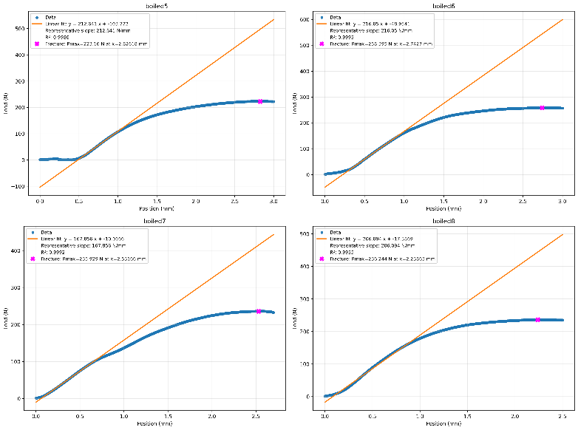
Figure 1(b). Plot of Data of Cooked Bone

Abstract
INTRODUCTION

MATERIALS AND METHODS
Results
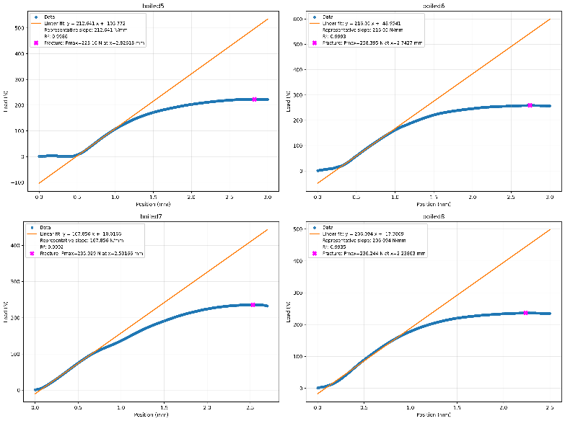
The mechanical properties of raw and cooked chicken cortical bone specimens were evaluated using three-point bending tests. A representative load-deflection curve, illustrating the relationship between applied force and specimen deformation for both conditions, is presented in Figure 1. Key parameters, including structural and material properties, were derived from these data and are summarized below.
Figure 1(a). Plot of Data of Raw Bone

For the raw bone specimen, the average outer diameter was 10.005 mm and the inner diameter was 6.365 mm. The specimen fractured under a load of 357.37 N and demonstrated a structural stiffness of 219.32 N/mm over a span of 40 mm. The calculated second moment of area was 210.48 mm⁴. The material's Young's Modulus was determined to be 1389.34 N/mm². The maximum strain and stress at failure were 0.061 and 84.94 N/mm², respectively, with a corresponding maximum bending moment of 3573.70 N·mm. (Figure 2)

In contrast, the cooked bone specimen, with average outer and inner diameters of 8.815 mm and 5.79 mm, exhibited a lower fracture load of 238.43 N and a slightly reduced stiffness of 200.66 N/mm under the same span. Its second moment of area was calculated as 105.98 mm⁴. A notably higher Young's Modulus of 2524.51 N/mm² was calculated for the cooked bone. The maximum strain was lower at 0.039, while the maximum stress was higher at 99.16 N/mm², with a maximum moment of 2384.30 N·mm. (Figure 2)
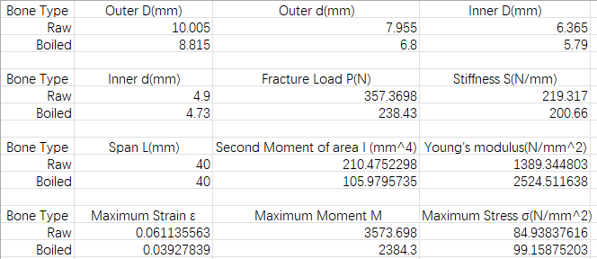
Figure 2. Calculated Data
A statistical comparison of the Young's Modulus, an intrinsic material property, revealed a significant increase in the cooked bone compared to the raw bone. Conversely, the structural properties, namely fracture load and stiffness, were lower in the cooked specimens. The raw bone sustained greater deformation before fracture, as indicated by its higher maximum strain.

discussion
In procedure 4, we processed the chicken bones with the three-point bending test. Discussing the final result, fracture load (P) refers to the maximum force that a sample can withstand before it fractures. The collagen fiber network in living bone can disperse stress through its own elongation and slippage, and prevent the expansion of microcracks. Young's modulus (E) is a material property that measures a material's ability to resist elastic deformation. Cooking denatures collagen, causing it to curl and lose its ordered structure, thereby undermining its effectiveness as a "viscous" energy-absorbing matrix. What remains is primarily a more brittle, mineral-rich skeleton. This more brittle material is less prone to elastic deformation when subjected to force, thus appearing "harder" and having a higher Young's modulus ^{[1]}. As for maximum strain, the toughness of raw bone enables it to undergo significant bending and deformation without breaking. Conversely, cooked bone is very brittle and will suddenly break when subjected to even minor deformation. And for maximum stress, after cooking, water loss and collagen denaturation may lead to a denser mineral phase in the bones, potentially slightly enhancing their strength. However, the material's ability to absorb energy before fracture decreases sharply.
The output data showed the initial segments had the displacement but the measured force was zero. This may be primarily due to the unproper settling of specimen. After the initial contact, the bone may settle slightly into a more stable position on the supports, which requires minimal force not detected by the load cell.

Acknowledgments
I would like to express my sincere gratitude to the members of the research team who contributed to the successful completion of this study. Their dedication, expertise, and commitment were instrumental in the realization of our research objectives. I am thankful for their valuable insights, collaborative spirit, and unwavering support throughout the project.
References
[1] Currey, J. D. (1988). The effect of drying and re-wetting on some mechanical properties of cortical bone. Journal of Biomechanics, 21(5), 439-441.

