September 19-29, 2025, SUSTech, Shenzhen, China
Biomedical Engineering Laboratory I (Fall 2025)

Lab 1 introduction to microscopy

姚子墨  12312221 | Author Name  Affiliation  City, State, Country

Author Name  Affiliation  City, State, Country | Author Name  Affiliation  City, State, Country | Author name  Affiliation  City, State, Country

Abstract
INTRODUCTION
In this laboratory, we aim to integrate biomechanical testing with fundamental materials—including metals, polymers, and bone—to develop a deeper understanding of their mechanical properties. Tensile tests and three-point bending experiments will be employed to facilitate this investigation.

Tensile testing involves applying an axial load to a specimen, enabling the measurement of its elongation response and providing insights into strength and ductility. During the test, the applied load 𝑃 (in Newtons, N) and the resulting deformation Δ𝐿 (change in length relative to the original length 𝐿₀) are recorded. Stress 𝜎 (in N/m²) is derived from the load and the specimen’s cross-sectional area 𝐴, while strain 𝜀 represents the relative deformation. These relationships are defined by the following equations:
$$σ=\frac{P}{A} \left(1\right)$$
$$ε=\frac{∆L}{L_{0}} (2)$$
To better interpret material behavior under load, stress-strain curves are constructed. These plots illustrate how materials deform under varying stress levels and reveal key characteristics such as elastic and plastic deformation, as well as strength. Young’s modulus (elastic modulus) 𝐸, defined as the slope of the curve in the elastic region, quantifies material stiffness and describes the material’s ability to return to its original shape upon unloading ^{[2]}. This relationship is expressed as:
$$σ=Eε (3)$$
The transition from elastic to plastic deformation is marked by the yield strength 𝜎𝑦. Typically identified as the point where the stress-strain curve deviates from linearity—or, for metals, using the 0.2% offset method—yield strength tends to increase with strain rate and decrease with temperature.

Ultimate tensile strength (UTS) refers to the maximum stress a material can sustain. For brittle materials, UTS occurs at the end of the elastic region, while for ductile materials, it lies within the plastic region. Fracture strength denotes the stress at which the material breaks, often aligning with UTS in brittle materials.
Another key method used in this lab is three-point bending, which applies a load at the midpoint of a specimen supported at both ends. This technique is especially suitable for biological specimens due to its minimal preparation requirements. Using a universal testing machine, the applied load 𝑃 and the resulting deflection 𝛿 are measured, following the relation:
$$P=\frac{48EIδ}{L^{3}} (4)$$

Structural stiffness 𝑆, defined as the slope of the load-deflection curve, is given by:
$$S=\frac{48E}{L^{3}}(5)$$
Stiffness depends on both material properties and geometric configuration. Young’s modulus can be determined experimentally via:
$$E=\frac{PL^{3}}{48Iδ}(6)$$
In this experiment, we will test, analyze, and compare data from cast iron and low-carbon steel, polystyrene (PS) and polyethylene (PE), as well as raw and cooked chicken drumsticks. Through these activities, we will develop a practical understanding of mechanical testing principles, learn to measure load and deformation, differentiate between structural and material properties, and empirically determine elastic and yield characteristics.
MATERIALS AND METHODS
Procedure 4. Point Bending Test - Bones
- Prepare ten chicken thigh bones by removing all muscle and connective tissue with scissors. Measure and record the span length of each bone.
- Assign five bones to the cooked group by boiling them for 10 minutes; reserve the remaining five as the raw group.
- Individually test each bone (both raw and cooked) to failure using a three-point bending fixture.
- Following the test, clean out the bone marrow and record all experimental data [5].
- Measure the inner and outer diameters of each bone specimen to calculate the maximum strain and ultimate stress.
- Compare the Young's modulus between the raw and cooked bones, and discuss the potential factors influencing the differences.

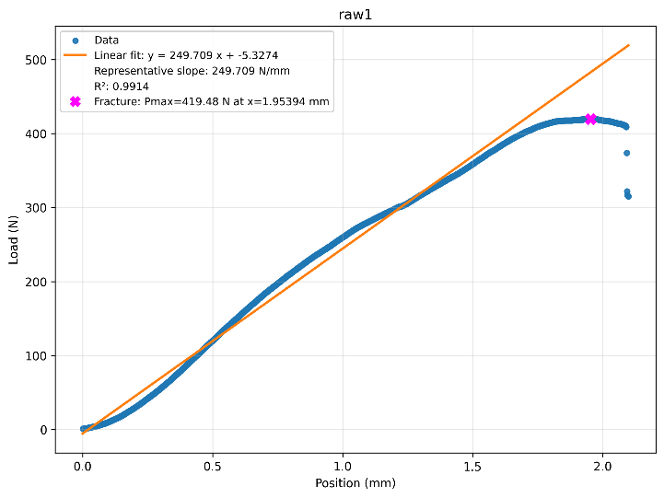
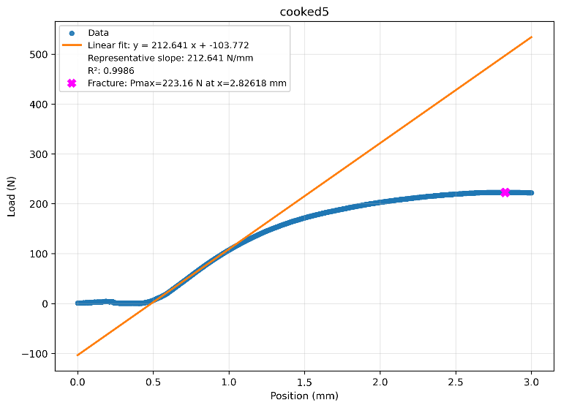
Results
Figure 1(a). Plot of Data of Raw Bones (Sample 1)
Figure 1(a). Plot of Data of Raw Bone (Sample 1)
Figure 2(b). Plot of Data of Cooked Bone (Sample 5)
The mechanical properties of raw and cooked chicken cortical bone specimens were evaluated using three-point bending tests. A representative load-deflection curve, illustrating the relationship between applied force and specimen deformation for both conditions with the crosshead speed of 5mm/min and, is presented in Figure 1, where the rest is shown in appendix. Key parameters, including structural and material properties, were derived from these data and are summarized below.
After the testing of bones, we measured the inner and outer diameters of our bones, which are presented in Table 1.

Table 1(a). Original Data of Raw Bone
Raw Bone |  | 1 | 2 | 3 | 4 | AVERAGE
Inner Diameter(mm) | x | 5.34 | 8.9 | 5.82 | 5.4 | 6.37
 | y | 4.84 | 4.88 | 4.88 | 5 | 4.90
Outer Diameter(mm) | x | 11.36 | 9.94 | 9.94 | 8.78 | 10.01
 | y | 8.76 | 7.76 | 7.76 | 7.54 | 7.96

Table 1(b). Original Data of Cooked Bone
Cooked Bone |  | 1 | 2 | 3 | 4 | AVERAGE
Inner Diameter(mm) | x | 5.90 | 6.30 | 5.88 | 5.08 | 5.7900
 | y | 4.52 | 5.34 | 4.80 | 4.26 | 4.7300
Outer Diameter(mm) | x | 8.74 | 9.78 | 9.02 | 7.72 | 8.8150
 | y | 6.54 | 7.06 | 7.32 | 6.28 | 6.8000

And in the following step, we calculated the second moment of area (I, mm^4), maximum strain (ε), maximum moment (M, N/mm²) and maximum stress (σ, N/mm^2),which were presented in Table 2.

Table 2(a). Calculated Data of Raw Bone
Raw | Property | Value | Property | Value
 | Outer D (mm) | 10.005 | Inner d (mm) | 4.9
 | Outer d (mm) | 7.955 | Fracture Load P (N) | 357.3698
 | Inner D (mm) | 6.365 | Stiffness S (N/mm) | 219.317
 | Span L (mm) | 40 | Second Moment of area I (mm⁴) | 210.4752298
 | Young's modulus (N/mm²) | 1389.344803 | Maximum Strain ε | 0.061135563
 | Maximum Moment M | 3573.698 | Maximum Stress σ (N/mm²) | 84.93837616

Table 2(b). Calculated Data of Cooked Bone
Cooked | Property | Value | Property | Value
 | Outer D (mm) | 8.815 | Inner d (mm) | 4.73
 | Outer d (mm) | 6.8 | Fracture Load P (N) | 238.43
 | Inner D (mm) | 5.79 | Stiffness S (N/mm) | 200.66
 | Span L (mm) | 40 | Second Moment of area I (mm⁴) | 105.979
 | Young's modulus (N/mm²) | 2524.511 | Maximum Strain ε | 0.03927
 | Maximum Moment M | 2384.3 | Maximum Stress σ (N/mm²) | 99.158

A statistical comparison of the Young's Modulus, an intrinsic material property, revealed a significant increase in the cooked bone compared to the raw bone. Conversely, the structural properties, namely fracture load and stiffness, were lower in the cooked specimens. The raw bone sustained greater deformation before fracture, as indicated by its higher maximum strain.

discussion
In procedure 4, we processed the chicken bones with the three-point bending test. Discussing the final result, fracture load (P) refers to the maximum force that a sample can withstand before it fractures. The collagen fiber network in living bone can disperse stress through its own elongation and slippage, and prevent the expansion of microcracks. Young's modulus (E) is a material property that measures a material's ability to resist elastic deformation. Cooking denatures collagen, causing it to curl and lose its ordered structure, thereby undermining its effectiveness as a "viscous" energy-absorbing matrix. What remains is primarily a more brittle, mineral-rich skeleton. This more brittle material is less prone to elastic deformation when subjected to force, thus appearing "harder" and having a higher Young's modulus ^{[2]}. As for maximum strain, the toughness of raw bone enables it to undergo significant bending and deformation without breaking. Conversely, cooked bone is very brittle and will suddenly break when subjected to even minor deformation. And for maximum stress, after cooking, water loss and collagen denaturation may lead to a denser mineral phase in the bones, potentially slightly enhancing their strength. However, the material's ability to absorb energy before fracture decreases sharply.
The output data showed the initial segments had the displacement but the measured force was zero. This may be primarily due to the unproper settling of specimen. After the initial contact, the bone may settle slightly into a more stable position on the supports, which requires minimal force not detected by the load cell.
For the ethical question in hip implant design, the best samples are human femurs from body donors (cadaveric specimens). These provide the most accurate data on bone structure and strength for the intended patient population.
The ideal donors are older adults (aged 60-80), with a mix of males and females, to match the typical patient profile. We should screen medical histories to exclude bones with major diseases like advanced cancer or severe osteoporosis, though some mild age-related bone loss is actually useful for realistic testing.
Ethically, this research depends entirely on documented consent from authorized body donation programs. All work must be conducted with respect for the donors and must receive formal ethical approval.
While studying living human tissue would be scientifically ideal, it is ethically impossible. Therefore, using carefully sourced cadaveric specimens is the best possible approach, balancing the need for valid scientific data with strict ethical responsibility.

Acknowledgments
I would like to express my sincere gratitude to the members of the research team who contributed to the successful completion of this study. Their dedication, expertise, and commitment were instrumental in the realization of our research objectives. I am thankful for their valuable insights, collaborative spirit, and unwavering support throughout the project.
References
[1] TWI. What is Tensile Testing? (2021), [Online]. Available: https://www.twi-global.com/technical-knowledge/faqs/ what-is-tensile-testing.
[2] Currey, J. D. (1988). The effect of drying and re-wetting on some mechanical properties of cortical bone. Journal of Biomechanics, 21(5), 439-441.

Appendix
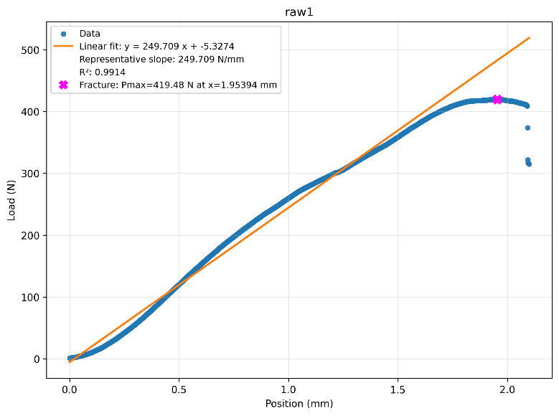

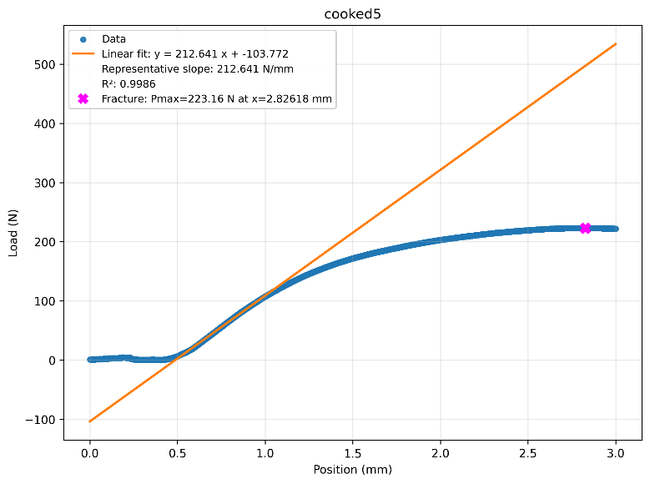
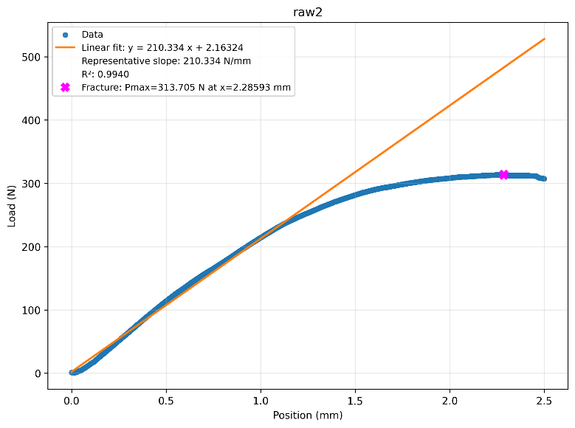
Figure 1(b). Plot of Data of Raw Bones (Sample 5)
Figure 1(a). Plot of Data of Raw Bones (Sample 2)
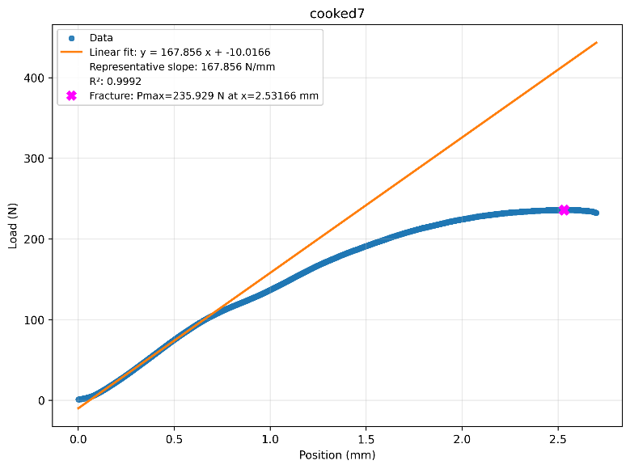
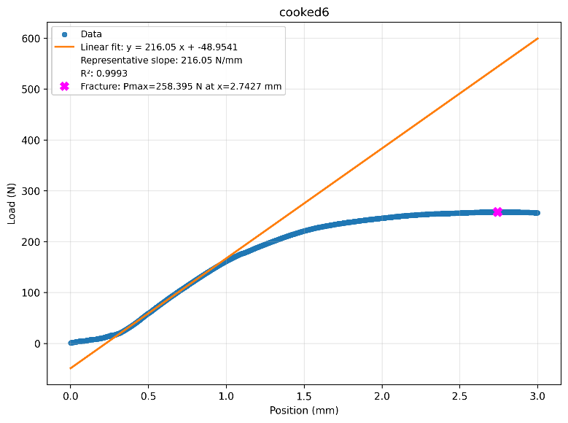
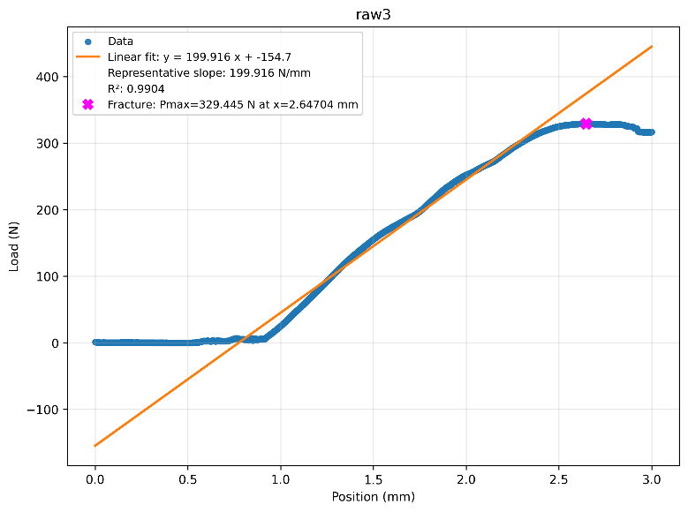
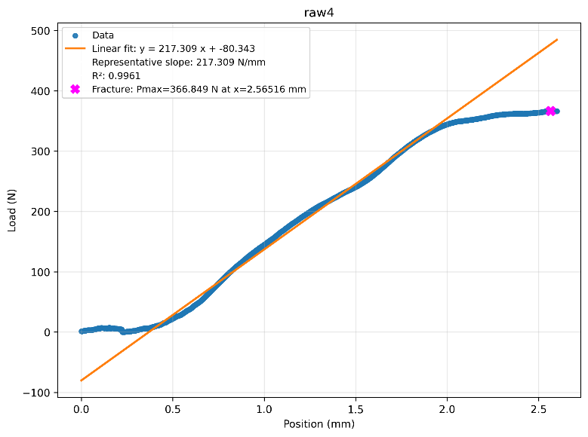
Figure 1(b). Plot of Data of Raw Bones (Sample 7)
Figure 1(b). Plot of Data of Raw Bones (Sample 6)
Figure 1(a). Plot of Data of Raw Bones (Sample 3)
Figure 1(a). Plot of Data of Raw Bones (Sample 4)
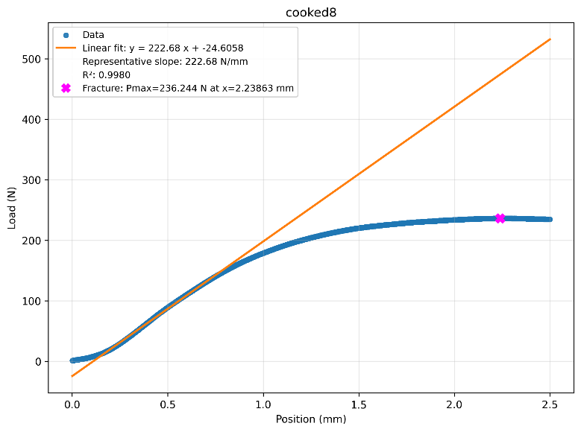
Figure 1(b). Plot of Data of Raw Bones (Sample 8)

