Sep 29 to Oct 18, 2025, SUSTech, Shenzhen, China
Biomedical Engineering Laboratory I (Fall 2025)

Lab 2 biomechanical testing

Group 5
姚子墨  12312221 | 吴赟戎  12313320

姜晨曦  12212109 | 涂昀烨  12313314

Abstract
We compared the mechanical responses of metals (Q235 steel, HT150 cast iron), polymers (PS, PE), and cortical bone using uniaxial tension and three-point bending. Engineering stress–strain and load–deflection data yielded Young’s modulus, yield metrics (offset or upper/lower yield), and ultimate stress when observed. Steel showed the highest stiffness (E ≈ 210.7 GPa), while cast iron was lower and more brittle (E ≈ 79.2 GPa). PS was stiffer (E ≈ 2.47 GPa) than PE (E ≈ 0.20 GPa), with PE displaying pronounced ductility. Moduli from bending differed from tension, consistent with system compliance and shear effects at short span-to-depth ratios. For bone, cooking produced a small, non-significant change in apparent modulus (2.88 → 2.16 GPa; P = 0.111). These results highlight method-dependent artifacts and material contrasts relevant to biomedical and structural applications.

INTRODUCTION
In this laboratory, we aim to integrate biomechanical testing with fundamental materials—including metals, polymers, and bone—to develop a deeper understanding of their mechanical properties. Tensile tests and three-point bending experiments will be employed to facilitate this investigation.
Tensile testing involves applying an axial load to a specimen, enabling the measurement of its elongation response and providing insights into strength and ductility. During the test, the applied load 𝑃 (in Newtons, N) and the resulting deformation Δ𝐿 (change in length relative to the original length 𝐿₀) are recorded. Stress 𝜎 (in N/m²) is derived from the load and the specimen’s cross-sectional area 𝐴, while strain 𝜀 represents the relative deformation. These relationships are defined by the following equations:
$$σ=\frac{P}{A}$$

$$ε=\frac{∆L}{L_{0}}$$

To better interpret material behavior under load, stress-strain curves are constructed. These plots illustrate how materials deform under varying stress levels and reveal key characteristics such as elastic and plastic deformation, as well as strength. Young’s modulus (elastic modulus) 𝐸, defined as the slope of the curve in the elastic region, quantifies material stiffness and describes the material’s ability to return to its original shape upon unloading ^{[2]}. This relationship is expressed as:

$$σ=Eε$$

The transition from elastic to plastic deformation is marked by the yield strength 𝜎_{s}. Typically identified as the point where the stress-strain curve deviates from linearity—or, for metals, using the 0.2% offset method—yield strength tends to increase with strain rate and decrease with temperature.
Ultimate tensile strength (UTS) refers to the maximum stress a material can sustain, or more specifically, the end point of the stress-strain plot. For brittle materials, UTS occurs shortly after the elastic region ends, while for ductile materials, it lies within the plastic region. Fracture strength denotes the stress at which the material breaks, often aligning with UTS in brittle materials.
Another key method used in this lab is three-point bending, which applies a load at the midpoint of a specimen supported at both ends. This technique is especially suitable for biological specimens due to its minimal preparation requirements. Using a universal testing machine, the applied load 𝑃 and the resulting deflection 𝛿 are measured, following the relation:

$$P=\frac{48EIδ}{L^{3}}$$

Structural stiffness 𝑆, defined as the slope of the load-deflection curve, is given by:

$$S=\frac{48E}{L^{3}}$$

Stiffness depends on both material properties and geometric configuration. Young’s modulus can be determined experimentally via:

$$E=\frac{PL^{3}}{48Iδ}$$

In this experiment, we will test, analyze, and compare data from cast iron and low-carbon steel, polystyrene (PS) and polyethylene (PE), as well as raw and cooked chicken drumsticks. Through these activities, we will develop a practical understanding of mechanical testing principles, learn to measure load and deformation, differentiate between structural and material properties, and empirically determine elastic and yield characteristics.
MATERIALS AND METHODS
Materials used in this laboratory are cast iron, low carbon steel, polystyrene and polyethylene specimens, raw drumstick bones, cooked drumstick bones, calipers, multipurpose material testers and extensometers.
In procedure 1, two kinds of metal rod specimens, cast iron (HT150) and low carbon steel (Q235), of circular cross section were subjected to the tensile test. Preparation of the specimens and the procedure of the test were completed based on Chinese GB Standard GB/T 228.1.
We first used a caliper to measure and record the diameters of the metal specimens and calculated the average dimension as the geometrical data for calculating stress. For each specimen, we marked on one end and measured the diameter at the upper, middle and lower part of the specimen, twice, respectively, and attained 6 data in total. Then, we mounted the specimen on the fixture of the testing machine and tied the extensometer onto the specimen with two rubber bands.
Each specimen ran through the testing protocol and stopped at fracture, after setting a crosshead speed at 10 mm/min for iron 4,5,6, steel 1,2,4 and 50 mm/min for iron 7,8,9, steel 5,6,7, which is a resultant strain rate of 0.2/min and 1/min under the gauge length (50 mm) given by manual. Specifically, for the 10 mm/min group in steel, we stopped the test in 120 s instead of at fracture. For the cast iron case, we used 9 specimens, among which the specimens labelled 1, 2 and 3 failed to produce correct tensile data, therefore their results were abandoned. Similarly, we abandoned specimen 3 and 8 in 8 low carbon steel specimens. A dataset of deform value and load value before fracture is acquired from the control panel of the experiment device for each specimen, stored in .mdb format. After converting them to stress and strain data by dividing the gauge length of 50mm and cross section area given by the diameters in table 1, stress-strain plots were drawn using MATLAB, along with linear fit of the elastic deformation part of the plot, carrying out the 0.2% strain offset method to find the yield strength of the iron specimens and the locating the lower yield strength of the steel specimens.
In procedure 2, to analyze the polymer specimens, we tested the cross-sectional area and the stress-strain curve of PS (polystyrene), PE (polyethylene) materials. Then, we are able to calculate the Young’s modulus and find the ultimate tensile strength and the yield strength.
First, we measured the width and height of each specimen, then we calculate the area of each specimen. After that, we followed the manual and did a tensile test for each material. The crosshead speed is constant (30 mm/min), the testing time is 120 s and we used the long travel extensometer to measure the exact deformation of the plastic.
For PE, we already knew this kind of material can be extended for a long length, which may go beyond the limit of the testing machine, so we stopped the experiment at t=120 s. For PS, the material is brittle, so we stopped at fracture.
The rest is similar to procedure 1. We analyzed the data with MATLAB, drew the stress-strain plot and calculate Young’s modulus. The UTS and yield strength are also counted, which appeared to be different from metal materials.
In procedure 3, we performed center-loaded three-point bending on rectangular beams of Q235 low carbon steel and HT150 cast iron. Specimen width$b$and thickness$h$were measured at three positions and averaged; the support span $L$was set with the bending fixture. Tests were run in displacement control at the specified crosshead rate (5 mm/min) until fracture or the machine limit (deflection reaches 10 mm), while recording load $F$and mid-span deflection $δ$. The initial stiffness $S$was obtained from a linear fit to the early$F$–$δ$ segment, and Young’s modulus was calculated as $E=SL^{3}/(48I)$with $I=bh^{3}/12$; fracture load was also recorded.
In procedure 4, we compared raw versus cooked chicken cortical bone under the same three-point bending setup and rate. 8 chicken thigh bones were cleaned of soft tissues and kept moist; five were boiled for 10 min and 4 remained raw. After setting the span $L$, each specimen was tested to fracture with continuous load–displacement acquisition. Post-test, outer diameter and inner diameter at mid-span were measured after removing the bone marrow to compute the second moment of area. The apparent modulus was then computed as $E_{\text{app}}=SL^{3}/(48I)$, with $S$taken from the initial linear region; fracture load and the corresponding deflection were recorded.
Results
For procedure 1, the measured dimensions are shown in Table 1. Average figures were used to calculate the cross-section area of the specimens so that the load result can be converted into stress results.

d(mm) | Iron 4 | Iron 5 | Iron 6 | Iron 7 | Iron 8 | Iron 9
1(up) | 3.94 | 4.00 | 4.02 | 4.06 | 3.92 | 4.20
2(up) | 4.00 | 3.94 | 4.06 | 4.04 | 3.90 | 4.18
3(mid) | 3.74 | 3.94 | 3.94 | 4.02 | 3.80 | 4.02
4(mid) | 3.84 | 4.00 | 4.16 | 3.90 | 3.80 | 4.12
5(low) | 4.12 | 4.02 | 3.84 | 4.02 | 4.00 | 4.16
6(low) | 4.10 | 4.10 | 3.82 | 3.90 | 4.02 | 4.14
average | 3.96 | 4.00 | 3.97 | 3.99 | 3.91 | 4.14

d(mm) | Steel 1 | Steel 2 | Steel 4 | Steel 5 | Steel 6 | Steel 7
1(up) | 4.02 | 4.00 | 4.04 | 4.00 | 3.98 | 4.10
2(up) | 3.94 | 3.94 | 4.06 | 4.10 | 3.98 | 4.08
3(mid) | 3.84 | 3.84 | 4.06 | 3.92 | 3.96 | 4.06
4(mid) | 3.82 | 3.86 | 4.06 | 3.94 | 3.98 | 4.02
5(low) | 3.84 | 3.94 | 4.06 | 3.96 | 3.92 | 4.08
6(low) | 3.82 | 3.92 | 4.12 | 3.94 | 3.86 | 4.04
average | 3.88 | 3.92 | 4.07 | 3.98 | 3.95 | 4.06
Table 1: Measured and average diameters of the specimens.

Two representative stress-strain plots from MATLAB are shown in Figure 2. The slope of the linear fit is the value of the Young’s modulus. The intersect of the 0.2% offset line and the curve is the yield point, where the yield strength and strain can be found. (Fig. 2)
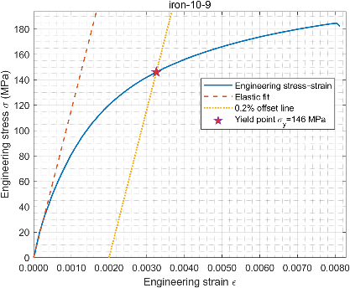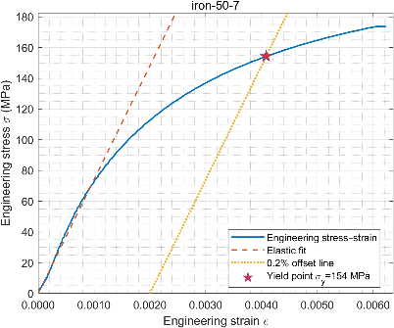
b
a
Figure 1: Stress-strain plot of specimen (a) Iron 9 (10 mm/min), (b) Iron 7 (50 mm/min), including linear fit of the elastic part and the 0.2% strain offset line.

In Fig. 1(a) we can see that stress-strain plots of cast iron have simple curve shapes, short linear part and an ambiguous yield point. The fracture happens shortly after yielding. In Fig. 1(b) we can notice that the fracture comes even faster when the strain rate is higher.
For the steel specimen, the upper yield strength is found at the point where stress begins to decrease, and the lower yield strength is the minimum stress within the early yielding plateau. (Fig. 2)

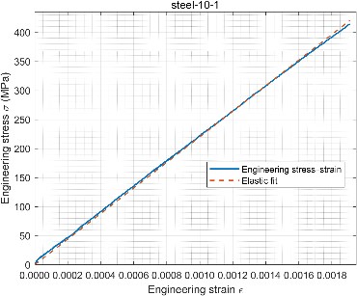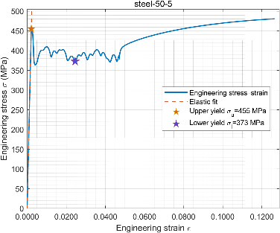
a
b
Figure 2: Stress-strain plot of specimen (a) Steel 1 (10mm/min, 120s), (b) Steel 5 (50mm/min), including linear fit of the elastic part and the upper/lower yield strength in(b).

In Fig. 2(a) the Steel 1 specimen behaved as almost perfect elasticity, showing a straight line in stress strain plot, which implies that steel is far from yielding after 120 s of loading. In Fig. 2(b), the plot has a typical pattern of the yielding of steel specimen, with a short linear section, a valley at the beginning of yielding, an oscillating plateau of yielding process and a long tail of plastic deformation.
The ultimate tensile strength is recorded by identifying a maximum stress at the end of the curve. For specimen steel 1,2,4, ultimate tensile strength is invalid since they did not fracture in the test.
Results are collected in Table 2.

Specimen Name | E (GPa) | σ_{s} (MPa) | Linear Fit R² | σ_{UTS} (MPa)
iron-10-4 | 84.18 | 119.54 | 0.9388 | 142.052
iron-10-5 | 81.76 | 185.99 | 0.9901 | 196.735
iron-10-9 | 116.36 | 146.10 | 0.9900 | 184.576
iron-50-6 | 86.70 | 155.65 | 0.9900 | 200.271
iron-50-7 | 74.07 | 154.24 | 0.9907 | 173.724
iron-50-8 | 81.87 | 149.21 | 0.9908 | 182.053
average | 87.49 | 151.79 | NaN | 179.901
STD | 14.76 | 21.30 | NaN | 20.954

Specimen Name | E (GPa) | Linear Fit R² | σ_{s-upper} (MPa) | σ_{s-lower} (MPa) | σ_{UTS} (MPa)
steel-10-1 | 220.26 | 0.9993 | NaN | NaN | NaN
steel-10-2 | 184.89 | 0.9875 | NaN | NaN | NaN
steel-10-4 | 249.64 | 0.9840 | NaN | NaN | NaN
steel-50-5 | 215.98 | 0.9959 | 455.41 | 372.81 | 480.844
steel-50-6 | 204.73 | 0.9902 | 461.79 | 386.52 | 491.422
steel-50-7 | 207.82 | 0.9987 | 461.49 | 373.57 | 484.899
average | 213.8867 | 0.9919 | 459.56 | 377.63 | 485.721
STD | 21.37643 | 0.0074 | 3.60 | 7.7054 | 5.33676

Table 2: Data analysis results given by MATLAB program.

During the test, the shape of cast iron barely has any noticeable change, and it forms a flat fracture face after ultimate tensile strength. This means that cast iron is a kind of brittle material, which withstand almost no plastic deformation.
On the other hand, “necking” phenomenon, where the specimen begins to elongate and forms a cross section with reducing area, happens a short period of time after the test has started. Such “necking” results from an instability during tensile deformation when the cross-sectional area of the sample decreases by a greater proportion than the material strain hardens. (Wikipedia) When fracture, the specimen comes in a cup-and-cone fracture mode.

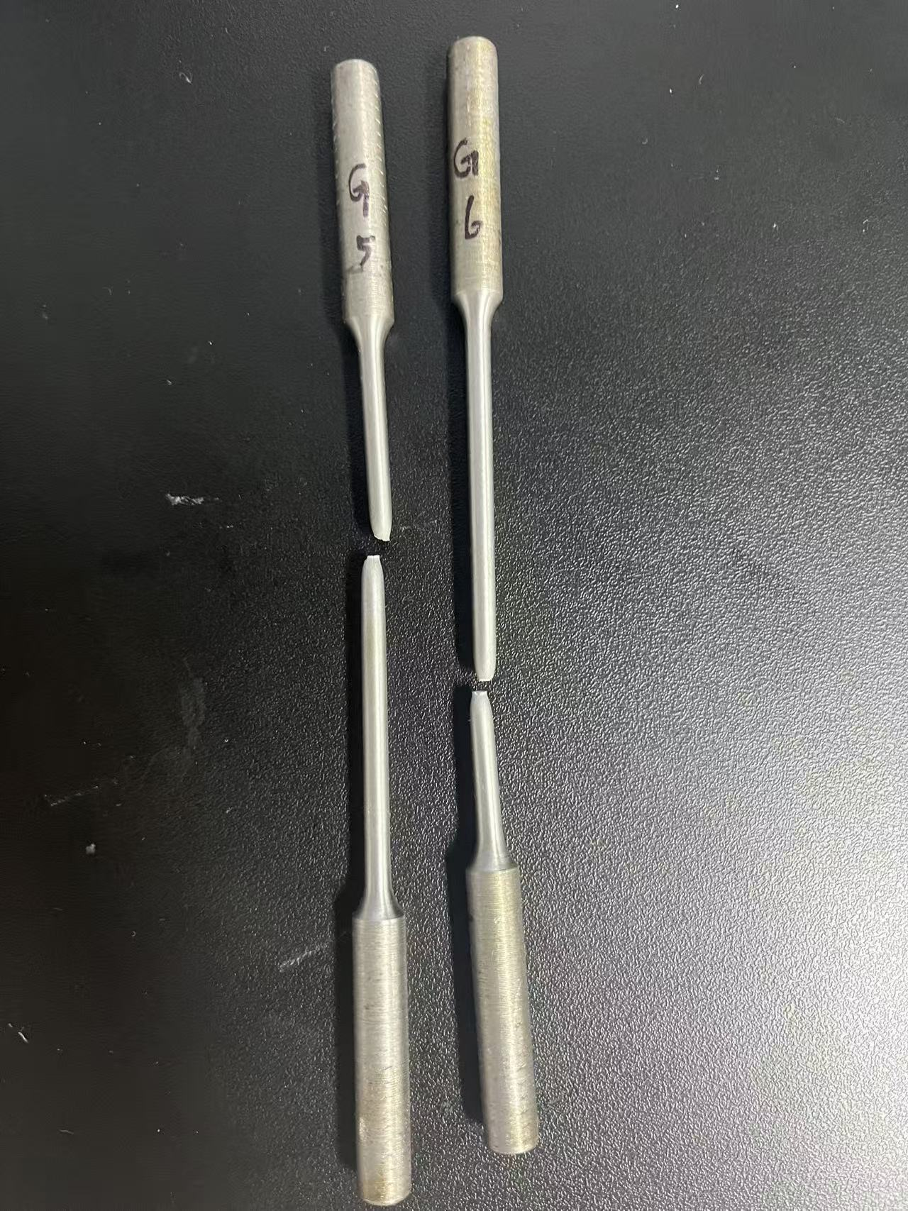
Figure 3: Shape of low carbon steel specimen 5 and 6 after fracture. A significant phenomenon of necking and forming a cup-and-cone fracture can be noticed.

The properties obtained were pooled for statistical analysis. Welch’s t-test was performed between the properties of the specimens with same crosshead speed but of different material, and vice versa. For convenience, lower yield strength was used for steel in comparison. Invalid values were excluded.
The t-test results are discussed later in the report. Complete plots of every case are included in appendix.

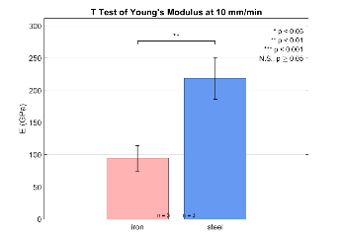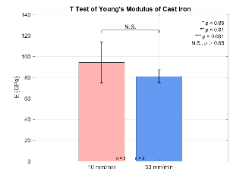
b
a
Figure 4: T-tests of Young’s Modulus between (a)different materials and (b)different crosshead speed in iron.

In procedure 2, the measured dimensions for calculating the cross-sectional area of the polymers are recorded in Table 3.

Table 3: Height, width and cross-sectional area of polymers

Figure 5 shows the stress-strain plot of PE and PS specimens. Apparently the two materials are different. PE has no obvious yield strength while PS has typical yield strength and ultimate tensile strength.

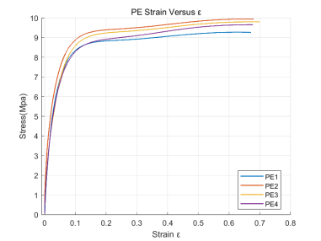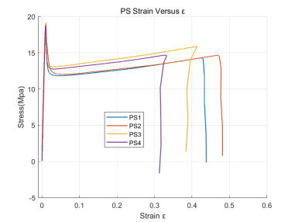
b
a
Figure 5: Stress-strain plot of polymers (a) PE (b) PS.

In Figure 6, we choose the first specimen (PE 1) as a representative to analyze the Young’s modules, yield strengths and ultimate tensile strengths. The figure is continuously going up, as well as the stress. We are unable to find the ultimate tensile strength since the material did not fracture. According to GB/T 1040.2-2006, in this situation, we should use x% strain tensile stress instead of yield stress.
In this case: 3% strain tensile stress = 5.4857 MPa, E=181.7793 MPa; 10% strain tensile stress = 8.3502 MPa, E=83.0239 MPa; UTS=9.2773 MPa.

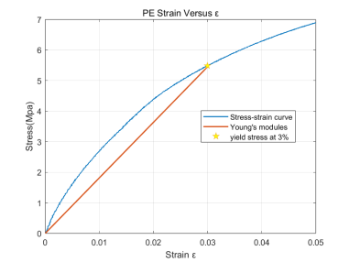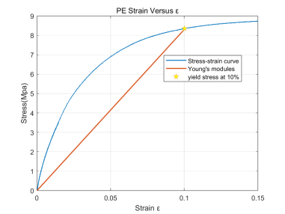
a
b
Figure 6: Stress-strain plot of PE specimen 1 with (a) 3% strain tensile stress line (b) 10% strain tensile stress line.

In Figure 7, we choose the PS1 as a representative to analyze the Young’s moduli, yield strengths and ultimate tensile strengths.
PS1 has obvious upper yield strength at 17.9243 MPa, lower yield strength at 11.8529 MPa, and the upper yield strength is also the ultimate tensile strength. The curve has a linear part in the beginning and then reaches the upper yield strength. After the ultimate tensile strength, the stress goes down and comes to the lower yield strength. Then the curve goes gentle until the curve ends. The Young’s Modulus is 2029.8 MPa.
During the test, we observed that PE specimen extended very long but didn’t fracture. The elongated part has become thinner and easy to bend. PS specimen is brittle, which fractured with a clear sound.
Table 4 contains all data we calculated with MATLAB. The ultimate tensile strength of PS is found in the figure, while the UTS of PE may not accurate. Limited by the test length, we did not break PE specimen. The stress may become bigger when strain is bigger.
It is apparent that the yield strength and ultimate tensile strength are material properties. In our lab, the shape of specimen is the same (Fig 8), all prepared under the instruction of GB/T 1040.2-2006, and the cross-section area difference is not significant.

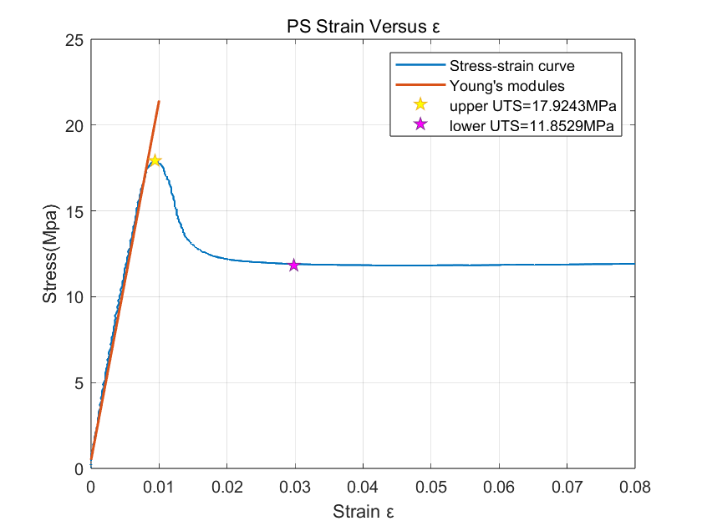
Figure 7: Stress-strain plot of PS specimen 1

table 4: Young’s modulus and UTS of polymer specimen.

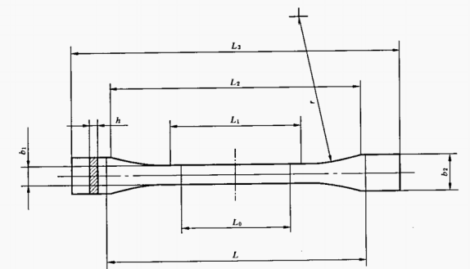
Figure 8: Dumbbell shaped specimen

Figure 9 shows the cross-sectional area. The T-test of PE and PS is 0.000308, proved that the shape has little influence in material feature.

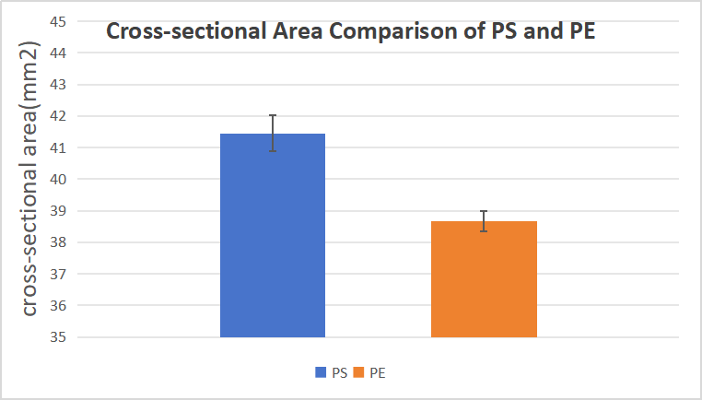
Figure 9: Analysis of cross-sectional area difference

In procedure 3, We measured the average width and thickness of four samples of each metal and calculated the moments of inertia of the cross sections using the equation:
$$I=\frac{bh^{3}}{12}$$. In addition, we recorded the crosshead velocity of the specimens and the span of the two lower supporting posts L. (Table 5)

Table 5: Width, Thickness and Moment of Inertia of metals.

In the test, the low carbon steel bent significantly in the center and became “U” shaped, while the cast iron broke quickly with insignificant deformation. With the data of load force P and displacement $δ$, we can plot the load-deflection curves for the three-point bending tests (Figure 10). Fitting the linear portion gives the stiffness S. We have also labeled the maximum load $P_{max}$, although no load drop has yet occurred on the low carbon steel. The curves show that cast iron broke immediately after the maximum load was reached, while low carbon steel had better toughness.

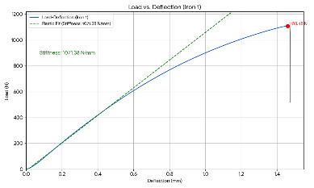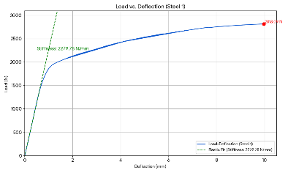
Figure 10: Load-deflection plots for the three-point bending tests. (a) Iron 1 (b) Steel 1

Getting the stiffness and the fracture load, we can calculate Young’s Modulus by $E=\frac{PL^{3}}{48δI}=\frac{SL^{3}}{48I}$. We can also fetch the maximum moment${ M}_{max}$ by${ M}_{max}=\frac{P_{max}L}{4}$ at the mid-span of the specimen during the whole process. Then from the beam theory $σ_{max}=\frac{M_{max}h}{2I}$, we calculate the maximum bending stress. The results are shown in Table 6. We have noted that the results for the Young’s Modulus of both low carbon steel and cast iron are much smaller than what are shown in Procedure 1.
According to the t-test results (Fig. 11), we can confirm that the Young's moduli of the two metal materials measured by the three-point bending method exhibit significant differences from those obtained via the tensile method. As shown in the following figure, the p-values of both materials are less than 0.01, which confirms the validity of our observation: the Young's modulus measured by the three-point bending method is lower than that measured by the tensile method.

Table 6: Calculation results of procedure 4.

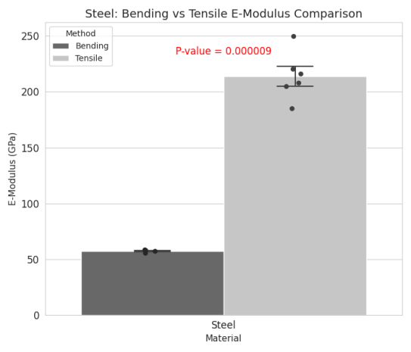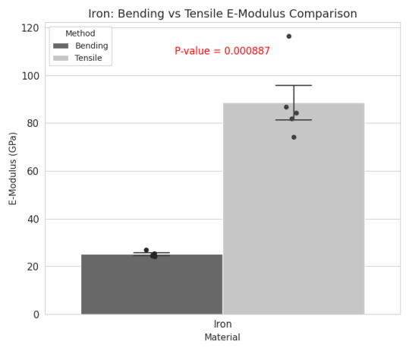
Figure 11: T-test results of Young’s Modulus obtained from tensile test and bending test of (a) Iron (b) Steel.

For procedure 4, the mechanical properties of raw and cooked chicken cortical bone specimens were evaluated using three-point bending tests. A representative load-deflection curve, illustrating the relationship between applied force and specimen deformation for both conditions with the crosshead speed of 5 mm/min and, is presented in Figure 12, where the rest is shown in appendix. Key parameters, including structural and material properties, were derived from these data and are summarized below.
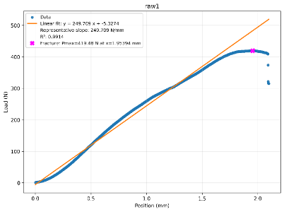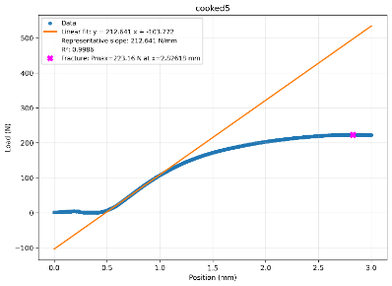
b
a
Figure 12: Load-Deflection plot of (a) Raw bone 1 and (b) Cooked bone 5.

After the testing of bones, we measured the inner and outer diameters of our bones, which are presented in Table 7. The shape of the bone cross-section is simplified as demonstrated in Figure 13, and the area and second moment of area is calculated is based on such simplification.

Table 7: Inner and Outer Diameters of Raw and Cooked Bones

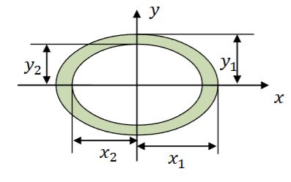
Figure 13: Schematic of the simplified bone cross-section.

And in the following step, we calculated the second moment of area (I, mm⁴), maximum strain (ε), maximum moment (M, N/mm) and maximum stress (σ, N/mm²),which were presented in Table 8.

Table 8: Calculation results of procedure 4.

A statistical comparison of the Young's Modulus, an intrinsic material property, revealed a significant increase in the cooked bone compared to the raw bone. Conversely, the structural properties, namely fracture load and stiffness, were lower in the cooked specimens. The raw bone sustained greater deformation before fracture, as indicated by its higher maximum strain.
discussion
In procedure 1, we obtained the Young’s moduli and the yield strengths of the samples with tensile tests and computer-assisted linear fits.
Using Welch’s t-tests, the strain-rate effect within each material was not significant: for Young’s modulus, cast iron 10 vs 50 mm/min p=0.359 and steel p=0.688; for cast iron, σ_{s} p=0.909 and UTS p=0.596. By contrast, the material effect at a fixed rate was strong: steel > cast iron for Young’s modulus (10 mm/min p=0.0085; 50 mm/min p=1.4×10⁻⁵), for yield strength at 50 mm/min (377.6±7.7 vs 153.0±3.4 MPa, p=4.7×10⁻⁵), and for UTS at 50 mm/min (485.7±5.3 vs 185.3±13.6 MPa, p=1.42×10⁻⁴). Overall, the dominant differences are between materials (steel ≫ cast iron), while increasing the strain rate from 10 to 50 mm/min shows no detectable effect in this dataset.
Regarding addressing the properties, yield strength and ultimate tensile strength are material properties—intrinsic responses defined by standardized tensile tests—rather than structural properties; they do not depend on specimen geometry or boundary conditions, although they can vary with microstructure and with rate/temperature as aspects of material behavior.
According to GB/T 9439-2010, the national standard of grey cast iron, the Young’s Modulus of cast iron HT150 should be 70-90 GPa and the yield strength should be 98-165 MPa. Except for the E = 116.366 GPa of Iron 9 and σs = 185.99 MPa for Iron 5, the other measured properties were all within the standard. According to GB 50017-2003, the national standard of steel parts, Young’s Modulus of low carbon steel Q235 should be 206 GPa and the yield strength should be 235 MPa. All three steel specimens that fractured in test showed a E = 206 ± 10 GPa. However, their lower yield strengths were far beyond standard, having an average 377.6 MPa, error≈60.68%. The minor error and two stray values may be the result of mistake in measurements of diameters or the bad calibration of the testing machine. On the other hand, the massive deviation from standard of the yield strength of Q235 is confusing. It could be that a wrong kind of steel specimen is provide, or the specimen already went through some kind of cold work hardening, changing its mechanical properties.
In Fig.7 a cup and cone fracture is shown. A cup and cone fracture is a type of failure observed in ductile metals and plastics that are subjected to a uniaxial force. For a cup and cone fracture to occur, the metal subjected to the tensile loading must be ductile, i.e., it must be able to exhibit significant amounts of plastic deformation before rupture. As the tensile stress in the metal approaches its yield strength, a small portion of the material’s cross-sectional area decreases in a process known as necking. As the load continues to increase, small cavities form at the necked portion of the material. Any further increase in the load causes the cavities to grow and eventually coalesce to form an elliptical crack perpendicular to the stress direction.
Eventually, the material fails, and the fractured ends of the material take on the distinctive cup and cone shape. This result once again demonstrated the ductile nature of low carbon steel.
In procedure 2, according to GB/T 40006.6-2021, the ultimate tensile strength of PS is ≥18 MPa, while the Young’s modulus is not limited. Relative researches show that the Young’s modulus is in range of 3000-3600 MPa, which is higher than our laboratory data.
The measured UTS data is consistent with the standard, while the Young’s modulus is not. A possible reason is the velocity difference. In the testing standard, the recommended speed is 50 mm/s and our speed is 30 mm/s. The difference in crosshead speed has a huge impact on the testing result.
According to GB/T 11115-2009, the ultimate tensile strength of blow molding type PE is ≥20 MPa, the ultimate strain is ≥ 200%. Limited by our equipment, we did not break the specimen nor get the ultimate data. As a result, we tried to compare the “x% yield strength”. In GB/T, the typical strain is 0.05%, in our specimen is 0.025 mm. The strain is so small that we must consider the measurement errors in modulus caused by possible initial effects at the beginning of the stress-strain curve, which often depends largely on the scale used. In our report, we choose a 3% point (1.5 mm) as a representative strain and calculate the Young’s modulus. The result is smaller than slope at the starting point but still effective.
In procedure 3, we observed that the Young's modulus measured by the three-point bending method was significantly underestimated compared to procedure 1. This is primarily attributed to the fact that the recorded displacement data does not solely represent the true flexure of the specimen; it also encapsulates the system compliance (i.e., the deformation of the test machine itself) and the indentation depth of the loading pin and supports. These combined extraneous displacements lead to an overestimation of the actual specimen deflection. Consequently, the calculated modulus is artificially low (i.e., the material appears softer). Furthermore, due to the specimen's low span-to-depth ratio (i.e., short and thick), errors from uncompensated shear deformation become significant, contributing to a further reduction in the calculated modulus."
In procedure 4, we processed the chicken bones with the three-point bending test. Discussing the final result, fracture load (P) refers to the maximum force that a sample can withstand before it fractures. The collagen fiber network in living bone can disperse stress through its own elongation and slippage and prevent the expansion of microcracks. Young's modulus (E) is a material property that measures a material's ability to resist elastic deformation. Cooking denatures collagen, causing it to curl and lose its ordered structure, thereby undermining its effectiveness as a "viscous" energy-absorbing matrix. What remains is primarily a more brittle, mineral-rich skeleton. This more brittle material is less prone to elastic deformation when subjected to force, thus appearing "harder" and having a higher Young's modulus [10]. As for maximum strain, the toughness of raw bone enables it to undergo significant bending and deformation without breaking. Conversely, cooked bone is very brittle and will suddenly break when subjected to even minor deformation. And for maximum stress, after cooking, water loss and collagen denaturation may lead to a denser mineral phase in the bones, potentially slightly enhancing their strength. However, the material's ability to absorb energy before fracture decreases sharply.
The output data showed the initial segments had displacement, but the measured force was zero. This may be primarily due to the unproper settling of specimen. After the initial contact, the bone may settle slightly into a more stable position on the supports, which requires minimal force not detected by the load cell.
For the ethical question in hip implant design, the best samples are human femurs from body donors (cadaveric specimens). These provide the most accurate data on bone structure and strength for the intended patient population.
The ideal donors are older adults (aged 60-80), with a mix of males and females, to match the typical patient profile. We should screen medical histories to exclude bones with major diseases like advanced cancer or severe osteoporosis, though some mild age-related bone loss is actually useful for realistic testing.
Ethically, this research depends entirely on documented consent from authorized body donation programs. All work must be conducted with respect for the donors and must receive formal ethical approval.
While studying living human tissue would be scientifically ideal, it is ethically impossible. Therefore, using carefully sourced cadaveric specimens is the best possible approach, balancing the need for valid scientific data with strict ethical responsibility.

References
[1] Lab Manual
[2] TWI. What is Tensile Testing? (2021), [Online]. Available: https://www.twi-global.com/technical-knowledge/faqs/ what-is-tensile-testing.
[7] National Technical Committee 54 on Foundry of Standardization Administration of China (GB/T 9439-2010). Shenyang, China, 2010.
[7] Ministry of Construction of the People’s Republic of China, Code for design of steel structures (GB 50017-2003). Beijing: China, Architecture & Building Press, 2003.
[8] https://www.corrosionpedia.com/definition/6218/cup-and-cone-fracture
[9] https://material-properties.org/what-is-work-hardening-cold-working-definition/

[10] Currey, J. D. (1988). The effect of drying and re-wetting on some mechanical properties of cortical bone. Journal of Biomechanics, 21(5), 439-441.
[11] chatgpt.com

Appendix
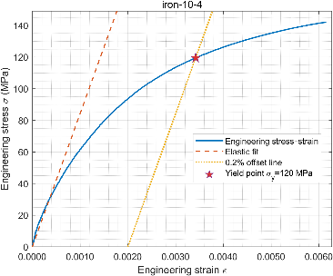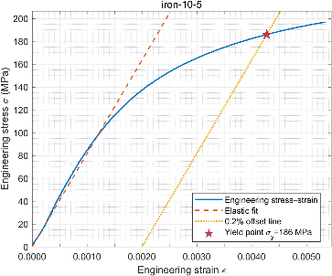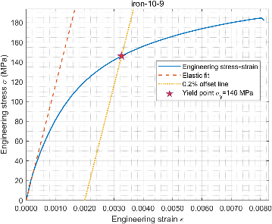
Figure 1: Tensile test of cast iron at 10 mm/min

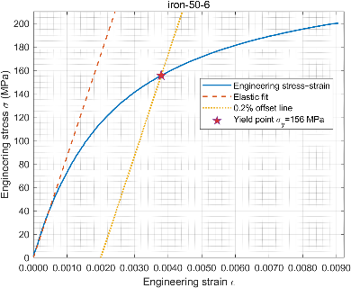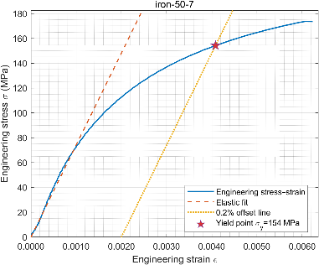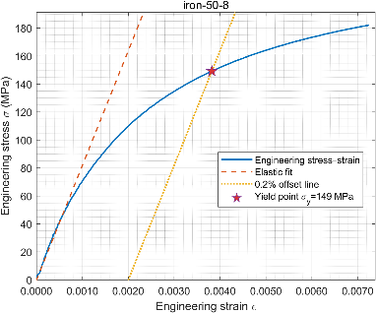
Figure 2: Tensile test of cast iron at 50 mm/min

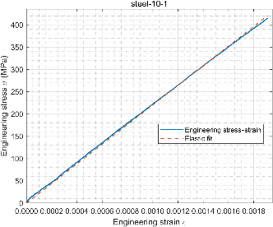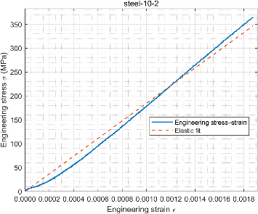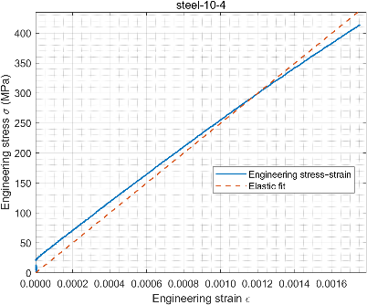
Figure 3: Tensile test of low carbon steel at 10 mm/min

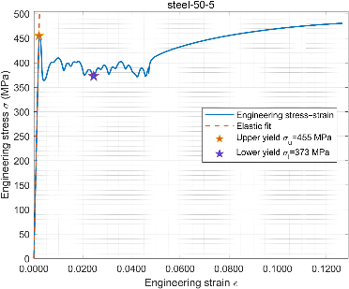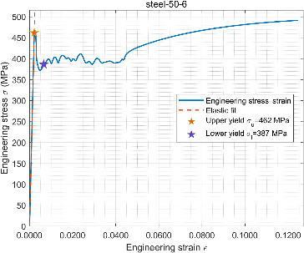
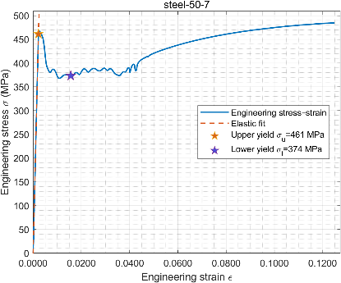
Figure 4: Tensile test of low carbon steel at 50 mm/min

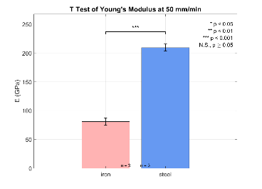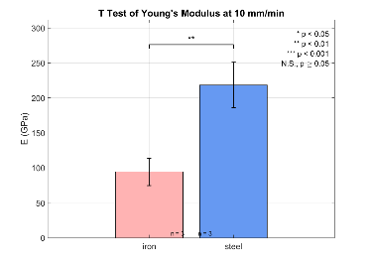 Figure 5: Welch’s T-test results of Young’s Modulus between different materials at 10 and 50 mm/min.

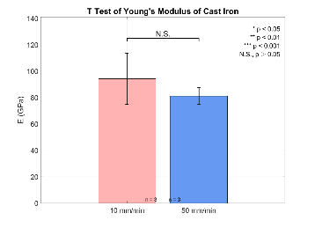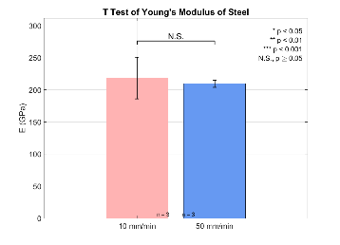
Figure 6: Welch’s T-test results of Young’s Modulus between different crosshead speeds in two materials.

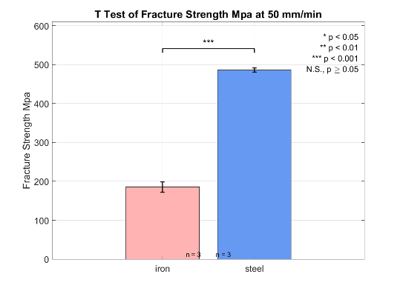
Figure 7: Welch’s T-test results of ultimate tensile strength between different materials at 50mm/min.

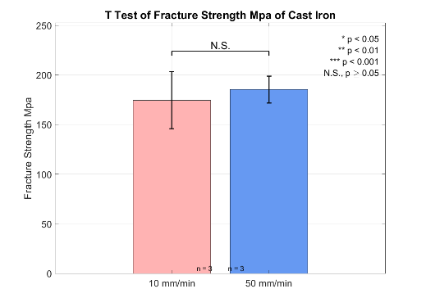
Figure 8: Welch’s T-test results of ultimate tensile strength between different crosshead speeds in cast iron.

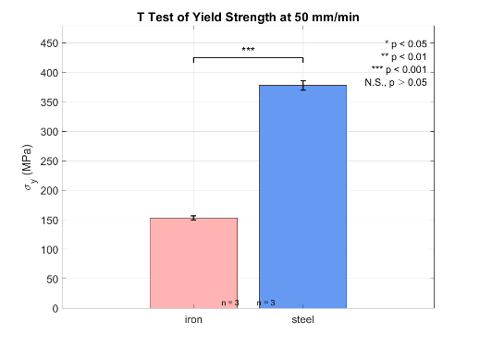
Figure 9: Welch’s T-test results of yield strength between different materials at 50mm/min.

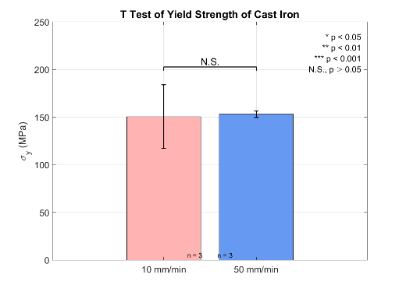
Figure 10: Welch’s T-test results of yield strength between different crosshead speeds in cast iron.

