Materials and Methods
Procedure 2 methods:
To analyze the polymer specimens, we tested the cross-sectional area and the stress-strain curve of PS (polystyrene), PE (polyethylene) materials. Then, we are able to calculate the Young’s modules and find the ultimate tensile strength and the yield strength.
First we measured the width and height of each specimen, then we calculate the area of each specimen. After that, we followed the manual and did a tensile test for each material. The crosshead speed is a constant(30mm/min), the testing time is 120 s and we used the long travel extensometer to measure the exact deformation of the plastic.
For PE, we already knew this kind of material can be extended for a long length, which may go beyond the limit of the testing machine, so we stopped the experiment at t=120 s.
For PS, the material is brittle, so we stopped at fracture.
We analyzed the data with MATLAB, drew the stress-strain plot and calculate Young’s modulus. The UTS and yield strength are also counted, which appeared to be different from metal materials.

Results
In procedure 2, our operation is similar to Procedure 1. Before tensile testing, we measured the cross-sectional area of the polymers.
Table 1: Height, width and cross-sectional area of polymers
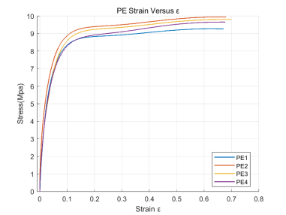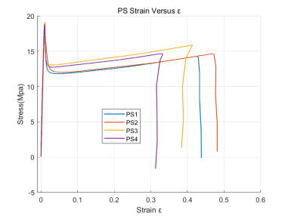
Figure 1: Stress-strain plot of polymers
Table 1 shows the height, width and cross-sectional area of each specimen. Figure 1 shows the stress-strain plot of PE and PS specimens. Apparently the two material is different. PE has no obvious yield strength while PS has typical yield strength and ultimate tensile strength.

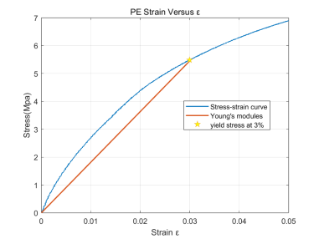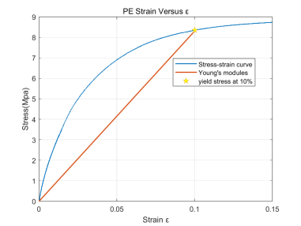
Figure 2: Stress-strain plot of PE specimen 1
In figure 2, we choose the first specimen (PE 1) as a representative to analyze the Young’s modules, yield strengths and ultimate tensile strengths. According to GB/T 1040.2-2006, in this situation, we should use x% strain tensile stress instead of yield stress.
3% strain tensile stress 5.4857 MPa, E=181.7793 MPa
10% strain tensile stress 8.3502 MPa, E=83.0239 MPa
UTS=9.2773 MPa

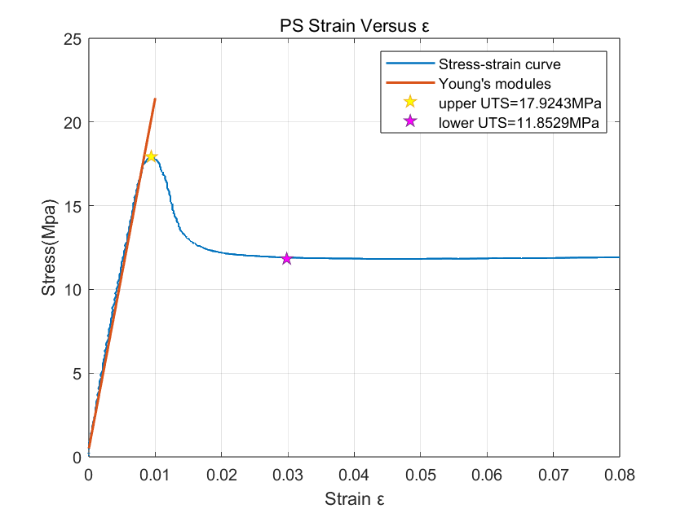
Figure 3: Stress-strain plot of PS specimen 1

In figure 3, we choose the PS1 as a representative to analyze the Young’s modules, yield strengths and ultimate tensile strengths.
PS1 has obvious upper yield strength at 17.9243 MPa, lower yield strength at 11.8529 MPa, and the upper yield strength is also the ultimate tensile strength. The Young’s Modules is 2029.8 MPa.

During the test, we observed that PE specimen extended very long but didn’t fracture. The elongated part has become thinner and easy to bend. PS specimen is brittle, which fractured with a clear sound.
table2: Young’s modulus and UTS of polymer specimen
Table 2 contains all data we calculated with MATLAB. The ultimate tensile strength of PS is found in the figure, while the UTS of PE may not accurate. Limited by the test length, we did not break PE specimen. The stress may become bigger when strain is bigger.
It is apparent that the yield strength and ultimate tensile strength are material properties. In our lab, the shape of specimen is the same (from the GB/T), and the cross-section area difference is not significant.
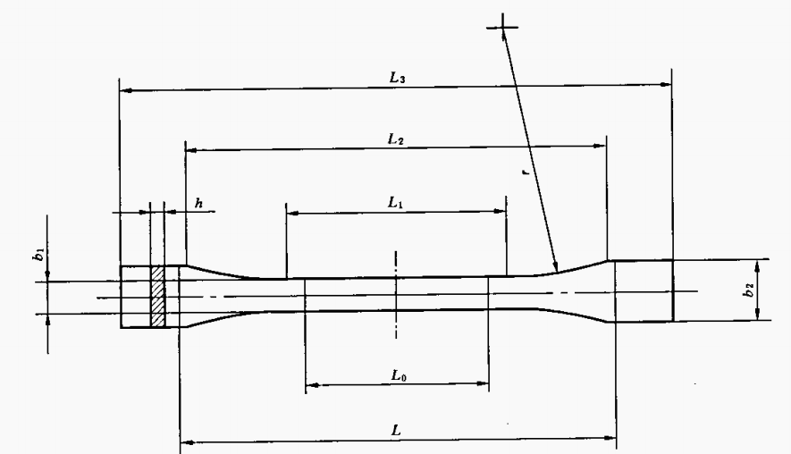
Figure 4: Dumbbell shaped specimen

