**Home Page:**

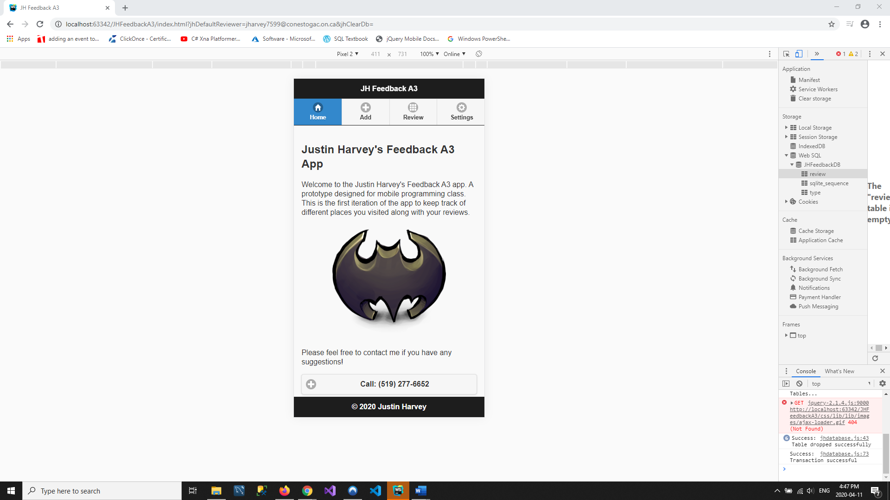

**Add a Feedback page with data with checkbox unchecked and with Alert:**

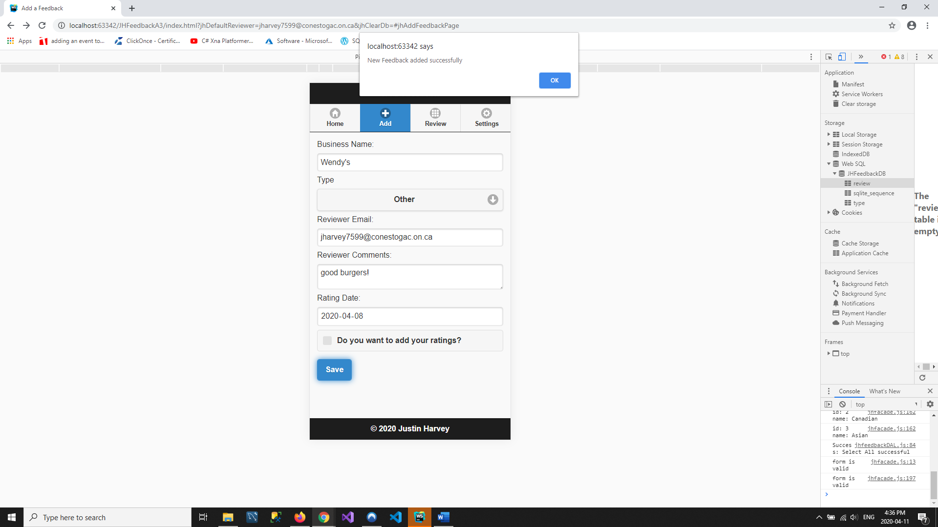

**Add a Feedback page with data with checkbox checked and with Alert:**

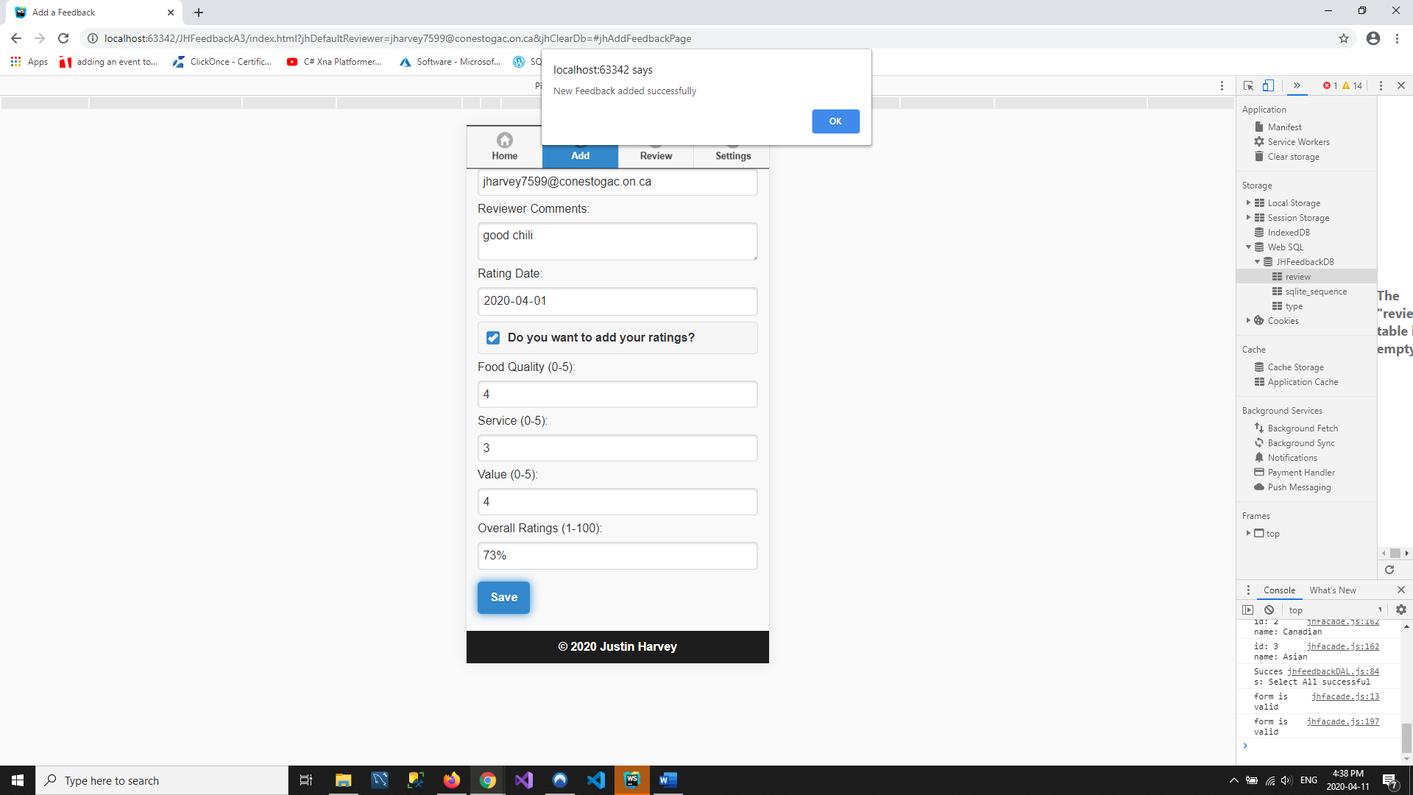

**Screenshot of Developers tools showing 2 records:**

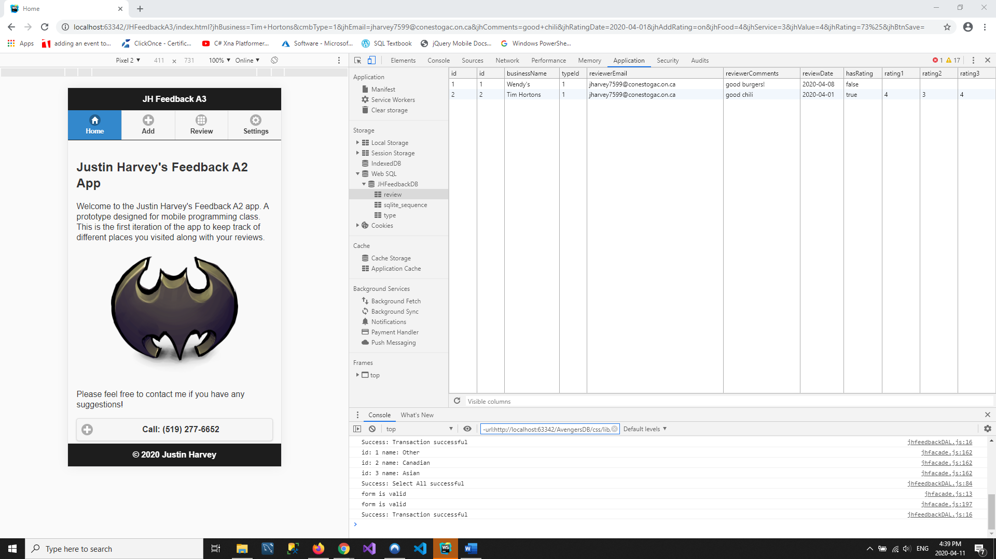

**Screenshot of Reviews page showing 2 items:**

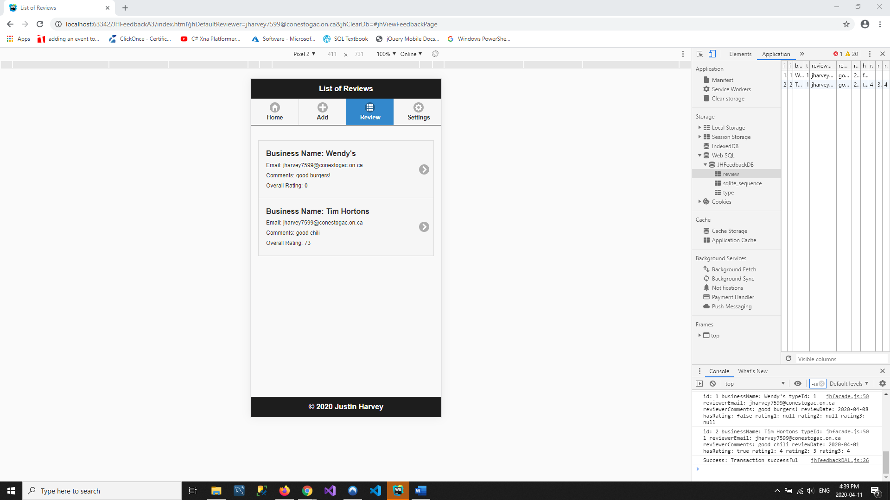

**Modify Feedback page with successfully updated Alert:**

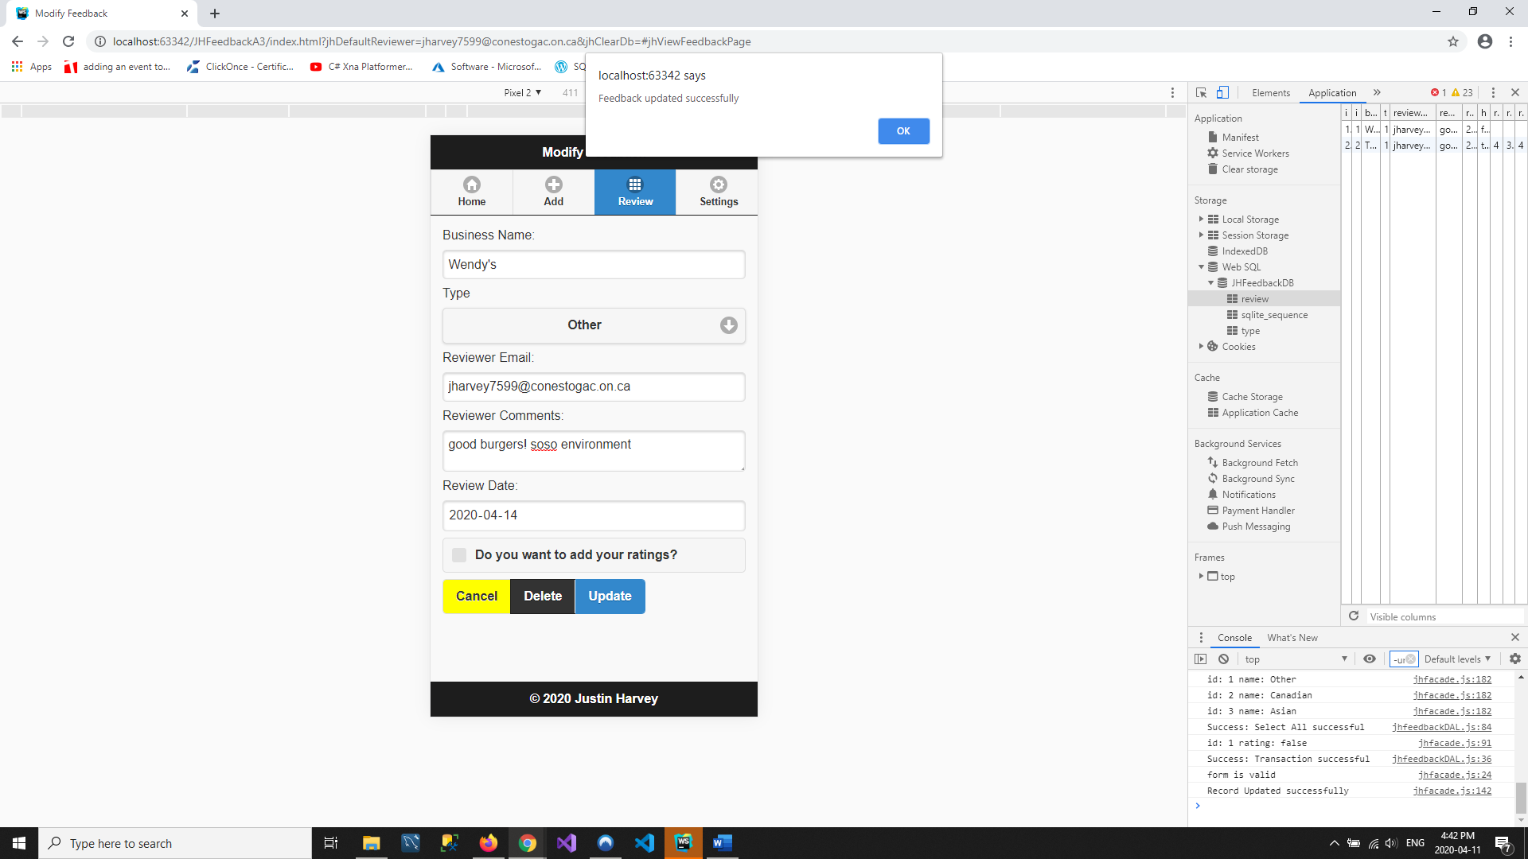

**Modify Feedback page with successfully deleted Alert:**

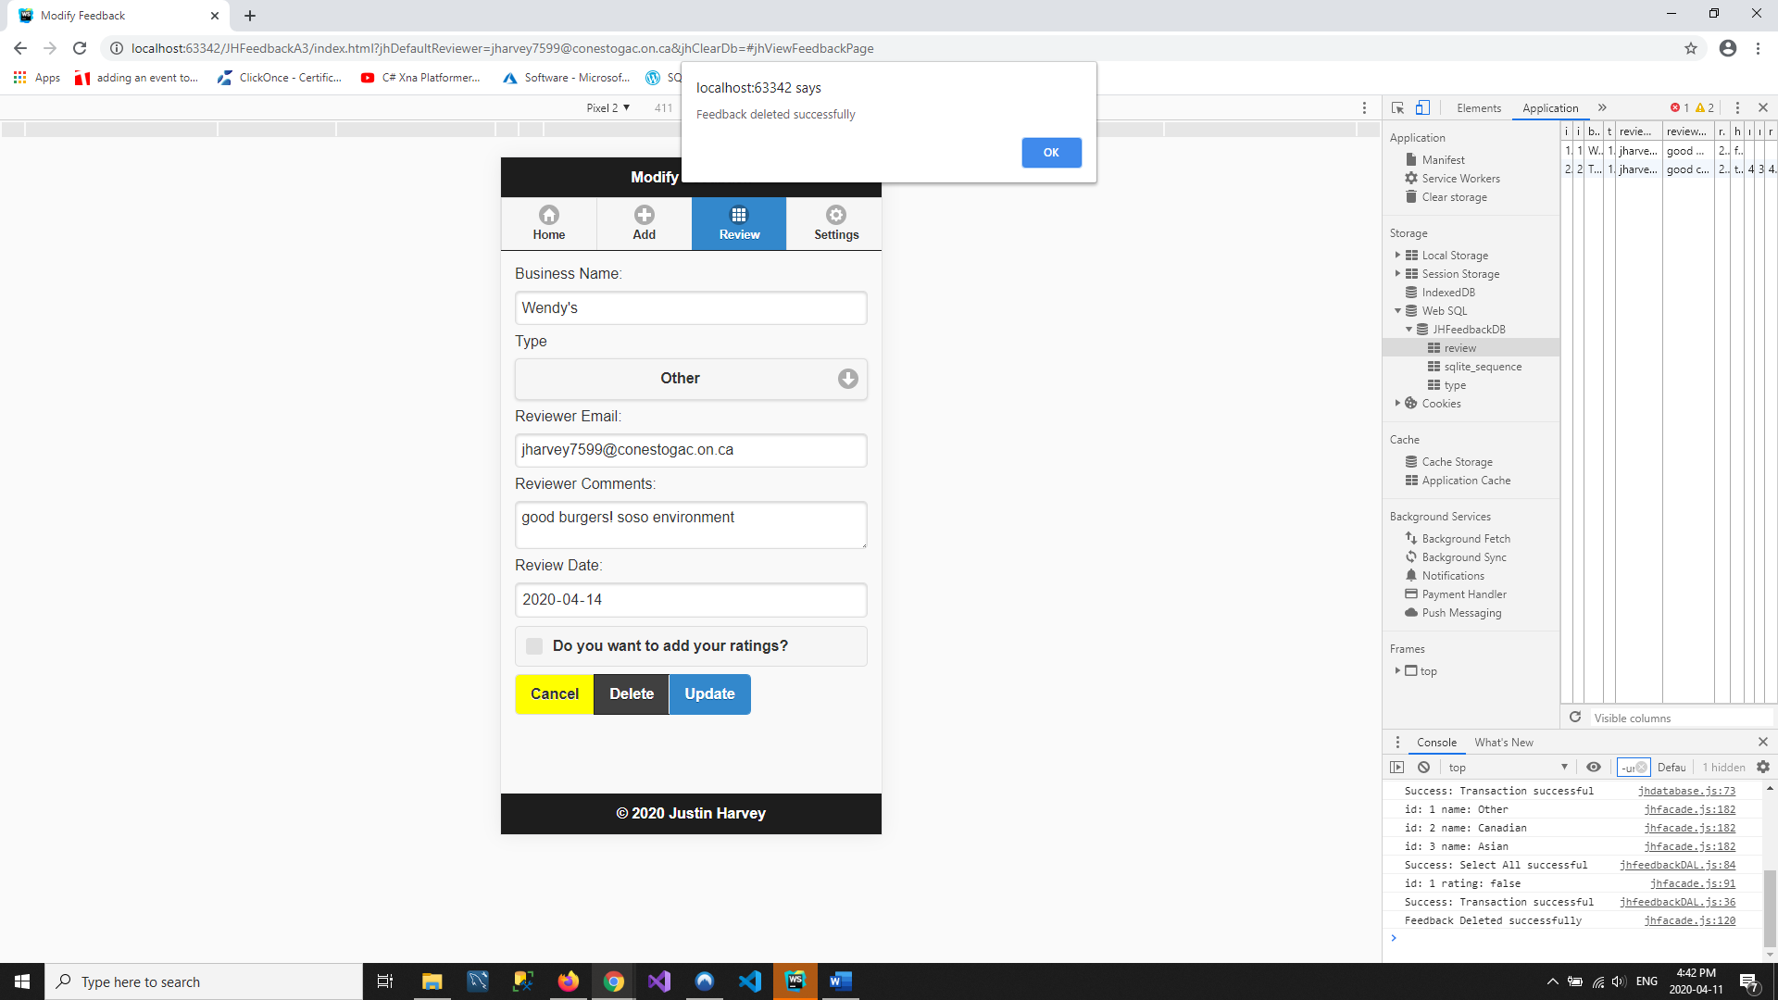

**Settings page with alert (after clearing database):**

