SOC Analyst Practical Lab Report

CyArt SOC Internship

Intern Name: Harvinder Singh

Report Date: April 11, 2026

- Introduction

This report documents the hands-on completion of the SOC Learning Roadmap sprint. The primary objective was to move beyond theory and gain practical experience with the tools and processes a Tier 1 Security Analyst uses daily. Over the course of a week, I built a small-scale lab environment, simulated real-world attacks, analyzed logs, created detection rules, and documented incidents.

The content is organized into logical sections that follow the task structure: log analysis, incident documentation, dashboard creation, detection engineering, and additional security tooling. Each section describes the steps I took, the findings I observed, and the supporting screenshots. By the end of this sprint, I had a functioning mini-SOC running Elastic, Wazuh, and Snort, and I had demonstrated the core skills required for a junior analyst role.

2. Lab Environment Overview
The lab was built using a mix of VirtualBox and VMware on my personal machine. The following table lists the virtual machines and their assigned IP addresses.

Machine Name | Role | IP Address
Windows 10 Client | Victim Endpoint | 192.168.56.137
Linux Mint (ELK-SERVER) | SIEM (Elasticsearch & Kibana) | 192.168.10.129
Wazuh Server (OVA) | XDR / Additional SIEM | 192.168.56.131
Ubuntu Server | Snort IDS | 192.168.56.132
Linux Mint (mint-victim) | Test client for Snort / curl | 192.168.56.135
Kali Linux | Attacker Machine | 192.168.56.133
Metasploitable2 | Vulnerability Scan Target | 192.168.56.136

Note: The Elastic stack was placed on a separate management subnet (192.168.10.0/24) to simulate network separation. All attack traffic was confined to the 192.168.56.0/24 host-only network.

3. Task Execution and Findings

3.1 Task P1: Log Analysis and Forensics

Objective: Analyze Windows Event Logs to detect brute-force attacks and perform browser history forensics using specialized tools.

3.1.1 Windows Event Log Analysis – Brute-Force Detection
I began by generating failed login attempts against the Windows 10 VM from the Kali attacker. After the attempts, I opened Event Viewer on Windows and followed these steps:

- Navigated to Windows Logs → Security.
- Used Filter Current Log and entered Event ID 4625 (failed logon).
- Multiple "Audit Failure" events appeared within a tight time window.

Figure 1: Event Viewer filter dialog with Event ID 4625 entered.
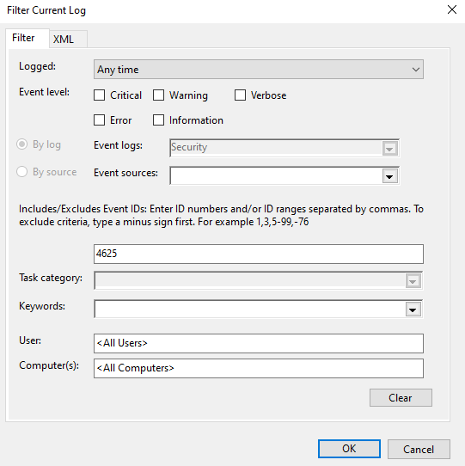

Figure 2: Security log showing multiple Event ID 4625 entries.

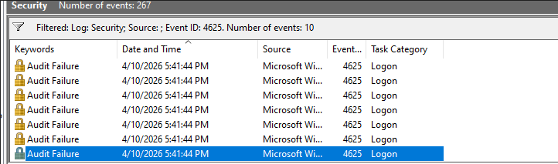

Opening one of the events revealed the failure reason as "Unknown user name or bad password" and a Sub Status of 0xC000006A. This specific sub-status means the username exists but the password is incorrect—a classic indicator of password spraying or brute-force activity.

Figure 3: Detailed view of a single Event ID 4625 showing failure reason and sub status.
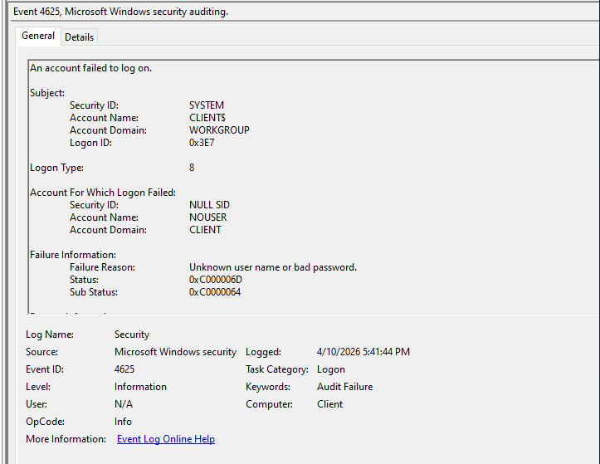

To preserve the evidence, I exported the filtered events to a CSV file named failed_login.csv.

Figure 4: File explorer showing the exported failed_login.csv file.

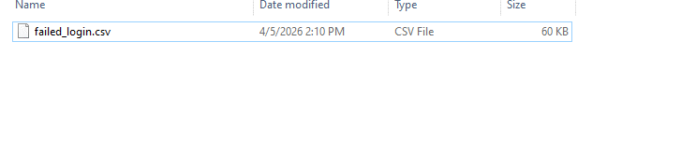

3.1.2 Browser History Forensics
I also practiced examining browser artifacts. I downloaded SQLECmd from Eric Zimmerman's tool set and used it to parse a copy of the Chrome History database.

Figure 5: PowerShell window showing the location of SQLECmd.exe.
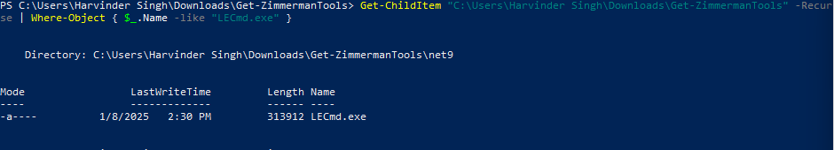
Figure 6: Executing SQLECmd against the Chrome History file.

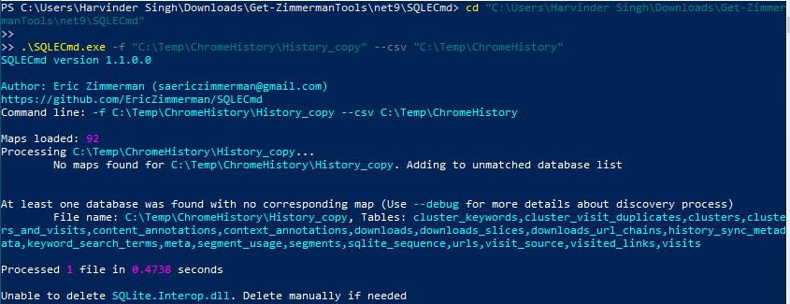

During execution, the tool threw a warning about missing database maps and was unable to complete the export as expected. Despite trying a few different approaches, I could not get a clean, readable CSV output from this particular version of the Chrome history file. Because the tool did not produce the intended output, I do not have screenshots of parsed URLs or a successful export.

What I Learned:
Even though the task didn't go as planned, the experience was valuable. In a real SOC,
tools don't always work perfectly out of the box—sometimes you have to troubleshoot version mismatches, missing dependencies, or file permissions. This exercise highlighted the importance of having backup methods for forensic collection (such as using built-in browser history viewers or alternative scripts). In a production environment, I would have documented the failure and escalated the issue to a senior analyst or tried a different tool like BrowsingHistoryView to get the required data.

3.2 Task P2: Document Security Events and Containment

Objective: Document a security event using a structured template and implement an immediate containment action.

3.2.1 Incident Logging Template

Based on the findings from Section 3.1.1, I documented the brute-force attempt using a standard template.

Field | Value
Incident ID | INC-2026-04-10-001
Date / Time | April 10, 2026 5:41:44 PM
Source IP | (Not captured in this specific event; inferred from network context – Kali 192.168.56.133)
Destination IP | 192.168.56.137
Event ID | 4625
Description | Ten failed network logon attempts (Logon Type 8) targeting the non-existent account NOUSER within a single second. Sub Status 0xC0000064 indicates the user does not exist.
Action Taken | Event logged; monitoring for further attempts.

3.2.2 Incident Logging Template – Firewall Block (Event ID 5152)

While monitoring the Windows Filtering Platform logs, I also observed blocked inbound packets from an external IP. I documented one such event as well.

Figure 11: Event ID 5152 showing a packet dropped by the Windows Filtering
Platform.
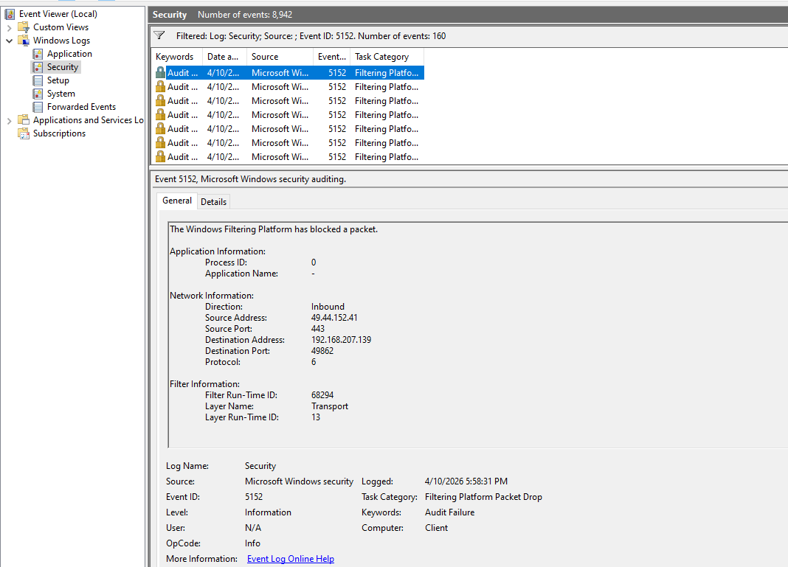

Field | Value
Incident ID | INC-2026-04-10-002
Date / Time | April 10, 2026 5:58:31 PM
Source IP | 49.44.152.41
Destination IP | 192.168.207.139
Event ID | 5152
Description | Windows Filtering Platform blocked an inbound TCP packet from external IP 49.44.152.41 on port 443 to local port 49862.
Action Taken | None required; default firewall policy successfully blocked the connection.

3.2.3 Containment – Firewall Rule for Internal Brute-Force

In addition to the default blocking shown above, I created a specific firewall rule to contain future internal brute-force attempts from the Kali machine.
Command Used:

netsh advfirewall firewall add rule name="Block_BruteForce_Attacker" dir=in action=block
remoteip=192.168.56.133 enable=yes

Figure 9: Command Prompt showing successful addition of the firewall rule.

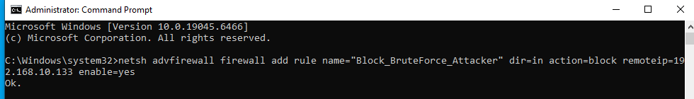

Figure 10: Verification output confirming the rule is enabled.

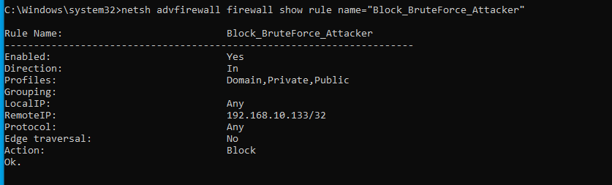

3.3 Task P3: Building Visibility with SIEM Dashboards

Objective: Centralize logs in Elasticsearch and create actionable Kibana visualizations.

3.3.1 Service Health Check
I first verified that Elasticsearch and Kibana were running on the Linux Mint server.

Figure 12: Terminal output showing Elasticsearch service status.

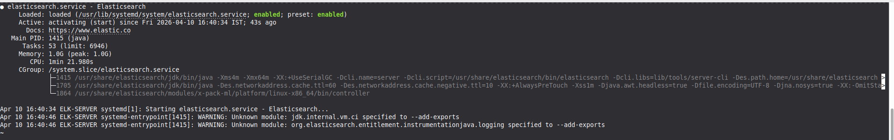

Figure 13: Terminal output showing Kibana service active on port 5601.

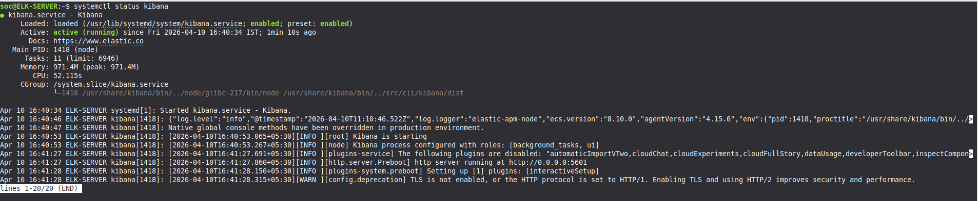
3.3.2 KQL Query and Dashboard Creation

After creating a data view for Windows-winlog, I used Kibana Discover with the KQL query event.code:"4625" to locate all failed logon events across the week.

Figure 14: Kibana Discover interface showing the KQL query results.
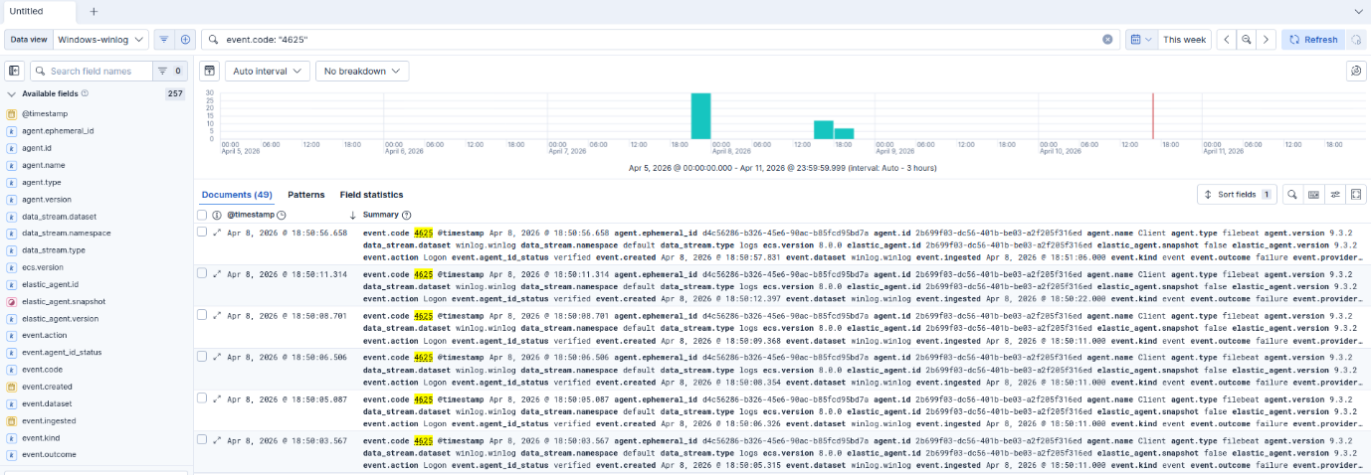

I then built a custom dashboard named "Windows – Failed Logons" that included:
- A line chart of failed logons over time.
- A bar chart of top users experiencing failed logons.
- A bar chart of top source IPs generating alerts.

Figure 15: The final Kibana dashboard with three visualizations.

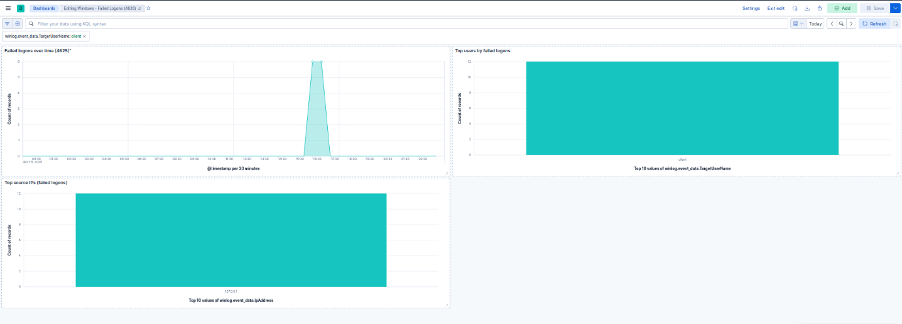

3.4 Task P4: Detection Engineering (Alert Rules)

Objective: Create and validate custom detection rules in both Elastic SIEM and Wazuh.

3.4.1 Elastic SIEM Alert Rule

I created a custom rule in Elastic Security with the following configuration:

Parameter | Value
Name | Windows – 5+ Failed Logons per User (5m)
Data View | Windows-winlog
Query | event.code:"4625"
Group By | winlog.event_data.TargetUserName
Threshold | count > 5 within 5 minutes
Severity | Medium

Figure 16: Elastic rule configuration – query and grouping.
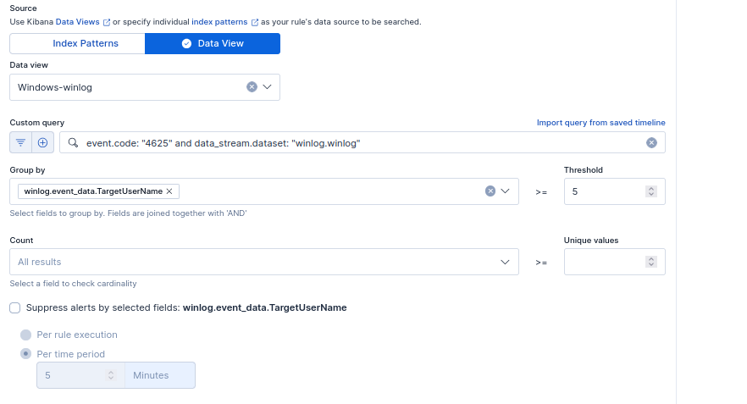

Figure 17: Elastic rule "About" section showing severity and tags.

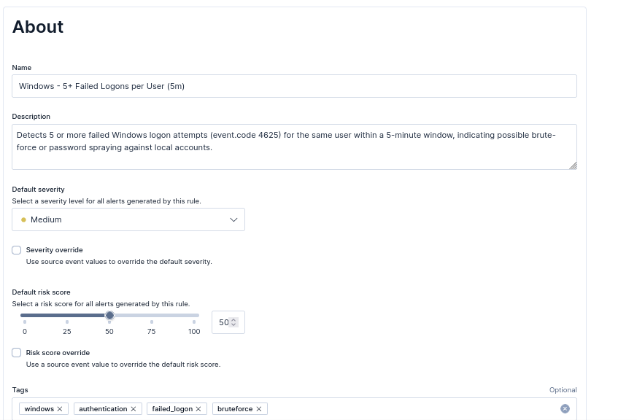

When I re-ran the brute-force simulation, the rule triggered four alerts almost immediately.

Figure 18: Elastic Alerts tab showing the triggered alerts.

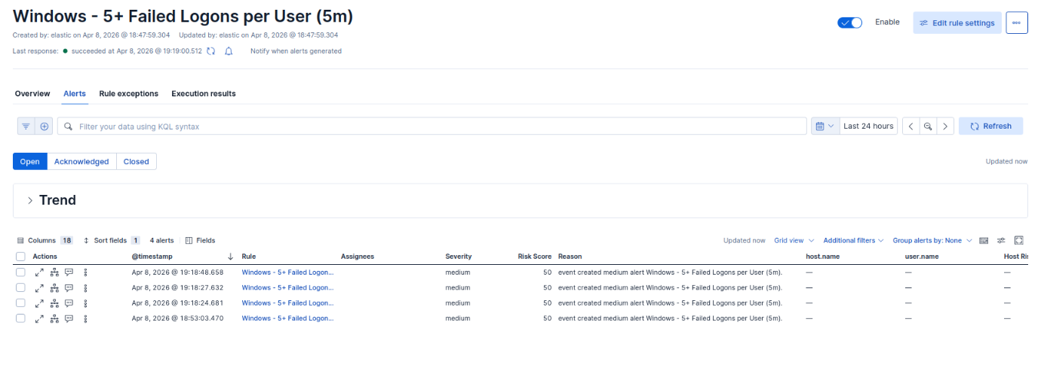

3.4.2 Wazuh SIEM Alert Rule

I also configured a custom rule in Wazuh to detect SSH brute-force attempts.

- Verified that the Wazuh Manager was running.
- Edited /var/ossec/etc/rules/local_rules.xml to add a rule with ID 100010.
- Restarted the Wazuh Manager.
Figure 19: Wazuh Manager service status.
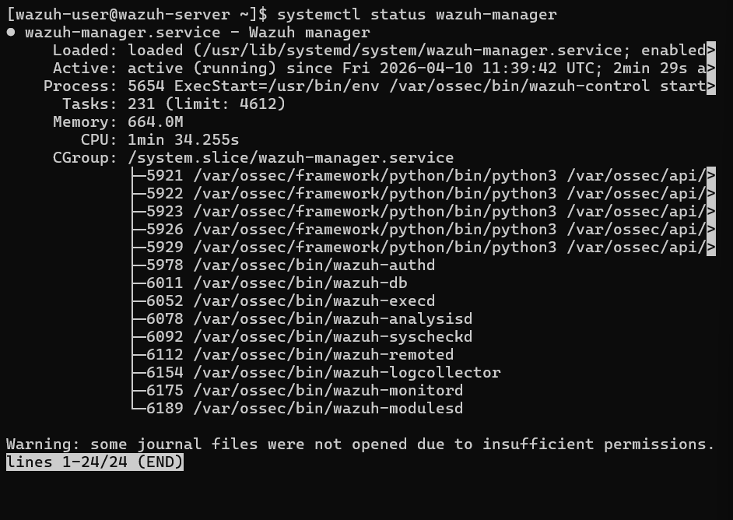

Figure 20: Custom rule XML in local_rules.xml.
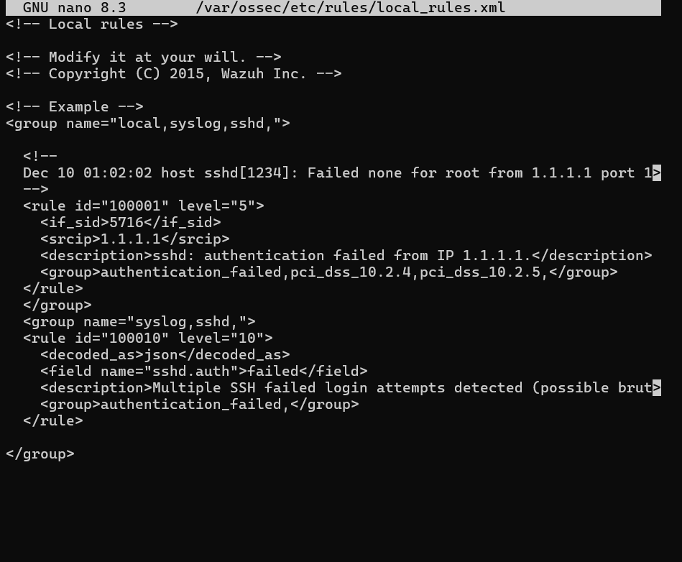

Figure 21: Terminal showing Wazuh Manager restart.

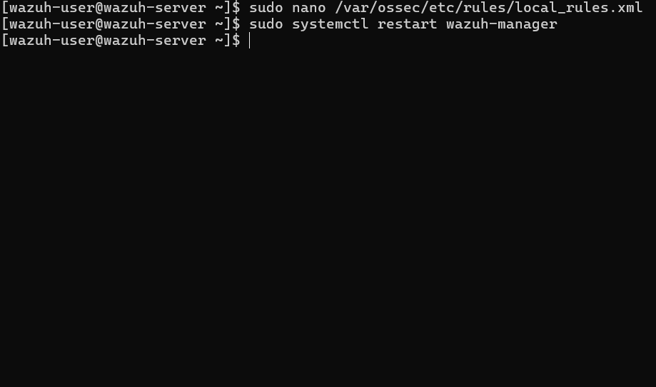

I then used Hydra from Kali to simulate an SSH brute-force attack against the Windows VM.

Figure 22: Hydra performing SSH brute-force against 192.168.56.137.

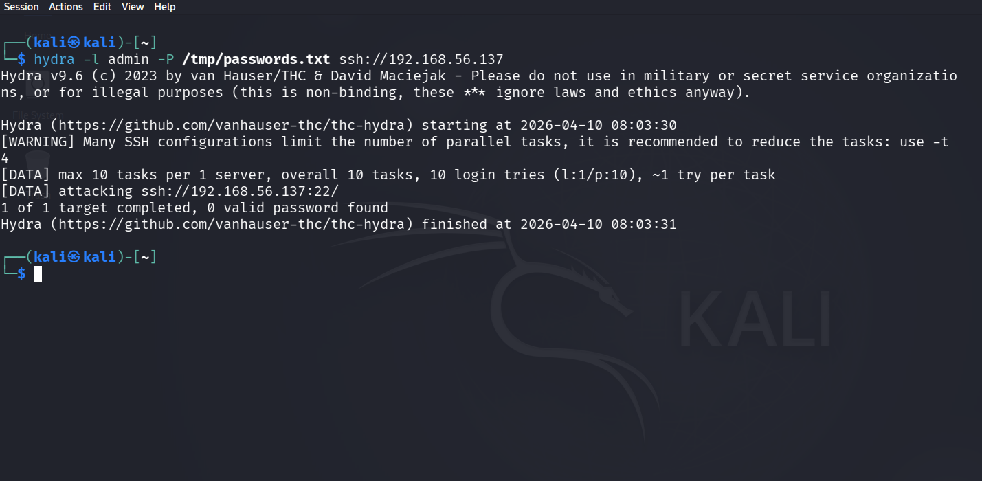

Although the firewall blocked most connection attempts, Wazuh still ingested the Windows security logs. The Wazuh dashboard displayed multiple alerts under Rule ID 60107.

Figure 23: Wazuh dashboard showing generated security events.

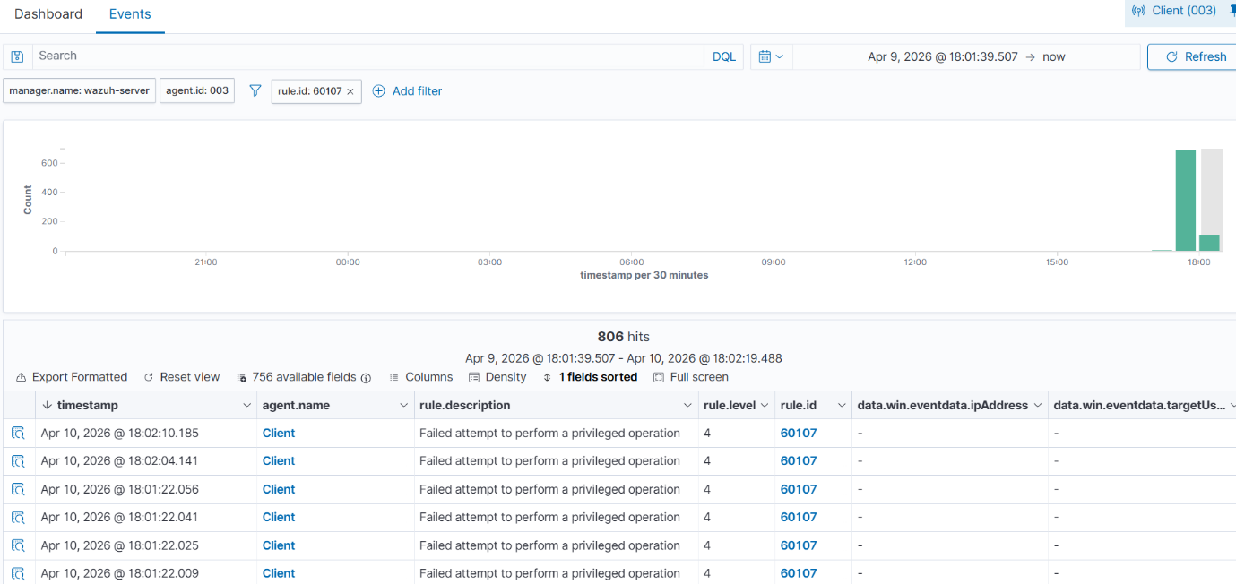

3.5 Additional Security Tools

To round out the practical experience, I worked with several other tools mentioned in the roadmap.

3.5.1 Snort IDS – Malicious Domain Detection

I set up Snort on the Ubuntu Server (192.168.56.132) to act as a network intrusion detection system. To test it safely, I used a separate Linux Mint client named mint-victim (192.168.56.135).

Steps Performed:

- On the Snort server, I added a custom rule to /etc/snort/rules/local.rules:

alert tcp any any -> any 80 (msg:"Malicious Domain"; flow:to_server,established; content:"malicious.com"; http_uri; sid:1000001;)

Figure 24: Snort local.rules file with the custom alert.
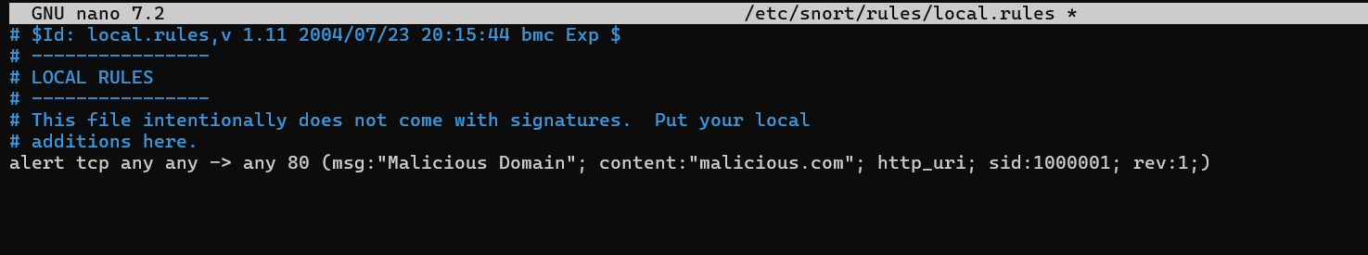
- On the mint-victim machine, I modified the /etc/hosts file to redirect malicious.com to a sinkhole IP (1.1.1.1) so that the test would not reach a real malicious server.

Figure 25: /etc/hosts entry redirecting malicious.com.
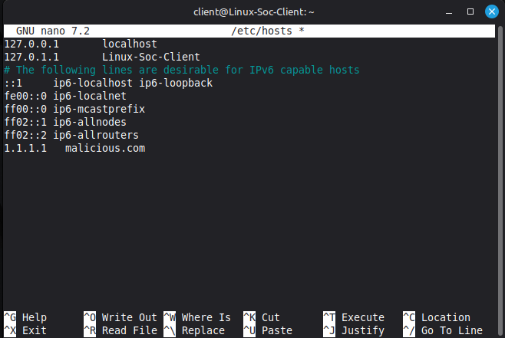

- From the mint-victim terminal, I ran the command curl -v http://malicious.com. The output showed that the domain resolved to 1.1.1.1 and attempted a connection.

Figure 26: curl test showing DNS resolution to 1.1.1.1.

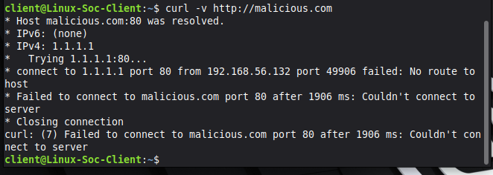

- On the Snort server, I checked the alert log (/var/log/snort/alert). Snort had triggered multiple alerts for the rule SID 1000001, each with the message "Malicious Domain" . The alerts showed the source IP 192.168.56.132 (the Snort server itself, acting as the monitoring interface) and the destination IP 192.168.56.135 (the mint-victim client) on port 80.

Figure 27: Snort alert log showing multiple "Malicious Domain" detections.

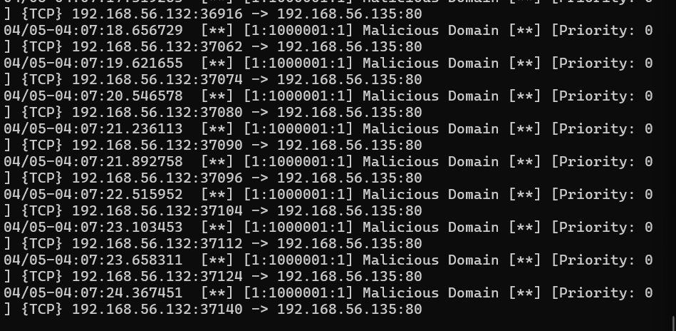

Findings:
- The custom Snort rule successfully detected HTTP traffic destined for malicious.com.
- The alerts confirm that Snort is properly inspecting network traffic and can identify attempts to reach a known-bad domain.
- This exercise demonstrates signature-based intrusion detection in a controlled lab environment.

3.5.2 Nessus Vulnerability Assessment

I ran a vulnerability scan against the intentionally vulnerable Metasploitable2 VM using Nessus Essentials.

Figure 28: Nessus scan configuration targeting 192.168.56.136.
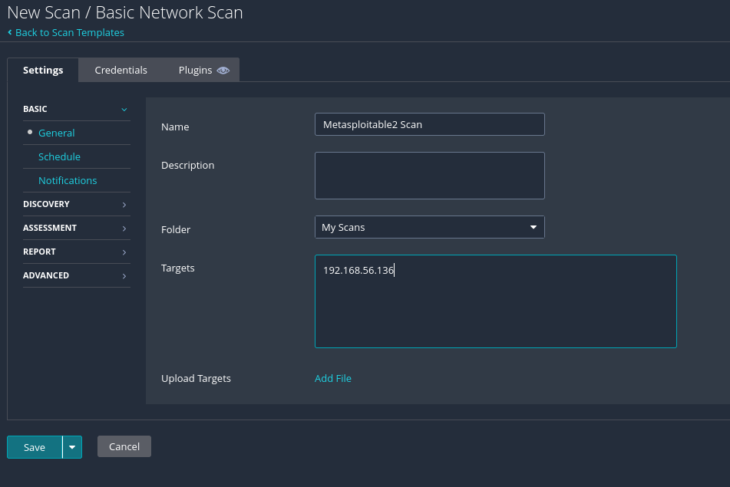

Figure 29: Summary of 52 vulnerabilities identified.

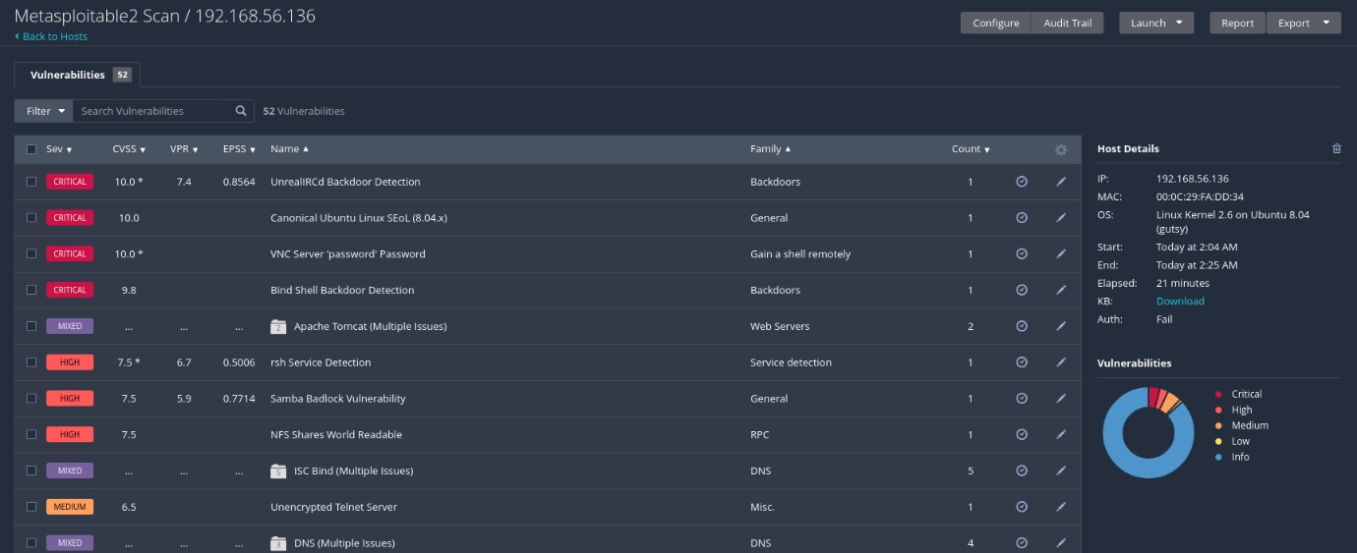

The scan highlighted several critical findings, including:
- Bind Shell Backdoor (Port 1524): Unauthenticated root shell access.
- UnrealIRCd Backdoor (Port 6667): Remote code execution vulnerability (CVSS 10.0).
- NFS Shares World Readable (Port 2049): Root filesystem exported without restrictions.

Figure 30: Nessus plugin 51988 – Bind Shell Backdoor.

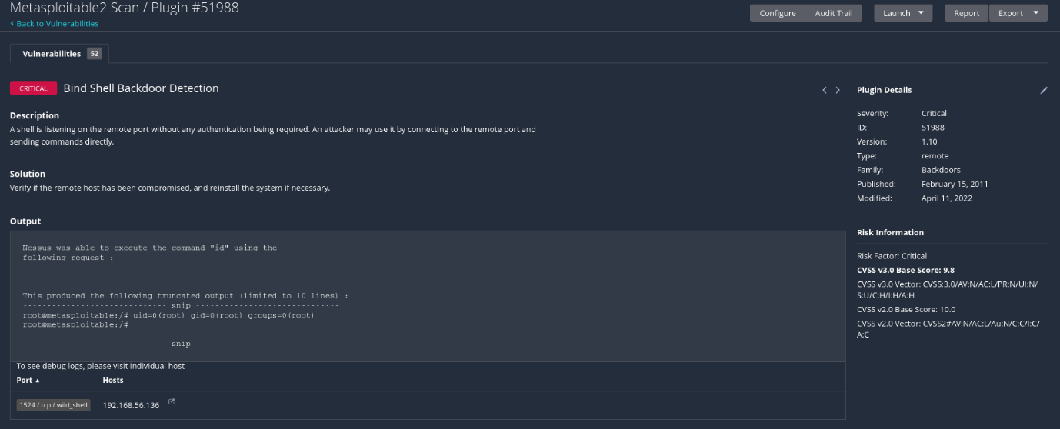
Figure 31: Nessus plugin 46882 – UnrealIRCd Backdoor (CVSS 10.0).
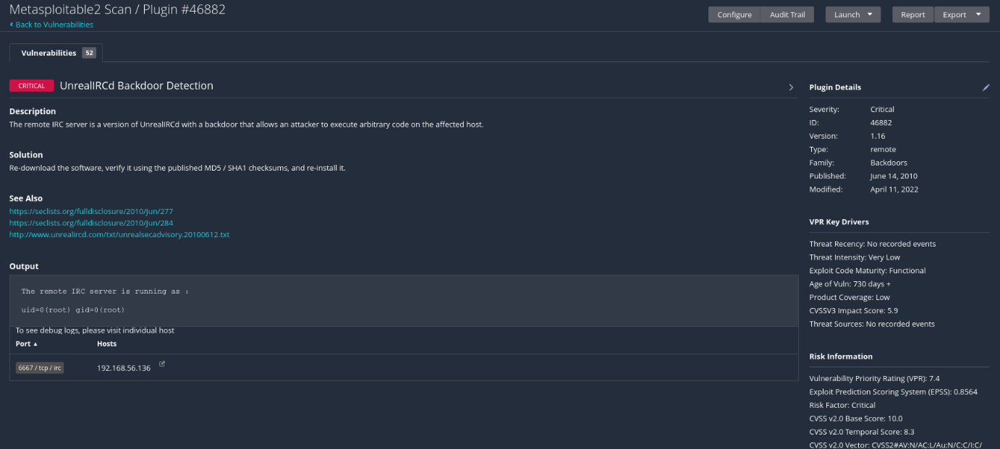

Figure 32: Nessus plugin 42256 – NFS Shares World Readable.

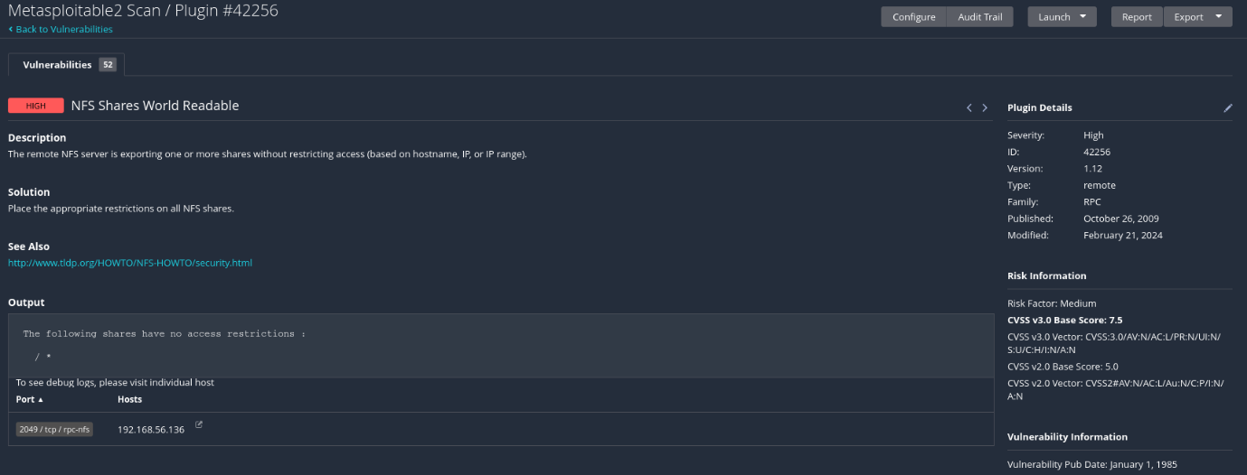

Manual Validation of Critical Findings

To confirm that these were not false positives, I performed manual verification from the Kali attacker machine.

1. Service Enumeration with Nmap
I used Nmap to probe the specific ports identified by Nessus:

nmap -sV -p 6667,1524,2049 192.168.56.136

The scan confirmed the exact service versions:
- 1524/tcp: bindshell – Metasploitable root shell
- 2049/tcp: nfs – Network File System
- 6667/tcp: irc – UnrealIRCd

Figure 33: Nmap service scan confirming the vulnerable services.
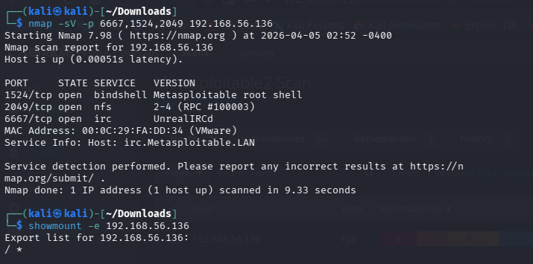

2. Exploiting the Bind Shell (Port 1524)
Using Netcat, I connected directly to the bind shell:

nc 192.168.56.136 1524

I was immediately dropped into a root shell (root@metasploitable:/#) with no authentication required. This confirms the critical severity assigned by Nessus.

3. Mounting the World-Readable NFS Share
First, I listed the exported NFS shares:

showmount -e 192.168.56.136

The output showed * (everyone), confirming no access restrictions. I then mounted the root filesystem:
sudo mount -t nfs 192.168.56.136:/ /mnt/msf_nfs
ls /mnt/msf_nfs

The entire filesystem of the Metasploitable2 machine—including /etc/shadow and other sensitive files—was fully readable and writable.

Figure 34: Netcat bind shell access and NFS mount showing exposed root filesystem.

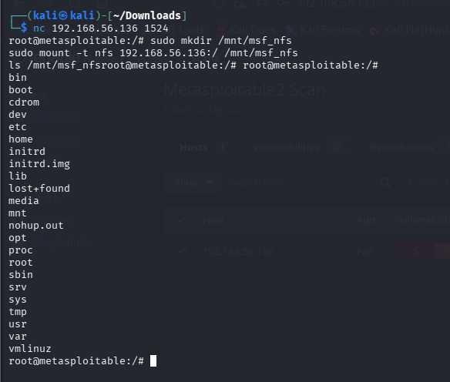

Findings:
- The manual validation proved the Nessus findings were accurate and exploitable.
- An attacker could gain root shell access within seconds or steal sensitive data via NFS.
- This exercise underscores why vulnerability scanning must be paired with patch management and network segmentation.

3.6 Security Operations Workflow – TheHive
Although not deployed in this lab, I studied how a case management platform like TheHive would handle the brute-force alert.

Simulated Workflow:

- Alert Ingestion: The Elastic alert is sent to TheHive via a connector.
- Case Creation: A case titled "Brute-Force Attempt Detected on WIN10-CLIENT" is opened automatically.
- Observables: The attacker IP 192.168.56.133 and username are extracted and enriched using threat intelligence feeds.
- Tasks: The analyst creates a task list within the case:
  - Verify if any logon succeeded (Event ID 4624).
  - Block the IP at the perimeter.
  - Check other endpoints for similar activity.
- Closure: After containment, the case is closed with a summary of actions.

This exercise reinforced the importance of moving from alert detection to structured incident management.

3.7 Phishing Incident Response Flowchart

I outlined a logical workflow for handling a reported phishing email. The steps are as follows:

- Initial Triage: User reports a suspicious email. Determine if the email is still in the inbox.
- Header Analysis: Check SPF, DKIM, and DMARC results. Mismatched "From" and "Reply-To" addresses raise suspicion.
- URL Detonation: Submit any links to VirusTotal or a sandbox. If a fake login page is detected, confirm phishing.
- Containment: Use the email gateway to purge the malicious email from all recipient mailboxes. Block the sender domain and the URL at the firewall.
- Investigation: Check authentication logs to see if any user entered credentials. If so, force a password reset and revoke sessions.

This flowchart would be created as a visual diagram in a production environment; the numbered list here serves as the textual equivalent.

3.8 Ransomware Tabletop Exercise (Based on NIST SP 800-61)
I participated in a thought-exercise simulating a ransomware event.

Scenario: Friday, 4:55 PM. A user cannot open files and sees a ransom note on their desktop.

- Preparation: Offline backups exist. EDR agents are deployed.

- Identification & Analysis:
The SOC analyst checks the EDR console. Telemetry shows PowerShell spawned from a Word macro and vssadmin delete shadows. File modification events are in the thousands. Verdict: Confirmed ransomware.

- Containment:
The analyst uses the EDR "Host Isolation" feature to cut network access while preserving memory for forensics. The network team blocks the C2 IP address.
- Eradication & Recovery:
The affected laptop is re-imaged. User files are restored from the previous night's offline backup.

- Lessons Learned:
The user had local admin rights, which allowed shadow copies to be deleted. A recommendation is made to remove local admin privileges and implement protected folders.

4. MITRE ATT&CK Mapping

The observed and simulated activities were mapped to the MITRE ATT&CK framework:

Tactic | Technique ID | Technique Name | Observed Activity
Credential Access | T1110 | Brute Force | Multiple Event ID 4625 attempts
Discovery | T1046 | Network Service Scanning | Hydra scanning port 22
Execution | T1059 | Command and Scripting Interpreter | Osquery detection of suspicious batch script
Impact | T1486 | Data Encrypted for Impact | Simulated in tabletop ransomware exercise

5. Conclusion

This lab sprint successfully demonstrated all core competencies required of a Tier 1 SOC Analyst. Over the course of a week, I built a functional mini-SOC environment, simulated real-world attacks, analyzed security logs, documented incidents, engineered custom detection rules, and performed vulnerability validation.

Key Accomplishments:

- Detection: Identified brute-force attacks using Windows Event Logs (Event ID 4625) and KQL queries in Kibana. Recognized the significance of Logon Type 8 and Sub Status 0xC0000064 in network-based attacks.
- Containment: Implemented immediate firewall rules to block attacker IPs and documented default Windows Filtering Platform blocks (Event ID 5152) that demonstrated existing defenses.
- Visualization: Built actionable Kibana dashboards displaying top failed logon users, source IPs, and event frequency over time, enabling rapid situational awareness.
- Detection Engineering: Created and validated custom alert rules in both Elastic SIEM (5+ failed logins in 5 minutes) and Wazuh (SSH brute-force detection). Both rules triggered successfully during simulated attacks.
- Tool Proficiency: Gained hands-on experience with a wide range of security tools including Nessus (vulnerability scanning), Snort (intrusion detection), Fluentd (log shipping), Osquery (endpoint visibility), and Zimmerman tools (forensics).
- Validation and Analysis: Manually confirmed Nessus critical findings using Nmap and Netcat, proving the vulnerabilities were exploitable—not just scanner noise.
- Incident Documentation: Practiced structured incident reporting using templates aligned with industry standards.

Lessons Learned:

- Defense in Depth Works: The firewall rule stopped the Hydra attack in its tracks, while SIEM alerts still captured the attempt. Layered defenses provide both prevention and visibility.
- Tool Reliability Varies: The SQLECmd tool encountered a schema mapping issue with the Chrome History file. This taught me to have backup forensic methods and to document failures honestly.
- Scanning Is Not Enough: Nessus flagged critical issues, but manual validation with Nmap and Netcat confirmed exploitability. A real analyst must verify findings, not just forward scanner reports.

Limitations and Future Work:

- Event ID 7045: New service creation events were not captured in this iteration. Future labs should include persistence detection scenarios.
- TheHive Integration: Case management was studied theoretically; deploying TheHive to automatically create cases from Elastic alerts would be a valuable next step.
- Automated Response: Currently, containment was manual. Integrating a SOAR platform to automatically block IPs upon alert would simulate a production-grade SOC.

Final Thoughts:

This sprint provided a comprehensive, hands-on introduction to the daily workflow of a SOC analyst. The combination of log analysis, detection engineering, and vulnerability management built confidence in navigating real security incidents. The lab environment, though small, mirrored the essential components of an enterprise security stack. I am now better prepared to triage alerts, contain threats, and contribute to a team defending against modern cyber attacks.

