Task 8: Simple Sales Dashboard Design Report

# 🔹 About the Data

The dataset used is based on Superstore Sales. It contains key fields such as Order Date, Region, Category, Sales, and Profit. The data represents historical sales performance across different product categories and geographical regions.

# 🔹 Task Objective

To create an interactive sales dashboard using Tableau that displays sales trends by Month, Category, and Region. The dashboard includes visualizations and KPIs to highlight top-performing areas, allowing users to quickly derive insights from the data.

# 📈 Dashboard Visuals

- Line Chart: Monthly Sales Trend  
- Bar Chart: Sales by Region  
- Donut Chart: Sales by Category  
- Slicer: Filter by Region  
- KPI Cards: Top Category, Top Region, and Top Month

# 🧠 Key Insights

1. 📅 Top Month: November 2021 recorded the highest sales during the period.  
2. 🏆 Top Category: Technology generated the maximum sales across all regions.  
3. 🌍 Top Region: The West region consistently outperformed others in total sales.

# 🖼️ Dashboard Screenshot

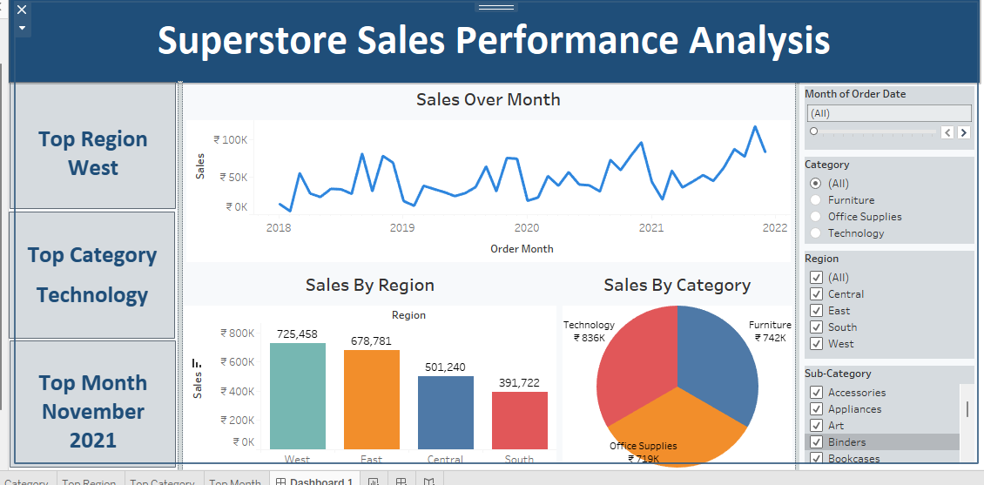

# 🎯 Outcome / Skills Gained

- Developed hands-on experience in Tableau for data visualization.  
- Learned to apply slicers, KPIs, and interactive charts in business dashboards.  
- Improved ability to extract and summarize actionable insights from sales data.