NTU RGB+D 120 Dataset Notes
--Conclusion first: before anything else the data needs cleaning, sample statistics, and a fresh .skeleton parser.

1. Basic Composition
Item | NTU RGB+D 120
Total samples | 114,480
Classes | 120
Subjects | 106
Setups | 32 (S001–S032)
Cameras | 3 x Kinect v2 (-45 deg / 0 deg / +45 deg)
Two-person interaction classes | 26 classes (A50-A60 + A106-A120)
Official corrupted-sample list | 535 entries
Usable after cleaning | 113,945
·File naming: SsssCcccPpppRrrrAaaa = setup / camera / subject / replication / action class
·R001/R002 means “performed once towards the left camera, once towards the right camera”

2. Modalities and Download Size
Modality | NTU120 (cumulative)
3D skeleton✅ | 10.3 GB
Masked depth maps | 147 GB
Full depth maps | 1,435 GB
RGB videos | 260 GB
Infrared | 389 GB
Total | 2.3 TB
Resolution: RGB 1920x1080; depth and infrared 512x424.

3. .skeleton File Format
Field order from read_skeleton_file.m. Plain ASCII text, whitespace-separated.
framecount
each frame: bodycount
each body:
bodyID clipedEdges handLeftConfidence handLeftState
handRightConfidence handRightState isResticted
leanX leanY trackingState jointCount(=25)
each joint (11 floats + 1 int):
x y z depthX depthY colorX colorY
orientationW X Y Z trackingState

3.1 The Three Coordinate Systems
Field | Meaning | Range / Unit
x, y, z | Real 3D physical-space coordinates  Origin = the IR sensor centre of that Kinect  Right-handed: X to the sensor's left, Y up, Z forward | metres
depthX, depthY | Pixel coordinates of the joint projected onto the depth map | 0–512, 0–424
colorX, colorY | Pixel coordinates of the joint projected onto the RGB image | 0–1920, 0–1080
·RGB and infrared are two different lenses, so the same 3D point lands on different pixels in the two images.
·Action recognition only needs x, y, z

3.2 Joint Numbering (NTU's own order, different from the Kinect SDK enum)
·NTU's own order. The 25 joints in sequence:
base of spine, middle of spine, neck, head, left shoulder, left elbow, left wrist, left hand, right shoulder, right elbow, right wrist, right hand, left hip, left knee, left ankle, left foot, right hip, right knee, right ankle, right foot, spine shoulder (commonly used as root), left hand tip, left thumb, right hand tip, right thumb

3.3 State Field Enum Values (Kinect v2 SDK)
Field | Value | Meaning
trackingState  (joint level & body level)  Rarely used by existing methods | 0  1  2 | NotTracked — not detected  Inferred — inferred, very low confidence  Tracked — genuinely tracked
handState | 0 / 1  2 / 3 / 4 | Unknown / NotTracked  Open / Closed / Lasso
handConfidence | 0 / 1 | Low / High
clipedEdges | 0/1/2/4/8 | none / right / left / top / bottom (can be combined)

4. Multi-Person Aspects
·bodyCount is stored per frame; different frames in the same file can hold 0/1/2/3/4. max_body = 4 in txt2npy.py.
·The storage order of the two bodies in the file = the order the Kinect SDK returned that frame, carrying no semantic information。
·bodyID (Kinect 64-bit tracking ID)
·The official preprocessing “sums the variance of X/Y/Z over all joints and takes the body with the higher value as the main subject” — a heuristic from the paper, not the file storage order.
·When only one person is observed, the second joint set is zero-filled.

4.1 bodyID Switching
·The Kinect SDK assigns a brand-new ID when a target is lost and then re-acquired.
·In a two-person sample, more than 2 distinct bodyIDs appearing across the clip > 2 means switching occurred.
·[Inference] Heavily occluded classes (A55 hugging) carry the highest risk.

4.2 The 26 Two-Person Interaction Classes
ID | Action | Official missing | ID | Action | Official missing
A50 | punch / slap other person | 7 | A106 | hit other person with something | 1
A51 | kick other person | 3 | A107 | wield knife | 0
A52 | push other person | 2 | A108 | knock over other person | 1
A53 | pat on back | 0 | A109 | grab other's stuff | 1
A54 | point finger at other person | 7 | A110 | shoot with a gun | 2
A55 | hugging | 42 ← worst | A111 | step on foot | 1
A56 | give something | 0 | A112 | high-five | 0
A57 | touch other's pocket | 3 | A113 | cheers and drink | 1
A58 | handshaking | 0 | A114 | carry something together | 1
A59 | walk towards each other | 9 | A115 | take a photo of other person | 1
A60 | walk apart from each other | 8 | A116 | follow other person | 0
 |  |  | A117 | whisper in ear | 2
 |  |  | A118 | exchange things | 1
 |  |  | A119 | support with hand | 3
 |  |  | A120 | finger-guessing game | 0
·The missing column was counted directly from the official 535-entry list: 81 entries for A50-A60, 15 for A106-A120, 96 in total.
·Nominal total 24,828 (948 per class for A50-A60, 960 per class for A106-A120), usable in practice 24,732; we should define a filtering rule and run the cleaning ourselves.

5. Evaluation Protocols
Protocol | How it splits | Note
NTU120 X-Sub | 53 subjects for training, the other 53 for testing | Train and test people are completely disjoint
NTU120 X-Set | Even setups for training, odd setups for testing | Cross-view and cross-environment at the same time
NTU120 X-Sub training subject IDs:
1,2,4,5,8,9,13,14,15,16,17,18,19,25,27,28,31,34,35,38,45,46,47,49,50,
52,53,54,55,56,57,58,59,70,74,78,80,81,82,83,84,85,86,89,91,92,93,94,
95,97,98,100,103
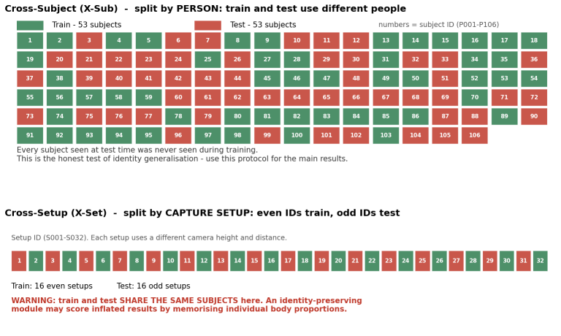
·X-Set and NTU60 X-View share subjects between train and test. An identity-preserving module may score inflated results by memorising individual body proportions. The main results of this project should use X-Sub.

6. Off-the-Shelf Preprocessed Versions
pyskl's 3D preprocessing (tools/data/ntu_preproc.py):
·Discards bodies with fewer than 11 valid frames
·Sorts by motion variance (more motion first) — reorders the two people
·Keeps at most 2 bodies
·Outputs (2, T, 25, 3) float16 — bodyID and trackingState are entirely lost
Conclusion: the 3D pkl destroys the identity information before we even receive it.

6.1 The 2D Version (tracking-consistent, usable as a control)
·Detector Faster R-CNN R50-FPN (COCO pretrained)
·Pose estimator HRNet-w32 (COCO pretrained), top-down
·17 joints (COCO), not 25; no 3D information
·bbox2tracklet: links detection boxes across adjacent frames with IoU > 0.6 into tracklets; tracklet2bbox fills the gaps
·The M dimension is tracking-consistent within a clip
·Only the NTU-specific ntu_pose_extraction.py does tracking; pyskl's generic custom_2d_skeleton.py works frame by frame with no tracking

Annotation Information
·Available: action class labels, filename metadata, bodyID, body-level trackingState, leanX/Y, handState, handConfidence, clipedEdges, per joint: 3D coordinates, depth 2D, color 2D, orientation quaternion, trackingState
·Not available: actor / receiver role annotation（the filename records only one subject ID）, object annotation (A106/A109/A114/A118 involve objects), camera calibration parameters

8. What to Do First After Getting the Data
·Count the proportion of corrupted samples (max(bodyCount) < 2 across the clip, labelled two-person but actually holding only one） + the proportion of bodyID switching (more than 2 distinct bodyIDs across the clip)
·Three ways to handle switching:
1.Discard outright
2.Re-associate using positional continuity
3.Keep and mark as a difficulty label. Count the proportion first, then decide — 2% can simply be discarded, 20% makes re-association mandatory.

9. Official Links
·Official GitHub (all technical details)：https://github.com/shahroudy/NTURGB-D
·File format definition：Matlab/read_skeleton_file.m
·NTU120 corrupted-sample list (535 entries)：Matlab/NTU_RGBD120_samples_with_missing_skeletons.txt
·NTU120 paper：arXiv:1905.04757
·Kinect v2 coordinate system documentation：
learn.microsoft.com/previous-versions/windows/kinect/dn785530
·mmaction2 skeleton data：
github.com/open-mmlab/mmaction2/blob/main/tools/data/skeleton/README.md
·README gives two direct Google Drive links for the skeletons:
https://drive.google.com/open?id=1CUZnBtYwifVXS21yVg62T-vrPVayso5H
https://drive.google.com/open?id=1tEbuaEqMxAV7dNc4fqu1O4M7mC6CJ50w

