**INTRODUCTION**

**What is Machine Learning?**

Machine Learning is a system of computer algorithms that can learn from example through self-improvement without being explicitly coded by a programmer. Machine learning is a part of artificial Intelligence which combines data with statistical tools to predict an output which can be used to make actionable insights.

The breakthrough comes with the idea that a machine can singularly learn from the data (i.e., example) to produce accurate results. Machine learning is closely related to data mining and Bayesian predictive modeling. The machine receives data as input and uses an algorithm to formulate answers.

A typical machine learning tasks are to provide a recommendation. For those who have a Netflix account, all recommendations of movies or series are based on the user's historical data. Tech companies are using unsupervised learning to improve the user experience with personalizing recommendation.

Machine learning is also used for a variety of tasks like fraud detection, predictive maintenance, portfolio optimization, automatize task and so on.

**Machine Learning vs. Traditional Programming**

Traditional programming differs significantly from machine learning. In traditional programming, a programmer code all the rules in consultation with an expert in the industry for which software is being developed. Each rule is based on a logical foundation; the machine will execute an output following the logical statement. When the system grows complex, more rules need to be written. It can quickly become unsustainable to maintain.

Traditional programming differs significantly from machine learning. In traditional programming, a programmer code all the rules in consultation with an expert in the industry for which software is being developed. Each rule is based on a logical foundation; the machine will execute an output following the logical statement. When the system grows complex, more rules need to be written. It can quickly become unsustainable to maintain.

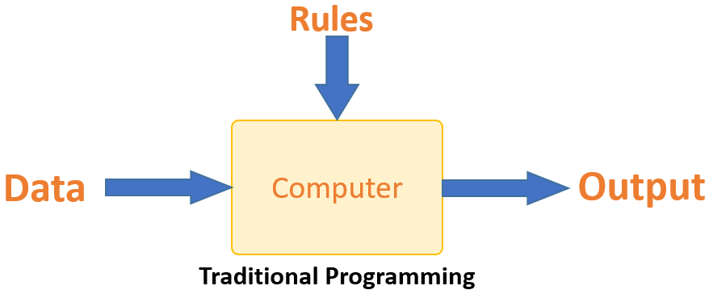

Traditional Programming

Machine learning is supposed to overcome this issue. The machine learns how the input and output data are correlated and it writes a rule. The programmers do not need to write new rules each time there is new data. The algorithms adapt in response to new data and experiences to improve efficacy over time.

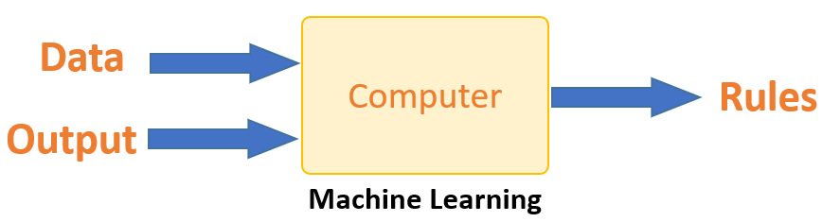

Machine Learning

**How does Machine Learning Work?**

Machine learning is the brain where all the learning takes place. The way the machine learns is similar to the human being. Humans learn from experience. The more we know, the more easily we can predict. By analogy, when we face an unknown situation, the likelihood of success is lower than the known situation. Machines are trained the same. To make an accurate prediction, the machine sees an example. When we give the machine a similar example, it can figure out the outcome. However, like a human, if its feed a previously unseen example, the machine has difficulties to predict.

The core objective of machine learning is the **learning** and **inference**. First of all, the machine learns through the discovery of patterns. This discovery is made thanks to the **data**. One crucial part of the data scientist is to choose carefully which data to provide to the machine. The list of attributes used to solve a problem is called a **feature vector.** You can think of a feature vector as a subset of data that is used to tackle a problem.

The machine uses some fancy algorithms to simplify the reality and transform this discovery into a **model**. Therefore, the learning stage is used to describe the data and summarize it into a model.

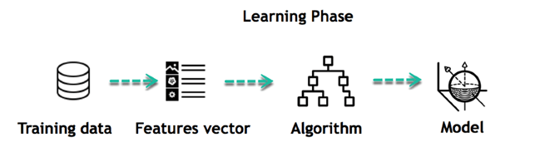

For instance, the machine is trying to understand the relationship between the wage of an individual and the likelihood to go to a fancy restaurant. It turns out the machine finds a positive relationship between wage and going to a high-end restaurant: This is the model

**Inferring**

When the model is built, it is possible to test how powerful it is on never-seen-before data. The new data are transformed into a features vector, go through the model and give a prediction. This is all the beautiful part of machine learning. There is no need to update the rules or train again the model. You can use the model previously trained to make inference on new data.

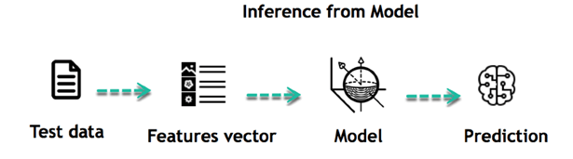

The life of Machine Learning programs is straightforward and can be summarized in the following points:

1. Define a question
2. Collect data
3. Visualize data
4. Train algorithm
5. Test the Algorithm
6. Collect feedback
7. Refine the algorithm
8. Loop 4-7 until the results are satisfying
9. Use the model to make a prediction

Once the algorithm gets good at drawing the right conclusions, it applies that knowledge to new sets of data.

**Machine Learning Algorithms and Where they are Used?**

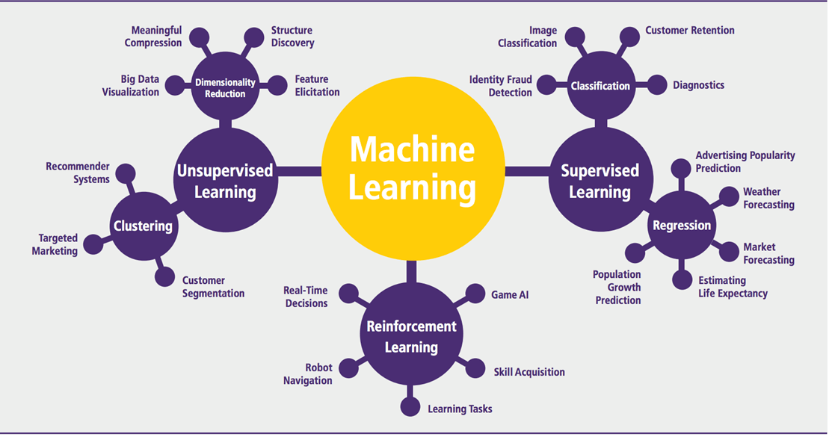

Machine learning Algorithms

Machine learning can be grouped into two broad learning tasks: Supervised and Unsupervised. There are many other algorithms

**Supervised learning**

An algorithm uses training data and feedback from humans to learn the relationship of given inputs to a given output. For instance, a practitioner can use marketing expense and weather forecast as input data to predict the sales of cans.

You can use supervised learning when the output data is known. The algorithm will predict new data.

There are two categories of supervised learning:

* Classification task
* Regression task

**Classification**

Imagine you want to predict the gender of a customer for a commercial. You will start gathering data on the height, weight, job, salary, purchasing basket, etc. from your customer database. You know the gender of each of your customer, it can only be male or female. The objective of the classifier will be to assign a probability of being a male or a female (i.e., the label) based on the information (i.e., features you have collected). When the model learned how to recognize male or female, you can use new data to make a prediction. For instance, you just got new information from an unknown customer, and you want to know if it is a male or female. If the classifier predicts male = 70%, it means the algorithm is sure at 70% that this customer is a male, and 30% it is a female.

The label can be of two or more classes. The above Machine learning example has only two classes, but if a classifier needs to predict object, it has dozens of classes (e.g., glass, table, shoes, etc. each object represents a class)

**Regression**

When the output is a continuous value, the task is a regression. For instance, a financial analyst may need to forecast the value of a stock based on a range of feature like equity, previous stock performances, macroeconomics index. The system will be trained to estimate the price of the stocks with the lowest possible error.

| **Algorithm Name** | **Description** | **Type** |
| --- | --- | --- |
| **Linear regression** | Finds a way to correlate each feature to the output to help predict future values. | Regression |
| **Logistic regression** | Extension of linear regression that's used for classification tasks. The output variable 3is binary (e.g., only black or white) rather than continuous (e.g., an infinite list of potential colors) | Classification |
| **Decision tree** | Highly interpretable classification or regression model that splits data-feature values into branches at decision nodes (e.g., if a feature is a color, each possible color becomes a new branch) until a final decision output is made | Regression Classification |
| **Naive Bayes** | The Bayesian method is a classification method that makes use of the Bayesian theorem. The theorem updates the prior knowledge of an event with the independent probability of each feature that can affect the event. | Regression Classification |
| **Support vector machine** | Support Vector Machine, or SVM, is typically used for the classification task. SVM algorithm finds a hyperplane that optimally divided the classes. It is best used with a non-linear solver. | Regression (not very common) Classification |
| **Random forest** | The algorithm is built upon a decision tree to improve the accuracy drastically. Random forest generates many times simple decision trees and uses the 'majority vote' method to decide on which label to return. For the classification task, the final prediction will be the one with the most vote; while for the regression task, the average prediction of all the trees is the final prediction. | Regression Classification |
| **AdaBoost** | Classification or regression technique that uses a multitude of models to come up with a decision but weighs them based on their accuracy in predicting the outcome | Regression Classification |
| **Gradient-boosting trees** | Gradient-boosting trees is a state-of-the-art classification/regression technique. It is focusing on the error committed by the previous trees and tries to correct it. | Regression Classification |

**Unsupervised learning**

In unsupervised learning, an algorithm explores input data without being given an explicit output variable (e.g., explores customer demographic data to identify patterns)

You can use it when you do not know how to classify the data, and you want the algorithm to find patterns and classify the data for you

| **Algorithm** | **Description** | **Type** |
| --- | --- | --- |
| **K-means clustering** | Puts data into some groups (k) that each contains data with similar characteristics (as determined by the model, not in advance by humans) | Clustering |
| **Gaussian mixture model** | A generalization of k-means clustering that provides more flexibility in the size and shape of groups (clusters) | Clustering |
| **Hierarchical clustering** | Splits clusters along a hierarchical tree to form a classification system. Can be used for Cluster loyalty-card customer | Clustering |
| **Recommender system** | Help to define the relevant data for making a recommendation. | Clustering |
| **PCA/T-SNE** | Mostly used to decrease the dimensionality of the data. The algorithms reduce the number of features to 3 or 4 vectors with the highest variances. | Dimension Reduction |

**How to Choose Machine Learning Algorithm**

**Machine Learning (ML) algorithm:**

There are plenty of machine learning algorithms. The choice of the algorithm is based on the objective.

In the Machine learning example below, the task is to predict the type of flower among the three varieties. The predictions are based on the length and the width of the petal. The picture depicts the results of ten different algorithms. The picture on the top left is the dataset. The data is classified into three categories: red, light blue and dark blue. There are some groupings. For instance, from the second image, everything in the upper left belongs to the red category, in the middle part, there is a mixture of uncertainty and light blue while the bottom corresponds to the dark category. The other images show different algorithms and how they try to classified the data.

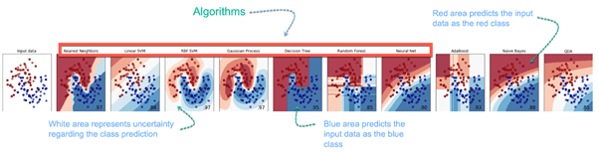

**Challenges and Limitations of Machine Learning**

The primary challenge of machine learning is the lack of data or the diversity in the dataset. A machine cannot learn if there is no data available. Besides, a dataset with a lack of diversity gives the machine a hard time. A machine needs to have heterogeneity to learn meaningful insight. It is rare that an algorithm can extract information when there are no or few variations. It is recommended to have at least 20 observations per group to help the machine learn. This constraint leads to poor evaluation and prediction.

**Application of Machine Learning**

**Augmentation**:

* Machine learning, which assists humans with their day-to-day tasks, personally or commercially without having complete control of the output. Such machine learning is used in different ways such as Virtual Assistant, Data analysis, software solutions. The primary user is to reduce errors due to human bias.

**Automation**:

* Machine learning, which works entirely autonomously in any field without the need for any human intervention. For example, robots performing the essential process steps in manufacturing plants.

**Finance Industry**

* Machine learning is growing in popularity in the finance industry. Banks are mainly using ML to find patterns inside the data but also to prevent fraud.

**Government organization**

* The government makes use of ML to manage public safety and utilities. Take the example of China with the massive face recognition. The government uses Artificial intelligence to prevent jaywalker.

**Healthcare industry**

* Healthcare was one of the first industry to use machine learning with image detection.

**Marketing**

* Broad use of AI is done in marketing thanks to abundant access to data. Before the age of mass data, researchers develop advanced mathematical tools like Bayesian analysis to estimate the value of a customer. With the boom of data, marketing department relies on AI to optimize the customer relationship and marketing campaign.

**Example of application of Machine Learning in Supply Chain**

Machine learning gives terrific results for visual pattern recognition, opening up many potential applications in physical inspection and maintenance across the entire supply chain network.

Unsupervised learning can quickly search for comparable patterns in the diverse dataset. In turn, the machine can perform quality inspection throughout the logistics hub, shipment with damage and wear.

For instance, IBM's Watson platform can determine shipping container damage. Watson combines visual and systems-based data to track, report and make recommendations in real-time.

In past year stock manager relies extensively on the primary method to evaluate and forecast the inventory. When combining big data and machine learning, better forecasting techniques have been implemented (an improvement of 20 to 30 % over traditional forecasting tools). In term of sales, it means an increase of 2 to 3 % due to the potential reduction in inventory costs.

**Example of Machine Learning Google Car**

For example, everybody knows the Google car. The car is full of lasers on the roof which are telling it where it is regarding the surrounding area. It has radar in the front, which is informing the car of the speed and motion of all the cars around it. It uses all of that data to figure out not only how to drive the car but also to figure out and predict what potential drivers around the car are going to do. What's impressive is that the car is processing almost a gigabyte a second of data.

**Why is Machine Learning Important?**

Machine learning is the best tool so far to analyze, understand and identify a pattern in the data. One of the main ideas behind machine learning is that the computer can be trained to automate tasks that would be exhaustive or impossible for a human being. The clear breach from the traditional analysis is that machine learning can take decisions with minimal human intervention.

Take the following example for this ML tutorial; a retail agent can estimate the price of a house based on his own experience and his knowledge of the market.

A machine can be trained to translate the knowledge of an expert into features. The features are all the characteristics of a house, neighborhood, economic environment, etc. that make the price difference. For the expert, it took him probably some years to master the art of estimate the price of a house. His expertise is getting better and better after each sale.

For the machine, it takes millions of data, (i.e., example) to master this art. At the very beginning of its learning, the machine makes a mistake, somehow like the junior salesman. Once the machine sees all the example, it got enough knowledge to make its estimation. At the same time, with incredible accuracy. The machine is also able to adjust its mistake accordingly.

Most of the big company have understood the value of machine learning and holding data. McKinsey have estimated that the value of analytics ranges from **$**9.5 trillion to **$**15.4 trillion while **$**5 to 7 trillion can be attributed to the most advanced AI techniques.

Machine learning (ML) is the study of computer algorithms that improve automatically through experience. It is seen as a part of artificial intelligence. Machine learning algorithms build a model based on sample data, known as "training data", in order to make predictions or decisions without being explicitly programmed to do so. Machine learning algorithms are used in a wide variety of applications, such as email filtering and computer vision, where it is difficult or unfeasible to develop conventional algorithms to perform the needed tasks.

A subset of machine learning is closely related to computational statistics, which focuses on making predictions using computers; but not all machine learning is statistical learning. The study of mathematical optimization delivers methods, theory and application domains to the field of machine learning. Data mining is a related field of study, focusing on exploratory data analysis through unsupervised learning. In its application across business problems, machine learning is also referred to as predictive analytics.

**Overview**

Machine learning involves computers discovering how they can perform tasks without being explicitly programmed to do so. It involves computers learning from data provided so that they carry out certain tasks. For simple tasks assigned to computers, it is possible to program algorithms telling the machine how to execute all steps required to solve the problem at hand; on the computer's part, no learning is needed. For more advanced tasks, it can be challenging for a human to manually create the needed algorithms. In practice, it can turn out to be more effective to help the machine develop its own algorithm, rather than having human programmers specify every needed step.

The discipline of machine learning employs various approaches to teach computers to accomplish tasks where no fully satisfactory algorithm is available. In cases where vast numbers of potential answers exist, one approach is to label some of the correct answers as valid. This can then be used as training data for the computer to improve the algorithm(s) it uses to determine correct answers. For example, to train a system for the task of digital character recognition, the MNIST dataset of handwritten digits has often been used.

**Machine learning approaches**

Machine learning approaches are traditionally divided into three broad categories, depending on the nature of the "signal" or "feedback" available to the learning system:

**Supervised learning:** The computer is presented with example inputs and their desired outputs, given by a "teacher", and the goal is to learn a general rule that maps inputs to outputs.

**Unsupervised learning:** No labels are given to the learning algorithm, leaving it on its own to find structure in its input. Unsupervised learning can be a goal in itself (discovering hidden patterns in data) or a means towards an end (feature learning).

**Reinforcement learning:** A computer program interacts with a dynamic environment in which it must perform a certain goal (such as driving a vehicle or playing a game against an opponent). As it navigates its problem space, the program is provided feedback that's analogous to rewards, which it tries to maximize.

Other approaches have been developed which don't fit neatly into this three-fold categorisation, and sometimes more than one is used by the same machine learning system. For example topic modeling, dimensionality reduction or meta learning.

As of 2020, deep learning has become the dominant approach for much ongoing work in the field of machine learning.

**History and relationships to other fields**

The term machine learning was coined in 1959 by Arthur Samuel, an American IBMer and pioneer in the field of computer gaming and artificial intelligence. A representative book of the machine learning research during the 1960s was the Nilsson's book on Learning Machines, dealing mostly with machine learning for pattern classification. Interest related to pattern recognition continued into the 1970s, as described by Duda and Hart in 1973. In 1981 a report was given on using teaching strategies so that a neural network learns to recognize 40 characters (26 letters, 10 digits, and 4 special symbols) from a computer terminal.

Tom M. Mitchell provided a widely quoted, more formal definition of the algorithms studied in the machine learning field: "A computer program is said to learn from experience E with respect to some class of tasks T and performance measure P if its performance at tasks in T, as measured by P, improves with experience E."This definition of the tasks in which machine learning is concerned offers a fundamentally operational definition rather than defining the field in cognitive terms. This follows Alan Turing's proposal in his paper "Computing Machinery and Intelligence", in which the question "Can machines think?" is replaced with the question "Can machines do what we (as thinking entities) can do?".

Modern day machine learning has two objectives, one is to classify data based on models which have been developed, the other purpose is to make predictions for future outcomes based on these models. A hypothetical algorithm specific to classifying data may use computer vision of moles coupled with supervised learning in order to train it to classify the cancerous moles. Where as, a machine learning algorithm for stock trading may inform the trader of future potential predictions.

**Artificial intelligence**

Machine Learning as subfield of AI

Part of Machine Learning as subfield of AI or part of AI as subfield of Machine Learning

As a scientific endeavor, machine learning grew out of the quest for artificial intelligence. In the early days of AI as an academic discipline, some researchers were interested in having machines learn from data. They attempted to approach the problem with various symbolic methods, as well as what was then termed "neural networks"; these were mostly perceptrons and other models that were later found to be reinventions of the generalized linear models of statistics. Probabilistic reasoning was also employed, especially in automated medical diagnosis.

However, an increasing emphasis on the logical, knowledge-based approach caused a rift between AI and machine learning. Probabilistic systems were plagued by theoretical and practical problems of data acquisition and representation. By 1980, expert systems had come to dominate AI, and statistics was out of favor. Work on symbolic/knowledge-based learning did continue within AI, leading to inductive logic programming, but the more statistical line of research was now outside the field of AI proper, in pattern recognition and information retrieval. Neural networks research had been abandoned by AI and computer science around the same time. This line, too, was continued outside the AI/CS field, as "connectionism", by researchers from other disciplines including Hopfield, Rumelhart and Hinton. Their main success came in the mid-1980s with the reinvention of backpropagation.

Machine learning (ML), reorganized as a separate field, started to flourish in the 1990s. The field changed its goal from achieving artificial intelligence to tackling solvable problems of a practical nature. It shifted focus away from the symbolic approaches it had inherited from AI, and toward methods and models borrowed from statistics and probability theory.

As of 2020, many sources continue to assert that machine learning remains a subfield of AI. The main disagreement is whether all of ML is part of AI, as this would mean that anyone using ML could claim they are using AI. Others have the view that not all of ML is part of AI where only an 'intelligent' subset of ML is part of AI.

The question to what is the difference between ML and AI is answered by Judea Pearl in The Book of Why. Accordingly ML learns and predicts based on passive observations, whereas AI implies an agent interacting with the environment to learn and take actions that maximize its chance of successfully achieving its goals.

**Data mining**

Machine learning and data mining often employ the same methods and overlap significantly, but while machine learning focuses on prediction, based on known properties learned from the training data, data mining focuses on the discovery of (previously) unknown properties in the data (this is the analysis step of knowledge discovery in databases). Data mining uses many machine learning methods, but with different goals; on the other hand, machine learning also employs data mining methods as "unsupervised learning" or as a preprocessing step to improve learner accuracy. Much of the confusion between these two research communities (which do often have separate conferences and separate journals, ECML PKDD being a major exception) comes from the basic assumptions they work with: in machine learning, performance is usually evaluated with respect to the ability to reproduce known knowledge, while in knowledge discovery and data mining (KDD) the key task is the discovery of previously unknown knowledge. Evaluated with respect to known knowledge, an uninformed (unsupervised) method will easily be outperformed by other supervised methods, while in a typical KDD task, supervised methods cannot be used due to the unavailability of training data.

**Optimization**

Machine learning also has intimate ties to optimization: many learning problems are formulated as minimization of some loss function on a training set of examples. Loss functions express the discrepancy between the predictions of the model being trained and the actual problem instances (for example, in classification, one wants to assign a label to instances, and models are trained to correctly predict the pre-assigned labels of a set of examples).

**Generalization**

The difference between optimization and machine learning arises from the goal of generalization: while optimization algorithms can minimize the loss on a training set, machine learning is concerned with minimizing the loss on unseen samples. Characterizing the generalization of various learning algorithms is an active topic of current research, especially for deep learning algorithms.

**Statistics**

Machine learning and statistics are closely related fields in terms of methods, but distinct in their principal goal: statistics draws population inferences from a sample, while machine learning finds generalizable predictive patterns. According to Michael I. Jordan, the ideas of machine learning, from methodological principles to theoretical tools, have had a long pre-history in statistics. He also suggested the term data science as a placeholder to call the overall field.

Leo Breiman distinguished two statistical modeling paradigms: data model and algorithmic model, wherein "algorithmic model" means more or less the machine learning algorithms like Random forest.

Some statisticians have adopted methods from machine learning, leading to a combined field that they call statistical learning.

**Theory**

A core objective of a learner is to generalize from its experience. Generalization in this context is the ability of a learning machine to perform accurately on new, unseen examples/tasks after having experienced a learning data set. The training examples come from some generally unknown probability distribution (considered representative of the space of occurrences) and the learner has to build a general model about this space that enables it to produce sufficiently accurate predictions in new cases.

The computational analysis of machine learning algorithms and their performance is a branch of theoretical computer science known as computational learning theory. Because training sets are finite and the future is uncertain, learning theory usually does not yield guarantees of the performance of algorithms. Instead, probabilistic bounds on the performance are quite common. The bias–variance decomposition is one way to quantify generalization error.

For the best performance in the context of generalization, the complexity of the hypothesis should match the complexity of the function underlying the data. If the hypothesis is less complex than the function, then the model has under fitted the data. If the complexity of the model is increased in response, then the training error decreases. But if the hypothesis is too complex, then the model is subject to overfitting and generalization will be poorer.

In addition to performance bounds, learning theorists study the time complexity and feasibility of learning. In computational learning theory, a computation is considered feasible if it can be done in polynomial time. There are two kinds of time complexity results. Positive results show that a certain class of functions can be learned in polynomial time. Negative results show that certain classes cannot be learned in polynomial time.

**Approaches**

**Types of learning algorithms**

The types of machine learning algorithms differ in their approach, the type of data they input and output, and the type of task or problem that they are intended to solve.

**Supervised learning**

A support vector machine is a supervised learning model that divides the data into regions separated by a linear boundary. Here, the linear boundary divides the black circles from the white.

Supervised learning algorithms build a mathematical model of a set of data that contains both the inputs and the desired outputs. The data is known as training data, and consists of a set of training examples. Each training example has one or more inputs and the desired output, also known as a supervisory signal. In the mathematical model, each training example is represented by an array or vector, sometimes called a feature vector, and the training data is represented by a matrix. Through iterative optimization of an objective function, supervised learning algorithms learn a function that can be used to predict the output associated with new inputs. An optimal function will allow the algorithm to correctly determine the output for inputs that were not a part of the training data. An algorithm that improves the accuracy of its outputs or predictions over time is said to have learned to perform that task.

Types of supervised learning algorithms include active learning, classification and regression. Classification algorithms are used when the outputs are restricted to a limited set of values, and regression algorithms are used when the outputs may have any numerical value within a range. As an example, for a classification algorithm that filters emails, the input would be an incoming email, and the output would be the name of the folder in which to file the email.

Similarity learning is an area of supervised machine learning closely related to regression and classification, but the goal is to learn from examples using a similarity function that measures how similar or related two objects are. It has applications in ranking, recommendation systems, visual identity tracking, face verification, and speaker verification.

**Unsupervised learning**

Unsupervised learning algorithms take a set of data that contains only inputs, and find structure in the data, like grouping or clustering of data points. The algorithms, therefore, learn from test data that has not been labeled, classified or categorized. Instead of responding to feedback, unsupervised learning algorithms identify commonalities in the data and react based on the presence or absence of such commonalities in each new piece of data. A central application of unsupervised learning is in the field of density estimation in statistics, such as finding the probability density function. Though unsupervised learning encompasses other domains involving summarizing and explaining data features.

Cluster analysis is the assignment of a set of observations into subsets (called clusters) so that observations within the same cluster are similar according to one or more predesignated criteria, while observations drawn from different clusters are dissimilar. Different clustering techniques make different assumptions on the structure of the data, often defined by some similarity metric and evaluated, for example, by internal compactness, or the similarity between members of the same cluster, and separation, the difference between clusters. Other methods are based on estimated density and graph connectivity.

**Semi-supervised learning**

Semi-supervised learning falls between unsupervised learning (without any labeled training data) and supervised learning (with completely labeled training data). Some of the training examples are missing training labels, yet many machine-learning researchers have found that unlabeled data, when used in conjunction with a small amount of labeled data, can produce a considerable improvement in learning accuracy.

In weakly supervised learning, the training labels are noisy, limited, or imprecise; however, these labels are often cheaper to obtain, resulting in larger effective training sets.

**Reinforcement learning**

Reinforcement learning is an area of machine learning concerned with how software agents ought to take actions in an environment so as to maximize some notion of cumulative reward. Due to its generality, the field is studied in many other disciplines, such as game theory, control theory, operations research, information theory, simulation-based optimization, multi-agent systems, swarm intelligence, statistics and genetic algorithms. In machine learning, the environment is typically represented as a Markov decision process (MDP). Many reinforcement learning algorithms use dynamic programming techniques. Reinforcement learning algorithms do not assume knowledge of an exact mathematical model of the MDP, and are used when exact models are infeasible. Reinforcement learning algorithms are used in autonomous vehicles or in learning to play a game against a human opponent.

**Self learning**

Self-learning as a machine learning paradigm was introduced in 1982 along with a neural network capable of self-learning named crossbar adaptive array (CAA). It is a learning with no external rewards and no external teacher advice. The CAA self-learning algorithm computes, in a crossbar fashion, both decisions about actions and emotions (feelings) about consequence situations. The system is driven by the interaction between cognition and emotion. The self-learning algorithm updates a memory matrix W =||w(a,s)|| such that in each iteration executes the following machine learning routine:

In situation s perform an action a;

Receive consequence situation s’;

Compute emotion of being in consequence situation v(s’);

Update crossbar memory w’(a,s) = w(a,s) + v(s’).

It is a system with only one input, situation s, and only one output, action (or behavior) a. There is neither a separate reinforcement input nor an advice input from the environment. The backpropagated value (secondary reinforcement) is the emotion toward the consequence situation. The CAA exists in two environments, one is the behavioral environment where it behaves, and the other is the genetic environment, wherefrom it initially and only once receives initial emotions about situations to be encountered in the behavioral environment. After receiving the genome (species) vector from the genetic environment, the CAA learns a goal-seeking behavior, in an environment that contains both desirable and undesirable situations.

**Feature learning**

Several learning algorithms aim at discovering better representations of the inputs provided during training. Classic examples include principal components analysis and cluster analysis. Feature learning algorithms, also called representation learning algorithms, often attempt to preserve the information in their input but also transform it in a way that makes it useful, often as a pre-processing step before performing classification or predictions. This technique allows reconstruction of the inputs coming from the unknown data-generating distribution, while not being necessarily faithful to configurations that are implausible under that distribution. This replaces manual feature engineering, and allows a machine to both learn the features and use them to perform a specific task.

Feature learning can be either supervised or unsupervised. In supervised feature learning, features are learned using labeled input data. Examples include artificial neural networks, multilayer perceptrons, and supervised dictionary learning. In unsupervised feature learning, features are learned with unlabeled input data. Examples include dictionary learning, independent component analysis, autoencoders, matrix factorization and various forms of clustering.

Manifold learning algorithms attempt to do so under the constraint that the learned representation is low-dimensional. Sparse coding algorithms attempt to do so under the constraint that the learned representation is sparse, meaning that the mathematical model has many zeros. Multilinear subspace learning algorithms aim to learn low-dimensional representations directly from tensor representations for multidimensional data, without reshaping them into higher-dimensional vectors. Deep learning algorithms discover multiple levels of representation, or a hierarchy of features, with higher-level, more abstract features defined in terms of (or generating) lower-level features. It has been argued that an intelligent machine is one that learns a representation that disentangles the underlying factors of variation that explain the observed data.

Feature learning is motivated by the fact that machine learning tasks such as classification often require input that is mathematically and computationally convenient to process. However, real-world data such as images, video, and sensory data has not yielded to attempts to algorithmically define specific features. An alternative is to discover such features or representations thorough examination, without relying on explicit algorithms.

**Sparse dictionary learning**

Sparse dictionary learning is a feature learning method where a training example is represented as a linear combination of basis functions, and is assumed to be a sparse matrix. The method is strongly NP-hard and difficult to solve approximately. A popular heuristic method for sparse dictionary learning is the K-SVD algorithm. Sparse dictionary learning has been applied in several contexts. In classification, the problem is to determine the class to which a previously unseen training example belongs. For a dictionary where each class has already been built, a new training example is associated with the class that is best sparsely represented by the corresponding dictionary. Sparse dictionary learning has also been applied in image de-noising. The key idea is that a clean image patch can be sparsely represented by an image dictionary, but the noise cannot.

**Anomaly detection**

In data mining, anomaly detection, also known as outlier detection, is the identification of rare items, events or observations which raise suspicions by differing significantly from the majority of the data. Typically, the anomalous items represent an issue such as bank fraud, a structural defect, medical problems or errors in a text. Anomalies are referred to as outliers, novelties, noise, deviations and exceptions.

In particular, in the context of abuse and network intrusion detection, the interesting objects are often not rare objects, but unexpected bursts of inactivity. This pattern does not adhere to the common statistical definition of an outlier as a rare object, and many outlier detection methods (in particular, unsupervised algorithms) will fail on such data unless it has been aggregated appropriately. Instead, a cluster analysis algorithm may be able to detect the micro-clusters formed by these patterns.

Three broad categories of anomaly detection techniques exist. Unsupervised anomaly detection techniques detect anomalies in an unlabeled test data set under the assumption that the majority of the instances in the data set are normal, by looking for instances that seem to fit least to the remainder of the data set. Supervised anomaly detection techniques require a data set that has been labeled as "normal" and "abnormal" and involves training a classifier (the key difference to many other statistical classification problems is the inherently unbalanced nature of outlier detection). Semi-supervised anomaly detection techniques construct a model representing normal behavior from a given normal training data set and then test the likelihood of a test instance to be generated by the model.

**Robot learning**

In developmental robotics, robot learning algorithms generate their own sequences of learning experiences, also known as a curriculum, to cumulatively acquire new skills through self-guided exploration and social interaction with humans. These robots use guidance mechanisms such as active learning, maturation, motor synergies and imitation.

**Association rules**

Association rule learning is a rule-based machine learning method for discovering relationships between variables in large databases. It is intended to identify strong rules discovered in databases using some measure of "interestingness".

Rule-based machine learning is a general term for any machine learning method that identifies, learns, or evolves "rules" to store, manipulate or apply knowledge. The defining characteristic of a rule-based machine learning algorithm is the identification and utilization of a set of relational rules that collectively represent the knowledge captured by the system. This is in contrast to other machine learning algorithms that commonly identify a singular model that can be universally applied to any instance in order to make a prediction. Rule-based machine learning approaches include learning classifier systems, association rule learning, and artificial immune systems.

Based on the concept of strong rules, Rakesh Agrawal, Tomasz Imieliński and Arun Swami introduced association rules for discovering regularities between products in large-scale transaction data recorded by point-of-sale (POS) systems in supermarkets. For example, the rule {\displaystyle \{\mathrm {onions,potatoes} \}\Rightarrow \{\mathrm {burger} \}}\{{\mathrm {onions,potatoes}}\}\Rightarrow \{{\mathrm {burger}}\} found in the sales data of a supermarket would indicate that if a customer buys onions and potatoes together, they are likely to also buy hamburger meat. Such information can be used as the basis for decisions about marketing activities such as promotional pricing or product placements. In addition to market basket analysis, association rules are employed today in application areas including Web usage mining, intrusion detection, continuous production, and bioinformatics. In contrast with sequence mining, association rule learning typically does not consider the order of items either within a transaction or across transactions.

Learning classifier systems (LCS) are a family of rule-based machine learning algorithms that combine a discovery component, typically a genetic algorithm, with a learning component, performing either supervised learning, reinforcement learning, or unsupervised learning. They seek to identify a set of context-dependent rules that collectively store and apply knowledge in a piecewise manner in order to make predictions.

Inductive logic programming (ILP) is an approach to rule-learning using logic programming as a uniform representation for input examples, background knowledge, and hypotheses. Given an encoding of the known background knowledge and a set of examples represented as a logical database of facts, an ILP system will derive a hypothesized logic program that entails all positive and no negative examples. Inductive programming is a related field that considers any kind of programming language for representing hypotheses (and not only logic programming), such as functional programs.

Inductive logic programming is particularly useful in bioinformatics and natural language processing. Gordon Plotkin and Ehud Shapiro laid the initial theoretical foundation for inductive machine learning in a logical setting. Shapiro built their first implementation (Model Inference System) in 1981: a Prolog program that inductively inferred logic programs from positive and negative examples. The term inductive here refers to philosophical induction, suggesting a theory to explain observed facts, rather than mathematical induction, proving a property for all members of a well-ordered set.

**Models**

Performing machine learning involves creating a model, which is trained on some training data and then can process additional data to make predictions. Various types of models have been used and researched for machine learning systems.

**Artificial neural networks**

An artificial neural network is an interconnected group of nodes, akin to the vast network of neurons in a brain. Here, each circular node represents an artificial neuron and an arrow represents a connection from the output of one artificial neuron to the input of another.

Artificial neural networks (ANNs), or connectionist systems, are computing systems vaguely inspired by the biological neural networks that constitute animal brains. Such systems "learn" to perform tasks by considering examples, generally without being programmed with any task-specific rules.

An ANN is a model based on a collection of connected units or nodes called "artificial neurons", which loosely model the neurons in a biological brain. Each connection, like the synapses in a biological brain, can transmit information, a "signal", from one artificial neuron to another. An artificial neuron that receives a signal can process it and then signal additional artificial neurons connected to it. In common ANN implementations, the signal at a connection between artificial neurons is a real number, and the output of each artificial neuron is computed by some non-linear function of the sum of its inputs. The connections between artificial neurons are called "edges". Artificial neurons and edges typically have a weight that adjusts as learning proceeds. The weight increases or decreases the strength of the signal at a connection. Artificial neurons may have a threshold such that the signal is only sent if the aggregate signal crosses that threshold. Typically, artificial neurons are aggregated into layers. Different layers may perform different kinds of transformations on their inputs. Signals travel from the first layer (the input layer) to the last layer (the output layer), possibly after traversing the layers multiple times.

The original goal of the ANN approach was to solve problems in the same way that a human brain would. However, over time, attention moved to performing specific tasks, leading to deviations from biology. Artificial neural networks have been used on a variety of tasks, including computer vision, speech recognition, machine translation, social network filtering, playing board and video games and medical diagnosis.

Deep learning consists of multiple hidden layers in an artificial neural network. This approach tries to model the way the human brain processes light and sound into vision and hearing. Some successful applications of deep learning are computer vision and speech recognition.

**Decision trees**

Decision tree learning uses a decision tree as a predictive model to go from observations about an item (represented in the branches) to conclusions about the item's target value (represented in the leaves). It is one of the predictive modeling approaches used in statistics, data mining, and machine learning. Tree models where the target variable can take a discrete set of values are called classification trees; in these tree structures, leaves represent class labels and branches represent conjunctions of features that lead to those class labels. Decision trees where the target variable can take continuous values (typically real numbers) are called regression trees. In decision analysis, a decision tree can be used to visually and explicitly represent decisions and decision making. In data mining, a decision tree describes data, but the resulting classification tree can be an input for decision making.

**Support vector machines**

Support vector machines (SVMs), also known as support vector networks, are a set of related supervised learning methods used for classification and regression. Given a set of training examples, each marked as belonging to one of two categories, an SVM training algorithm builds a model that predicts whether a new example falls into one category or the other. An SVM training algorithm is a non-probabilistic, binary, linear classifier, although methods such as Platt scaling exist to use SVM in a probabilistic classification setting. In addition to performing linear classification, SVMs can efficiently perform a non-linear classification using what is called the kernel trick, implicitly mapping their inputs into high-dimensional feature spaces.

**Regression analysis**

Regression analysis encompasses a large variety of statistical methods to estimate the relationship between input variables and their associated features. Its most common form is linear regression, where a single line is drawn to best fit the given data according to a mathematical criterion such as ordinary least squares. The latter is often extended by regularization (mathematics) methods to mitigate overfitting and bias, as in ridge regression. When dealing with non-linear problems, go-to models include polynomial regression (for example, used for trendline fitting in Microsoft Excel, logistic regression (often used in statistical classification) or even kernel regression, which introduces non-linearity by taking advantage of the kernel trick to implicitly map input variables to higher-dimensional space.

**Bayesian networks**

A simple Bayesian network. Rain influences whether the sprinkler is activated, and both rain and the sprinkler influence whether the grass is wet.

A Bayesian network, belief network, or directed acyclic graphical model is a probabilistic graphical model that represents a set of random variables and their conditional independence with a directed acyclic graph (DAG). For example, a Bayesian network could represent the probabilistic relationships between diseases and symptoms. Given symptoms, the network can be used to compute the probabilities of the presence of various diseases. Efficient algorithms exist that perform inference and learning. Bayesian networks that model sequences of variables, like speech signals or protein sequences, are called dynamic Bayesian networks. Generalizations of Bayesian networks that can represent and solve decision problems under uncertainty are called influence diagrams.

**Genetic algorithms**

A genetic algorithm (GA) is a search algorithm and heuristic technique that mimics the process of natural selection, using methods such as mutation and crossover to generate new genotypes in the hope of finding good solutions to a given problem. In machine learning, genetic algorithms were used in the 1980s and 1990s. Conversely, machine learning techniques have been used to improve the performance of genetic and evolutionary algorithms.

**Training models**

Usually, machine learning models require a lot of data in order for them to perform well. Usually, when training a machine learning model, one needs to collect a large, representative sample of data from a training set. Data from the training set can be as varied as a corpus of text, a collection of images, and data collected from individual users of a service. Overfitting is something to watch out for when training a machine learning model. Trained models derived from biased data can result in skewed or undesired predictions. Algorithmic bias is a potential result from data not fully prepared for training.

**Federated learning**

Federated learning is an adapted form of distributed artificial intelligence to training machine learning models that decentralizes the training process, allowing for users' privacy to be maintained by not needing to send their data to a centralized server. This also increases efficiency by decentralizing the training process to many devices. For example, Gboard uses federated machine learning to train search query prediction models on users' mobile phones without having to send individual searches back to Google