Perfect. Below is the Phase 2 documentation, written in the same tone, structure, and rigor as Phase 1 and Phase 8.3, so your entire workshop stays consistent and confusion-free.
You can save this as:
docs/Phase-2-Fixtures-and-Test-Lifecycle.md

📘 Phase 2 — Test Lifecycle Management with Pytest Fixtures

(Browser Initialization, Reuse & Clean Teardown)

1️⃣ Objective of Phase 2
Phase 2 introduces controlled test lifecycle management using pytest fixtures.
By the end of Phase 2, the framework must:
- remove browser setup from test files
- initialize browser in a reusable way
- share setup across tests
- guarantee clean teardown
- enable future scalability (POM, BasePage, etc.)
📌 Phase 2 is where the framework stops being script-based and becomes structured.

2️⃣ Scope of Phase 2

Included
- conftest.py
- pytest fixtures
- browser setup abstraction
- fixture scopes
- dependency injection into tests

Explicitly Excluded
- Page Object Model
- BasePage
- Logging
- Reporting
- Data-driven testing
Those come after Phase 2.

3️⃣ Why Phase 2 Exists (Core Reason)
Phase 1 proved automation works.
Phase 2 ensures automation is maintainable.
Without Phase 2:
- browser code duplicated
- teardown forgotten
- tests tightly coupled
- scaling impossible
Phase 2 solves this using fixtures.

4️⃣ Folder Structure (After Phase 2)
Automation-Practice-Website/
│
├── tests/
│ ├── test_smoke.py
│
├── conftest.py ⭐ PHASE 2 CORE
├── requirements.txt
└── pytest.ini (optional)
📌 conftest.py is automatically discovered by pytest — no imports needed.

5️⃣ What is a Fixture? (Concept Clarity)
A fixture is:
A reusable setup/teardown mechanism managed by pytest.
Fixtures:
- run before tests
- can return objects (like WebDriver)
- can clean up after tests
- are injected into tests automatically
📌 Fixtures are not helpers.
They control lifecycle.

6️⃣ Creating the First Fixture (Browser)

📍 File: conftest.py

✅ Phase-2 Browser Fixture
import pytest
from selenium import webdriver
from selenium.webdriver.chrome.service import Service
from webdriver_manager.chrome import ChromeDriverManager

@pytest.fixture
def driver():
service = Service(ChromeDriverManager().install())
driver = webdriver.Chrome(service=service)
driver.maximize_window()

driver.get("https://rahulshettyacademy.com/AutomationPractice/")

yield driver

driver.quit()

What each part does
Line | Purpose
@pytest.fixture | Declares lifecycle-managed setup
yield driver | Hands control to test
code after yield | Teardown logic
driver.quit() | Ensures cleanup
📌 yield is mandatory for teardown support.

7️⃣ Using the Fixture in Tests

📍 File: tests/test_smoke.py

✅ Updated Smoke Test
def test_smoke(driver):
assert "Practice Page" in driver.title

Why this is important
- Test contains only validation
- Browser logic is centralized
- Multiple tests can reuse same fixture
📌 This is the first sign of clean framework design.

8️⃣ Fixture Injection Rule (Very Important)
If a test function has:
def test_something(driver):
pytest:
- finds a fixture named driver
- executes it
- injects returned value
❌ No imports
❌ No object creation inside tests
This is dependency injection, pytest-style.

9️⃣ Fixture Scope (Introduced, Not Used Yet)
By default:
@pytest.fixture
Means:
scope="function"
Which implies:
- new browser per test
Scopes (for awareness):
Scope | Meaning
function | new setup per test
class | shared within class
module | shared within file
session | shared across run
📌 Phase 2 uses function scope only.

🔁 Common Phase 2 Errors (And Meaning)
Error | Meaning
driver is None | Forgot yield driver
Browser not closing | Teardown missing
Fixture not found | Name mismatch
Importing conftest | Wrong approach

🔑 Phase 2 Design Principles (Interview Gold)
“Phase 2 removes setup duplication by introducing pytest fixtures, centralizing browser lifecycle and enabling clean dependency injection.”
This shows framework thinking, not scripting.

1️⃣0️⃣ Phase 2 Exit Criteria ✅ (Frozen)
You must not proceed unless:
- All tests run without browser code inside test files
- Browser launches via fixture
- Browser closes automatically
- Tests are readable & minimal
- No duplicated setup logic
If teardown fails even once → Phase 2 incomplete.

🔜 Transition to Phase 3
Phase | What changes
Phase 3 | BasePage abstraction
Phase 4 | Page Object Model
Phase 5 | Configuration management
📌 Phase 2 is the foundation for every phase that follows.

🎤 Interview-Ready Explanation (Memorize)
“In Phase 2, I introduced pytest fixtures to manage browser lifecycle centrally. This removed setup duplication, ensured reliable teardown, and prepared the framework for scalable abstractions like BasePage and Page Objects.”

🧊 Final Freeze Statement
Phase 2 is complete when:
“Tests describe what to validate, and fixtures control how the browser is managed.”
Nothing more. Nothing less.

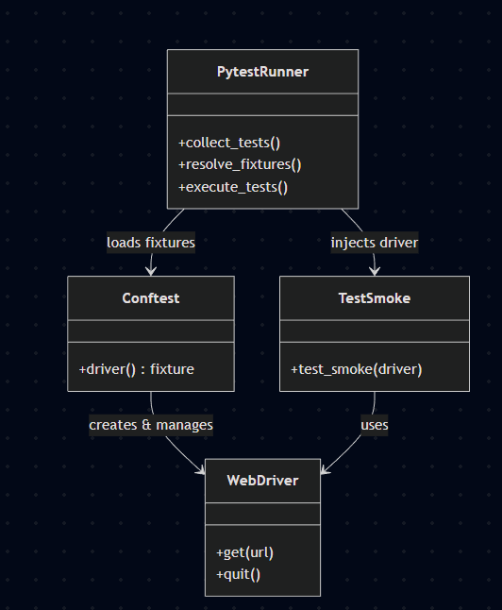

🧠 Pytest Fixture Lifecycle & Dependency Injection

(Core Concept)
This section explains how pytest actually runs your code, not just what you write.
Understanding this flow eliminates:
- confusion around yield
- fear of fixtures
- misuse of setup/teardown logic

🔁 The Fixture Lifecycle (Mental Execution Flow)
Pause and visualize this sequence every time you write a fixture:
fixture starts
↓
browser opens
↓
URL loads
↓
yield hands driver to test
↓
test executes
↓
control returns after test
↓
driver.quit()
This is exactly how pytest executes a fixture.

📍 What yield Really Means (Important)
In pytest fixtures:
@pytest.fixture
def driver():
setup_code
yield resource
teardown_code
yield does not mean:
- pause forever
- return like a function
- end execution
It means:
“Pause fixture execution, give control to the test, and resume after the test finishes.”
So pytest internally does:
- Run everything before yield
- Execute the test
- Resume execution after yield
- Perform teardown

🔄 Comparison with Phase 1 (try / finally)

Phase 1 (Manual, local)
driver = webdriver.Chrome()
try:
driver.get(url)
assert something
finally:
driver.quit()
Problems:
- duplicated in every test
- easy to forget
- not reusable
- not scalable

Phase 2 (Centralized, pytest-managed)
@pytest.fixture
def driver():
driver = webdriver.Chrome()
driver.get(url)
yield driver
driver.quit()
Advantages:
- single definition
- enforced teardown
- reusable across tests
- lifecycle controlled by pytest
📌 Fixture replaces try/finally globally.

🔑 Why This is Called Dependency Injection
When you write:
def test_smoke(driver):
assert "Practice Page" in driver.title
You are not creating driver.
Instead:
- pytest inspects the test signature
- sees a parameter named driver
- finds a fixture with the same name
- executes the fixture
- injects the returned value
This is dependency injection, pytest-style.

🧩 Key Dependency Injection Rules
- Fixture name == parameter name
- Tests do not import fixtures
- Tests do not know how objects are created
- Fixtures manage lifecycle, tests use behavior
This leads to:
- loose coupling
- clean test code
- easy refactoring

🧠 Why This Matters for Framework Design
Once you understand this flow:
- BasePage becomes easy (Phase 3)
- Page Objects feel natural (Phase 4)
- Driver reuse makes sense (Phase 6+)
- Screenshot timing issues are understandable (Phase 7)
Without this mental model, everything feels like “magic”.

🎤 Interview-Ready Explanation (Very Strong)
If asked:
“How does pytest manage setup and teardown?”
Answer:
“Pytest fixtures use yield to pause execution, hand control to the test, and resume teardown afterward. This centralizes setup/teardown and replaces manual try/finally blocks.”
That answer demonstrates true understanding, not memorization.

🧊 Freeze Statement for Phase 2
Phase 2 is truly understood when you can say:
“Fixtures define lifecycle, tests define intent.”
If you understand that sentence, you’re ready to move forward.

