Automation Framework: Architecture & Code Flow

Overview
This document summarizes the current architecture and code flow of the automation framework present in this repository. It is intended to help new contributors understand responsibilities, interactions, and test execution flow.

Project Structure
Key folders and files:
- base/ — Contains BasePage with low-level Selenium helpers (click, type, wait, etc.)
- pages/ — Page objects; represent pages and page-specific behaviors
- steps/ — Higher-level flows or step helpers (composition with pages)
- tests/ — Pytest tests expressing intent using fixtures and pages
- conftest.py — Driver and page fixtures (setup / teardown)
- requirements.txt — External Python dependencies (selenium, pytest, webdriver-manager)

Responsibility by Layer
Tests ➜ Pages ➜ BasePage ➜ WebDriver
Tests: Express business intent and assertions; use fixtures to get page instances
Pages: Encapsulate locators and page-specific actions; may delegate to Steps helpers (composition)
Steps: Hold higher-level flows and use a page instance (composition) to orchestrate multiple page actions
BasePage: Provide low-level interactions and common waits for reliable operations
conftest: Fixtures for driver lifecycle and page instantiation

Execution Flow (Typical Test)
- Pytest collects tests and fixtures
- `driver` fixture starts a browser and navigates to base URL
- `practice_page` fixture constructs a `PracticePage(driver)` instance
- Test calls page methods (e.g., `practice_page.click_show_button()`)
- Page methods use BasePage helpers (e.g., `clickit`, `typeit`) to interact with WebDriver
- For complex flows, Page delegates to `PracticePageSteps` (composition) which uses the page instance
- Alerts / dialogs and other browser interactions are handled via BasePage helpers (e.g., `switch_to_alert`)
- Assertions verify expected behavior, and fixtures teardown closes the browser

Current Implementation Notes
Recent changes: `PracticePage` now instantiates `PracticePageSteps(self)` and delegates higher-level flows to it. This uses composition rather than inheritance for steps/flows.

Architecture Diagram
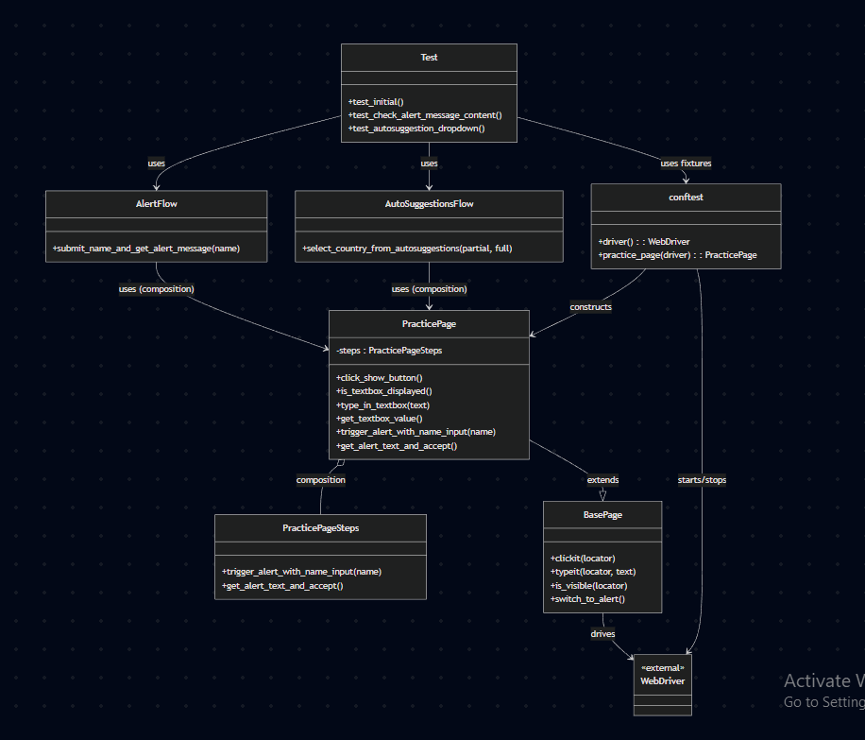

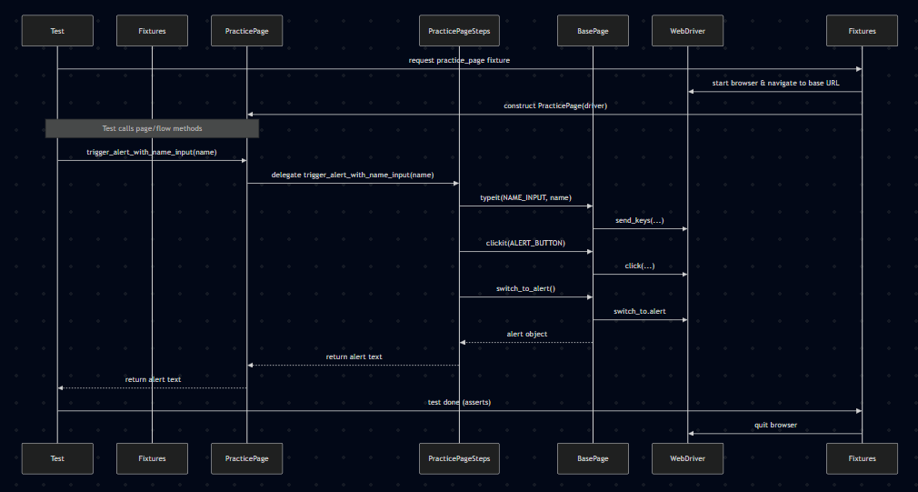

How to Run Tests
1. Create a virtual environment (recommended)
2. Install dependencies: `pip install -r requirements.txt`
3. Run tests: `python -m pytest -q`

Tips & Next Steps
- Consider adding a README for each folder describing its intent
- Add automatic doc generation or a diagram export for visualization
- Add unit tests for Steps classes by injecting fake page objects to validate orchestration logic
- Consider adding a simple architecture diagram (PNG) into the docs folder

