# Flow Documentation - closeOutSendNotificationService_EstateManager-FCF722F6-1D2D-EE11-BDF4-000D3A2FDACF

|  |  |
| --- | --- |
| **Flow Name** | closeOutSendNotificationService_EstateManager-FCF722F6-1D2D-EE11-BDF4-000D3A2FDACF |
| **Documentation generated at** | Saturday, 5 August 2023 10:00 AM |
| **Number of Variables** | 0 |
| **Number of Actions** | 5 |

## Flow Overview

The following chart shows the top level layout of the Flow. For a detailed view, please visit the section called Detailed Flow Diagram

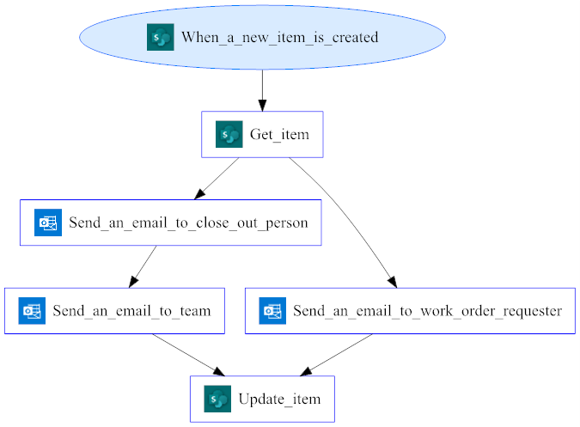

## Connections

There are a total of 2 connections used in this Flow:

### shared

|  |  |
| --- | --- |
| **Connector** | [shared](https://docs.microsoft.com/connectors/shared) |
| **Connection Type** | ConnectorReference |
| **Connection Reference Name** | cinsight_sharedsharepointonline_fb3fb |
| **Source** | embedded |

## Variables

## Trigger

|  |  |
| --- | --- |
| **Name** | When_a_new_item_is_created |
| **Type** | ApiConnection |
| **Connector** | sharepointonline |
| **Recurrence Details** | |
| **interval** | 5 |
| **frequency** | Minute |
| **Inputs Details** | |
| **host** | |  |  |  |  | | --- | --- | --- | --- | | connection | |  |  | | --- | --- | | name | @parameters('$connections')['shared_sharepointonline']['connectionId'] | | |
| **method** | get |
| **path** | /datasets/@{encodeURIComponent(encodeURIComponent(parameters('TSL Estate Team (cinsight_TSLEstateTeam)')))}/tables/@{encodeURIComponent(encodeURIComponent(parameters('Support Close Out Request (cinsight_SupportCloseOutRequest)')))}/onnewitems |
| **authentication** | @parameters('$authentication') |
| **Other Trigger Properties** | |
| **splitOn** | @triggerBody()?.value |
| **metadata** | |  |  |  |  | | --- | --- | --- | --- | | flowSystemMetadata | |  |  | | --- | --- | | swaggerOperationId | GetOnNewItems | | | operationMetadataId | ff573766-d74c-43d1-b4a6-29b352875f74 | |
| **conditions** |  |

## Actions

There are a total of 5 actions used in this Flow:

### Get_item

|  |  |
| --- | --- |
| **Name** | Get_item |
| **Type** | ApiConnection |
| **Connection** | |  |  | | --- | --- | |  | [SharePoint](https://docs.microsoft.com/connectors/sharepointonline) | |
| **Inputs** | |
| **metadata** | |  |  | | --- | --- | | operationMetadataId | 2f3cba46-aa49-4281-978e-76926941970a | | flowSystemMetadata | |  |  | | --- | --- | | swaggerOperationId | GetItem | | |
| **host** | |  |  |  |  | | --- | --- | --- | --- | | connection | |  |  | | --- | --- | | name | @parameters('$connections')['shared_sharepointonline']['connectionId'] | | |
| **method** | get |
| **path** | /datasets/@{encodeURIComponent(encodeURIComponent(parameters('TSL Estate Team (cinsight_TSLEstateTeam)')))}/tables/@{encodeURIComponent(encodeURIComponent(parameters('Support Close Out Request (cinsight_SupportCloseOutRequest)')))}/items/@{encodeURIComponent(triggerBody()?['ID'])} |
| **authentication** | @parameters('$authentication') |
| **Next Action(s) Conditions** | Send_an_email_to_close_out_person [Succeeded]  Send_an_email_to_work_order_requester [Succeeded] |

### Send_an_email_to_close_out_person

|  |  |
| --- | --- |
| **Name** | Send_an_email_to_close_out_person |
| **Type** | ApiConnection |
| **Connection** | |  |  | | --- | --- | |  | [Office 365 Outlook](https://docs.microsoft.com/connectors/office365) | |
| **Inputs** | |
| **metadata** | |  |  | | --- | --- | | operationMetadataId | 051f0504-d519-49cd-b110-bf3303568c07 | | flowSystemMetadata | |  |  | | --- | --- | | swaggerOperationId | SendEmailV2 | | |
| **host** | |  |  |  |  | | --- | --- | --- | --- | | connection | |  |  | | --- | --- | | name | @parameters('$connections')['shared_office365']['connectionId'] | | |
| **method** | post |
| **body** | |  |  | | --- | --- | | To | @body('Get_item')?['Author']?['Email'] | | Subject | Work Order Request Closure Notification | | Body | <p>Hi, @{body('Get_item')?['Author']?['DisplayName']}.<br> <br> <br> You have successfully closed out the work order request with ID @{body('Get_item')?['RequestID']} by @{body('Get_item')?['Requester']?['DisplayName']}.<br> <br> <br> Regards,<br> <br> TSL Estate.<br> </p> | | Importance | Normal | |
| **path** | /v2/Mail |
| **authentication** | @parameters('$authentication') |
| **Next Action(s) Conditions** | Send_an_email_to_team [Succeeded] |

### Send_an_email_to_team

|  |  |
| --- | --- |
| **Name** | Send_an_email_to_team |
| **Type** | ApiConnection |
| **Connection** | |  |  | | --- | --- | |  | [Office 365 Outlook](https://docs.microsoft.com/connectors/office365) | |
| **Inputs** | |
| **metadata** | |  |  | | --- | --- | | operationMetadataId | b970f26f-f925-4265-a7f2-b855d29f7759 | | flowSystemMetadata | |  |  | | --- | --- | | swaggerOperationId | SendEmailV2 | | |
| **host** | |  |  |  |  | | --- | --- | --- | --- | | connection | |  |  | | --- | --- | | name | @parameters('$connections')['shared_office365']['connectionId'] | | |
| **method** | post |
| **body** | |  |  | | --- | --- | | To | aoseragbaje@tsllimited.com;iosoria@tsllimited.com;cmadubuike@tsllimited.com;cibekwe@tsllimited.com;TSLEstateTeam@tsllimited.com | | Subject | Work Order Request Closure Notification | | Body | <p>Hello, Team.<br> <br> <br> The work order request with ID @{body('Get_item')?['RequestID']} created by @{body('Get_item')?['Requester']?['DisplayName']} has been closed out by @{body('Get_item')?['Author']?['DisplayName']}.<br> <br> <br> <br> Regards,<br> <br> TSL Estate.<br> </p> | | Importance | Normal | |
| **path** | /v2/Mail |
| **authentication** | @parameters('$authentication') |
| **Next Action(s) Conditions** | Update_item [Succeeded] |

### Send_an_email_to_work_order_requester

|  |  |
| --- | --- |
| **Name** | Send_an_email_to_work_order_requester |
| **Type** | ApiConnection |
| **Connection** | |  |  | | --- | --- | |  | [Office 365 Outlook](https://docs.microsoft.com/connectors/office365) | |
| **Inputs** | |
| **metadata** | |  |  | | --- | --- | | operationMetadataId | 79d4a037-1750-4b8b-a64f-04e26285a069 | | flowSystemMetadata | |  |  | | --- | --- | | swaggerOperationId | SendEmailV2 | | |
| **host** | |  |  |  |  | | --- | --- | --- | --- | | connection | |  |  | | --- | --- | | name | @parameters('$connections')['shared_office365']['connectionId'] | | |
| **method** | post |
| **body** | |  |  | | --- | --- | | To | @body('Get_item')?['Requester']?['Email'] | | Subject | Work Order Request has been Closed | | Body | <p>Hi, @{triggerBody()?['Requester']?['DisplayName']}.<br> <br> <br> This is to notify you that your work order request with ID @{body('Get_item')?['RequestID']} has been closed out successfully.<br> <br> <br> Regards,<br> <br> TSL Estate.<br> </p> | | Importance | Normal | |
| **path** | /v2/Mail |
| **authentication** | @parameters('$authentication') |
| **Next Action(s) Conditions** | Update_item [Succeeded] |

### Update_item

|  |  |
| --- | --- |
| **Name** | Update_item |
| **Type** | ApiConnection |
| **Connection** | |  |  | | --- | --- | |  | [SharePoint](https://docs.microsoft.com/connectors/sharepointonline) | |
| **Inputs** | |
| **metadata** | |  |  | | --- | --- | | operationMetadataId | eea195ad-3e5b-4b30-9a15-87419d281928 | | flowSystemMetadata | |  |  | | --- | --- | | swaggerOperationId | PatchItem | | |
| **host** | |  |  |  |  | | --- | --- | --- | --- | | connection | |  |  | | --- | --- | | name | @parameters('$connections')['shared_sharepointonline']['connectionId'] | | |
| **method** | patch |
| **body** | |  |  |  |  | | --- | --- | --- | --- | | Status | |  |  | | --- | --- | | Value | Closed | | |
| **path** | /datasets/@{encodeURIComponent(encodeURIComponent(parameters('TSL Estate Team (cinsight_TSLEstateTeam)')))}/tables/@{encodeURIComponent(encodeURIComponent(parameters('Support Close Out Request (cinsight_SupportCloseOutRequest)')))}/items/@{encodeURIComponent(body('Get_item')?['ID'])} |
| **authentication** | @parameters('$authentication') |

## Detailed Flow Diagram

The following chart shows the detailed layout of the Flow

