Title: Driver Behavior Classification and Alert System using Deep Learning and Computer Vision
- Introduction:
The escalating rate of vehicle accidents worldwide underscores the urgent need for innovative solutions to enhance road safety. Leveraging advancements in technology, particularly in the realms of deep learning and computer vision, presents a promising avenue for addressing this challenge. This proposal outlines a comprehensive project aimed at developing a robust system capable of classifying driver behaviors in real-time and implementing an alert mechanism to mitigate unsafe activities on the road.

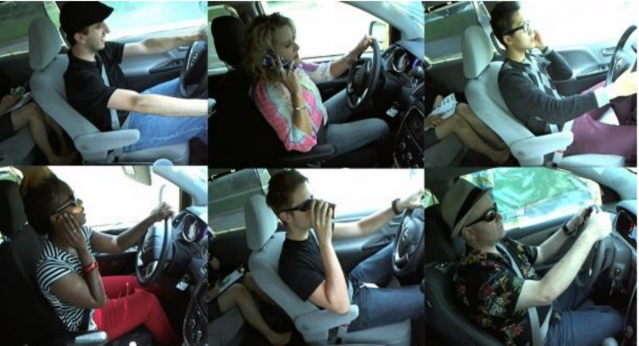
- Objective:
The primary objective of this project is to design and implement a sophisticated deep learning system that can accurately classify various driver behaviors within the confines of an in-car environment. Specifically, the project aims to achieve the following:
- Develop a convolutional neural network (CNN) architecture utilizing transfer learning techniques to classify driver responses.
- Train the CNN model on a diverse dataset of in-car driver activities, ensuring robustness and generalizability.
- Implement a real-time alert mechanism to notify drivers of unsafe behaviors, thereby enhancing road safety.

- Methodology:
3.1 Convolutional Neural Network Architecture:
- The project will employ a state-of-the-art CNN architecture, Vanilla, for feature extraction and classification.
- Transfer learning techniques will be utilized to leverage the pre-trained weights of Vanilla, optimizing model performance and reducing training time.
3.2 Dataset Preparation:
- The primary dataset for training and validation will be the State Farm Distracted Driver Dataset, comprising 22,424 images distributed across ten classes of driver activities.
- Data augmentation techniques, including rotation, flipping, and scaling, will be applied to augment the dataset, enhancing model generalizability.
3.3 Model Training and Evaluation:
- The CNN model will be trained using a combination of supervised learning and fine-tuning strategies to optimize performance.
- Training will be conducted on GPU-accelerated hardware to expedite convergence and improve efficiency.
- Model evaluation will involve rigorous testing on validation data to assess accuracy, precision, recall, and F1-score metrics.
- Expected Outcomes:
The anticipated outcomes of this project include:
- Development of a highly accurate deep learning model capable of classifying driver behaviors with precision.
- Implementation of a real-time alert system that effectively notifies drivers of unsafe activities, contributing to enhanced road safety.
- Potential impact on reducing the incidence of vehicle accidents and fatalities through proactive driver monitoring and intervention.

- Conclusion and Future Works:
In conclusion, this project represents a significant endeavor to harness the power of deep learning and computer vision technologies in addressing the pressing issue of road safety. By developing an advanced classification model and implementing a real-time alert system, the project aims to make substantial contributions towards reducing the frequency and severity of vehicle accidents. Future work may involve further refinement of the model architecture, exploration of additional datasets, and integration of advanced features such as night vision capabilities to enhance the system's efficacy in diverse driving conditions.

