

**Object Oriented Programming**

**Lab Assignment 1**

**SUBMITTED BY:**

Hasaan Ahmad SP22-BSE-017

**SUBMITTED TO: Sir Muzaffar Iqbal**

**Solved lab Activies**

**Activity 1:**

package LAB1;

import java.util.Scanner;

class CarPart {

    private String modelNumber;

    private String partNumber;

    private String cost;

    public void setparameter(String x, String y, String z) {

        modelNumber = x;

        partNumber = y;

        cost = z;

    }

    public void display() {

        System.out.println("Model Number: " + modelNumber + "Part Number: " + partNumber + "Cost: " + cost);

    }

}

public class CarPartRunner {

    public static void main(String[] args) {

        Scanner sc = new Scanner(System.in);

        CarPart car1 = new CarPart();

        System.out.println("What is Model Number?");

        System.out.println("What is Part Number?");

        System.out.println("What is Cost?");

        String x = sc.nextLine();

        String y = sc.nextLine();

        String z = sc.nextLine();

        car1.setparameter(x, y, z);

        car1.display();

    }

}

**Output:**

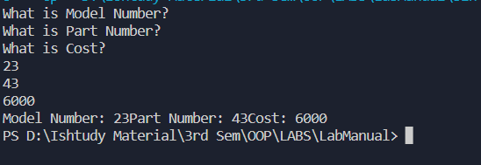

**Activity 2:**

package LAB1;

class CourseResult {

    public String studentname;

    public String coursename;

    public String grade;

    public void display() {

        System.out.println("Student Name is:" +

                studentname + "Course Name is:" + coursename + "Grade is:" + grade);

    }

}

public class CourseResultRun {

    public static void main(String[] args) {

        CourseResult c1 = new CourseResult();

        c1.studentname = "Ali";

        c1.coursename = "OOP";

        c1.grade = "A";

        c1.display();

        CourseResult c2 = new CourseResult();

        c2.studentname = "Saba";

        c2.coursename = "ICP";

        c2.grade = "A+";

        c2.display();

    }

}

**Output:**

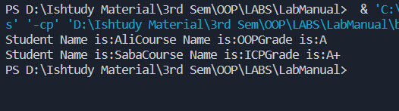

**Activity 3:**

package LAB1;

class Date {

    public String month;

    public int day;

    public int year; // a four digit number.

    public void displayDate() {

        System.out.println(month + " " + day + ", " + year);

    }

}

public class DateDemo {

    public static void main(String[] args) {

        Date date1, date2;

        date1 = new Date();

        date1.month = "December";

        date1.day = 31;

        date1.year = 2012;

        System.out.println("date1:");

        date1.displayDate();

        date2 = new Date();

        date2.month = "July";

        date2.day = 4;

        date2.year = 1776;

        System.out.println("date2:");

        date2.displayDate();

    }

}

**Output:**

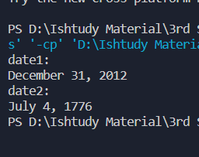

**Graded Lab Tasks:**

**Graded Lab Task 1:**

package LAB1;

import java.util.Scanner;

public class GLT1 {

    public static void main(String[] args) {

        Scanner input = new Scanner(System.in);

        Student Hasaan = new Student();

        System.out.println("Enter your name: ");

        String x = input.nextLine();

        System.out.println("Enter your Roll: ");

        int y = input.nextInt();

        System.out.println("Enter your Marks: ");

        int z = input.nextInt();

        Hasaan.setParams(x, y, z);

        Hasaan.display();

        System.out.println(Hasaan.getGrade());

    }

}

/**

 * Student

 */

class Student {

    String name;

    int roll;

    int marks;

    char grade;

    void setParams(String x, int y, int z) {

        name = x;

        roll = y;

        marks = z;

    }

    void display() {

        System.out.println("Name of Student is " + name + "\n" + "Roll number is " + roll + "\n" + "Total Marks are "

                + marks + "\n" + "Use getGrade Method to calculate the grade.");

    }

    char getGrade() {

        if (marks >= 90) {

            grade = 'A';

        } else if (marks >= 80 && marks < 90) {

            grade = 'B';

        } else if (marks >= 70 && marks < 80) {

            grade = 'C';

        } else if (marks >= 60 && marks < 70) {

            grade = 'D';

        } else if (marks >= 50 && marks < 60) {

            grade = 'E';

        } else {

            grade = 'F';

        }

        return grade;

    }

}

**Output:**

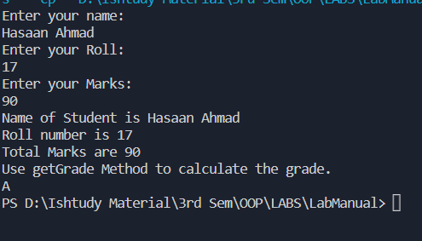

**Graded Lab Task 2:**

package LAB1;

public class GLT2 {

    public static void main(String[] args) {

        Time newTime = new Time(10, 4, 50);

        newTime.display();

        newTime.tick();

        newTime.display();

    }

}

class Time {

    int hours;

    int minutes;

    int seconds;

    public Time(int hours, int minutes, int seconds) {

        this.hours = hours;

        this.minutes = minutes;

        this.seconds = seconds;

    }

    public int getHours() {

        return hours;

    }

    public void setHours(int hours) {

        this.hours = hours;

    }

    public int getMinutes() {

        return minutes;

    }

    public void setMinutes(int minutes) {

        this.minutes = minutes;

    }

    public int getSeconds() {

        return seconds;

    }

    public void setSeconds(int seconds) {

        this.seconds = seconds;

    }

    public void setTime(int hours, int minutes, int seconds) {

        this.hours = hours;

        this.minutes = minutes;

        this.seconds = seconds;

    }

    void display() {

        System.out.println(String.format("%02d:%02d:%02d", hours, minutes, seconds));

    }

    void tick() {

        seconds++;

        if (seconds >= 60) {

            seconds = 0;

            minutes++;

            if (minutes >= 60) {

                minutes = 0;

                hours++;

                if (hours >= 24) {

                    hours = 0;

                }

            }

        }

    }

}

**Output:**

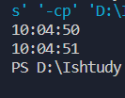

**Graded Lab Task 3:**

package LAB1;

public class GLT3 {

    public static void main(String[] args) {

        Car mehran = new Car("Mehran", 800, "White", 2010);

        mehran.horn();

        mehran.park();

        mehran.crash();

        mehran.display();

        mehran.setColor("black");

        mehran.display();

    }

}

/**

 * Car

 */

class Car {

    String name;

    int cc;

    String color;

    int manufactureYear;

    public Car(String name, int cc, String color, int manufactureYear) {

        this.name = name;

        this.cc = cc;

        this.color = color;

        this.manufactureYear = manufactureYear;

    }

    void display() {

        System.out

                .println("name=" + name + ", cc=" + cc + ", color=" + color + ", manufactureYear= " + manufactureYear);

    }

    void setColor(String clr) {

        this.color = clr;

    }

    void horn() {

        System.out.println("TUT TUT!! Give me the way.");

    }

    void park() {

        System.out.println("TUT TUT!! Car is Parked");

    }

    void crash() {

        System.out.println("Shushhhhhh!!!!! You crashed it! Man!!! ");

    }

}

**Output:**

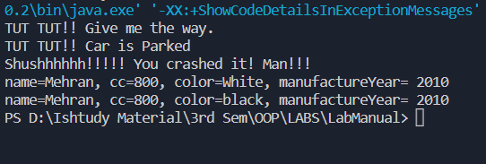

**Graded Lab Task 4:**

package LAB1;

class Rectangle {

    double length;

    double width;

    Rectangle(double length, double width) {

        this.length = length;

        this.width = width;

    }

    void calculateArea() {

        System.out.println(length * width);

    }

    void calculatePerimeter() {

        System.out.println(2 * (length + width));

    }

    void display() {

        System.out.println("length=" + length + ", width=" + width);

    }

    public double getLength() {

        return length;

    }

    public void setLength(double length) {

        this.length = length;

    }

    public double getWidth() {

        return width;

    }

    public void setWidth(double width) {

        this.width = width;

    }

}

public class GLT4 {

    public static void main(String[] args) {

        Rectangle Rec1 = new Rectangle(4.6, 8.6);

        Rectangle Rec2 = new Rectangle(2.6, 3.4);

        Rec1.calculateArea();

        Rec1.calculatePerimeter();

        Rec2.calculateArea();

        Rec2.calculatePerimeter();

    }

}

**Output:**

