Sri Lanka Institute of Information Technology

Final Project Report

E-Commerce System using MERN Stack

Application Frameworks (SE3040)

Group members:

IT18140576 - Pinnawala N. M

IT18129922 - Wijerathna W. A. K. T

IT18136784 - Senevirathna B. W. H. K

IT18163278 - Thilakaratne B. M. S. A

**Overview**

Our ReactJS + NodeJS + Express + MongoDB application has the following architecture.

MongoDB Database

controller

router

service

router

components

http

axios

ReactJS

NodeJS + ExpressJS

* NodeJS Express exports REST APIs and interacts with MongoDB Database to transfer data between the client application and the database
* React client sends HTTP requests and retrieves HTTP responses using Axios, consumes data on the components.
* React router is used for navigating among pages.

**Technologies used**

**Backend**

* NodeJS
* Express

**Frontend**

* ReactJS
* react-router-dom
* Axios
* Bootstrap
* Ant design

MongoDB as the NoSQL database

**Assumptions**

* Initially, the discount of a product will be 0. If needed, the product can be updated by adding the discount later.

**Workload Division**

**Account Management**

* Registration
* Login
* Permissions
* Manager Account Creation
* User Account
* User Control Panel
* Admin Panel

**Product Management**

* Product CRUD
* Search
* Review CRUD

**Shopping Cart & Wish List**

* Shopping Cart CRUD
* Wish List CRUD

**Payment Management**

* Payment CRUD

**Sequence Diagrams**

**Account Management**

* 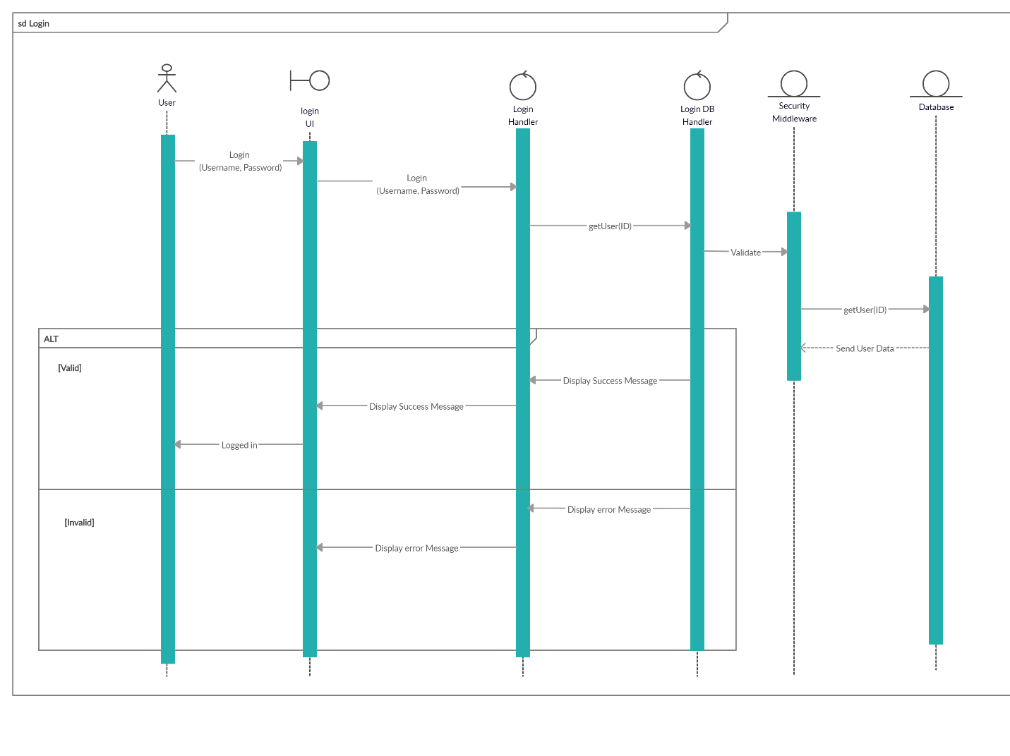Login

Figure : Login

* User Registration

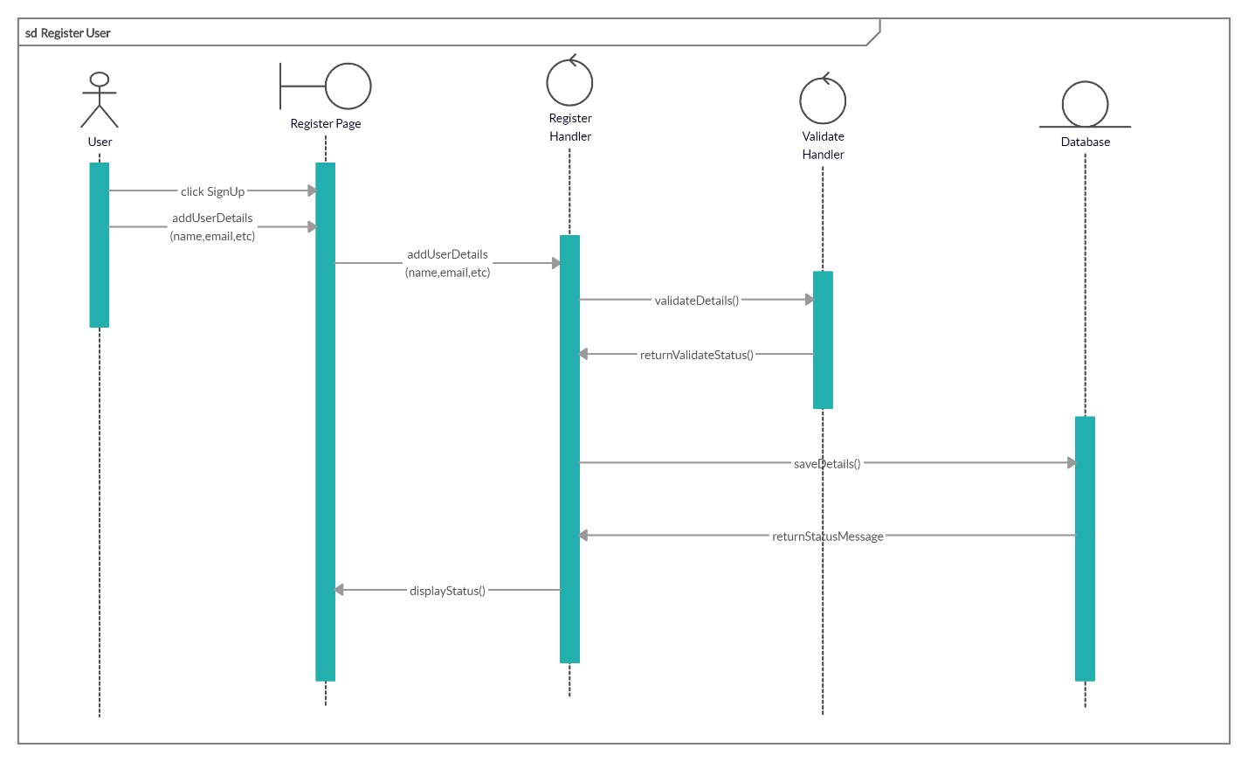

Figure 2: Register

* Manager CRUD

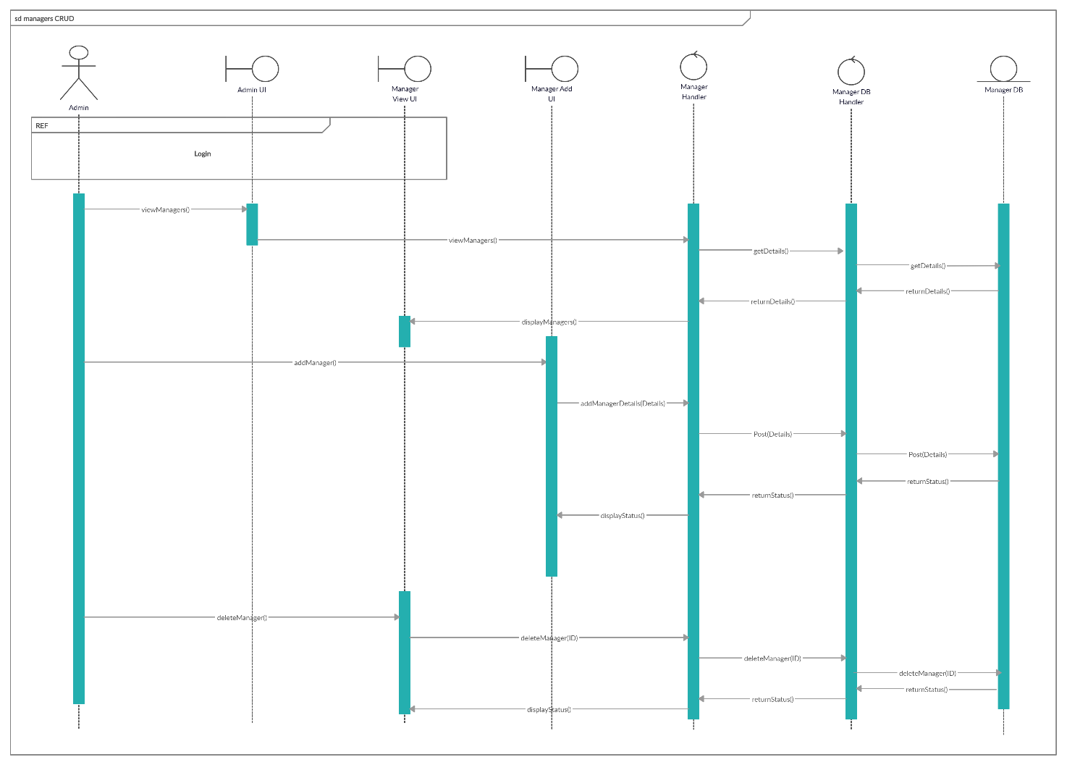

Figure 3: Manager CRUD

* View User

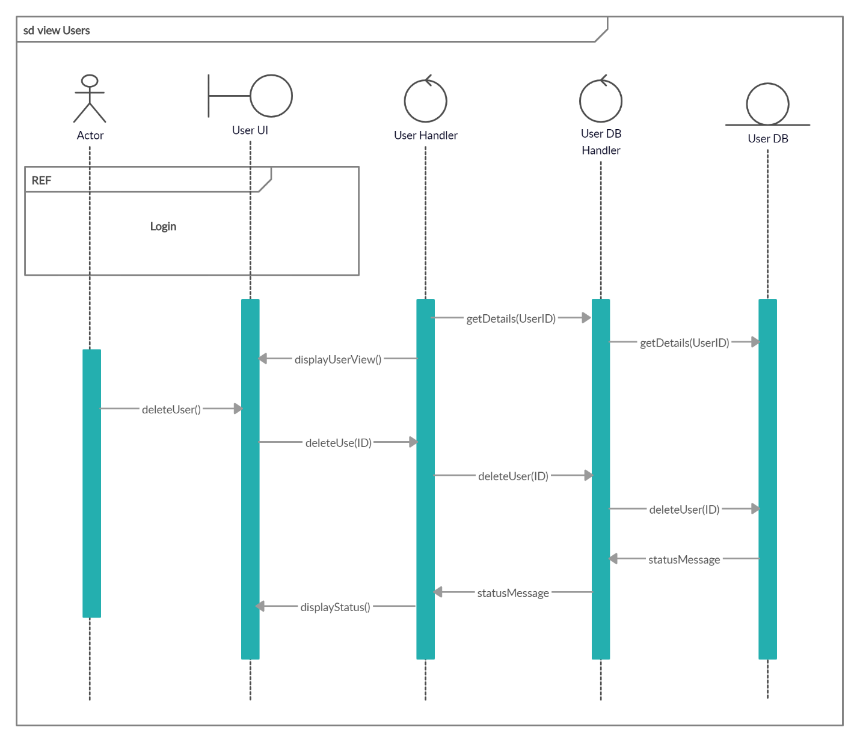

Figure 4: View User

**Product CRUD**

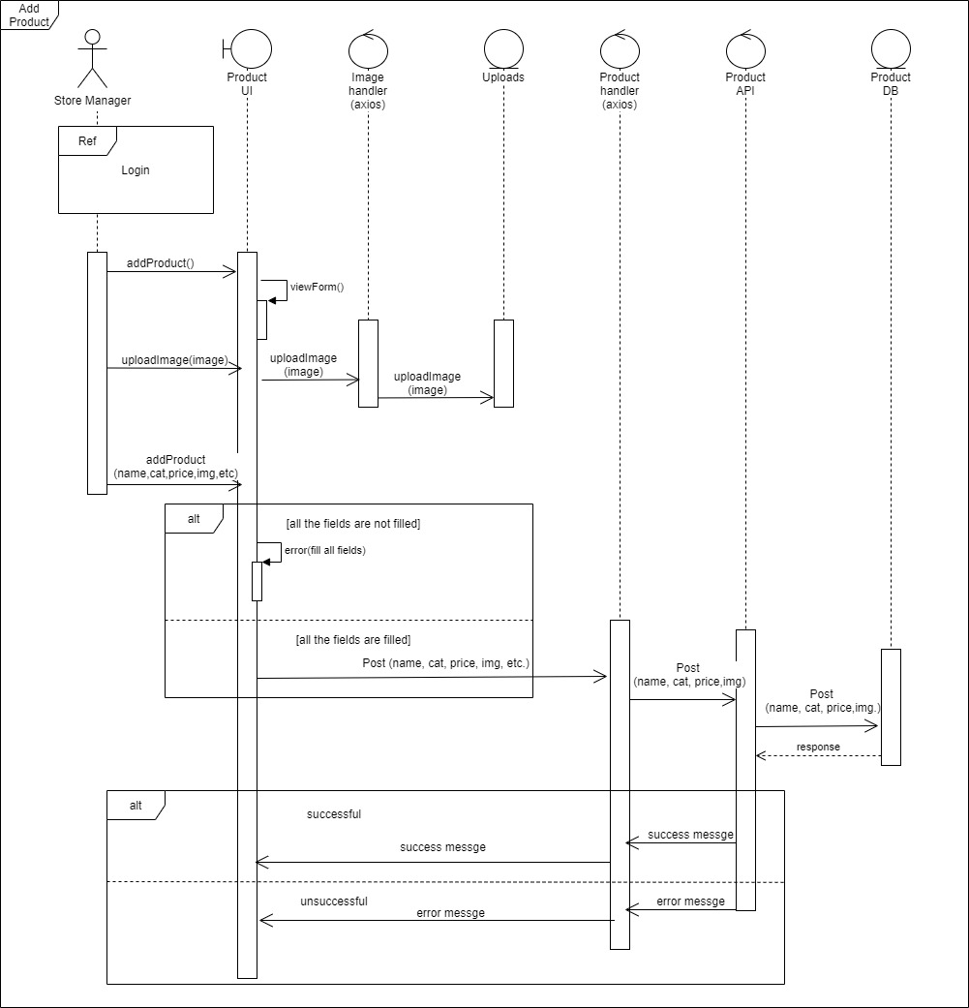

Figure 6: Insert New Product

Figure 7: Retrieve Products

Figure 8: Search Products

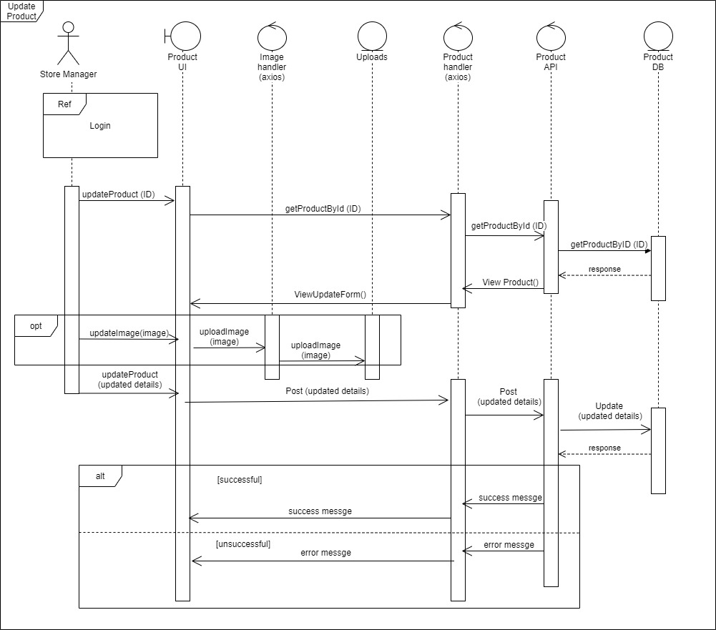

Figure 9: Update Product

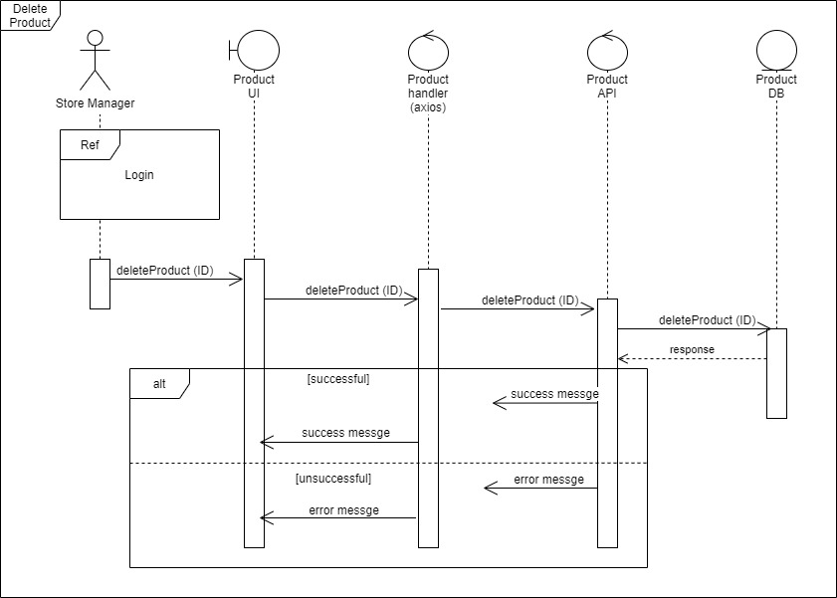

Figure 10: Delete Product

**Insert Categories**

Figure 11: Insert Categories

* Review CRUD

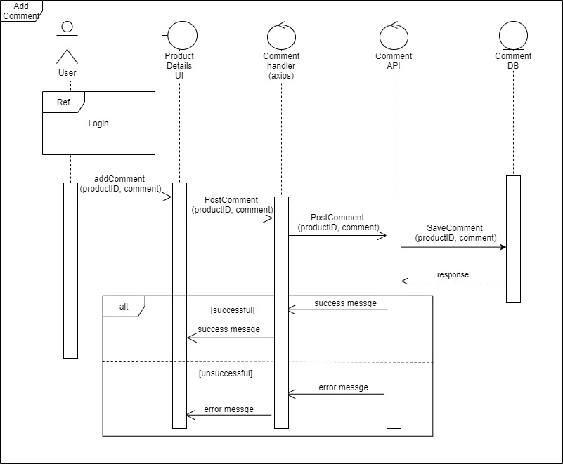

Figure 12: Add Comments

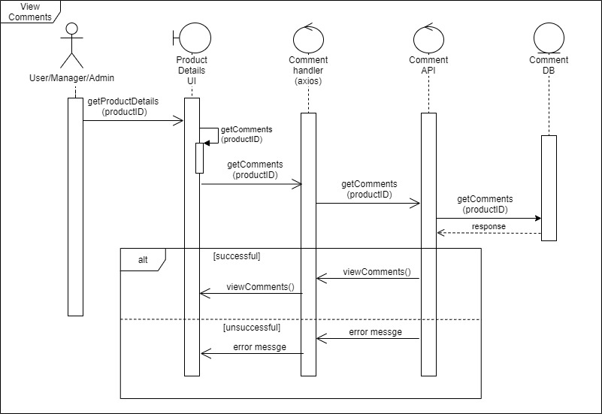

Figure 13 : View Comments

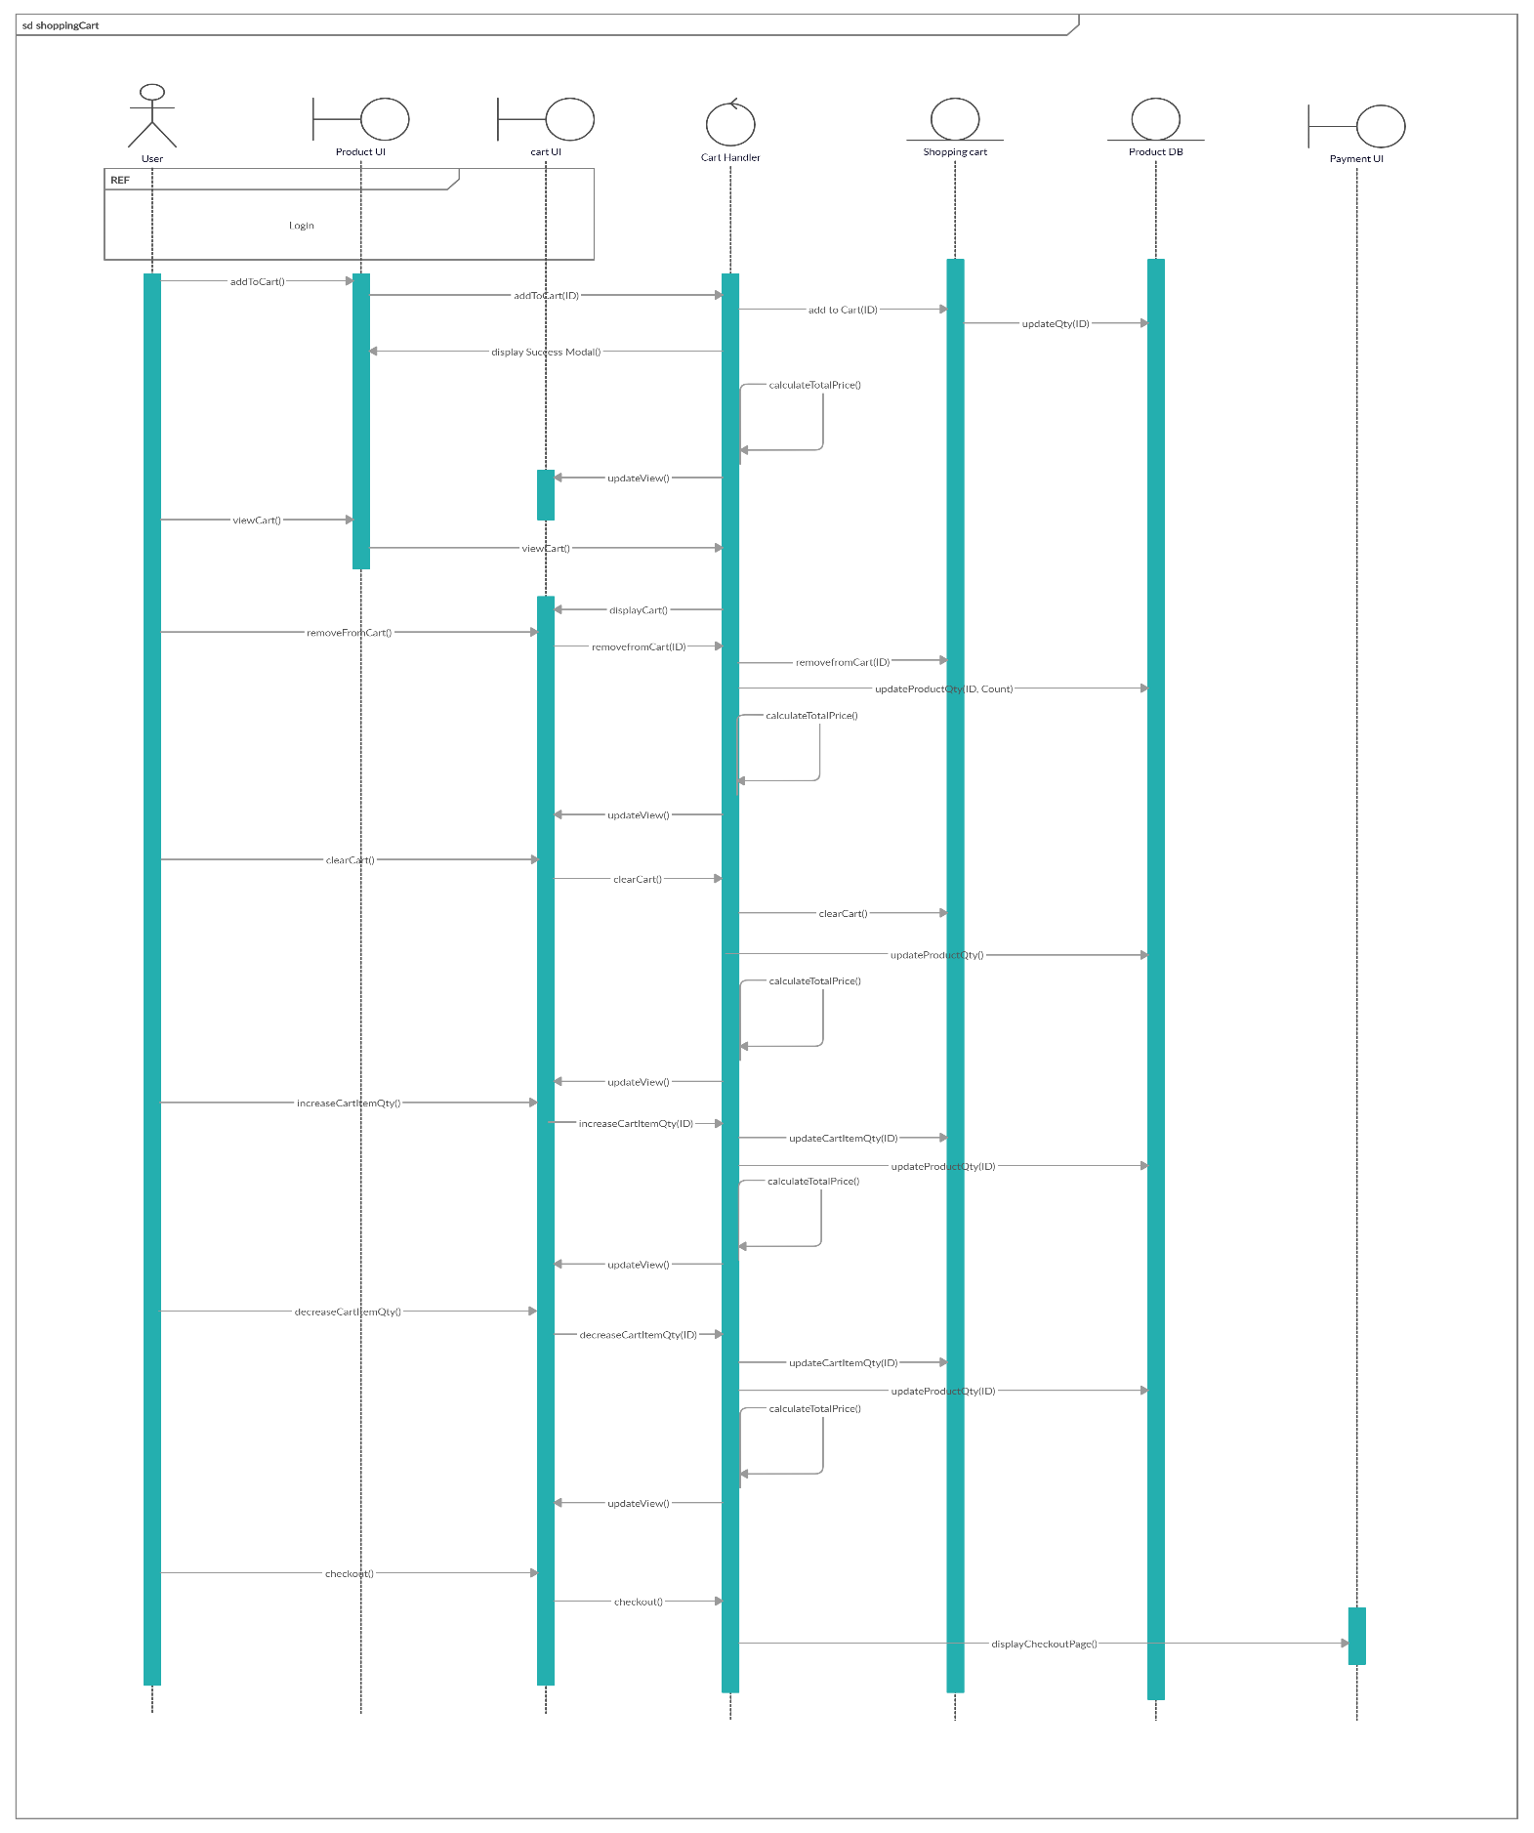**Shopping Cart**

Figure 4: Cart CRUD

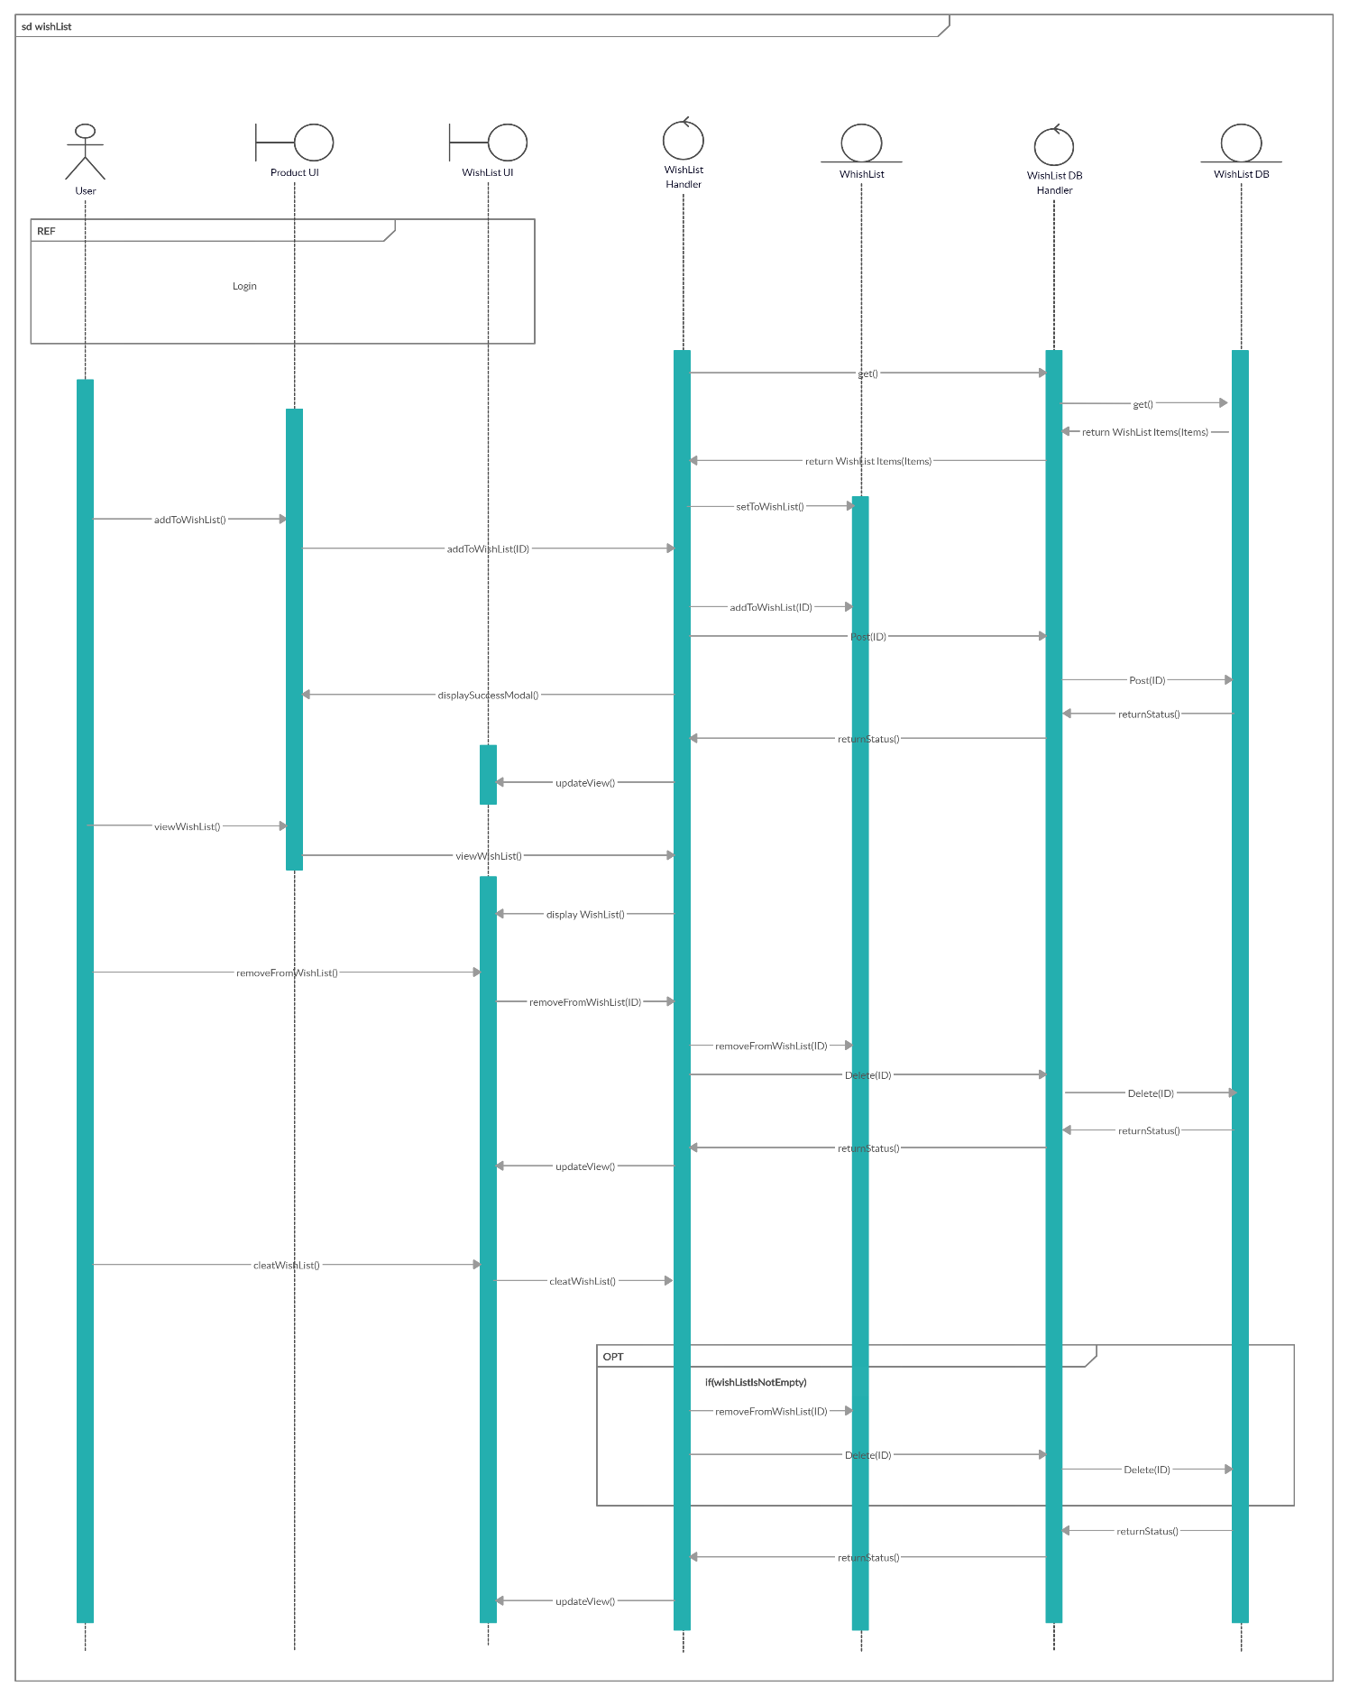**Wish List**

Figure 5: Wish List CRUD

**Payment Management**

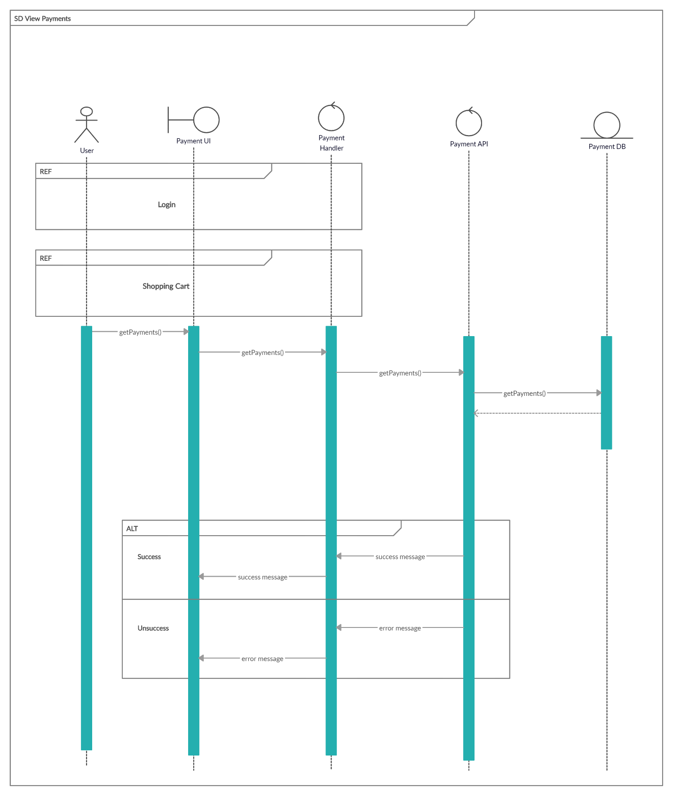 Figure 6: View Payment

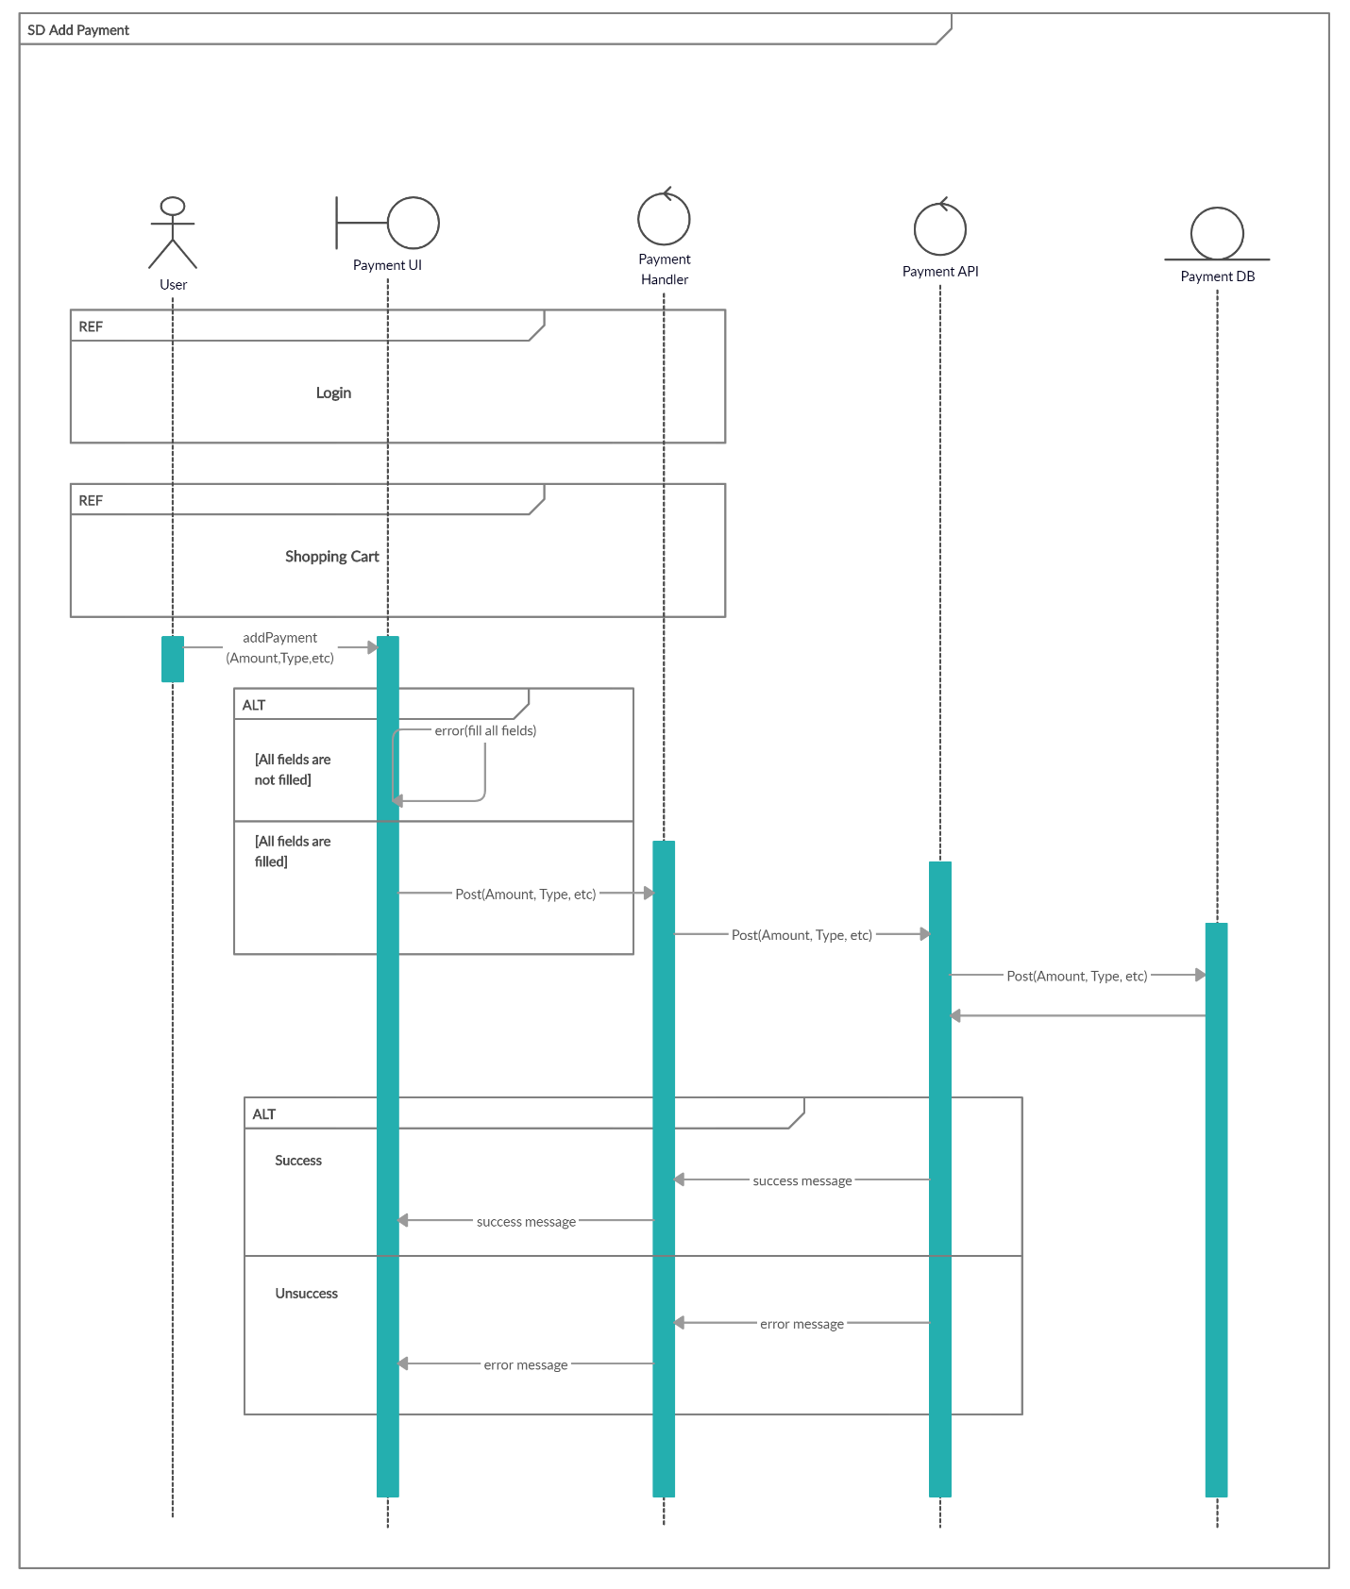

Figure 17: Add Payment

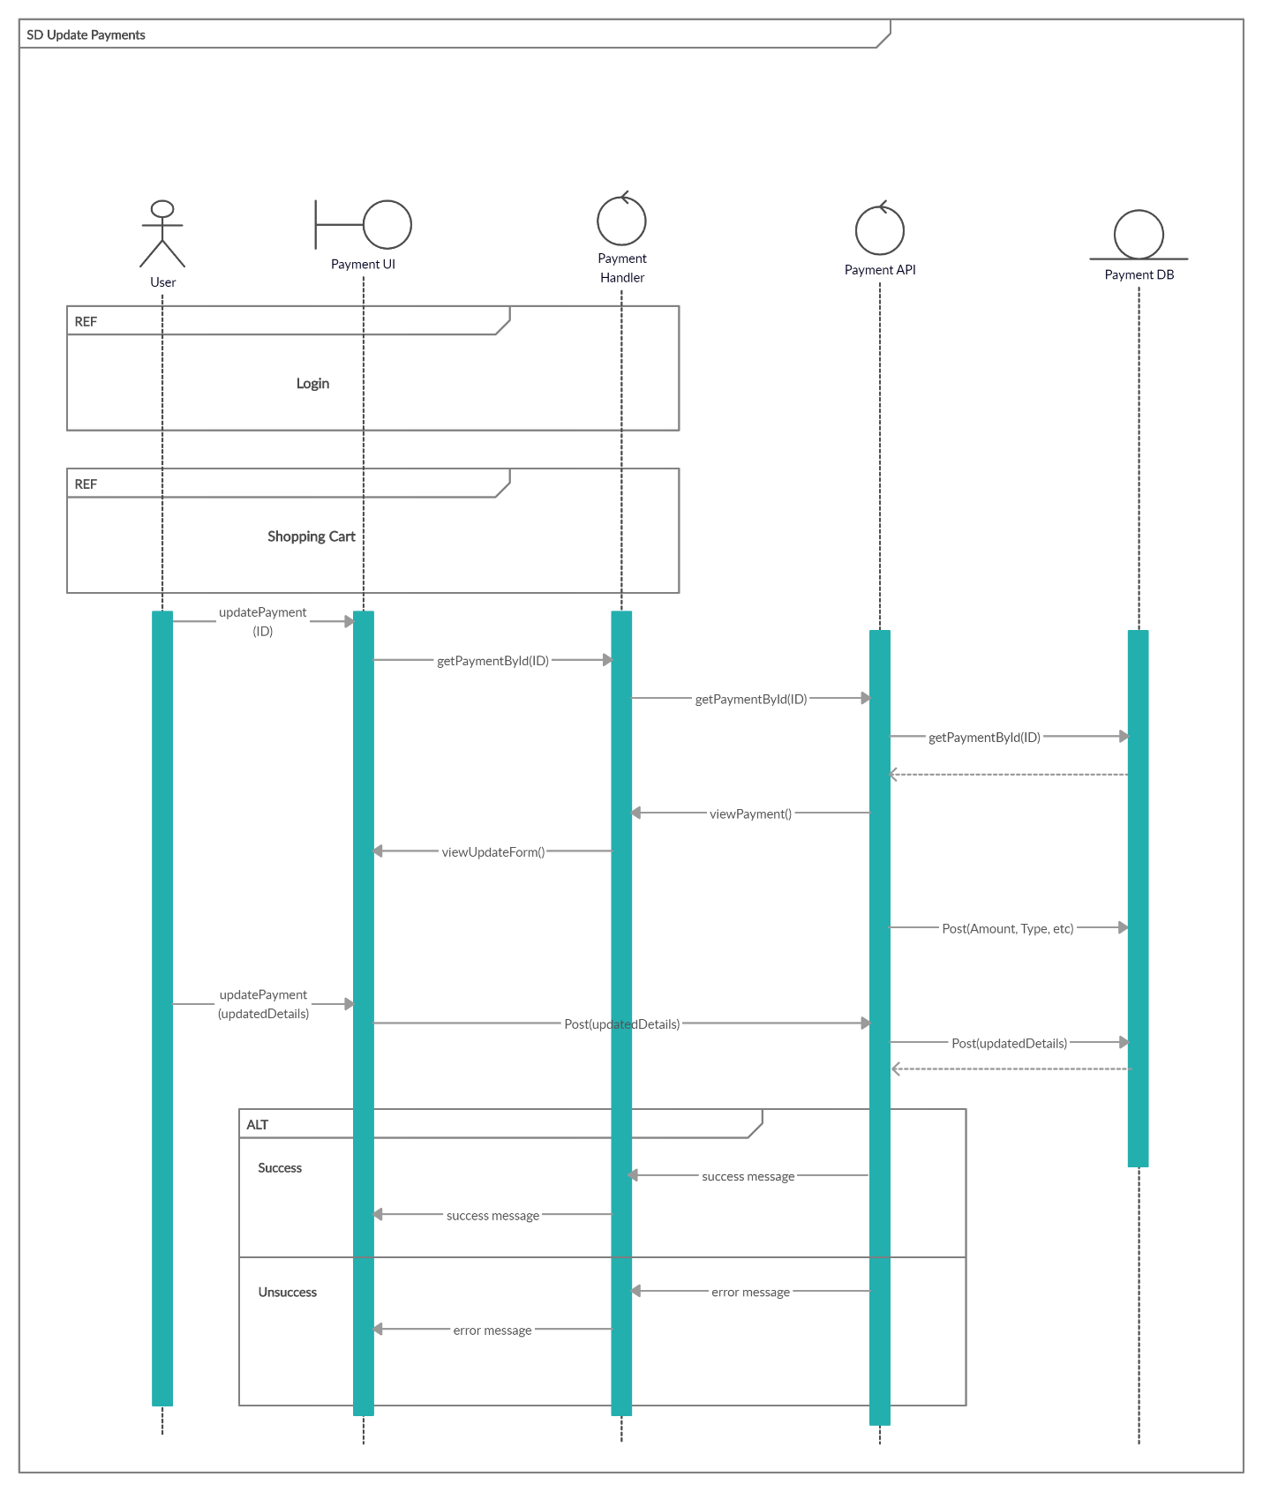

Figure 8: Update Payment

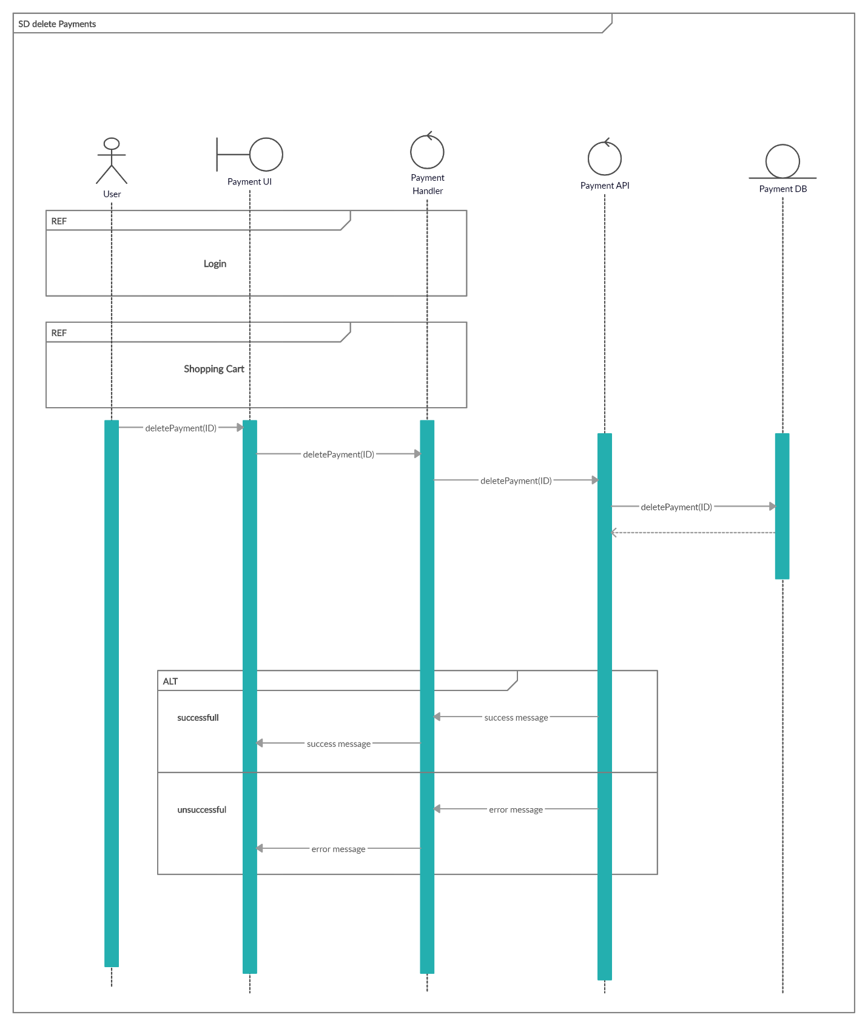

Figure 9: Delete Payment

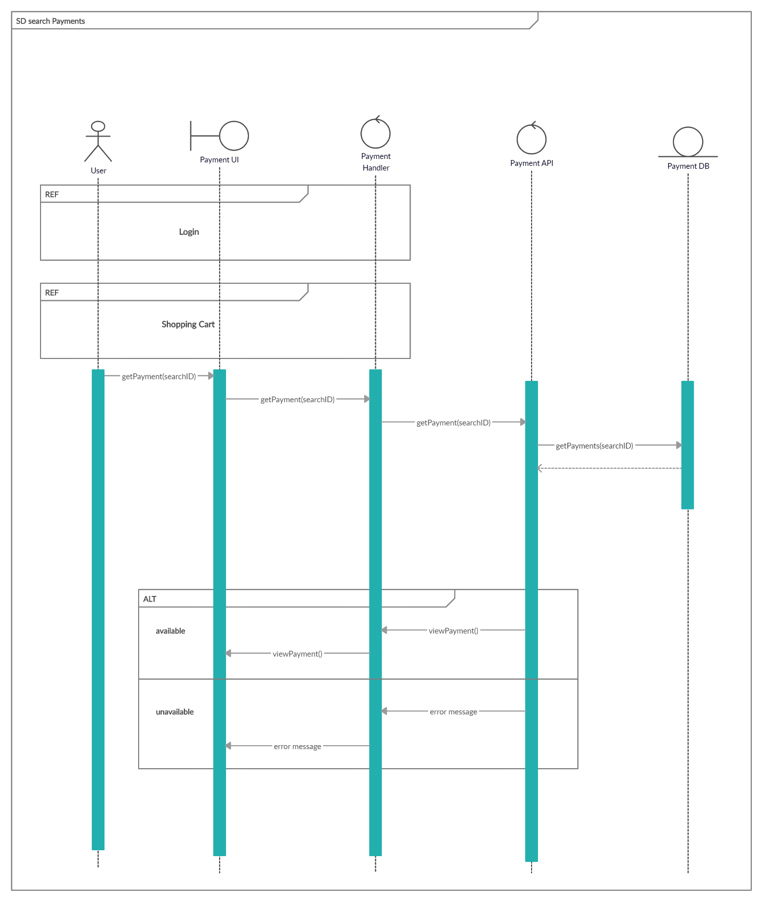

Figure 20: Search payment