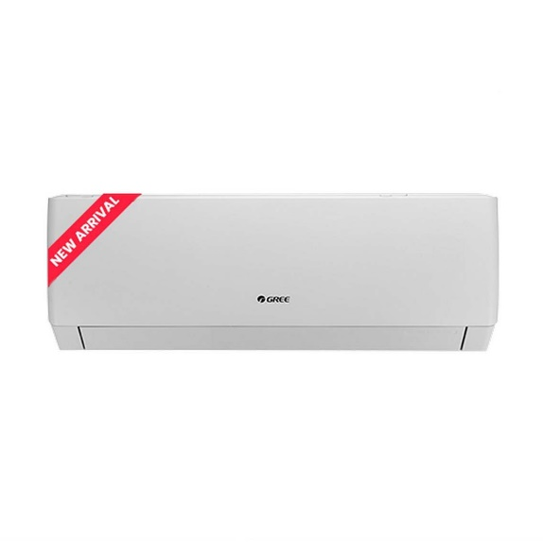

Candy by Haier 1 Ton Heat n Cool DC Inverter-White Colour AC-CSU-12HP-10 Years Brand Warranty

* Brand Warranty
* Heat & Cool DC Inverter
* Anti Corrosion
* Voltage 150V - 264V
* Running Current (A): 2.6 - 6.7
* Indoor Dimensions L\*W\*H : 850\*200\*290
* Outdoor Dimensions L\*W\*H : 700\*245\*535

AIR CONDITIONER