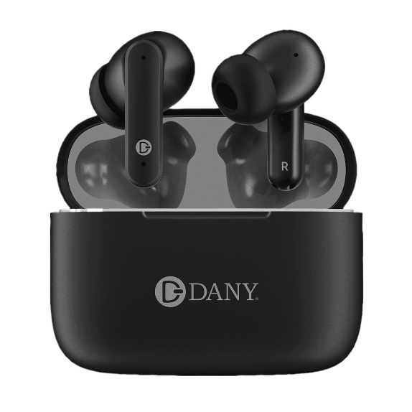

Air pod Pro Wireless Earphone with Bluetooth Sport Ear Buds HD Stereo Noise Cancelling Waterproof Ear Phones Earbuds for Smartphones

* Wireless Type

Bluetooth

Wearing Type

In-Ear

* Bluetooth

Yes

* Express delivery

Karachi

Not Specified

AIRPODS