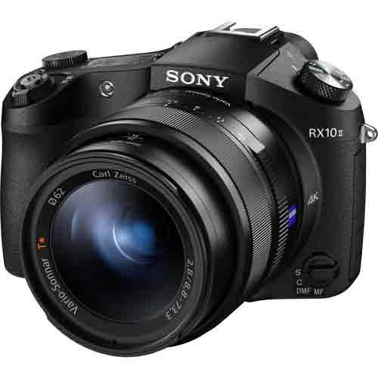

HD 1080P Video Camcorder Handheld Digital Camera 16X Zoom Digital Camera

* 16x digital zoom..
* --Pixel: 5 million (real value) 16 million (interpolation)..
* --Video format size: 720p (real) 1080p (interpolation)..
* -Memory card: Maximum support for 32GB-SD card..

CAMERA