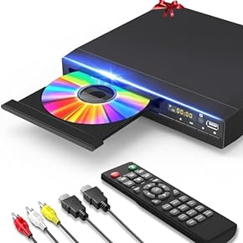

Rioddas External CD Drive, USB 3.0 Portable CD/DVD +/-RW Drive Slim DVD/CD ROM Rewriter Burner for Laptop Desktop PC Windows and Linux OS

* 【PLUG & PLAYP】Easy to use. Rioddas external DVD drive is powered by USB port.No external driver and power needed. Just plug it into your USB port and the DVD driver will be detected.
* 【TRENDY DESIGN】 Brushed texture shell brings trendy sight and touch enjoyment. Embedded cable design, worry- off cable missing any when and where
* 【HIGH SPEED】 Rioddas external CD drive floppy is compatible with USB3.0 and backwards compatible with USB2.0 USB1.0,bringing you faster data transmission speed (up to a maximum of 5Gbps) and stable performance with strong fault tolerance

CD PLAYER