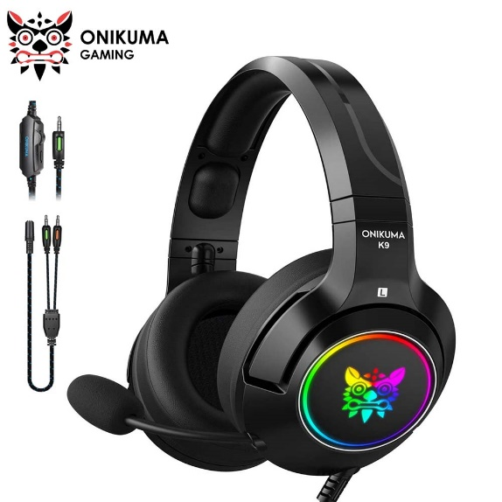

Gaming Headset with Microphone And Led Lights for Notebook Computers 3.5mm Wired Noise Isolation Volume Control Transformers Headset Gaming Headset

* Product size (L x W x H): 17.5 x 19.5 x 8.0 cm / 6.89 x 7.677 x 3.15 inches
* Type: Over-the-ear
* Speaker diameter:40mm
* Frequency Response: 20Hz-20KHz

HEADPHONES