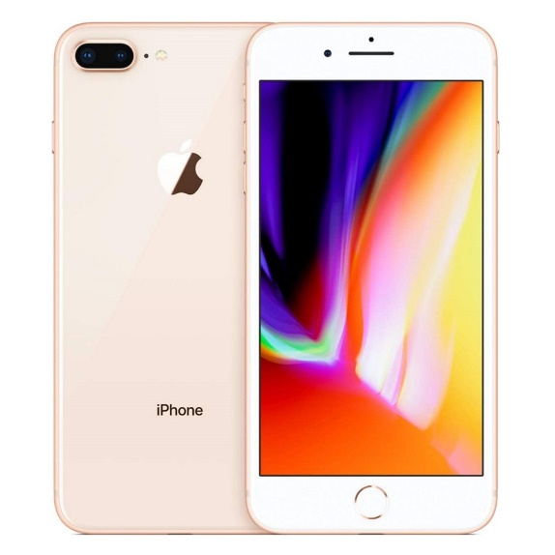

Realme C35 - 6.6" Inch Display - 4GB RAM - 128GB ROM

* Brand Warranty
* 6.7" Inch IPS LCD, 480 nits Display
* OS : Android 11
* Memory : 6GB RAM , 128GB ROM
* Processor : Powerful Octa-core (Unisoc Tiger T616)
* 50+2+0.3 MP Main Camera
* 8 MP Front Camera
* Side-Mounted FingerPrint Sensor
* Battery : 5000mAh
* 18W Fast Charging
* PTA Approved

SMART PHONE