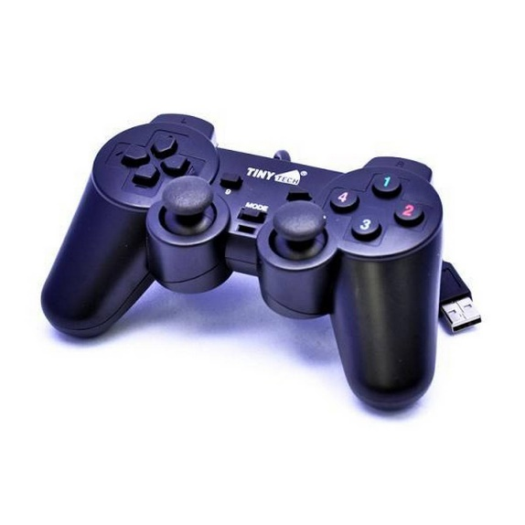

* Wired Game Controller Gaming Joypad Joystick USB Gamepad For PC & Laptop For Win7/8/10 XP
* Original game pad
* Single Shock
* Best for High Hd Games
* Multi Colour
* Most Demanded Game Pad

JOY STICK