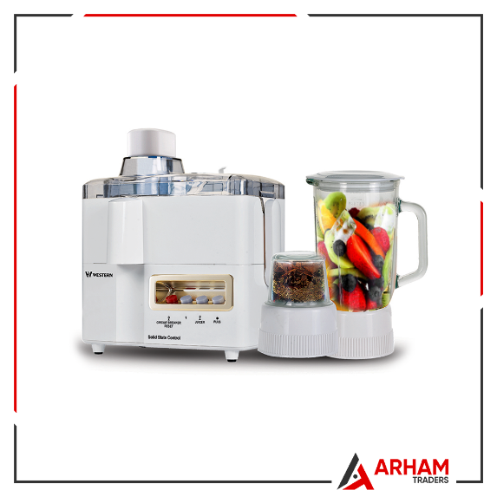

4 in 1 Juicer Blender Grinder & Dry Mill – White

Spell Juicer Blender and Chopper can be used for pureeing, liquefying or mixing in an effective, efficient and a quick way. Spell has especially designed this energy efficient product in order to save on the power consumption, thereby preventing your electricity bills from getting too high. The juicer, blender and chopper are easy to operate, yet Spell provide a manual containing all the step by step instructions for operating them. Thanks to the juicer, now you can enjoy fresh and healthy homemade juice like never before!

* Brand Warranty
* Easy to Use
* 1000 ML glassjug
* Stainless Steel Blades
* 220 Volts

JUICER