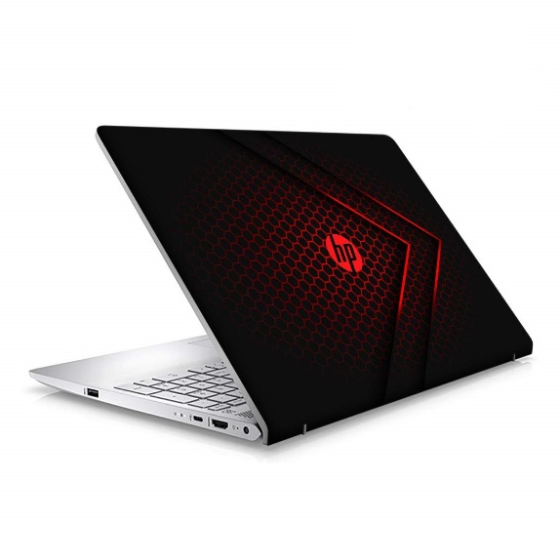

New Laptops - Dell Latitude E5490 - Core i5 8th Generation - 8gb RAM - 512gb SSD - 14" Screen - Windows 10 Activated - Free Laptop Bag

* Dell Latitude E5490
* Core i5
* 8th Generation
* 8GB RAM DDR4
* 512GB SSD
* 14.1" screen
* 6 Months Warranty (T&C apply)
* Daraz Like New products are in Good Condition. They feel like new.
* Fully functional with all features working, with minimal scratches, minor usage but no damage.
* A preinstalled operating system
* Product will be in Daraz Like New Original Packaging

LAPTOP