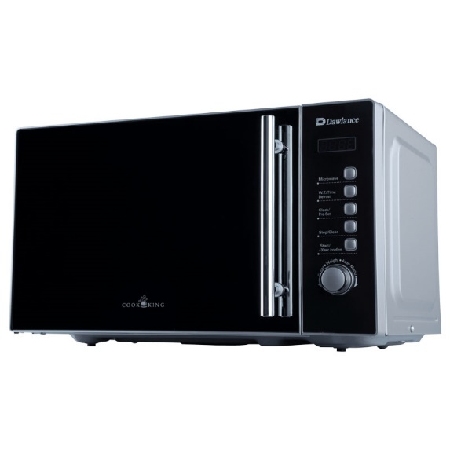

Dawlance 5 in 1 Air Fryer Microwave Oven 30 Ltr DW-530AF

* 5 in 1 Microwave Oven With Heating, Baking, Cooking, Grilling And Air Frying Function
* Digital Soft Touch Control Panel
* 900 W Microwave Oven Power
* 2100 W Convection
* 1000 W Grill Power
* 30L Capacity
* 300 Built-In Recipe

MICROWAVE