Group # 06

Project Title:

Disaster Response and Resource Allocation System

Member Name | Member Roll #
Muhammad Hasan Butt | L24 – 3022
Kabeer Ahmed Shahzeb | L24 – 3087
Muhammad Haider Mughal | L24 – 3006

List of Table Names and Attributes

Disaster
Represents an emergency event.

Attributes:
- DisasterID
- Title
- Type (Flood, Earthquake, Fire, etc)
- SeverityLevel (1-5)
- StartDate
- EndDate
- Status (Active/Contained/Resolved)
- Description

Location
Represent geographical areas.

Attributes:
- LocationID
- City
- Region
- Latitude
- Longitude

DisasterLocation (Junction Table)
Handles many-to-many relationships.

Attributes:
- DisasterID
- LocationID

Resource
Represents available assets.

Attributes:
- ResourceID
- ResourceName
- ResourceType (Medical, Food, Transport, Personnel)
- TotalQuantity
- AvailableQuantity
- Units (Units, Liters, Kits)

ResponseTeam:
Represents operational teams.

Attributes:
- TeamID
- TeamName
- Specialization
- ContactInfo
- AvailabilityStatus

Allocation:
Represents the allocation of resources to response teams based on approved requests.

Attributes:
- AllocationID
- DisasterID
- ResourceID
- TeamID
- AllocatedQuantity
- AllocationDate
- Status (Pending/Approved/Deployed/Completed)

User:
Represents system users with different roles.

Attributes:
- UserID
- FullName
- Email
- PasswordHash
- Role
- CreatedAt

ResourceRequest:
A formal request for resources before they are approved and allocated.

Attributes:
- RequestID
- DisasterID
- ResourceID
- RequestByUserID
- RequestedQuantity
- RequestDate
- PriorityLevel (Low/Medium/High/Critical)
- Status (Pending/Approved/Rejected/Fulfilled)
- Remarks

SQL Table Queries:
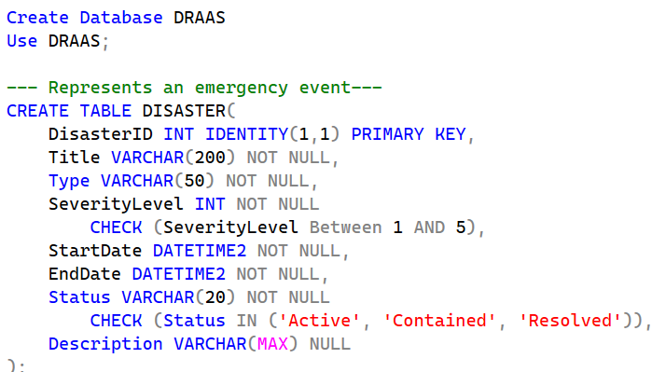
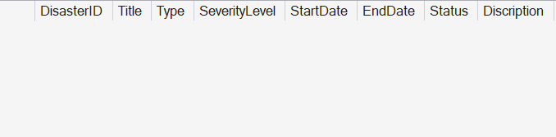
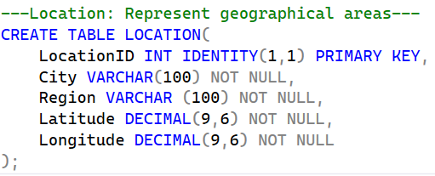
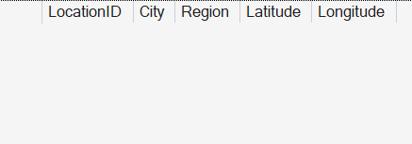

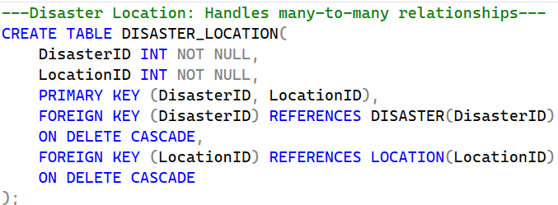
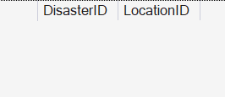

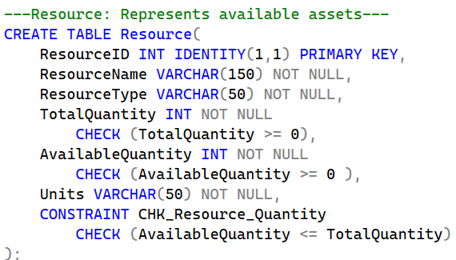
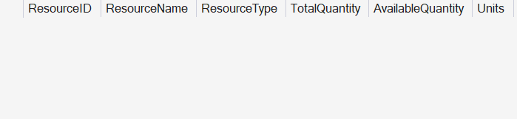

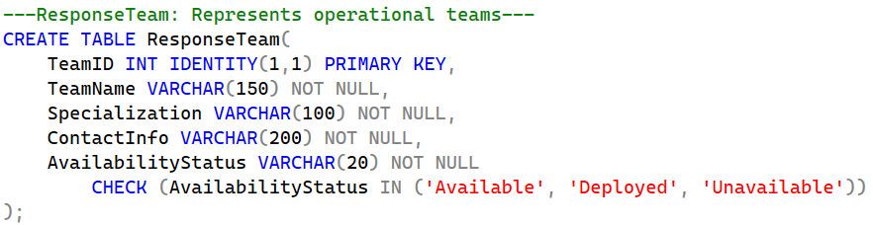
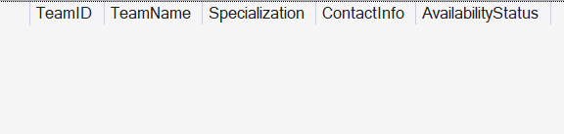

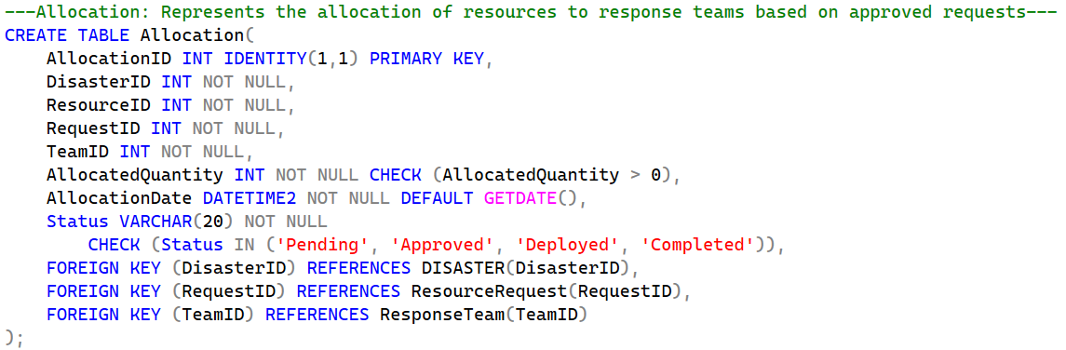
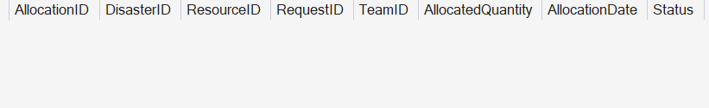

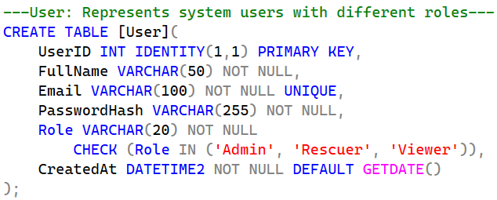

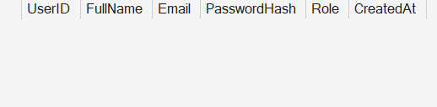

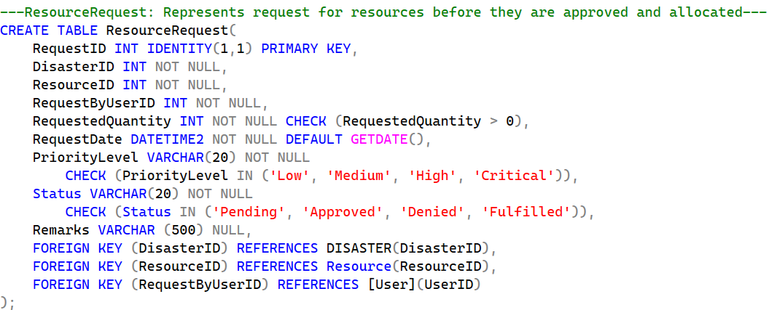
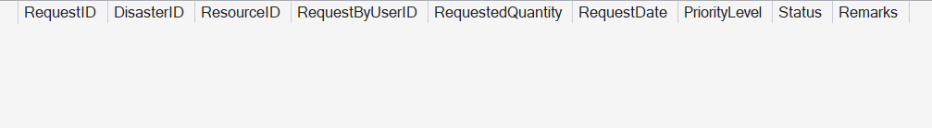

FUNCTIONALITIES
Below are 33 queries based on the functionalities which are sub-divided into 10 categories:

1. Disaster Management
1.1 Add a new disaster incident (INSERT)
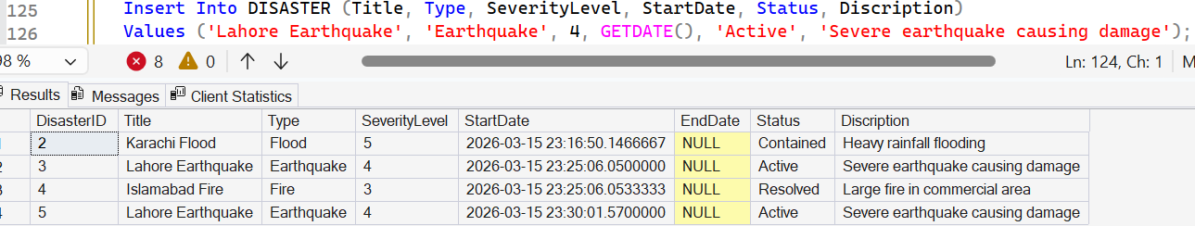

1.2 Update disaster status (UPDATE + WHERE)
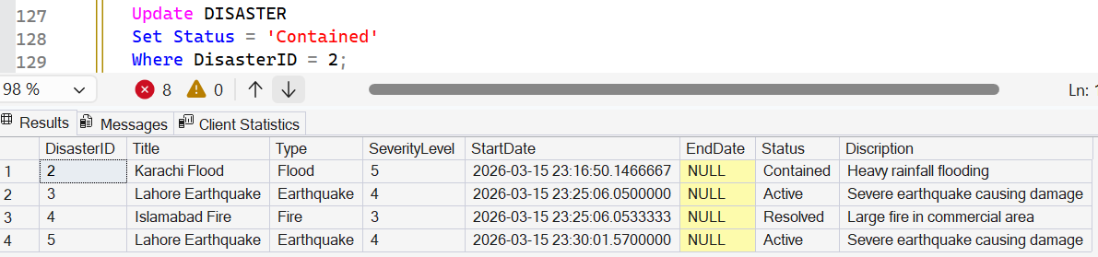

1.3 Search disasters containing a keyword (LIKE)
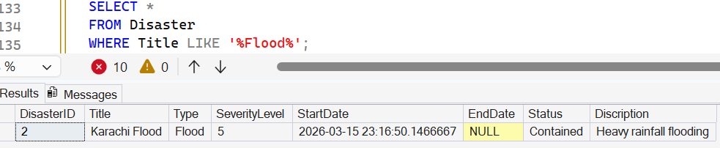

1.4 List active disasters ordered by severity (ORDER BY)
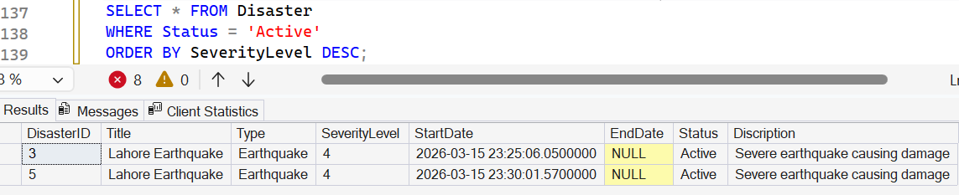

2. Location & Disaster Mapping
2.1 Assign a disaster to a location (INSERT)
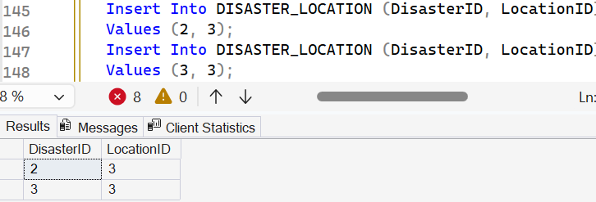

2.1 View disasters with their locations (JOIN)
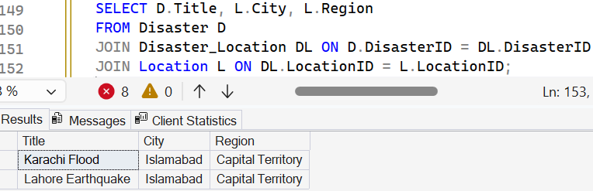

2.3 Show disasters even if no location assigned (LEFT JOIN)
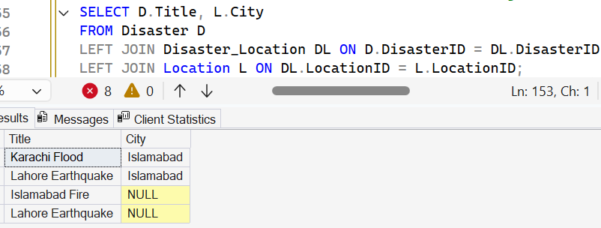

3. Resource Inventory Management
3.1 Add a new resource (INSERT)
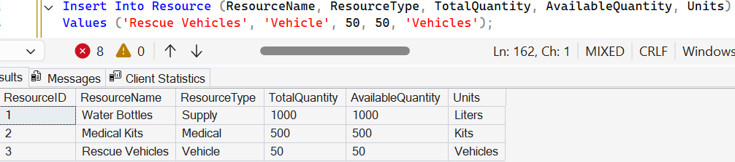

3.2 Update resource quantity after new shipment (UPDATE)
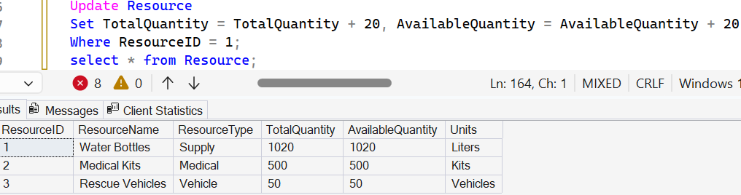

3.3 Find resources below critical stock level (WHERE)
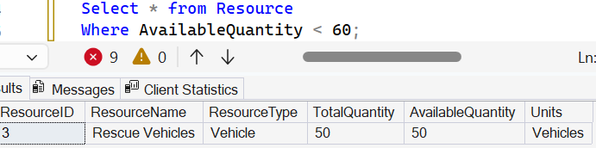

3.4 Sort resources by availability (ORDER BY)
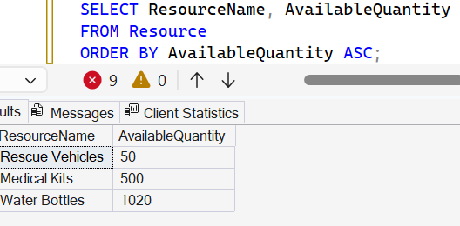

4. Resource Request Workflow
4.1 Create resource request (INSERT)
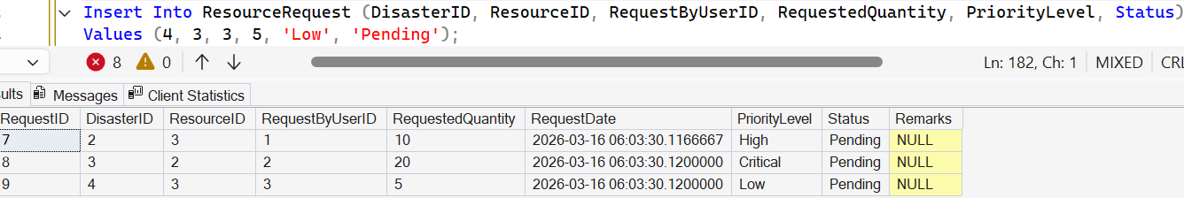

4.2 Approve a request (UPDATE)
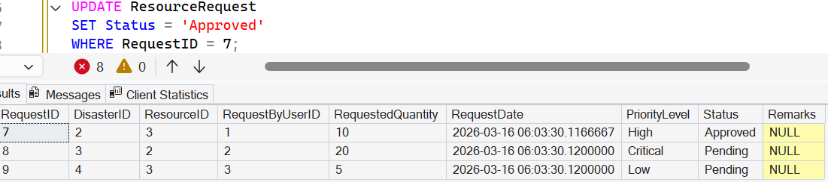

4.3 Find pending requests (WHERE)
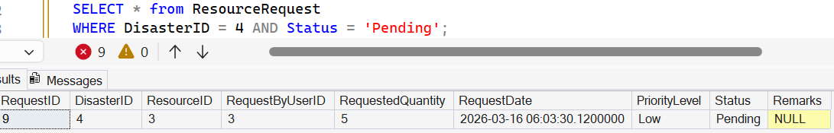

4.4 Requests grouped by priority (GROUP BY)
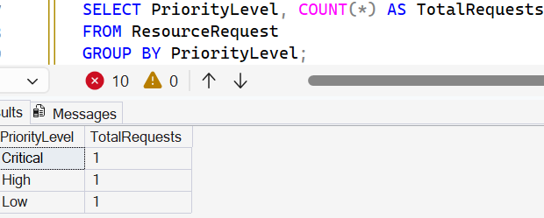

4.5 Locations with 2 or more requests (HAVING)
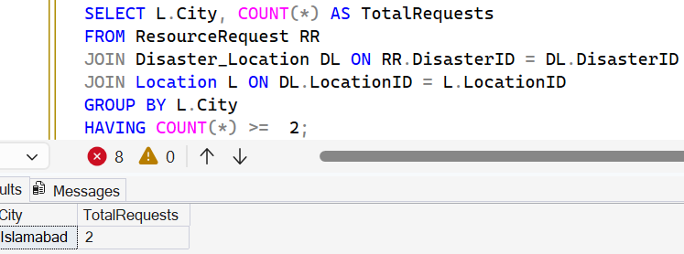

5. Allocation Management
5.1 Allocate resources to disaster (INSERT)
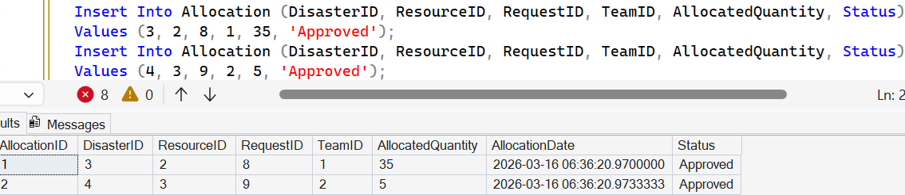

5.2 Update allocation status (UPDATE)
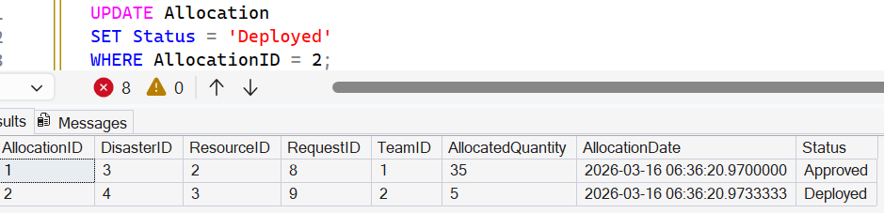

5.3 Show Allocation Dashboard details with disaster, resource, and team information (JOIN)
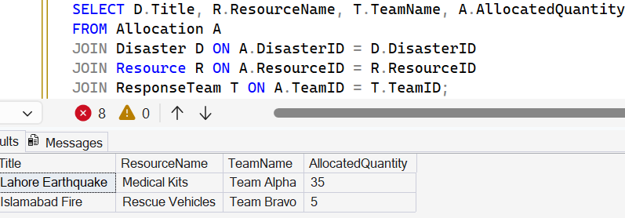

5.4 Find disasters without allocations (LEFT JOIN)
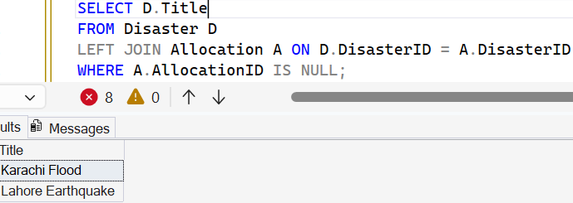

6. Team Operations
6.1 Register response team (INSERT)
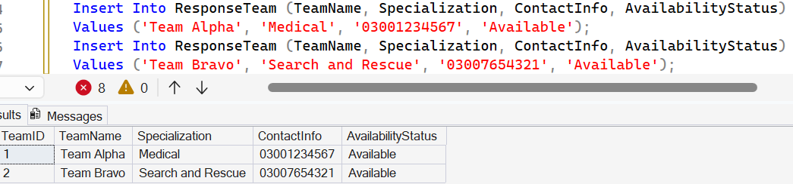

6.2 Find available teams (WHERE)
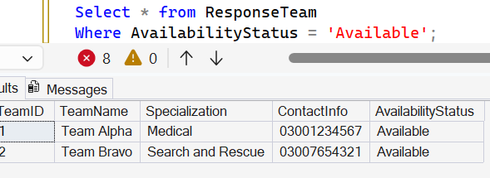

7. Analytical Queries (Aggregates)
7.1 Total resources allocated per disaster (SUM + GROUP BY)
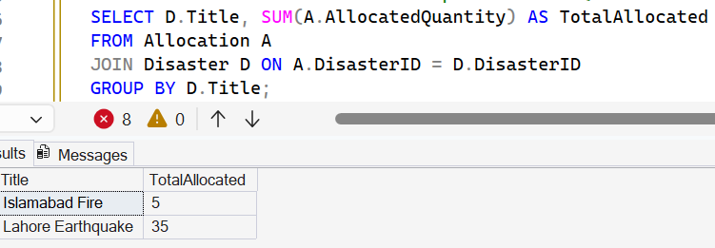

7.2 Average resource request size (AVG)
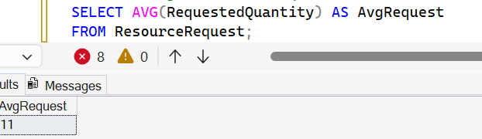

7.3 Maximum severity disaster (MAX)
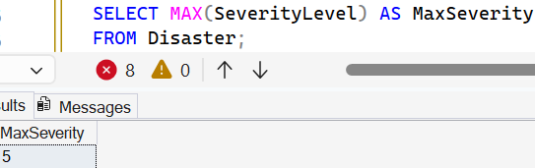

8. Subqueries
8.1 Find disasters with highest severity
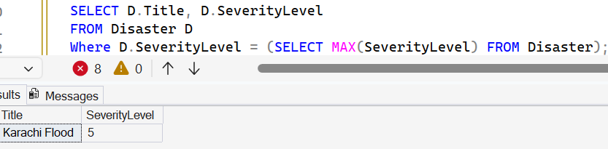

8.2 Resources below average availability
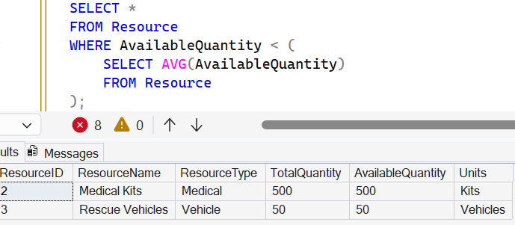

9. Set Operations
9.1 Combine disaster titles and resource names (UNION)

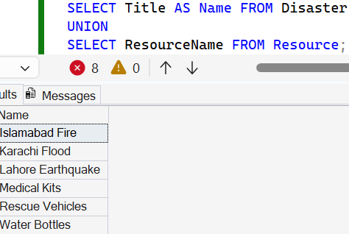

9.2 Resources requested AND allocated (INTERSECT)
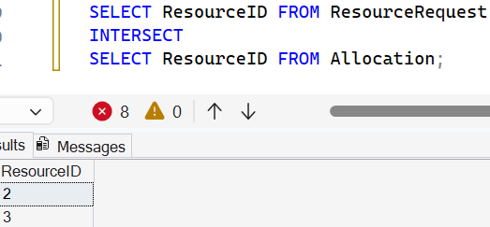

9.3 Requested but not allocated resources (EXCEPT)
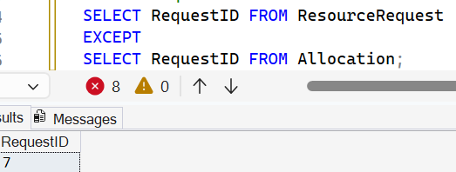

10. Full System Overview Queries
10.1 Comprehensive disaster report with locations, resources, and teams (JOIN)
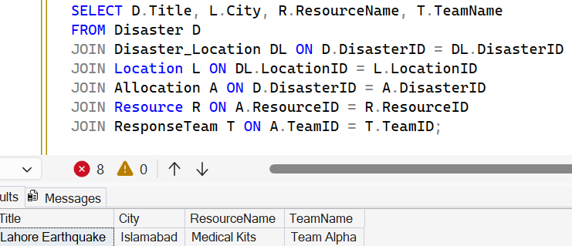

10.2 Disasters with no resource allocations (FULL OUTER JOIN)
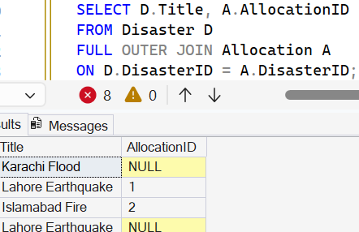

10.3 All Teams including those not assigned (RIGHT JOIN)
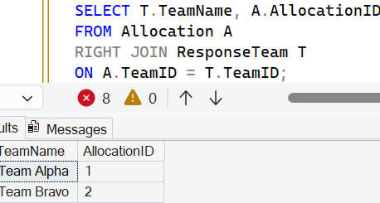

Data Base Schema
