Group # 06
Project Title:

Disaster Response And Resource Allocation System
Group members:
1. | Muhammad Hasan Butt | – 24L-3022
2. | Kabeer Ahmed Shahzeb | – 24L-3087
3. | Muhammad Haider Mughal | – 24L-3006

List of Table Names and Attributes

Disaster
Represents an emergency event.

Attributes:
- DisasterID
- Title
- Type (Flood, Earthquake, Fire, etc)
- SeverityLevel (1-5)
- StartDate
- EndDate
- Status (Active/Contained/Resolved)
- Description

Location
Represent geographical areas.

Attributes:
- LocationID
- City
- Region
- Latitude
- Longitude

DisasterLocation (Junction Table)
Handles many-to-many relationships.

Attributes:
- DisasterID
- LocationID

Resource
Represents available assets.

Attributes:
- ResourceID
- ResourceName
- ResourceType (Medical, Food, Transport, Personnel)
- TotalQuantity
- AvailableQuantity
- Units (Units, Liters, Kits)

ResponseTeam:
Represents operational teams.

Attributes:
- TeamID
- TeamName
- Specialization
- ContactInfo
- AvailabilityStatus

Allocation:
Represents the allocation of resources to response teams based on approved requests.

Attributes:
- AllocationID
- DisasterID
- ResourceID
- TeamID
- AllocatedQuantity
- AllocationDate
- Status (Pending/Approved/Deployed/Completed)

User:
Represents system users with different roles.

Attributes:
- UserID
- FullName
- Email
- PasswordHash
- Role
- CreatedAt

ResourceRequest:
A formal request for resources before they are approved and allocated.

Attributes:
- RequestID
- DisasterID
- ResourceID
- RequestByUserID
- RequestedQuantity
- RequestDate
- PriorityLevel (Low/Medium/High/Critical)
- Status (Pending/Approved/Rejected/Fulfilled)
- Remarks

SQL Queries:

CREATE DATABASE DRRAS;
USE DRRAS;

--- Disaster: Represents an emergency event---
CREATE TABLE DISASTER(
DisasterID INT IDENTITY(1,1) PRIMARY KEY,
Title VARCHAR(200) NOT NULL,
Type VARCHAR(50) NOT NULL,
SeverityLevel INT NOT NULL
CHECK (SeverityLevel Between 1 AND 5),
StartDate DATETIME2 NOT NULL,
EndDate DATETIME2 NOT NULL,
Status VARCHAR(20) NOT NULL
CHECK (Status IN ('Active', 'Contained', 'Resolved')),
Description VARCHAR(MAX) NULL
);

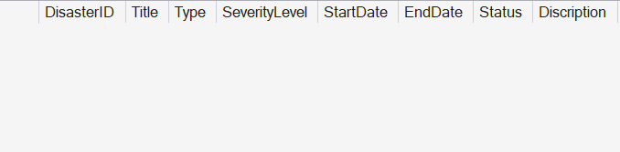

---Location: Represent geographical areas---
CREATE TABLE LOCATION(
LocationID INT IDENTITY(1,1) PRIMARY KEY,
City VARCHAR(100) NOT NULL,
Region VARCHAR (100) NOT NULL,
Latitude DECIMAL(9,6) NOT NULL,
Longitude DECIMAL(9,6) NOT NULL
);

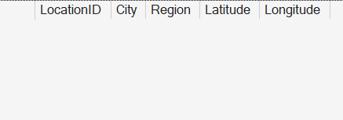

---Disaster Location: Handles many-to-many relationships---
CREATE TABLE DISASTER_LOCATION(
DisasterID INT NOT NULL,
LocationID INT NOT NULL,
PRIMARY KEY (DisasterID, LocationID),
FOREIGN KEY (DisasterID) REFERENCES DISASTER(DisasterID)
ON DELETE CASCADE,
FOREIGN KEY (LocationID) REFERENCES LOCATION(LocationID)
ON DELETE CASCADE
);

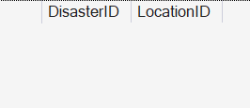

---Resource: Represents available assets---
CREATE TABLE Resource(
ResourceID INT IDENTITY(1,1) PRIMARY KEY,
ResourceName VARCHAR(150) NOT NULL,
ResourceType VARCHAR(50) NOT NULL,
TotalQuantity INT NOT NULL
CHECK (TotalQuantity >= 0),
AvailableQuantity INT NOT NULL
CHECK (AvailableQuantity >= 0 ),
Units VARCHAR(50) NOT NULL,
CONSTRAINT CHK_Resource_Quantity
CHECK (AvailableQuantity <= TotalQuantity)
);

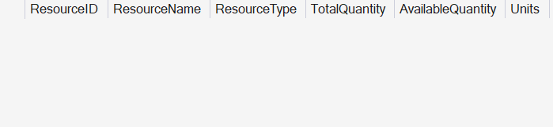

---ResponseTeam: Represents operational teams---
CREATE TABLE ResponseTeam(
TeamID INT IDENTITY(1,1) PRIMARY KEY,
TeamName VARCHAR(150) NOT NULL,
Specialization VARCHAR(100) NOT NULL,
ContactInfo VARCHAR(200) NOT NULL,
AvailabilityStatus VARCHAR(20) NOT NULL
CHECK (AvailabilityStatus IN ('Available', 'Deployed', 'Unavailable'))
);

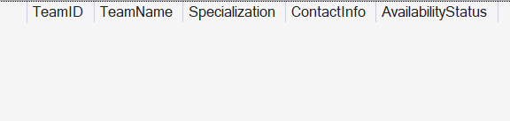

---Allocation: Represents the allocation of resources to response teams based on approved requests---
CREATE TABLE Allocation(
AllocationID INT IDENTITY(1,1) PRIMARY KEY,
DisasterID INT NOT NULL,
ResourceID INT NOT NULL,
RequestID INT NOT NULL,
TeamID INT NOT NULL,
AllocatedQuantity INT NOT NULL CHECK (AllocatedQuantity > 0),
AllocationDate DATETIME2 NOT NULL DEFAULT GETDATE(),
Status VARCHAR(20) NOT NULL
CHECK (Status IN ('Pending', 'Approved', 'Deployed', 'Completed')),
FOREIGN KEY (DisasterID) REFERENCES DISASTER(DisasterID),
FOREIGN KEY (RequestID) REFERENCES ResourceRequest(RequestID),
FOREIGN KEY (TeamID) REFERENCES ResponseTeam(TeamID)
);

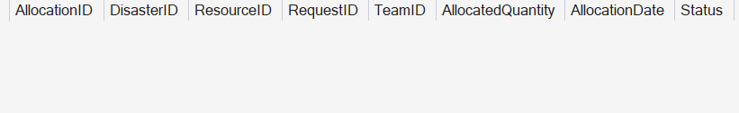

---User: Represents system users with different roles---
CREATE TABLE [User](
UserID INT IDENTITY(1,1) PRIMARY KEY,
FullName VARCHAR(50) NOT NULL,
Email VARCHAR(100) NOT NULL UNIQUE,
PasswordHash VARCHAR(255) NOT NULL,
Role VARCHAR(20) NOT NULL
CHECK (Role IN ('Admin', 'Rescuer', 'Viewer')),
CreatedAt DATETIME2 NOT NULL DEFAULT GETDATE()
);

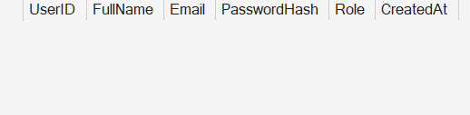

---ResourceRequest: Represents request for resources before they are approved and allocated---
CREATE TABLE ResourceRequest(
RequestID INT IDENTITY(1,1) PRIMARY KEY,
DisasterID INT NOT NULL,
ResourceID INT NOT NULL,
RequestByUserID INT NOT NULL,
RequestedQuantity INT NOT NULL CHECK (RequestedQuantity > 0),
RequestDate DATETIME2 NOT NULL DEFAULT GETDATE(),
PriorityLevel VARCHAR(20) NOT NULL
CHECK (PriorityLevel IN ('Low', 'Medium', 'High', 'Critical')),
Status VARCHAR(20) NOT NULL
CHECK (Status IN ('Pending', 'Approved', 'Denied', 'Fulfilled')),
Remarks VARCHAR (500) NULL,
FOREIGN KEY (DisasterID) REFERENCES DISASTER(DisasterID),
FOREIGN KEY (ResourceID) REFERENCES Resource(ResourceID),
FOREIGN KEY (RequestByUserID) REFERENCES [User](UserID)
);

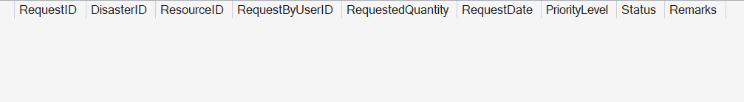

Data Base Diagram:
