Intellecta

Phase # 02

Team # 06
Member Name | Member Roll # | Primary Responsibility
Muhammad Hasan Butt | L24-3022 | SD-01– SD-07, Integration
Muhammad Anas | L24-3004 | SD-08 – SD-16
Fatima Asif | L24-3075 | SD-28 – SD-42
Hania Zahra | L24-3065 | SD-17 – SD-27

Table of Contents
Table of Contents ii
1. Design Class Diagram iii
2. Design Sequence Diagram 1
2.1 SD-01 Register/Login 1
2.2 SD-02 Input Courses, Exams & Deadlines 2
2.3 SD-03 Create Study Schedule 3
2.4 SD-04 Manage Study Sessions 4
2.5 SD-05 Use Pomodoro Timer 5
2.6 SD-06 Start/Pause/Stop Study Session 6
2.7 SD-07 View Session Statistics 7
2.8 SD-08 Track Focus Time 8
2.9 SD-09 View Focus Analytics 9
2.10 SD-10 Create Notes 10
2.11 Tag Note by Subject/Topic 11
2.12 SD-12 Search Notes 12
2.13 SD-13 Add Notes to Review Queue 13
2.14 SD-14 Upload Documents 14
2.15 SD-15 Organize Documents and Tag Documents 15
2.16 SD-16 Search Documents 16
2.17 SD-17 Open Document in Viewer 17
2.18 SD-18 Track Coverage 18
2.19 SD-19 Set Exam Countdown 19
2.20 SD-20 Manage Pre-Exam Checklist 20
2.21 SD-21 View Review Queue 21
2.22 SD-22 Enable Distraction Blocker 22
2.23 SD-23 Log Distraction 23
2.24 SD-24 Add Custom Motivational Quote 24
2.25 SD-25 Attempt Quiz/Exam 25
2.26 SD-26 View Auto-Graded Results 26
2.27 SD-27 View Quiz Results 27
2.28 SD-28 View Personal Analytics 28
2.29 SD-29 View Exam Countdown 29
2.30 SD-30 Export Study Plan 30
2.31 SD-31 Compare Progress with Peers 31
2.32 SD-32 Earn XP Points 32
2.33 SD-33 Unlock Achievement Badges 33
2.34 SD-34 Admin Login 34
2.35 SD-35 Manage Users 35
2.36 SD-36 Create Question Bank 36
2.37 SD-37 Create Quiz/Exam 37
2.38 SD-38 Configure Auto-Grading 38
2.39 SD-39 Grade Descriptive Answer 39
2.40 SD-40 View System Analytics 40
2.41 SD-41 Monitor Performance Trends 41
2.42 SD-42 Configure Achievement System 42
3. Package Diagram 43

Design Class Diagram

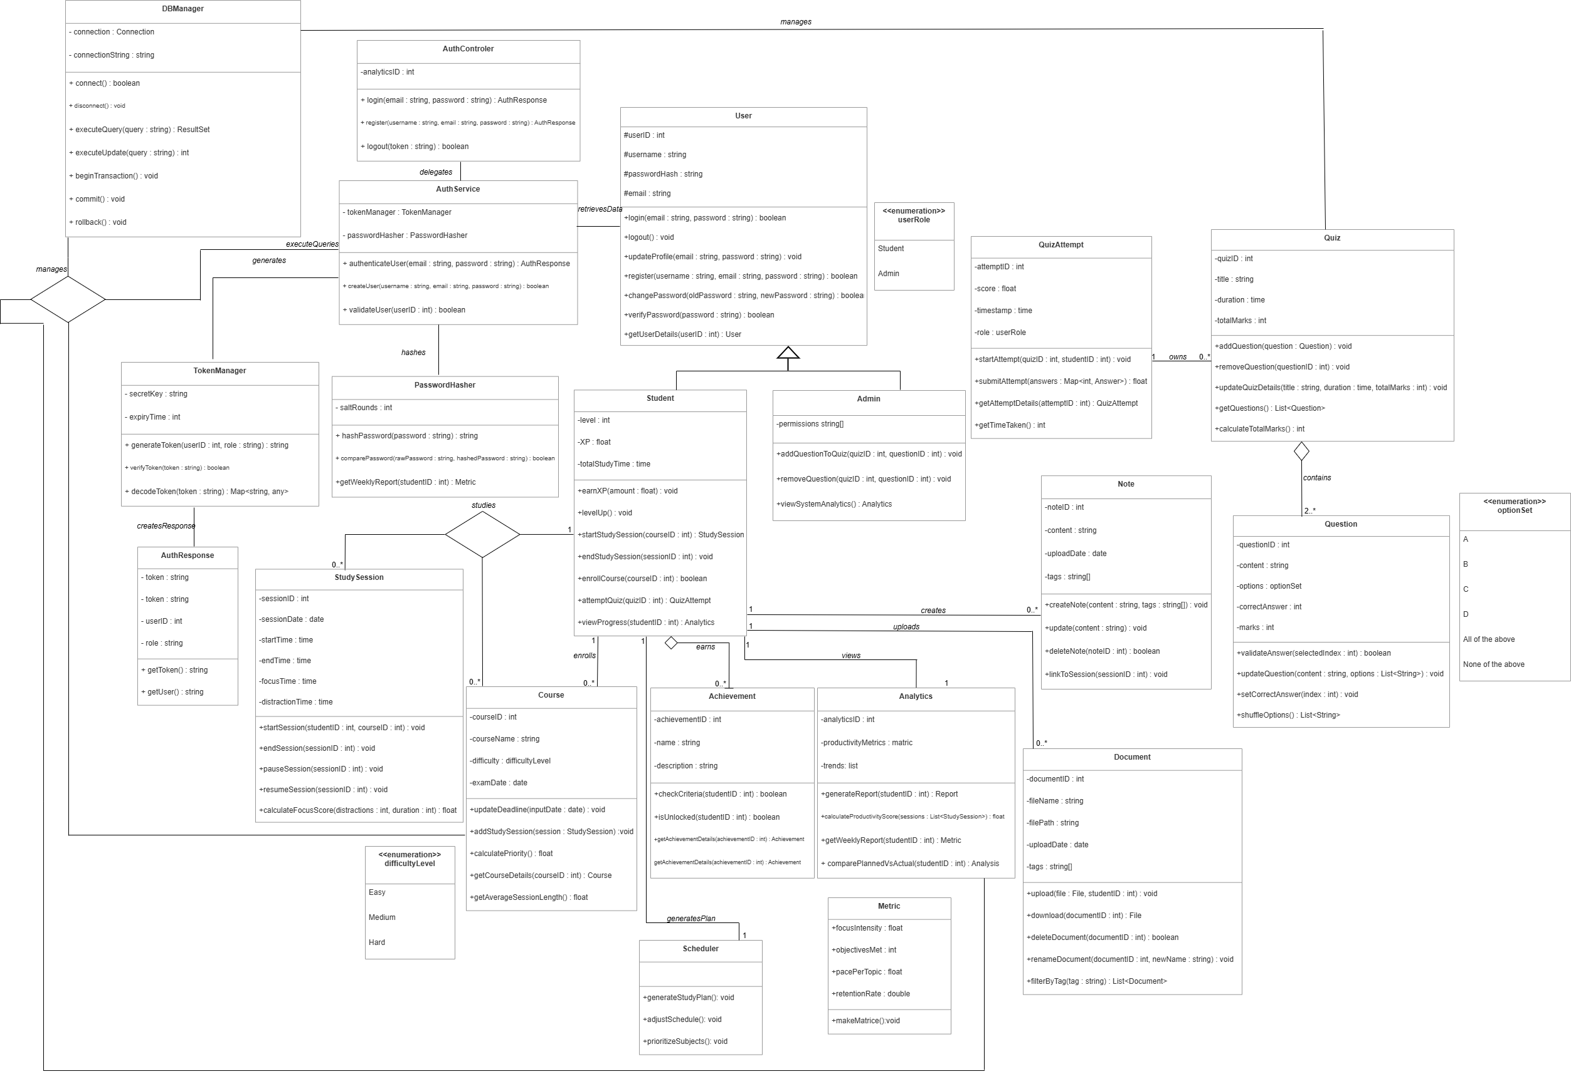

Design Sequence Diagram

SD-01 Register/Login
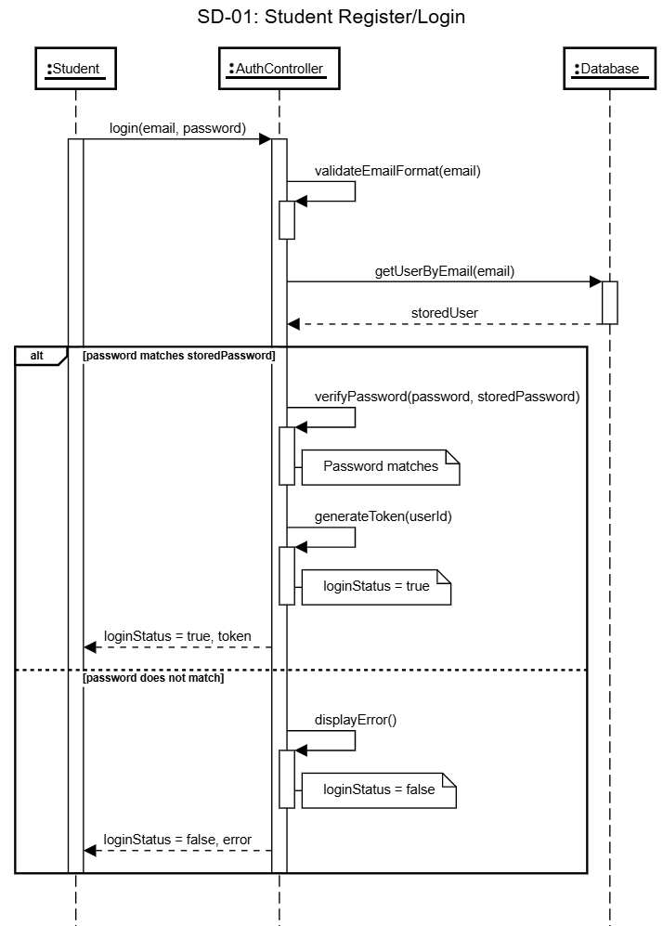

SD-02 Input Courses, Exams & Deadlines
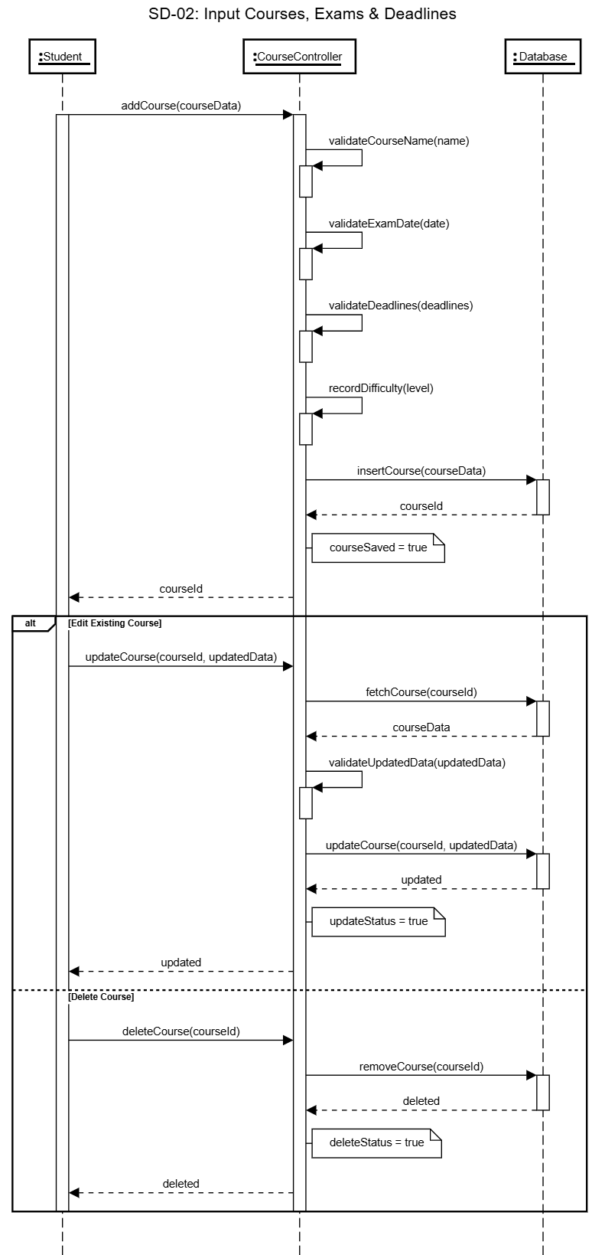

SD-03 Create Study Schedule
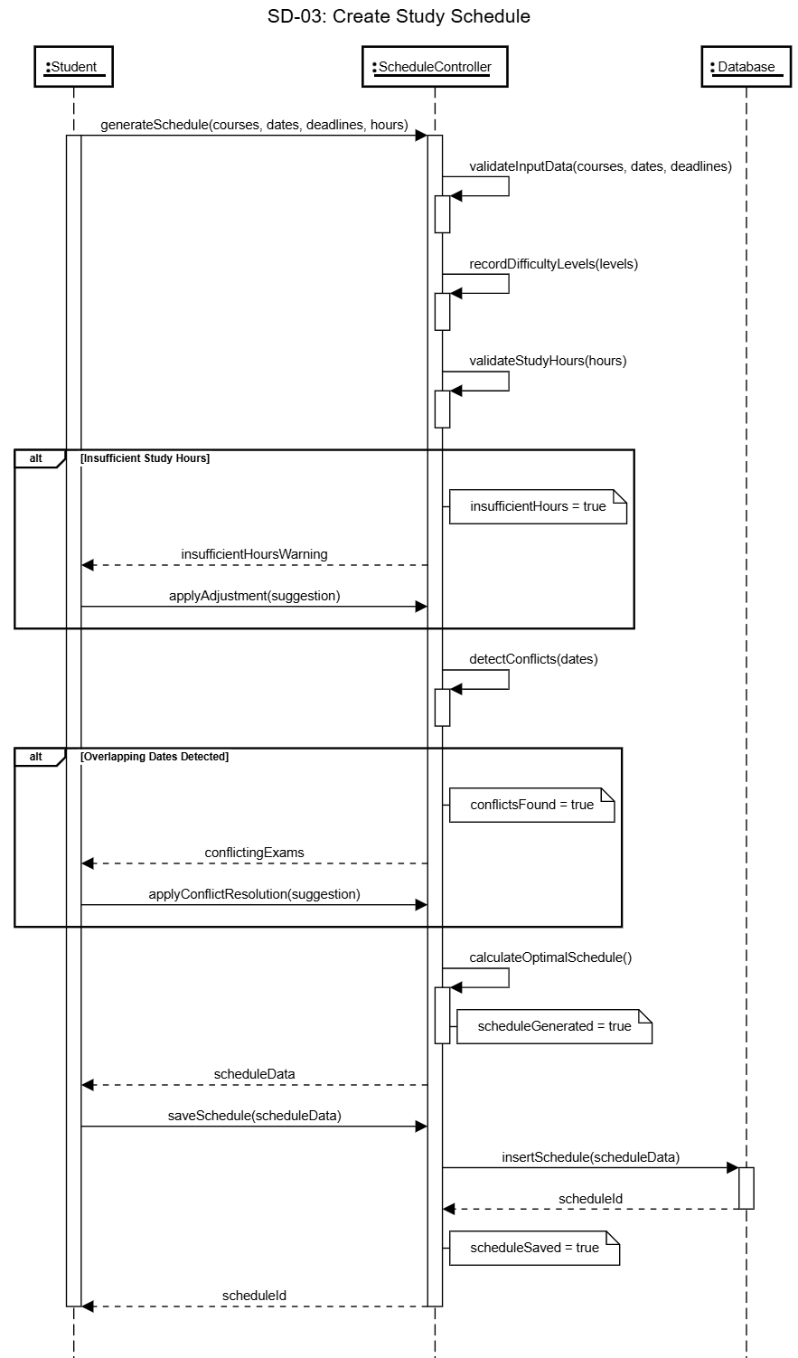

SD-04 Manage Study Sessions
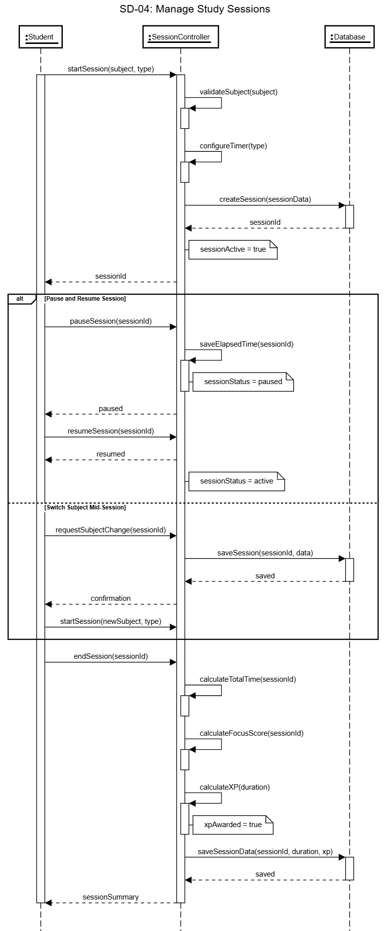

SD-05 Use Pomodoro Timer
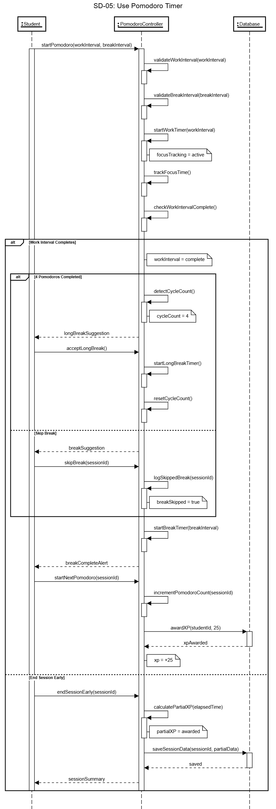

SD-06 Start/Pause/Stop Study Session
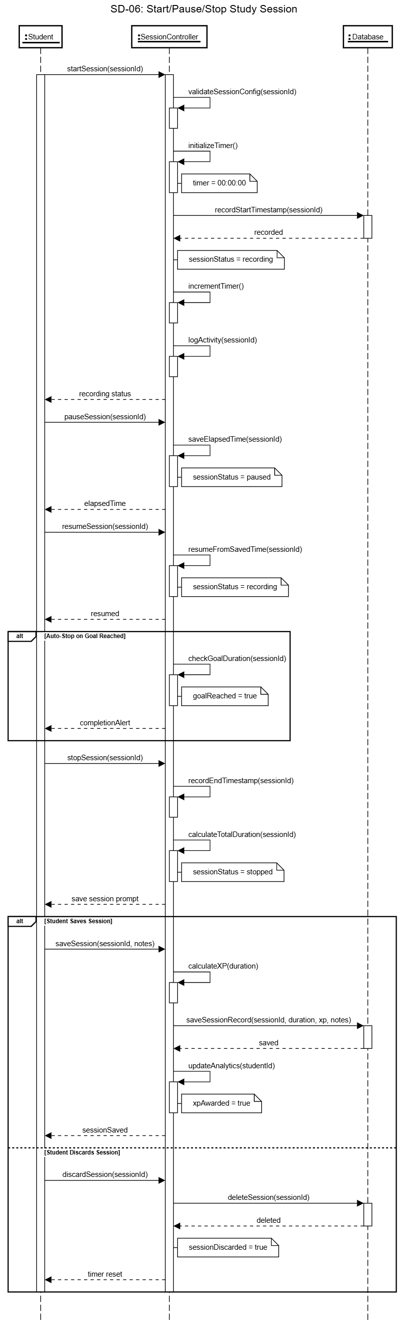

SD-07 View Session Statistics
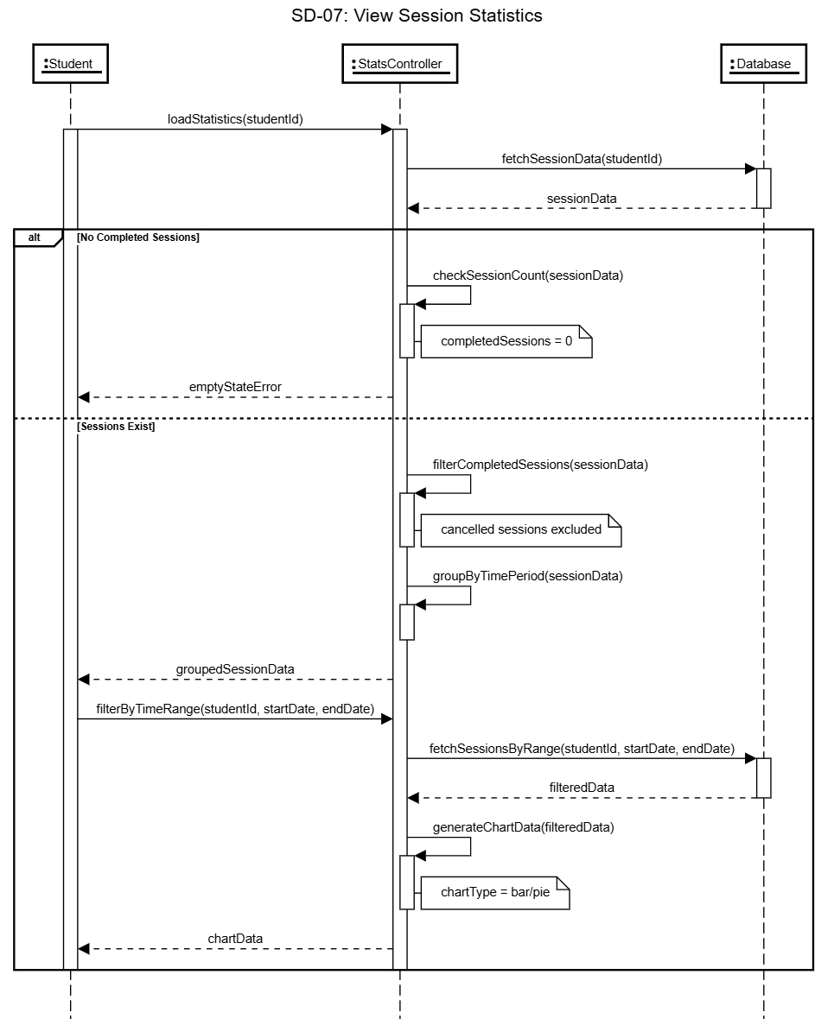

SD-08 Track Focus Time

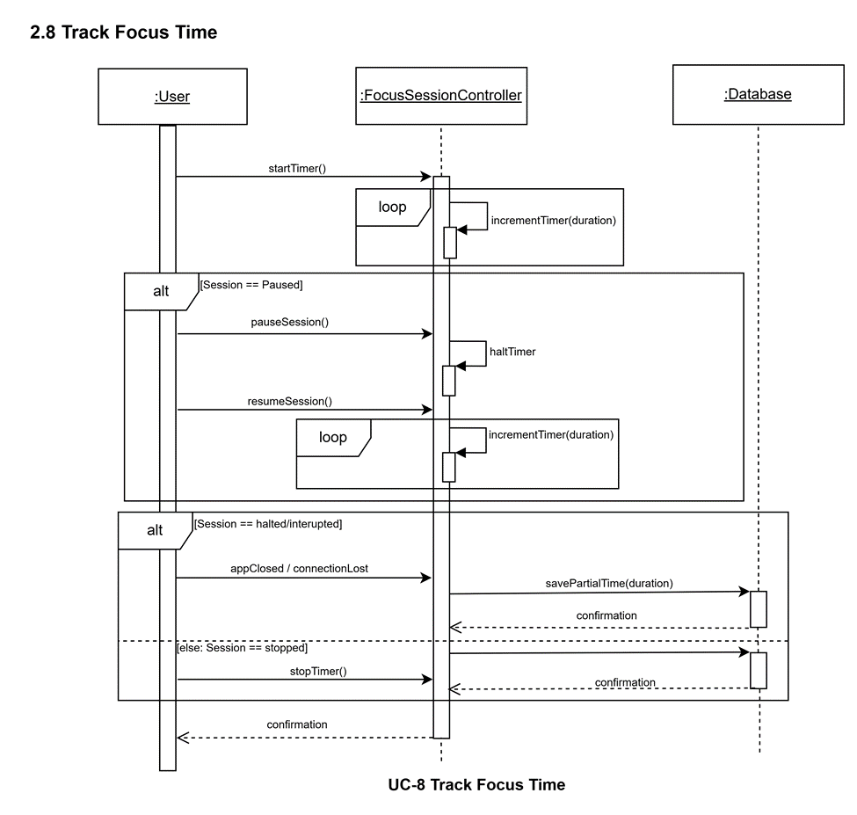

SD-09 View Focus Analytics

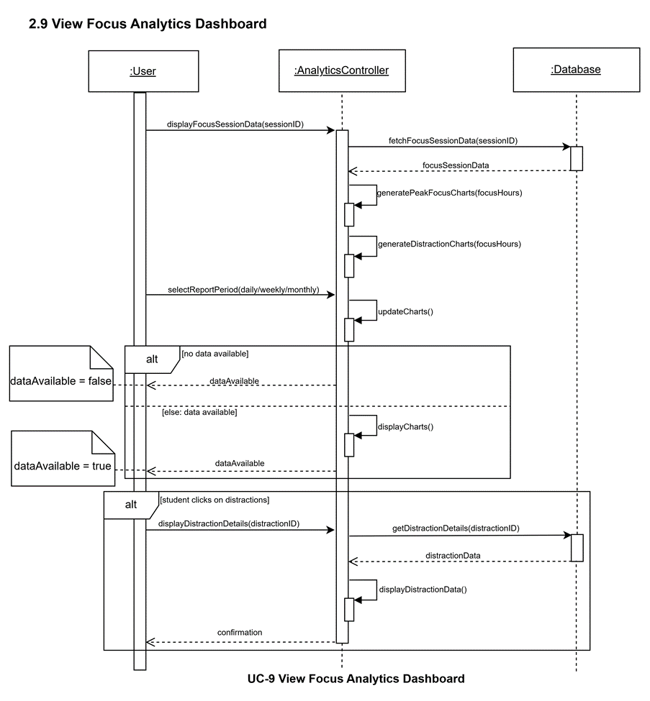

SD-10 Create Notes

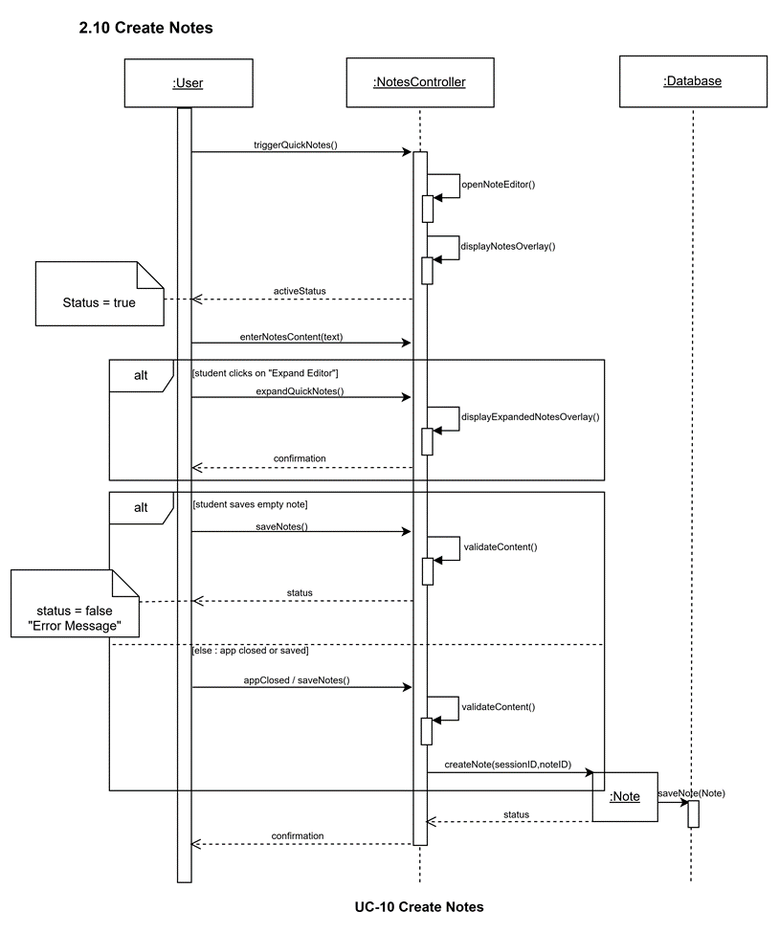

Tag Note by Subject/Topic

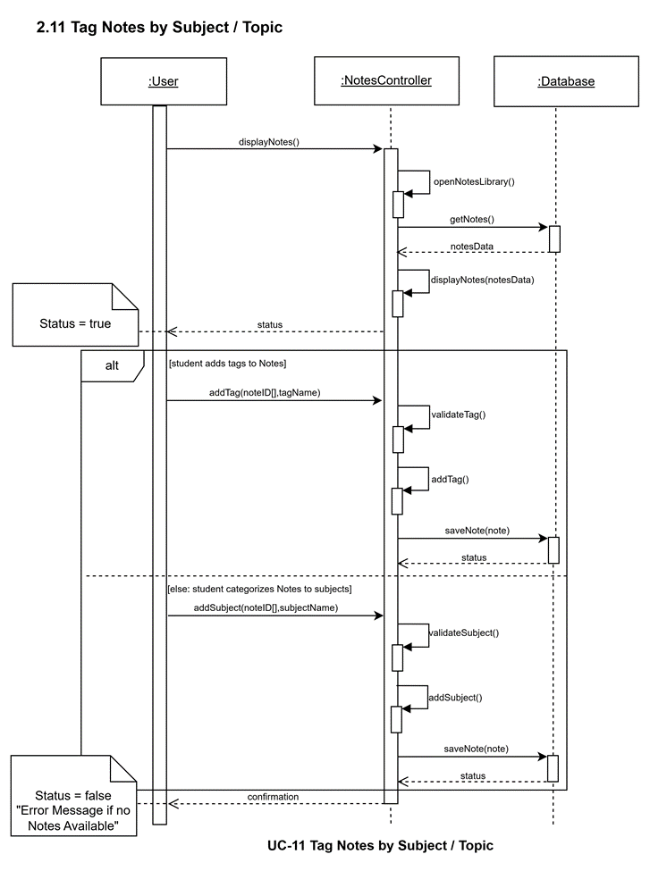

SD-12 Search Notes

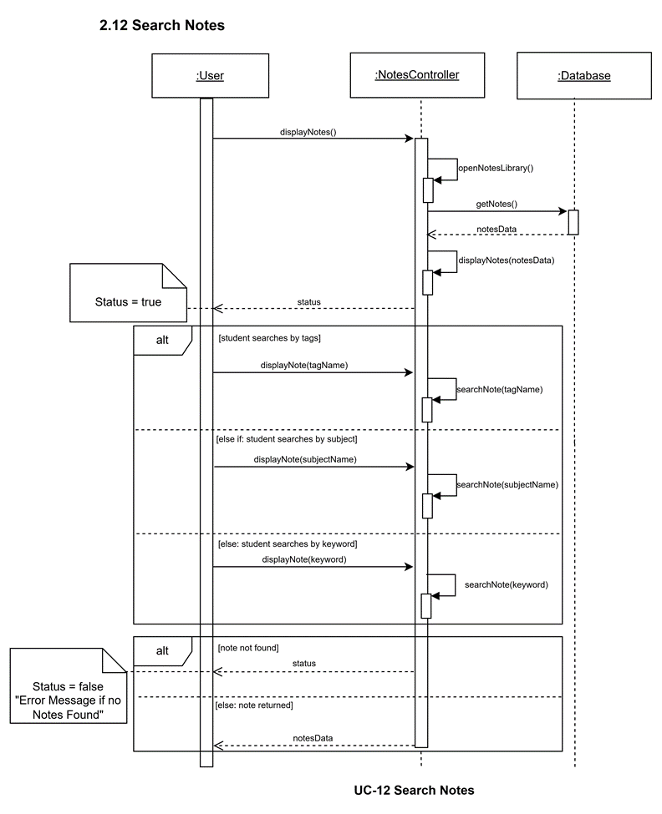

SD-13 Add Notes to Review Queue

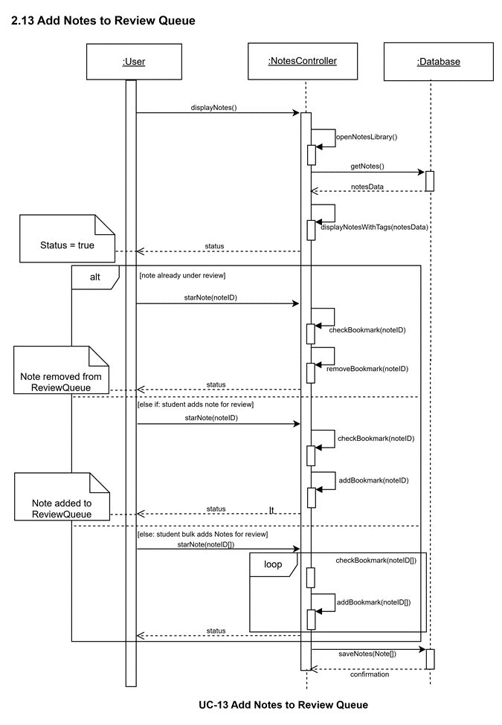

SD-14 Upload Documents

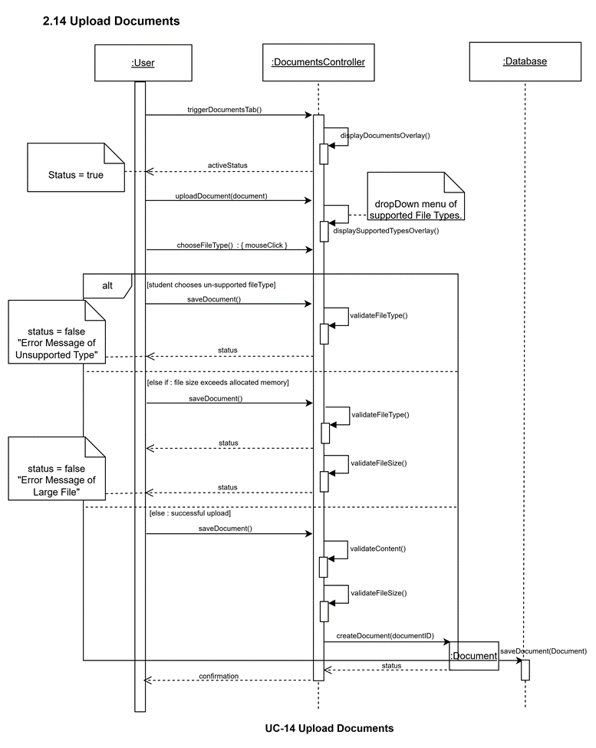

SD-15 Organize Documents and Tag Documents

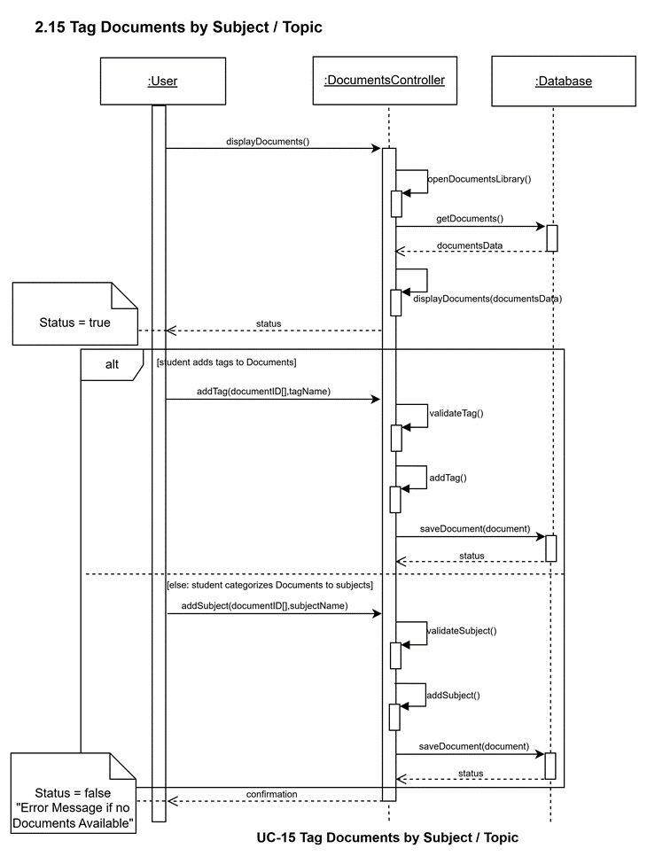

SD-16 Search Documents

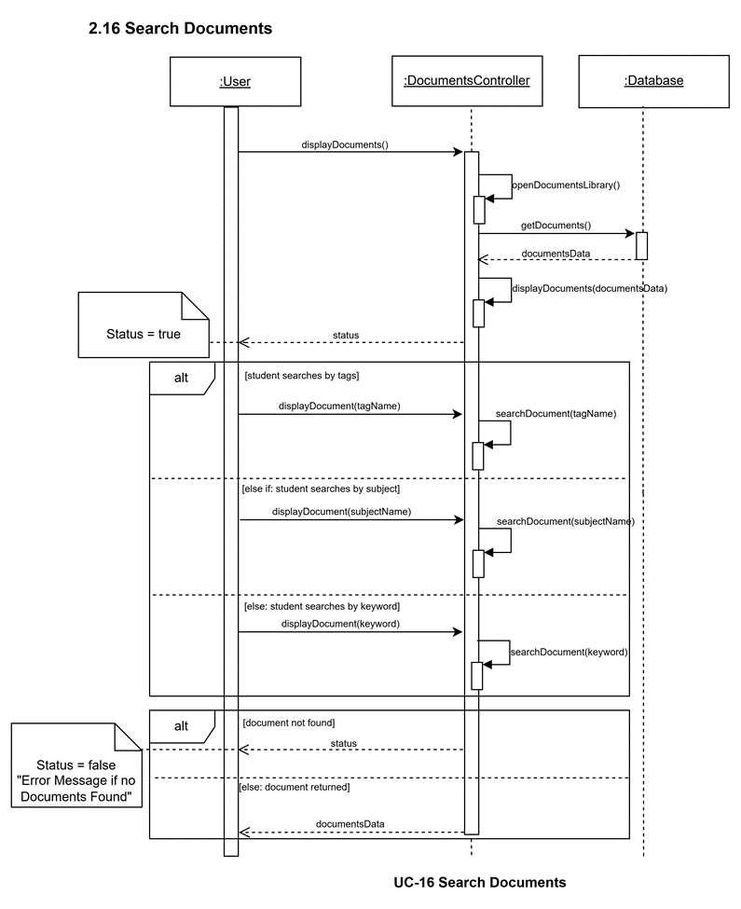

SD-17 Open Document in Viewer

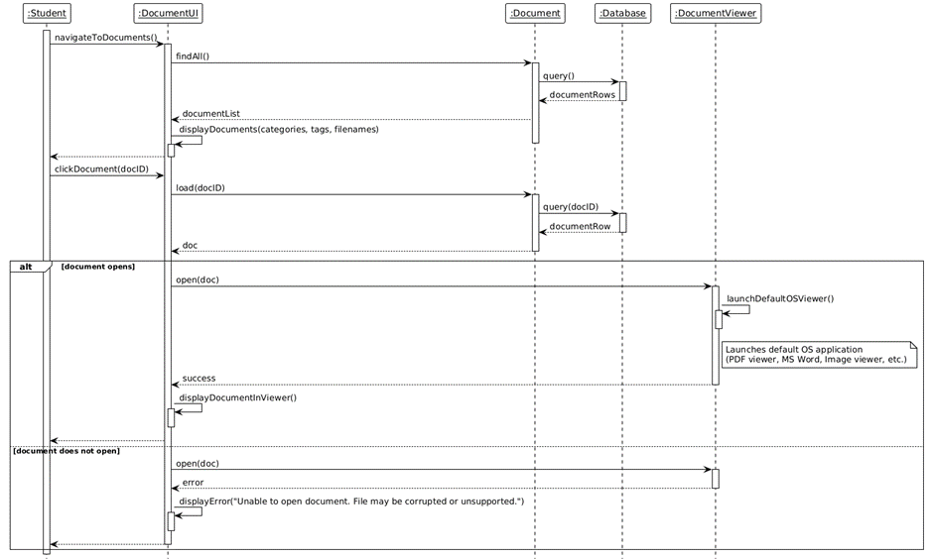

SD-18 Track Coverage

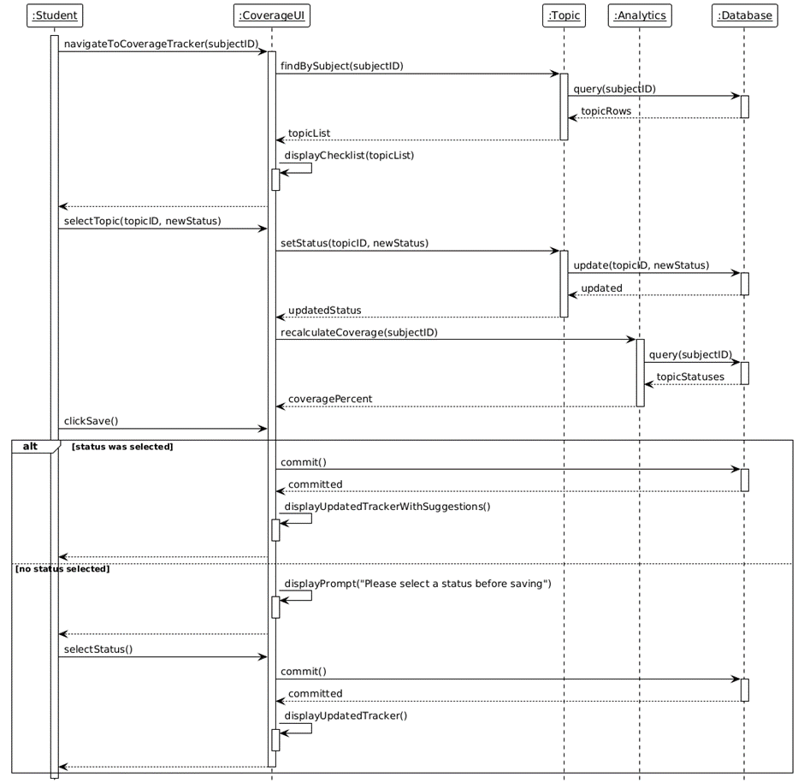

SD-19 Set Exam Countdown

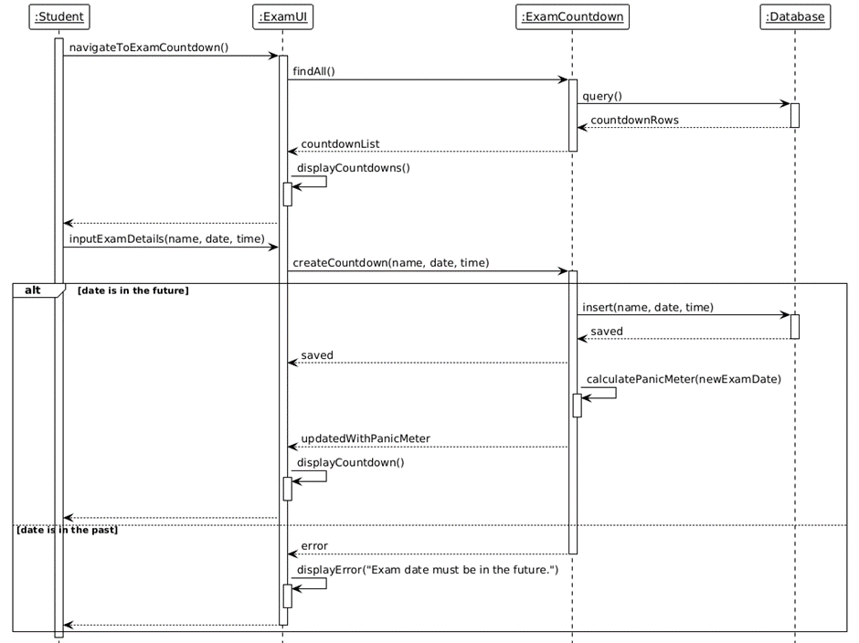

SD-20 Manage Pre-Exam Checklist

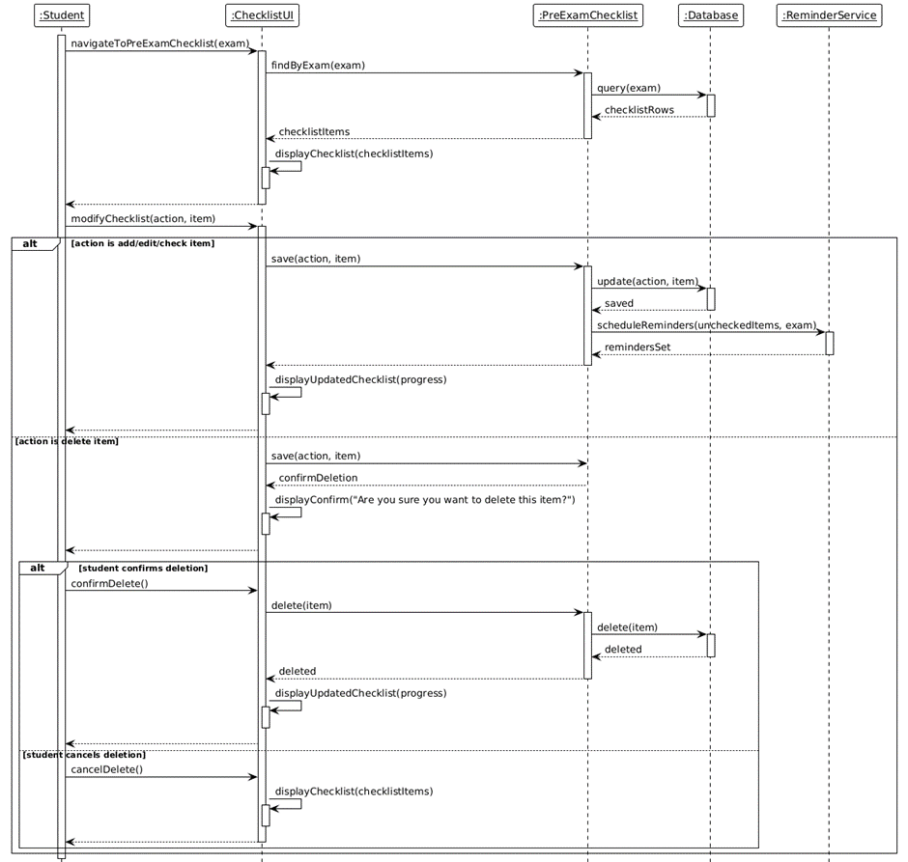

SD-21 View Review Queue

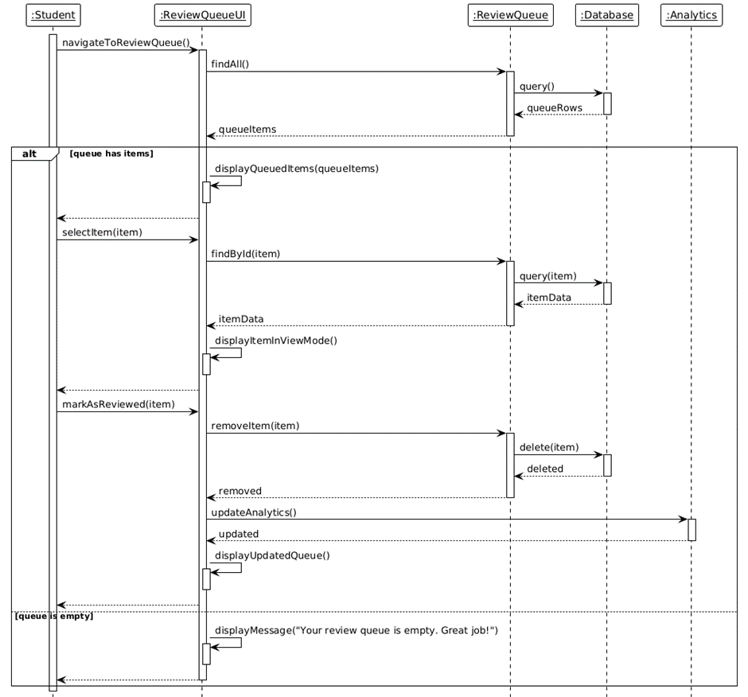

SD-22 Enable Distraction Blocker

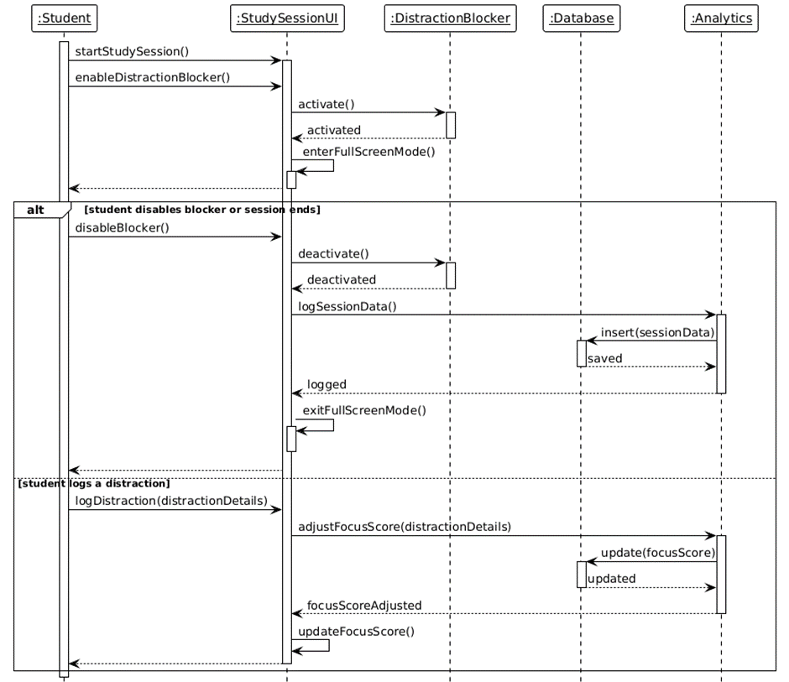

SD-23 Log Distraction

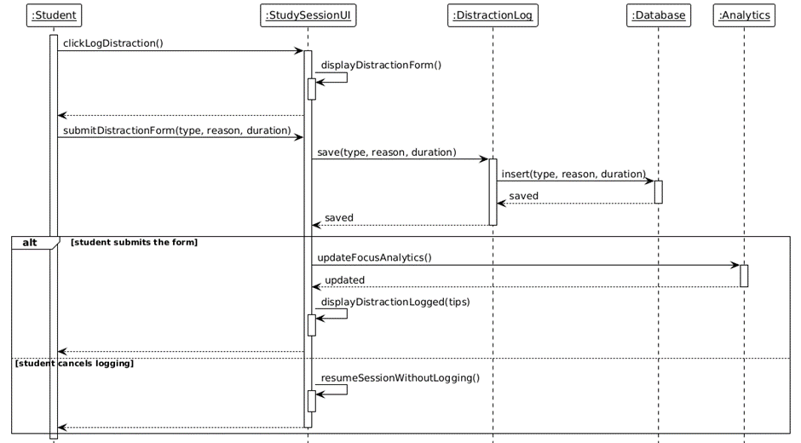

SD-24 Add Custom Motivational Quote

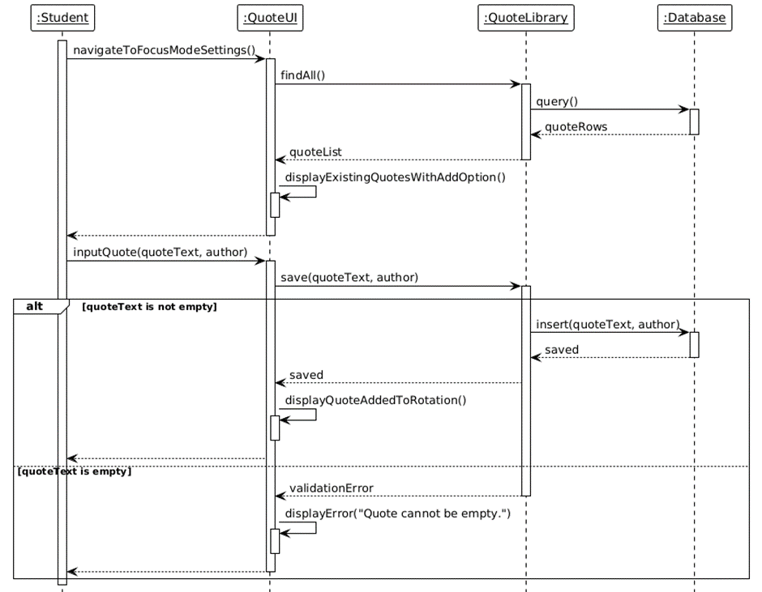

SD-25 Attempt Quiz/Exam

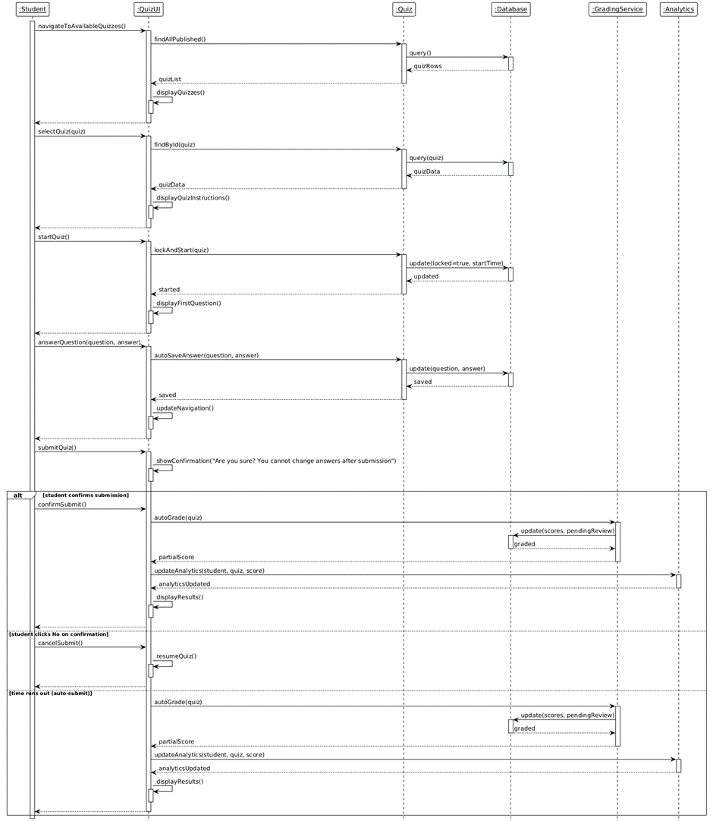

SD-26 View Auto-Graded Results

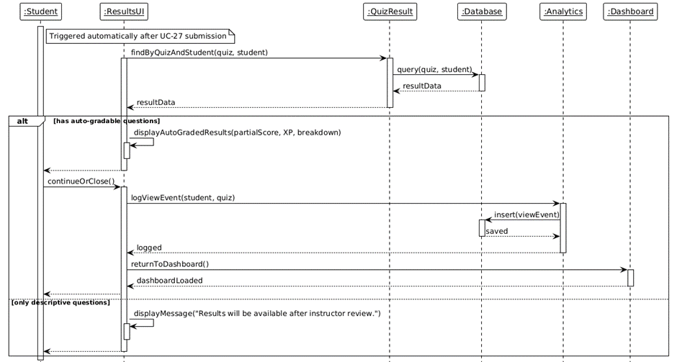

SD-27 View Quiz Results

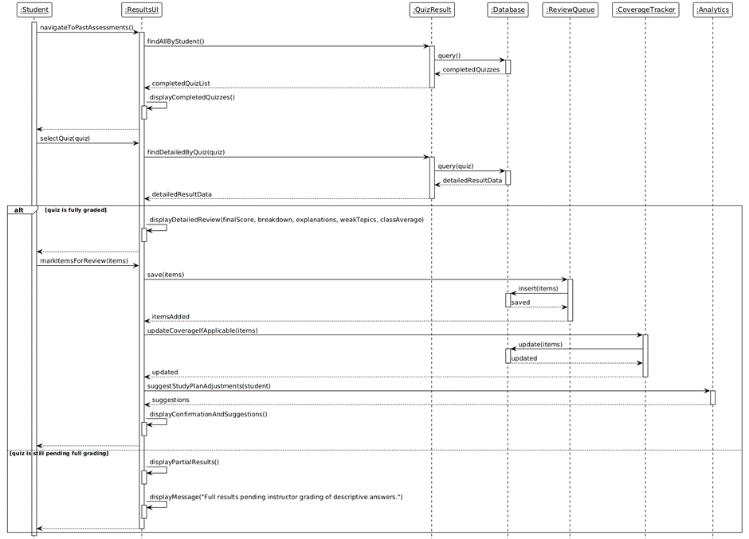

SD-28 View Personal Analytics

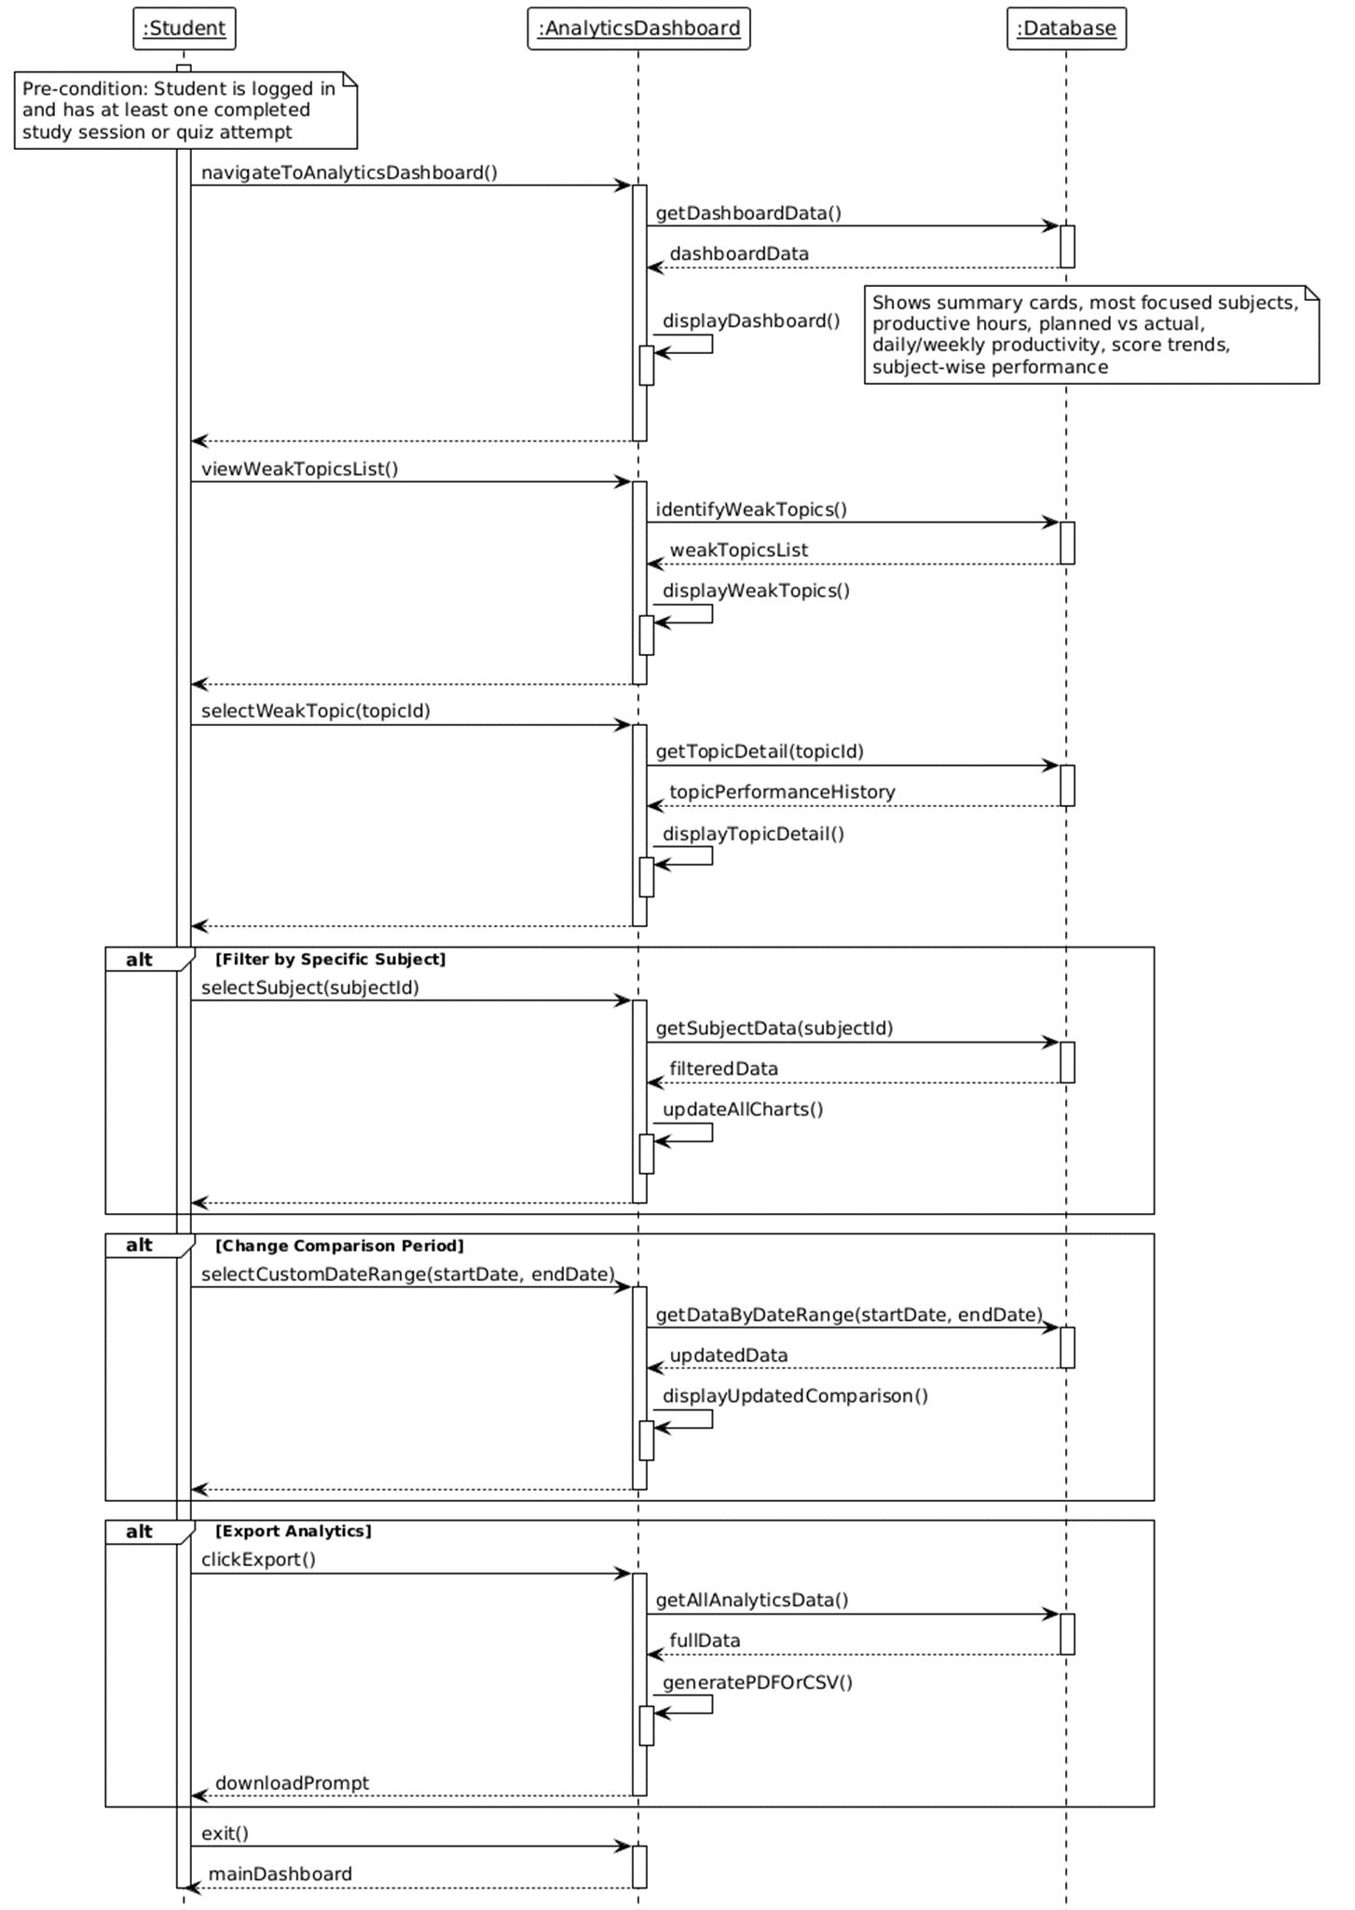

SD-29 View Exam Countdown

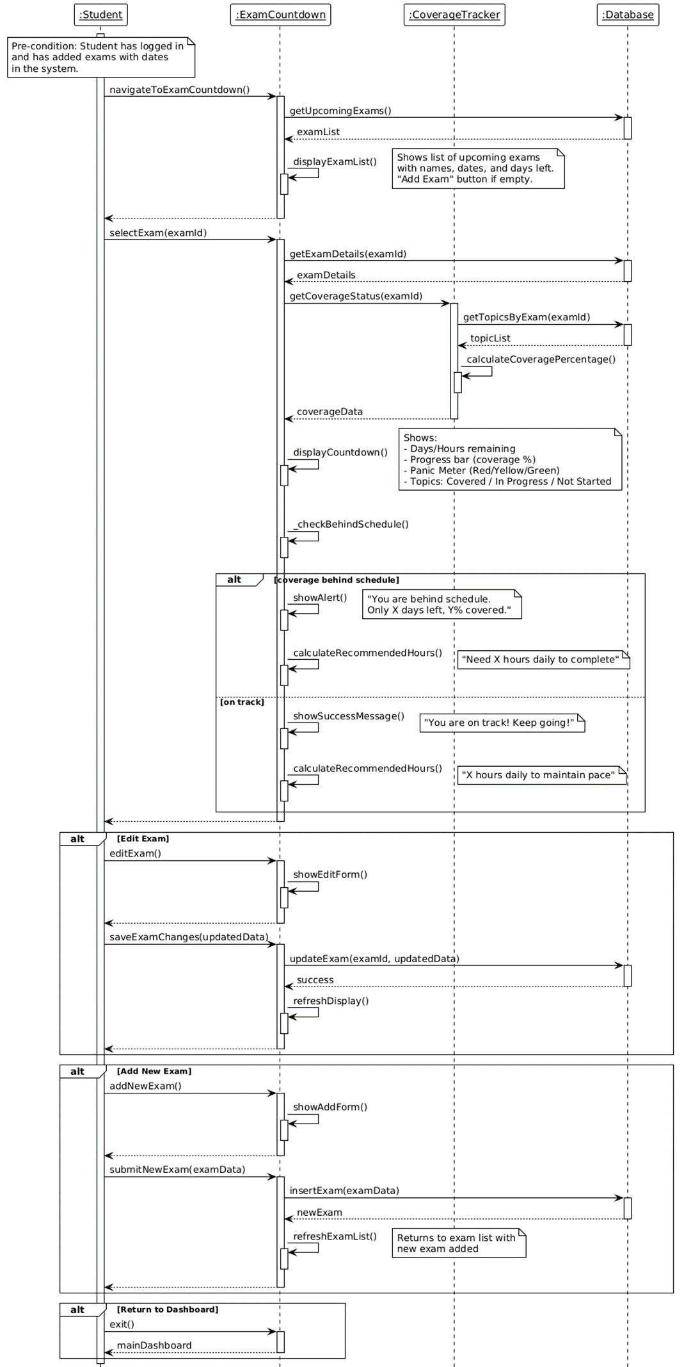

SD-30 Export Study Plan

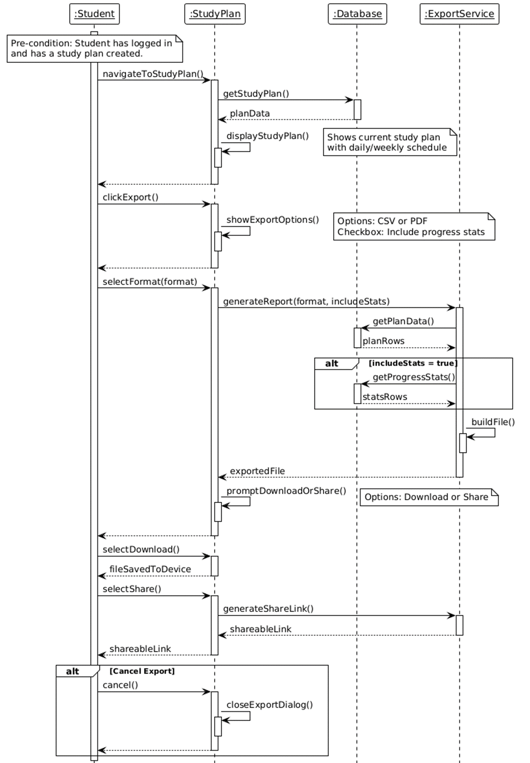

SD-31 Compare Progress with Peers

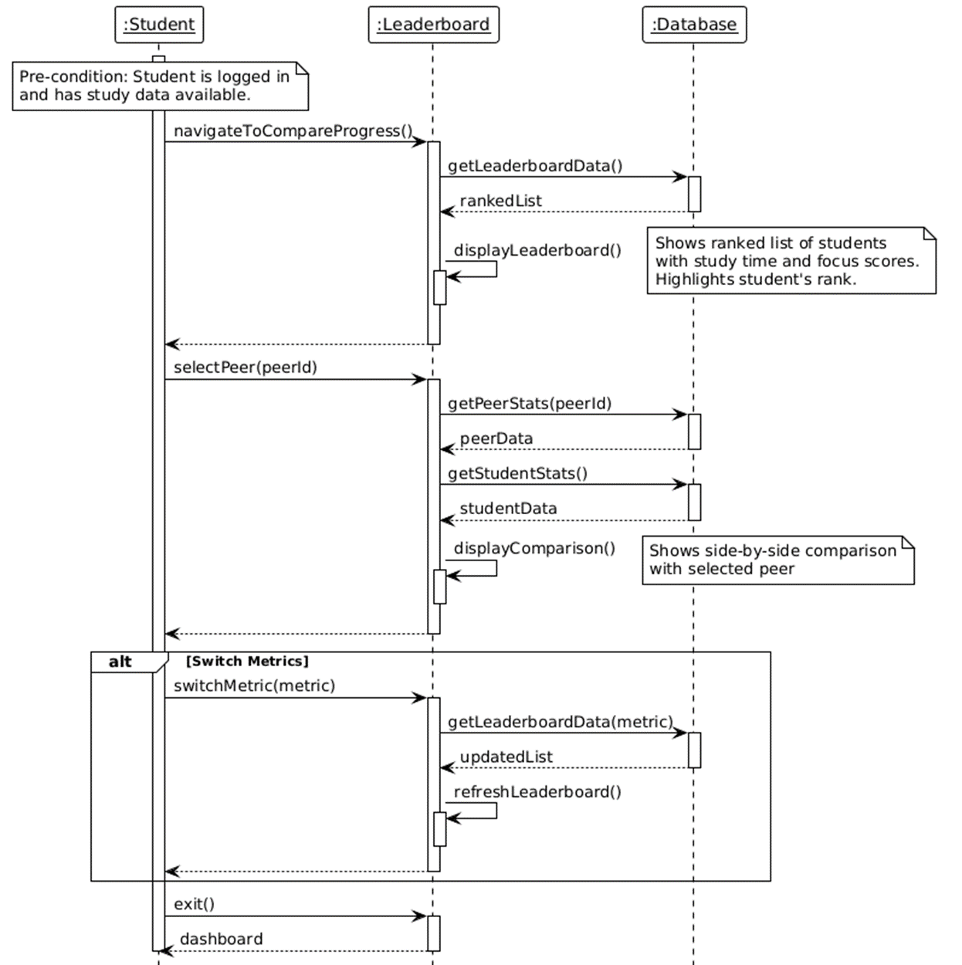

SD-32 Earn XP Points

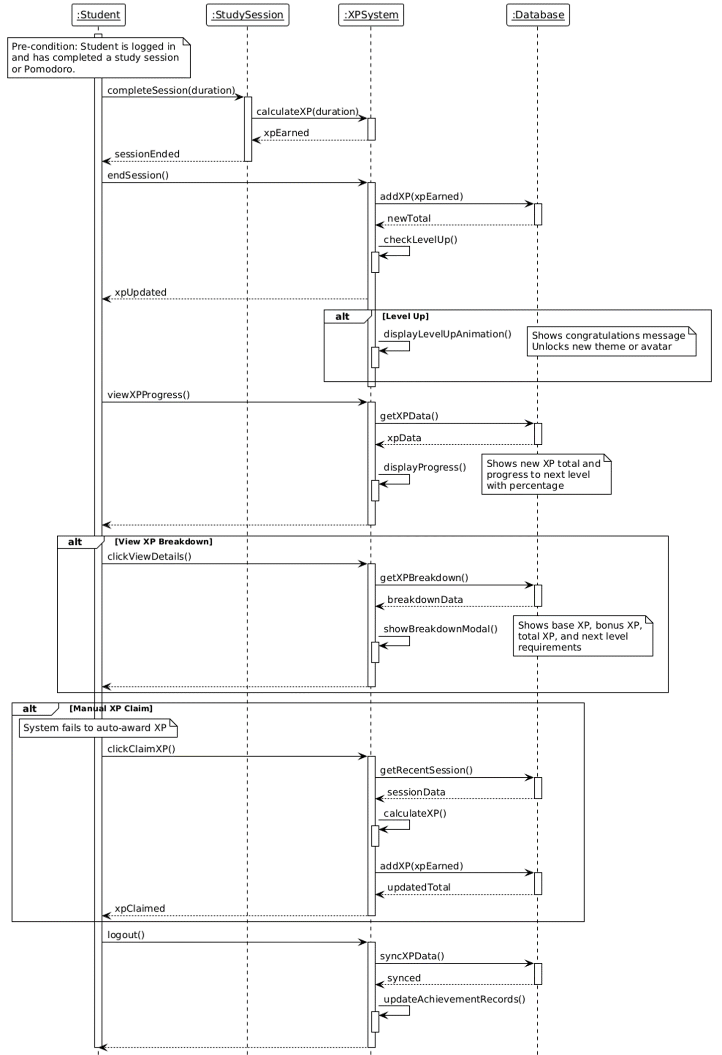

SD-33 Unlock Achievement Badges

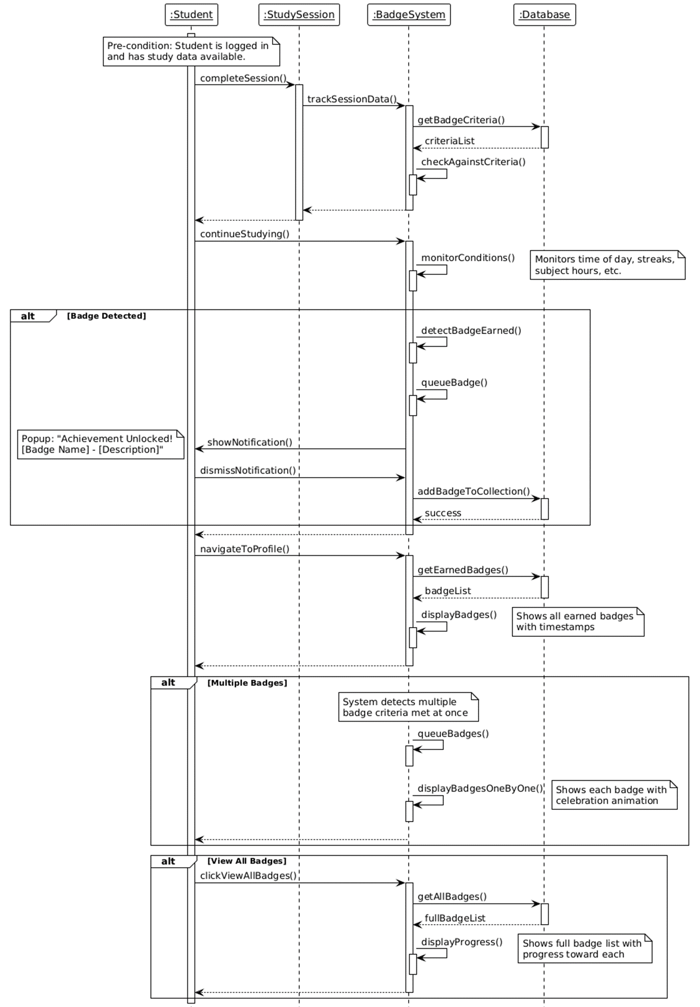

SD-34 Admin Login

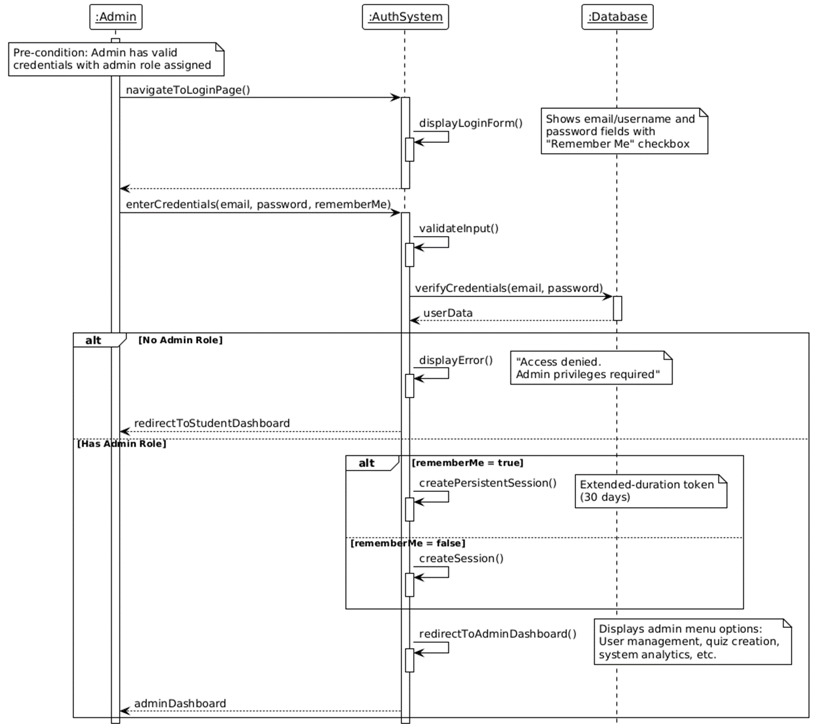

SD-35 Manage Users

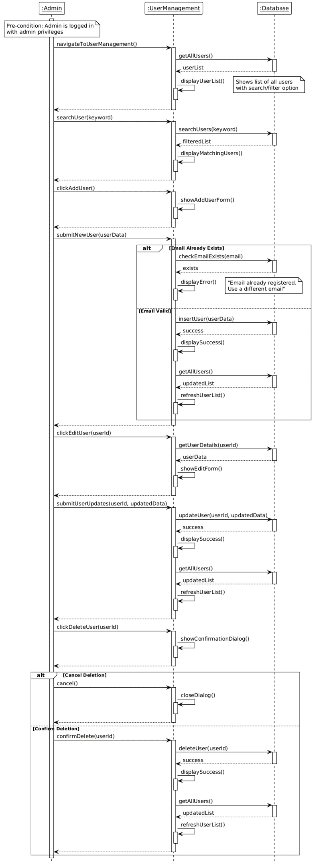

SD-36 Create Question Bank

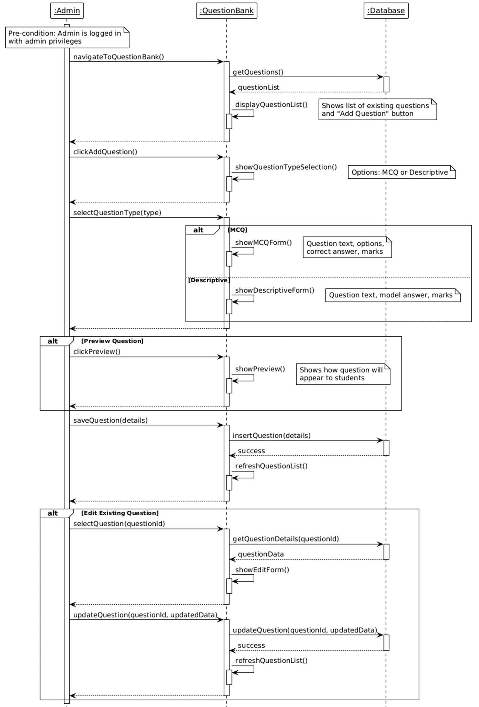

SD-37 Create Quiz/Exam

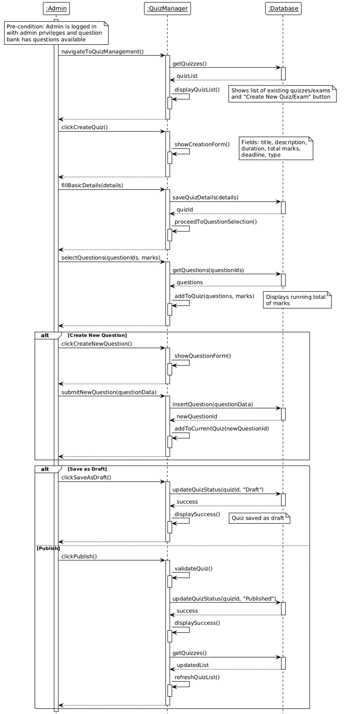

SD-38 Configure Auto-Grading

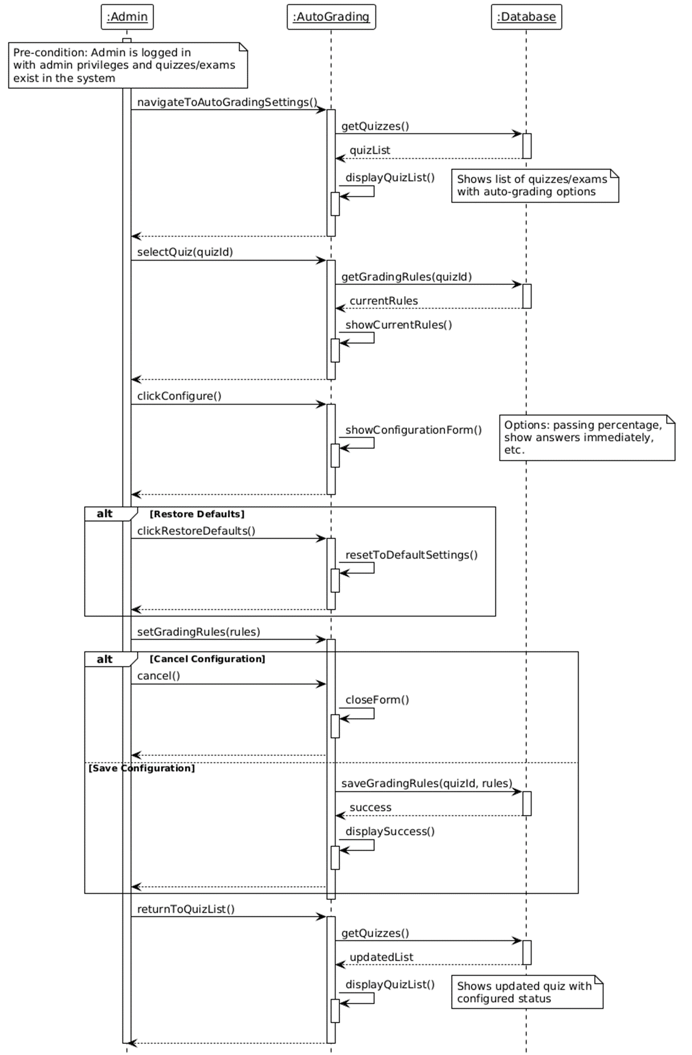

SD-39 Grade Descriptive Answer

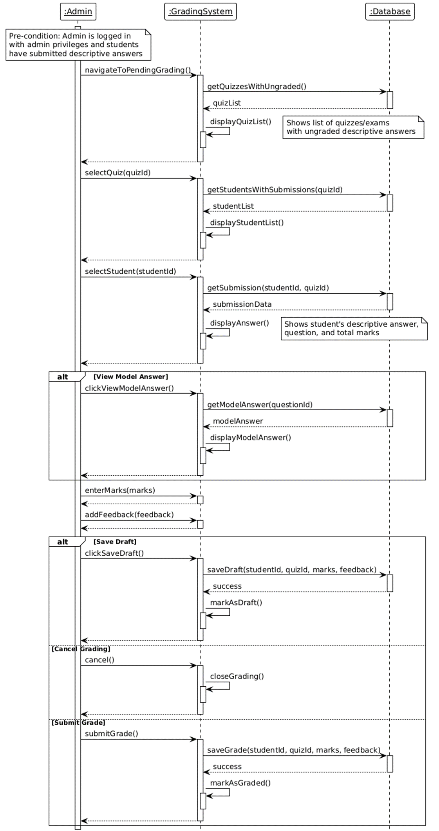

SD-40 View System Analytics

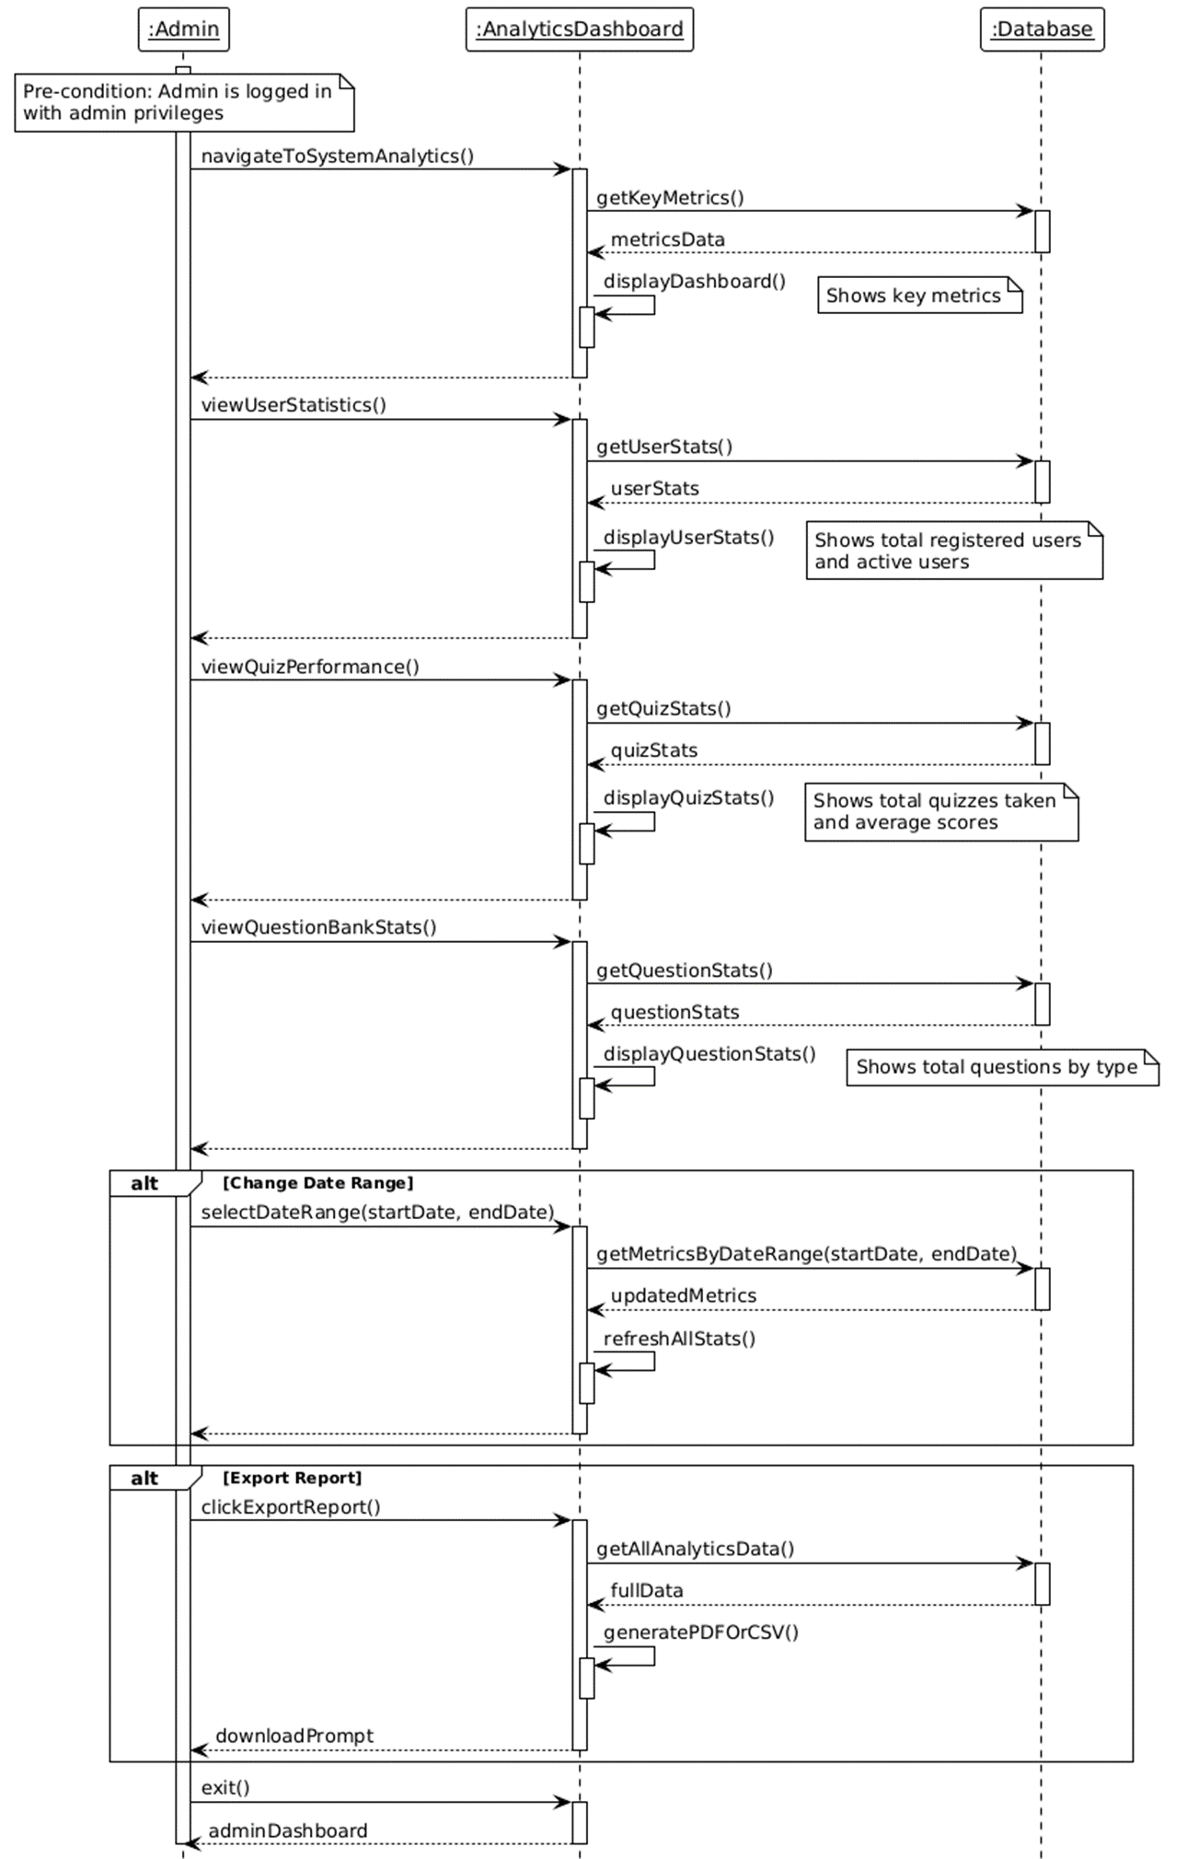

SD-41 Monitor Performance Trends

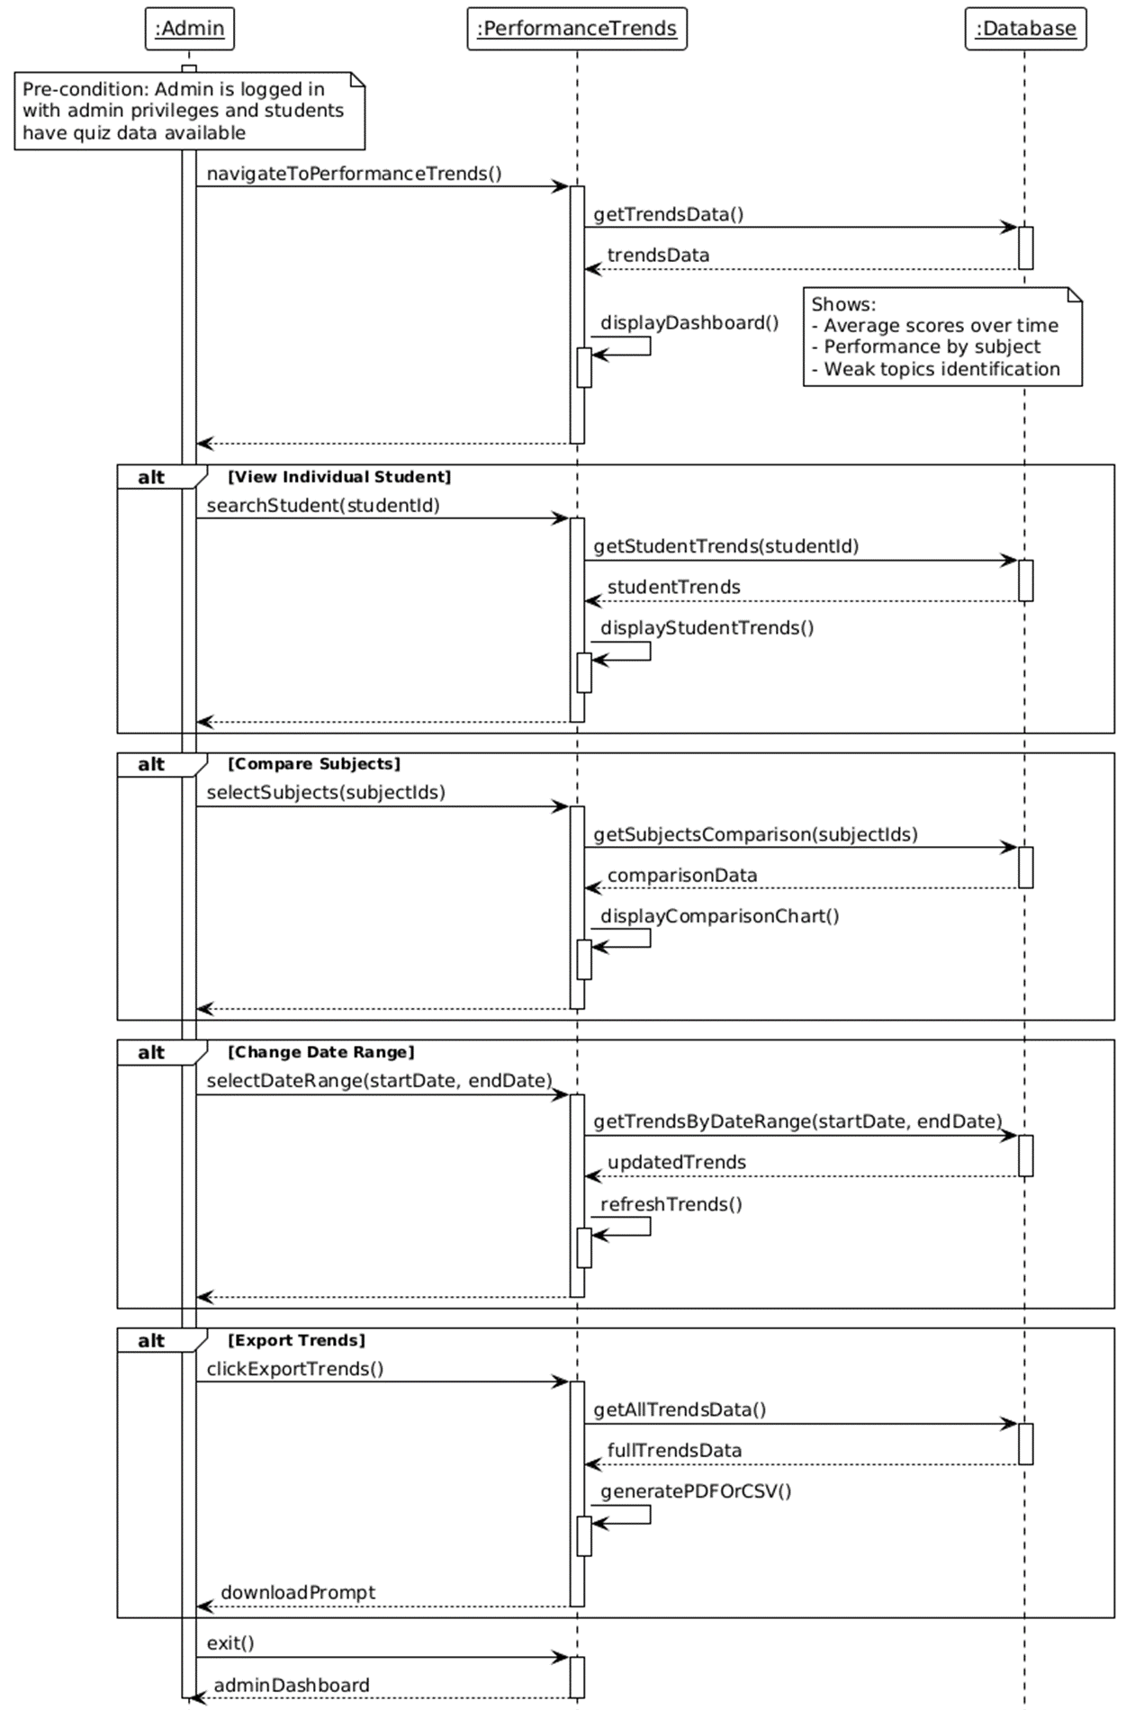

SD-42 Configure Achievement System

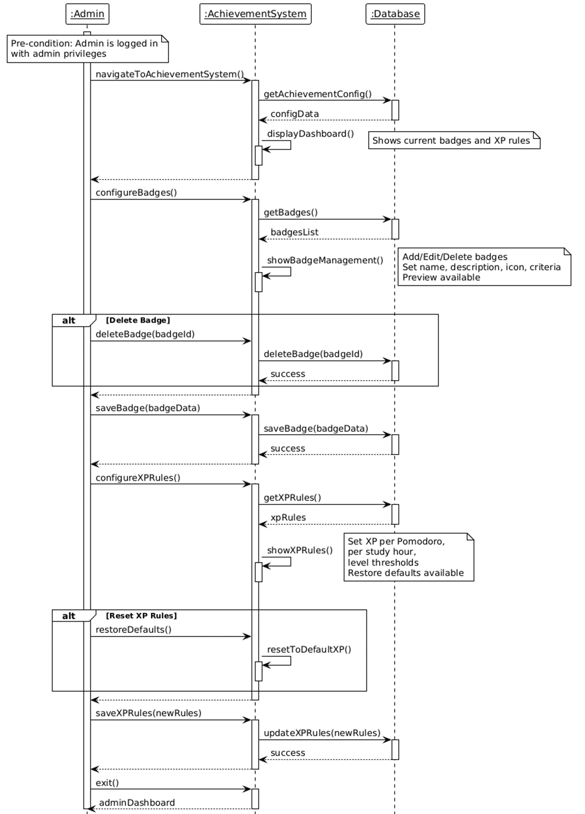

Package Diagram

