Railway Management System
Group 6 Members:
- M Soban Shahzad 23L-0847
- Zayan Ahmed 23L-0951
- Zain Ahmad 19L-1166
List of Tables to be Implemented in the Project:
Passengers → Passenger_ID (Primary Key), Name, Email, Contact_Number, Status (Active, Inactive)
Trains → Train_ID (Primary Key), Train_Name, Capacity
Stations → Station_ID (Primary Key), Station_Name, Platform_Count, Contact_Info
Train_Routes → Route_ID (Primary Key), Train_ID (Foreign Key from Trains), Source_Station_ID (Foreign Key from Stations), Destination_Station_ID (Foreign Key from Stations)
Train_Schedules → Schedule_ID (Primary Key), Train_ID (Foreign Key from Trains), Station_ID (Foreign Key from Stations), Arrival_Time, Departure_Time
Ticket_Pricing → Pricing_ID (Primary Key), Route_ID (Foreign Key from Train_Routes), Class (First, Economy), Fixed_Price
Tickets → Ticket_ID (Primary Key), Passenger_ID (Foreign Key from Passengers), Train_ID (Foreign Key from Trains), Seat_Number, Status (Booked, Cancelled)
Payments → Payment_ID (Primary Key), Ticket_ID (Foreign Key from Tickets), Amount (Should match Fixed_Price from Ticket_Pricing), Payment_Method (Card, Cash), Payment_Status (Completed, Pending)
SQL
create table passengers (
passenger_id int primary key,
name varchar(255) not null,
email varchar(255) unique,
contact_number varchar(20),
status varchar(10) check (status in ('active', 'inactive')) default 'active'
);
INSERT INTO passengers (passenger_id, name, email, contact_number, status)
VALUES
(101, 'Ali', 'ali@example.com', '03011223344', 'active'),
(102, 'Sara', 'sara@example.com', '03022334455', 'active'),
(103, 'Hassan', 'hassan@example.com', '03033445566', 'active'),
(104, 'Mina', 'mina@example.com', '03044556677', 'inactive'),
(105, 'Khan', 'khan@example.com', '03055667788', 'active');
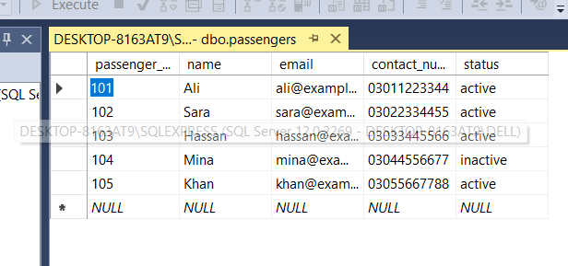

create table trains (
train_id int primary key,
train_name varchar(255) not null,
capacity int not null
);
INSERT INTO trains (train_id, train_name, capacity)
VALUES
(301, 'GreenLine', 150),
(302, 'KarakoramExpress', 120),
(303, 'ShalimarExpress', 100),
(304, 'BolanExpress', 130),
(305, 'FaisalExpress', 110);
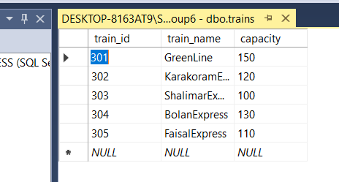

create table stations (
station_id int primary key,
station_name varchar(255) not null,
platform_count int not null,
contact_info varchar(255)
);

INSERT INTO stations (station_id, station_name, platform_count, contact_info)
VALUES
(201, 'Karachi', 5, '021-1234567'),
(202, 'Lahore', 4, '042-2345678'),
(203, 'Islamabad', 3, '051-3456789'),
(204, 'Peshawar', 4, '091-4567890'),
(205, 'Quetta', 3, '081-5678901');
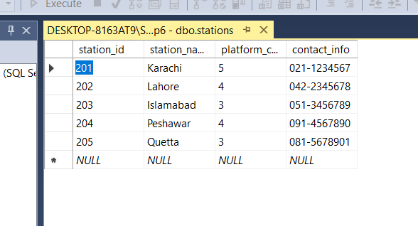
create table train_routes (
route_id int primary key,
train_id int,
source_station_id int,
destination_station_id int,
foreign key (train_id) references trains(train_id),
foreign key (source_station_id) references stations(station_id),
foreign key (destination_station_id) references stations(station_id)
);
INSERT INTO train_routes (route_id, train_id, source_station_id, destination_station_id)
VALUES
(401, 301, 201, 202),
(402, 301, 201, 203),
(403, 301, 201, 204),
(404, 301, 201, 205),
(405, 302, 202, 201),
(406, 302, 202, 203),
(407, 302, 202, 204),
(408, 302, 202, 205),
(409, 303, 203, 201),
(410, 303, 203, 202),
(411, 303, 203, 204),
(412, 303, 203, 205),
(413, 304, 204, 201),
(414, 304, 204, 202),
(415, 304, 204, 203),
(416, 304, 204, 205),
(417, 305, 205, 201),
(418, 305, 205, 202),
(419, 305, 205, 203),
(420, 305, 205, 204);
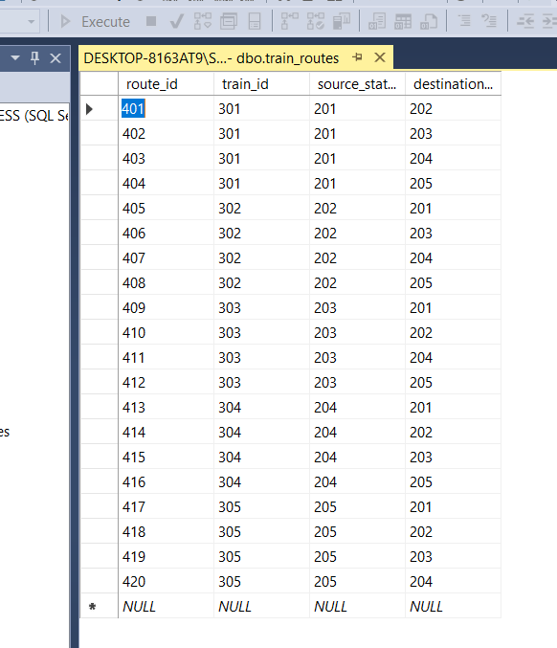

create table train_schedules (
schedule_id int primary key,
train_id int,
station_id int,
arrival_time time,
departure_time time,
foreign key (train_id) references trains(train_id),
foreign key (station_id) references stations(station_id)
);
INSERT INTO train_schedules (schedule_id, train_id, station_id, arrival_time, departure_time)
VALUES
(501, 301, 201, '06:00:00', '06:30:00'),
(502, 301, 202, '09:00:00', '09:30:00'),
(503, 301, 203, '12:00:00', '12:30:00'),
(504, 301, 204, '15:00:00', '15:30:00'),
(505, 301, 205, '18:00:00', '18:30:00'),
(506, 302, 201, '07:00:00', '07:30:00'),
(507, 302, 202, '10:00:00', '10:30:00'),
(508, 302, 203, '13:00:00', '13:30:00'),
(509, 302, 204, '16:00:00', '16:30:00'),
(510, 302, 205, '19:00:00', '19:30:00'),
(511, 303, 201, '08:00:00', '08:30:00'),
(512, 303, 202, '11:00:00', '11:30:00'),
(513, 303, 203, '14:00:00', '14:30:00'),
(514, 303, 204, '17:00:00', '17:30:00'),
(515, 303, 205, '20:00:00', '20:30:00'),
(516, 304, 201, '09:00:00', '09:30:00'),
(517, 304, 202, '12:00:00', '12:30:00'),
(518, 304, 203, '15:00:00', '15:30:00'),
(519, 304, 204, '18:00:00', '18:30:00'),
(520, 304, 205, '21:00:00', '21:30:00'),
(521, 305, 201, '10:00:00', '10:30:00'),
(522, 305, 202, '13:00:00', '13:30:00'),
(523, 305, 203, '16:00:00', '16:30:00'),
(524, 305, 204, '19:00:00', '19:30:00'),
(525, 305, 205, '22:00:00', '22:30:00');

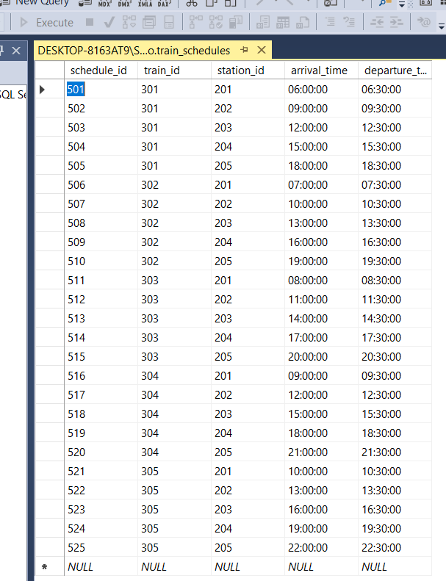
create table ticket_pricing (
pricing_id int primary key,
route_id int,
class varchar(10) check (class in ('first', 'economy')) not null,
fixed_price decimal(10,2) not null,
foreign key (route_id) references train_routes(route_id)
);

INSERT INTO ticket_pricing (pricing_id, route_id, class, fixed_price)
VALUES
(601, 401, 'economy', 1000.00),
(602, 402, 'first', 1500.00),
(603, 403, 'economy', 1200.00),
(604, 404, 'economy', 900.00),
(605, 405, 'first', 2000.00),
(606, 406, 'economy', 1000.00),
(607, 407, 'first', 1500.00),
(608, 408, 'economy', 1200.00),
(609, 409, 'economy', 900.00),
(610, 410, 'first', 2000.00),
(611, 411, 'economy', 1000.00),
(612, 412, 'first', 1500.00),
(613, 413, 'economy', 1200.00),
(614, 414, 'economy', 900.00),
(615, 415, 'first', 2000.00),
(616, 416, 'economy', 1000.00),
(617, 417, 'first', 1500.00),
(618, 418, 'economy', 1200.00),
(619, 419, 'economy', 900.00),
(620, 420, 'first', 2000.00);
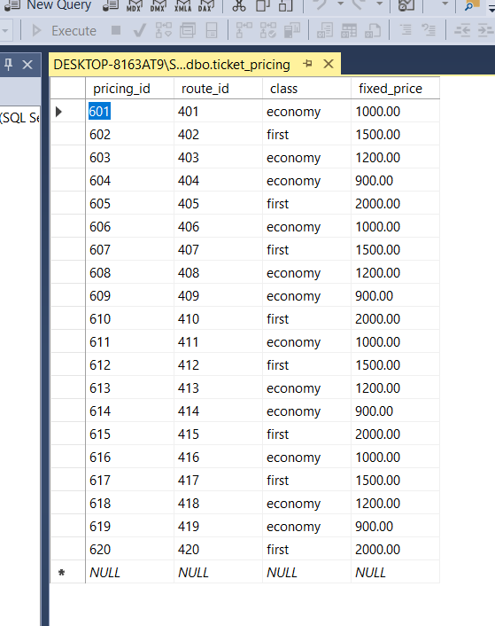

create table tickets (
ticket_id int primary key,
passenger_id int,
train_id int,
seat_number varchar(10),
status varchar(10) check (status in ('booked', 'cancelled')) default 'booked',
foreign key (passenger_id) references passengers(passenger_id),
foreign key (train_id) references trains(train_id)
);
INSERT INTO tickets (ticket_id, passenger_id, train_id, seat_number, status)
VALUES
(701, 101, 301, 'A01', 'booked'),
(702, 102, 302, 'B02', 'booked'),
(703, 103, 303, 'C03', 'booked'),
(704, 104, 304, 'D04', 'cancelled'),
(705, 105, 305, 'E05', 'booked');

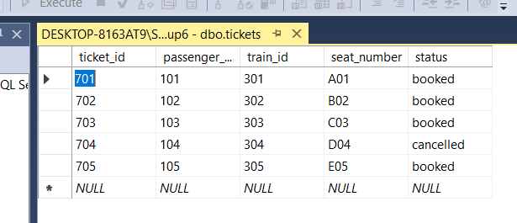
create table payments (
payment_id int primary key,
ticket_id int,
amount decimal(10,2) not null,
payment_method varchar(10) check (payment_method in ('card', 'cash')) not null,
payment_status varchar(10) check (payment_status in ('completed', 'pending')) default 'pending',
foreign key (ticket_id) references tickets(ticket_id)
);

INSERT INTO payments (payment_id, ticket_id, amount, payment_method, payment_status)
VALUES
(801, 701, 1000.00, 'card', 'completed'),
(802, 702, 1500.00, 'cash', 'pending'),
(803, 703, 1200.00, 'card', 'completed'),
(804, 704, 0.00, 'cash', 'pending'),
(805, 705, 2000.00, 'card', 'completed');
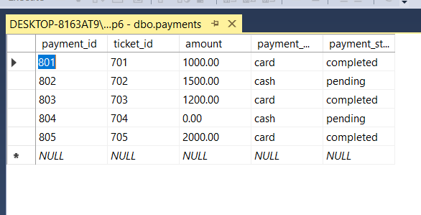

FUNCTIONALITIES
Add New Passenger:
insert into passengers (passenger_id, name, email, contact_number, status)
values (111, 'john', 'john@example.com', '1234567890', 'active');
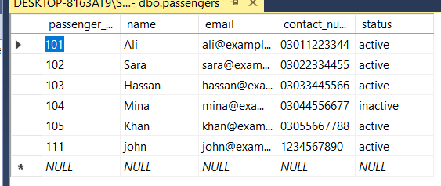
View Passenger Details:
select * from passengers where passenger_id = 101;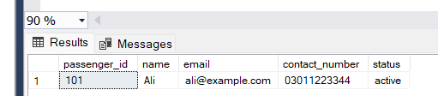
Update Passenger Status:
update passengers
set status = 'inactive'
where passenger_id = 101;
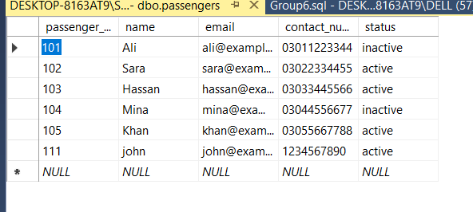
View Booking History:
select t.ticket_id, t.seat_number, tr.train_name, ts.arrival_time, ts.departure_time
from tickets t
join trains tr on t.train_id = tr.train_id
join train_schedules ts on ts.train_id = tr.train_id

where t.passenger_id = 101;

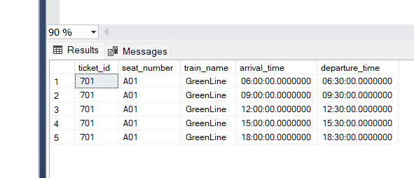

2. Train Management
Add New Train:
insert into trains (train_id, train_name, capacity)
values (201, 'express-101', 500);
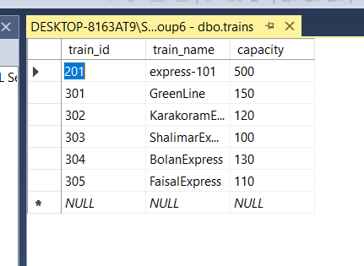
View Train Details:
select * from trains
where train_id = 201;
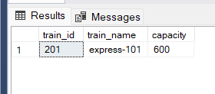
Update Train Information:
update trains
set capacity = 600
where train_id = 201;
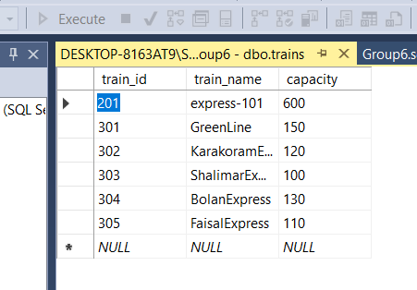

3. Station Management
Add New Station:
insert into stations (station_id, station_name, platform_count, contact_info)
values (301, 'karachi station', 5, '123-456-7890');
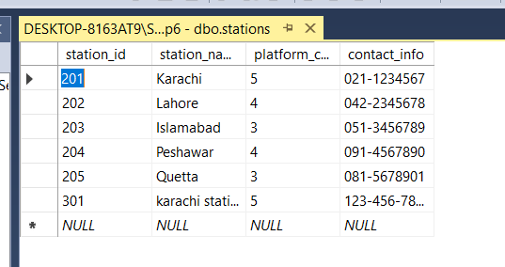
View Station Details:
select * from stations
where station_id = 301;
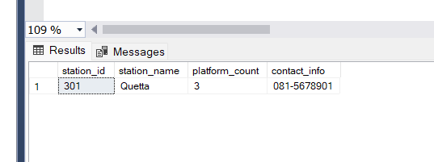
Update Station Information:
update stations
set platform_count = 6
where station_id = 301;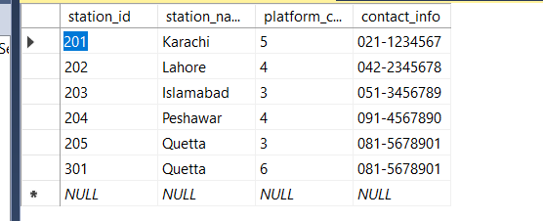
Remove Station:
delete from stations
where station_id = 301;
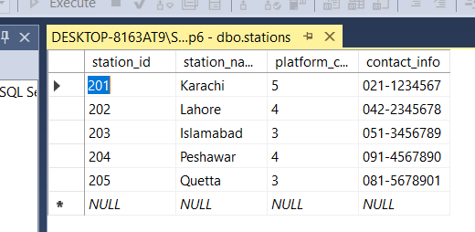

4. Train Route Management
View Route Details:
select * from train_routes
where route_id = 401;
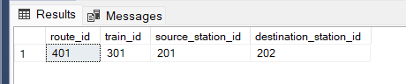

5. Train Schedule Management
View Train Schedule:
select * from train_schedules
where train_id = 301;
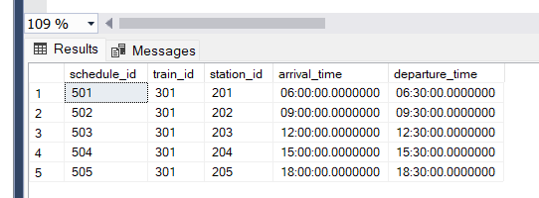
Update Schedule Information:
update train_schedules
set arrival_time = '08:15', departure_time = '08:45'
where schedule_id = 501;
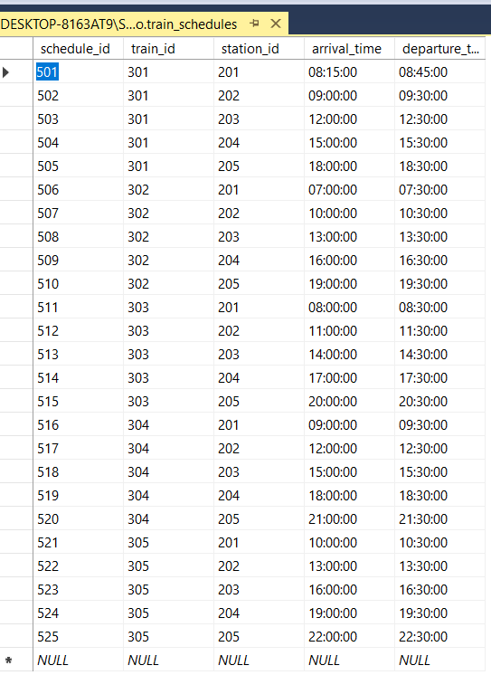
Remove Schedule:
delete from train_schedules
where schedule_id = 501;
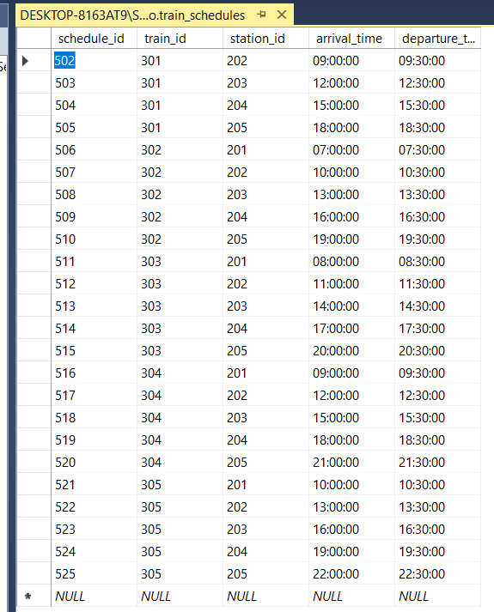

6. Ticket Management
View Ticket Details:
select * from tickets
where ticket_id = 601;
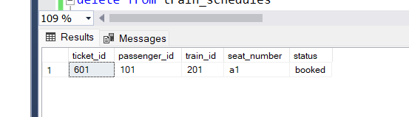
Update Ticket Status:
update tickets
set status = 'cancelled'
where ticket_id = 601;
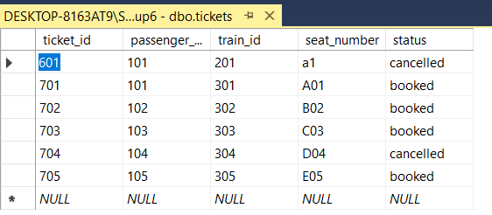
Cancel Ticket:
update tickets
set status = 'cancelled'
where ticket_id = 601;

View Passenger Ticket History:
select t.ticket_id, tr.train_name, ts.arrival_time, ts.departure_time
from tickets t
join trains tr on t.train_id = tr.train_id
join train_schedules ts on t.train_id = ts.train_id
where t.passenger_id = 101;
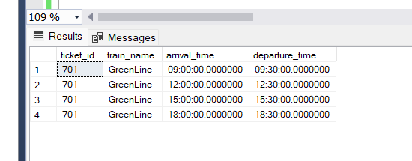

7. Pricing Management
Add New Pricing:
insert into ticket_pricing (pricing_id, route_id, class, fixed_price)
values (701, 401, 'economy', 500.00);
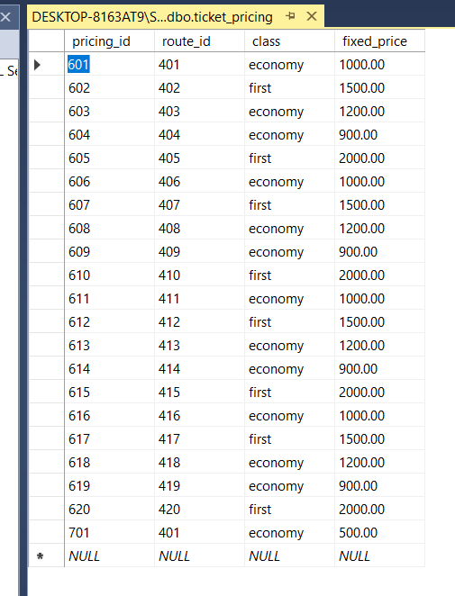
View Pricing Information:
select * from ticket_pricing
where route_id = 401;
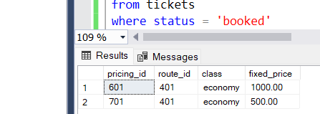

Update Pricing:
update ticket_pricing
set fixed_price = 550.00
where pricing_id = 701;

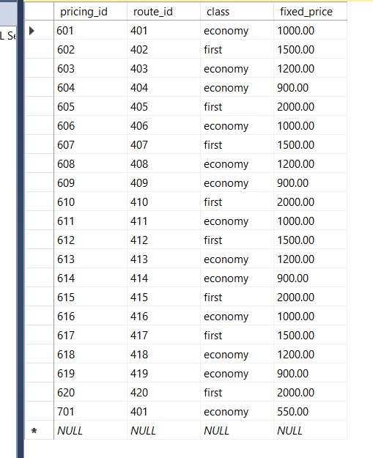
Remove Pricing:
delete from ticket_pricing
where pricing_id = 701;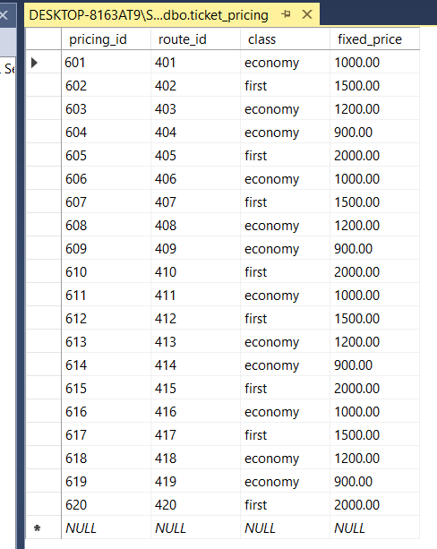
8. Payment Management
Make Payment:
insert into payments (payment_id, ticket_id, amount, payment_method, payment_status)
values (811, 601, 500.00, 'card', 'completed');
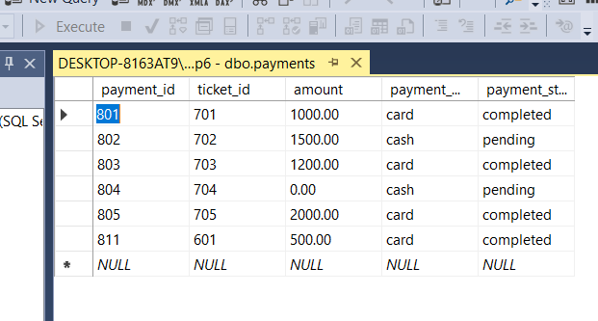
View Payment Details:
select * from payments
where ticket_id = 601;
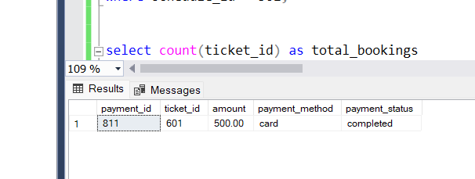
Update Payment Status:
update payments
set payment_status = 'pending'
where payment_id = 801;
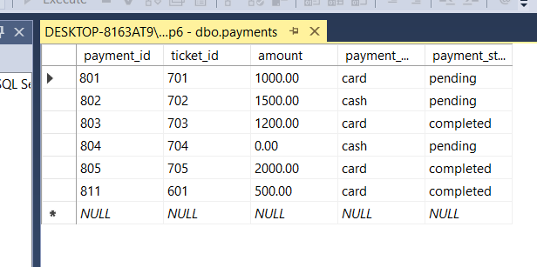
Cancel Payment:
delete from payments
where payment_id = 801;
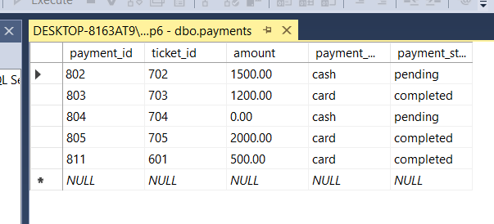

9. Reports & Analytics (Queries)
Passenger Booking Statistics:
select count(ticket_id) as total_bookings
from tickets
where status = 'booked'
group by passenger_id;
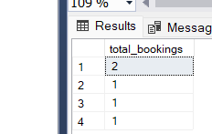
Train Utilization:
select tr.train_name, count(t.ticket_id) as bookings
from tickets t
join trains tr on t.train_id = tr.train_id
group by tr.train_name;
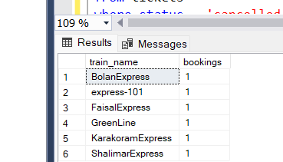
Revenue Reports:
select tr.train_name, sum(p.amount) as total_revenue
from payments p
join tickets t on p.ticket_id = t.ticket_id
join trains tr on t.train_id = tr.train_id
group by tr.train_name;
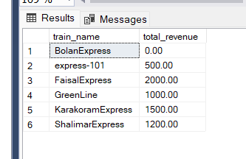
Cancelled Tickets Report:
select count(ticket_id) as cancelled_tickets
from tickets
where status = 'cancelled';
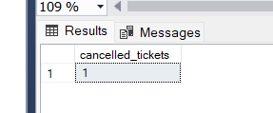
Train Schedule Report:
select tr.train_name, ts.arrival_time, ts.departure_time
from train_schedules ts
join trains tr on ts.train_id = tr.train_id
order by ts.arrival_time;
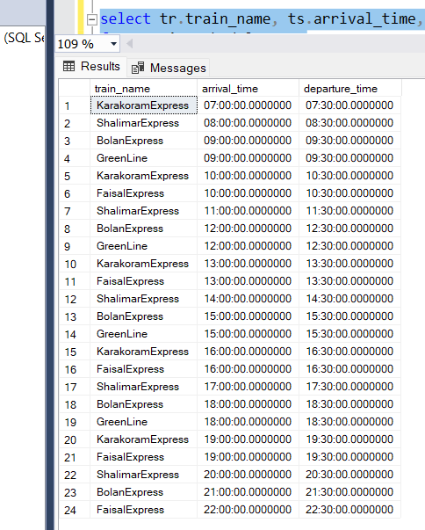

10. Search and Filtering (SQL Queries)
Search for Trains by Route:
select tr.train_name
from trains tr
join train_routes trt on tr.train_id = trt.train_id
where trt.source_station_id = 201 and trt.destination_station_id = 202;

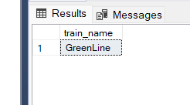
Search for Passengers by Name or Email:
select * from passengers
where name like '%john%' or email like '%@example.com%';
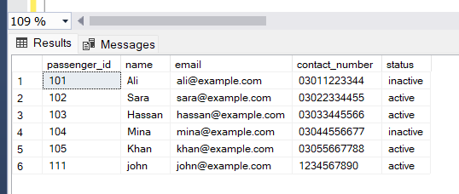
Search Tickets by Status:
select * from tickets
where status = 'booked';
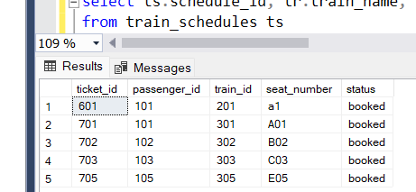
Search Train Schedules by Train or Station:
select ts.schedule_id, tr.train_name, ts.arrival_time, ts.departure_time
from train_schedules ts
join trains tr on ts.train_id = tr.train_id
where ts.station_id = 201;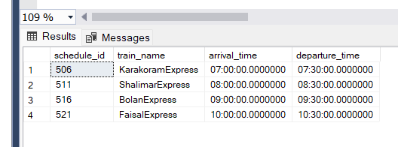

View Passenger Booking Statistics by Train with Revenue
select tr.train_name,
count(t.ticket_id) as total_bookings,
sum(p.amount) as total_revenue
from tickets t
join trains tr on t.train_id = tr.train_id
left join payments p on t.ticket_id = p.ticket_id
right join passengers ps on t.passenger_id = ps.passenger_id
where ps.name like '%john%' or ps.email like '%@example.com%'
group by tr.train_name
having count(t.ticket_id) > 0
order by total_revenue desc;
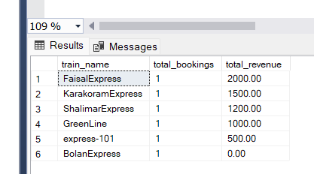
View Passenger Ticket History for a Specific Train Route
select t.ticket_id, t.seat_number, tr.train_name, ts.arrival_time, ts.departure_time
from tickets t
join trains tr on t.train_id = tr.train_id
join train_schedules ts on ts.train_id = tr.train_id
where t.ticket_id in (
select ticket_id
from train_routes trt
join tickets t2 on trt.train_id = t2.train_id
where trt.source_station_id = 201 and trt.destination_station_id = 202
)
and t.passenger_id = 101;
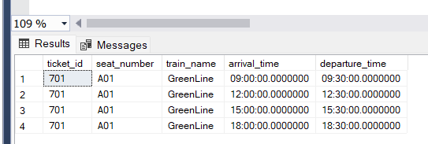
SCHEMA
